East Rowan Saddle Club
Games Show
14210 Old Beatty Ford Rd, Rockwell NC 28138
Start Time: 6:00 PM Dates: July 13th, August 10th
$8 per class or $30 All Day Fee
Jackpot Classes - $10
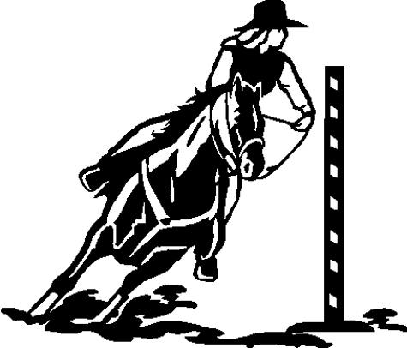
- Ride A Buck
- Keyhole Race – PW
- Keyhole Race – JR
- Keyhole Race – AD
- Water Glass Class
- Barrel Racing – PW
- Barrel Racing – JR
- Barrel Racing – AD
- Jackpot Barrel Racing - $
- Egg & Spoon
- Pole Bending – PW
- Pole Bending – JR
- Pole Bending – AD
- Jackpot Pole Bending - $
- Ribbon Relay (Teams)
- Hurry Scurry – PW
- Hurry Scurry – JR
- Hurry Scurry – AD
- Panty Race
- Figure 8 Flag Race – PW
- Figure 8 Flag Race – JR
- Figure 8 Flag Race - AD
- Potato Race
- Buddy Pick-Up (Youth MUST wear helmet, have adult consent)

Daily high point awards to each age division.
For more information visit www.eastrowansaddleclub.com or
Call Jessie Hellems at 704-202-5701

