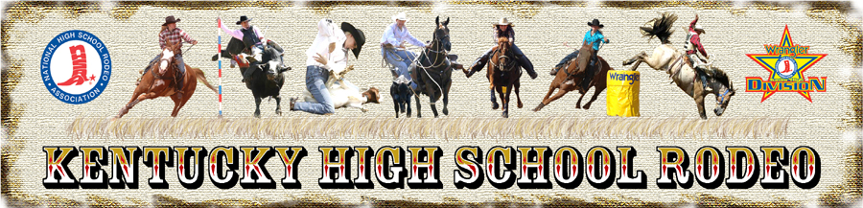

The Kentucky High School Rodeo Association is asking for your help in collecting money for our High School Rodeo Association. This can be done either by donation or sponsorship. The Kentucky High School Rodeo Association is a nonprofit organization. We have student’s members from all over the state of Kentucky. All members must currently be enrolled in school, have good conduct and must have passing grades in their classes. The Kentucky High School Rodeo Association would like to thank you for your support.

Member Name________________________________
Sponsor Name________________________________
Sponsor Address _____________________________
Sponsorship/Donation Amount __________________

Make Checks payable to: KHSRA (KHSRA tax#31-1117784)

Sarah Rogers
8011 Wallonia Rd.
Cadiz, KY 42211

- Arena Banner-------------------------------------------(You Provide Banner)$300 rodeo season
- Bucking Chute Sign----------------------------------- (You Provide Sign) $500 for rodeo season
- Boys or Girls All Around Sponsor -----------------$1,000
- Event Buckle Sponsor--------------------------------(Year and Champion) $500
- Scholarship or Donation------------------------------$250, $500, $1,000
- Monetary Donation any amount--------------------$_________
(Please provide any specific information, so it can be announced during the rodeo performances.) Any questions please call Sarah Rogers 270-348-1514.

