What Materials Do We Need For Our Business?
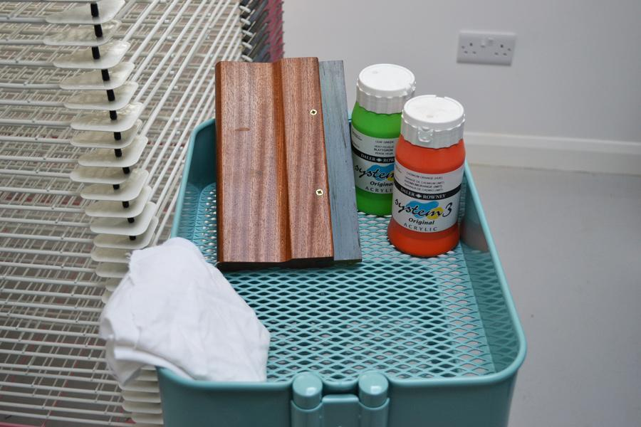

T-Shirts Ink

What is the cost of our materials?

Look up shirt prices from the following websites. Our shirt is Gilden 500

www.amazon.com | www.shirtspace.com
What does one T-Shirt cost? | What does one T-Shirt cost?
S M L XL 2X | S M L XL 2X
www.blankapparel.com | www.t-shirtwholesaler.com
What does one T-Shirt cost? | What does one T-Shirt cost?
S M L XL 2X | S M L XL 2X

Supplier for T-Shirts:

Look up ink prices from the following websites. We are using Plastisol ink, white.
Supplier | Cost Per quart | Cost per gallon
www.amazon.com
www.screeningsuppliesstore.com
www.neverthelessscreenprintingsupplies.com

Supplier for Ink:

Look up emulsion prices from the following websites.
Supplier | Cost Per quart | Cost per gallon
www.amazon.com
www.screeningsuppliesstore.com
www.neverthelessscreenprintingsupplies.com

Supplier for emulsion:

Average cost of shirt. | Cost of Ink | Cost of emulsion
(s+m+l+xl+2xl) ÷ 5 = | Cost ÷ 50 = | Cost ÷ 10 =

The total cost of 1 shirt
The total cost of 1 shirt. | Shirt + Ink + Emulsion =
What will our mark-up percentage be? | %
Total sell price to the customer. | Total Cost + Percentage

