30 Hours Free Childcare

You may be able to get up to 30 hours free childcare
If you are eligible for the extra hours you sign up online to get a code to give to your childcare provider - You’ll get the extra hours once the next term starts

Eligibility
- You can usually get 30 hours free childcare if you (and your partner, if you have one) are in work or getting parental leave, sick leave or annual leave
For example, over the next 3 months you expect to earn at least £1,813.76 - the National Living Wage for people over 23.
- This earnings limit doesn’t apply if you’re self-employed and started your business less than 12 months ago
You’re Not Eligible if:-
- Your child doesn’t usually live with you
- The child is your Foster Child
- Either you or your partner has a taxable income over £100,000
- You’re from outside the EEA and your UK residence card says you can’t access public funds
You can get 30 hours free childcare at the same time as claiming Universal Credit, Tax Credits or Childcare Vouchers

IF YOU CAN’T WORK
You may still be eligible if your partner is working and you get Incapacity Benefit, Severe Disablement Allowance, Carer’s Allowance or Employment and Support Allowance

How to Apply
You’ll need your details (and your partner’s if you have one), including your
- National Insurance Number
- Unique Taxpayer Reference (UTR) if you’re self employed
You’ll get a childcare account if your application is successful
You can use it to get your code for 30 hours free childcare
If you pay for childcare and want to use Tax Free Childcare to get help with costs you can also apply using this service

You may find out if you’re eligible straight away, but it can take up to 7 days Go To:
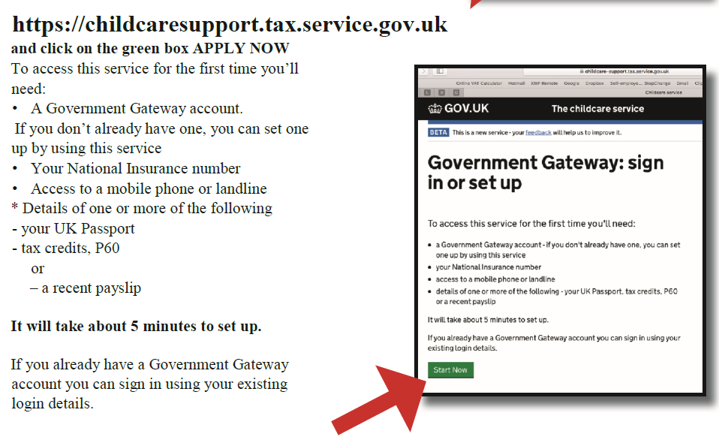

Reconfirm eligibility

You must reconfirm your eligibility every 3 months from the date you applied to receive the extra hours (or Tax-Free Childcare). You must also reconfirm your code even if your child has not yet started their 30 hour place.

Finding your 30 hours code
After you have successfully applied online you need to log into your childcare service account to get your 11-digit code.
If you are having problems follow this step-by-step guide to finding your 30 hours code in your childcare service account (PDF, 198.8 KB).

How to reconfirm
If you applied online you must reconfirm your eligibility up to 4 weeks before your reconfirmation date by logging into your childcare service account and finding your reconfirmation date in the 'secure message' section. You should make a note of this date in case you don't receive the reminder from HMRC.
Although you should receive a reminder from HMRC by text or email 4 weeks, and then 2 weeks before the deadline to log into your Childcare Service account. You should keep them informed of any changes to your contact details.
The reconfirmation process may be different for some parents/carers. If your:
- circumstances haven't changed you will need to tick a box to confirm this - you will not receive a new code as your existing one will get extended for 3 months more
- circumstances have changed you must amend and resubmit your details - if your eligibility gets reconfirmed, your existing code will be extended for 3 months more
- original application was made over the phone you need to call HMRC to reconfirm your eligibility on 0300 123 4097
- code is temporary (starting with 11), you must complete a new application through your childcare service account to get a permanent code - your temporary code cannot be renewed and you will fall out of eligibility if you do not complete a new application for a permaneent code.

If you are no longer eligible
If your family no longer meets the criteria, we will inform your childcare provider and you will stop being eligible to claim the extra hours. There will be a grace period until the start of the next funded period to give you the opportunity to start work again. If your circumstances change during the grace period you can apply again and continue to receive the extra hours.
You will still be able to receive 15 hours of Free Early Education and Childcare for 3 and 4 year olds even if you are no longer eligible for the extended entitlement.

