**FUN FEBRUARY**

**During the month of February, we pick a fun spirit event**

**to do each week.**

February 5th-8th is **Crazy Sock Week**

February 12th-15th is **Crazy Hair**

February 19th-22nd is **Spirit Week**

February 26th-29th is **Pajama Week**

GET READY TO BRING F* U* N

TO FEBRUARY!



C:\Users\Stephanie\Pictures\Microsoft Clip Organizer\j0416014.wmfC:\Users\Stephanie\Pictures\Microsoft Clip Organizer\j0416014.wmfC:\Users\Stephanie\Pictures\Microsoft Clip Organizer\j0416014.wmf

**INSPIRATION** C:\Users\Stephanie\Pictures\Microsoft Clip Organizer\j0416014.wmf

“Be self disciplined. Find someone wise and follow them.”

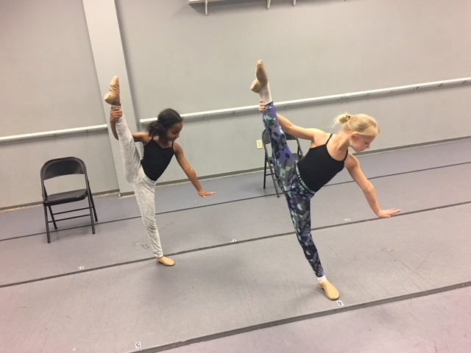

**#class of the month** C:\Users\Stephanie\Pictures\Microsoft Clip Organizer\j0416014.wmf

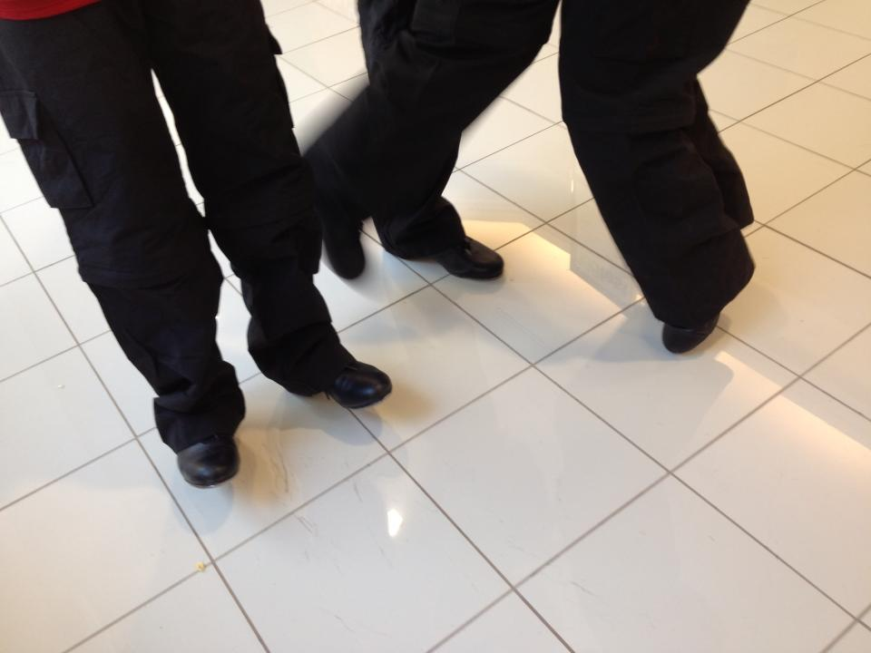

***TAP CLASSES***

One of the most exciting sounds to hear coming from the studios are the rhythmic sounds of students tapping. Whether it is warm-up or a combination, with music or acappella those shoes are singing a song!

**2018 SUMMER CLASSES **

Our 2018 Summer Classes will be online soon! Check out what is happening for summer during our 4-week session. We have a wide variety of dance styles and camps along with our Tiny Stepper Program (ages 2-4). If you are age 2 & up there is something for you at Next Step Dance. If you are interested in recreational or competition classes there is something for you at Next Step Dance. Refer family and friends and share in their excitement of dance when you receive a credit to your dance account! This is a perfect time to try something different and see if it is something you might want to add for fall!

C:\Users\Stephanie\Pictures\Microsoft Clip Organizer\j0416014.wmf C:\Users\Stephanie\Pictures\Microsoft Clip Organizer\j0416014.wmf

Steppin’ into FEBRUARY 2018 with Next Step Dance

[**www.thenextstepnc.com**](http://www.thenextstepnc.com)

**7712 Sossamon Lane, NW Concord, NC 28027 (704) 786-7837 nsdcalendar@gmail.com**

**OPEN HOUSE**

Thinking ahead to summer activities or even Fall 2018? Have a friend or relative interested in dance? Have a younger sibling that will be old enough for our Tiny Steppers program? Find out schedules and all the important stuff at our Open House on Saturday, May 19th, 2018 from 10:00am-1:00pm. There will be classes to tryout and informational sessions to learn more about Next Step Dance and what is happening with us for the rest of 2018.

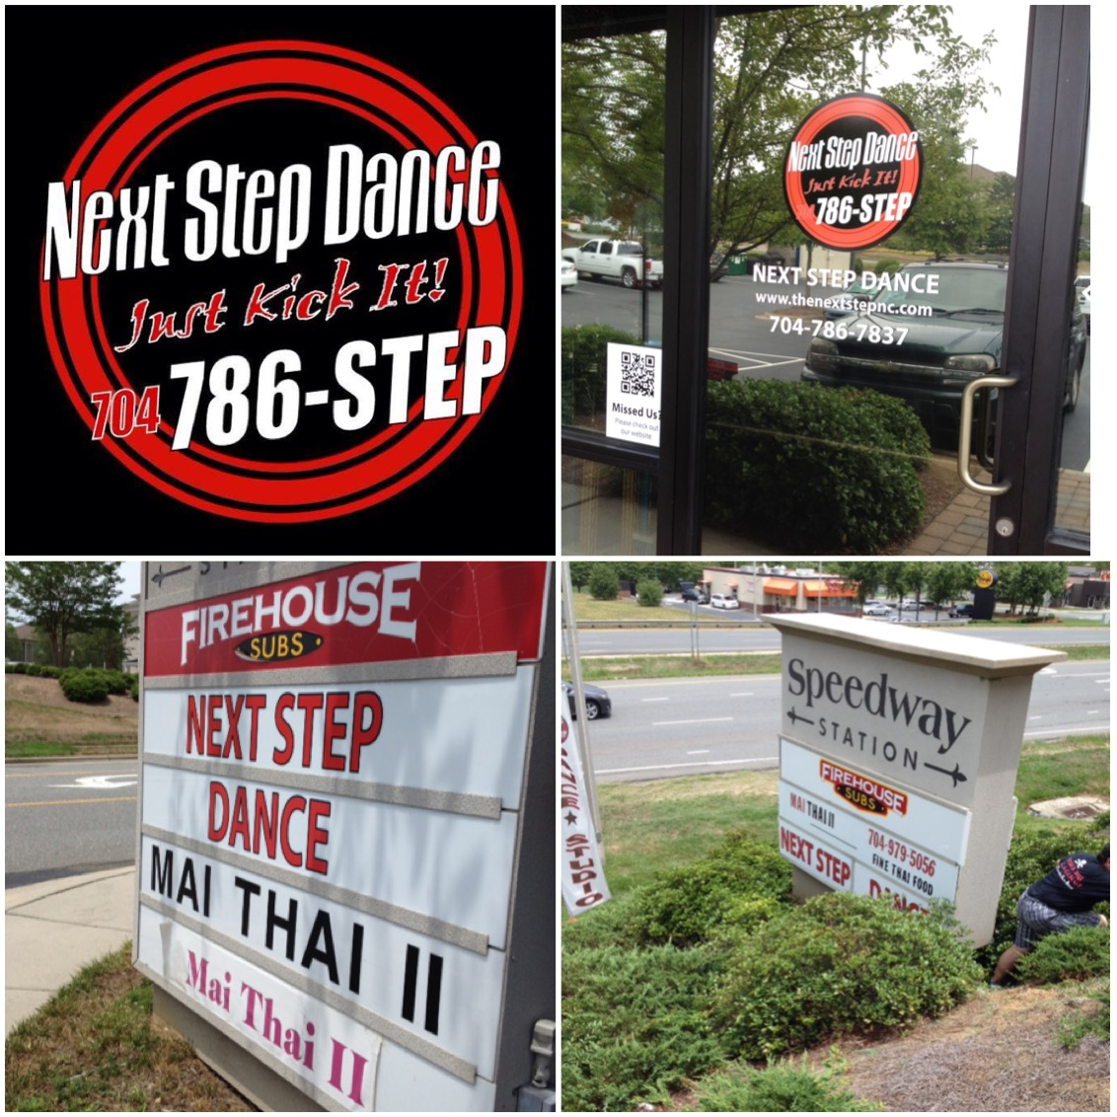

**SAVE THE DATE** C:\Users\Stephanie\Pictures\Microsoft Clip Organizer\j0416014.wmf

February 9th Hip Hop Friday Night

February 12th-15th Parent Appreciation

February 14, 2018

Don’t forget your Valentine!



Shoe orders take approximately 1-week for delivery and some we have in stock!

REMEMBER TO JOIN US ON

Facebook, Twitter, & Instagram!