The Start-Up Guide to Vision Statements, Goal-Setting, Resource Libraries, Advisory Boards

By: Natascha F. Saunders, MBA, MS
Certified Professional Career Coach (PARW/CC)
Doctor of Education, Candidate, neu.edu

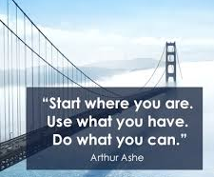

Your Name: ____________________________________________________

Accountability Partner: ____________________________________________________

Date: ____________________________________________________

Natascha F. Saunders, MBA,MS, CPCC

Vision – the faculty or state of being able to see.

Vison Statement – is a road map, indicating both what you want to become and a guide to transformative initiatives by setting a defined direction for your growth.

Goal – the object of a person’s ambition or effort; an aim or desired result.

Goal Setting – the process of identifying something you want to accomplish and establishing measurable steps and time frames.

Dictionary.com

Your personal vision statement guides your life and provides the direction necessary to chart the course of your days, choices you make, helps you achieve your goals, guides you to apply what you’ve learned and ultimately is the legacy you leave behind.

Vision is defined as:
- A thought, concept, or object formed by the imagination
- A manifestation to the senses of something immaterial
- To act or power of imagination

What is your Vision?
We have all thought about the things we’d like to accomplish in our lifetime. However, most never write these thoughts down. A vision statement describes how you see yourself in the future by speaking it and writing it into existence. Meaning you have not accomplished these things yet, but you are making the statement as if you have. For example, ‘I am a motivational speaker.’ ‘I am a business owner.’ ‘I am a president of a internationally branded company. ’I am happy.’ ‘I am smart.’ ‘I am an author of a best-selling book.’ ‘I am a straight A & B student and have landed an internship at a fortune 100.’ ‘I am a famous recording artist.” “I am a doctor.” “I am Press Secretary for the United States of America. ‘I am starting a highly-competitive fellows program.’ ‘I am an inventor and have been working with Ivy League schools and Silicon Valley to bring my idea to market.’ “I am a real estate owner’. ‘I am living in a penthouse apartment.’ ‘I am making 100,000+ a year.’ ~ Although you haven’t accomplished these things you are speaking them into existence.

Parts of your Vision Statement?

Your vision statement should be a compilation of what you’d like to accomplish in your lifetime and what legacy you want to leave behind.
Start with this:
- What brings you happiness? ___________________________________________________
- What inspires you to do great things? ____________________________________________
- What have you overcome? _____________________________________________________
- What do others say they see you doing? __________________________________________
- What do you enjoy doing? _____________________________________________________
- What problems are you always solving for people? _________________________________
- List things you’ve always wanted to do? __________________________________________
- Do you see yourself in a higher position? _________________________________________
- Do you want to be in a meaningful relationship? ___________________________________
- What type of parent do you want to be? __________________________________________

When you have answered all of these questions, think about how they may fit into a vision statement.

PLEASE ANSWER

Write down a few reasons why it is important for you to have a vision statement within the following areas: FINANCIAL, (investments, savings, money), CAREER (entrepreneurship, job, business, social media), FAMILY (children, parents, pets*), SPIRITUAL (faith, church, prayer, meditation), HEALTH (fitness, doctors, eating, exercise), ACADEMIC (education, grades, knowledge) , LEISURE (travel, reading, activities), or LEADERSHIP (supporting others, management)?
____________________________________________________________________________________________________________________________________________________________________________________________________________________________________________________________________________________________________________
Write down a reason why it is important for your family/peers/spouse/children that you have a vision statement?
____________________________________________________________________________________________________________________________________________________________________________________________________________________________________________________________________________________________________________
- First, remember you are creating this vision for you. Without your own vision you cannot lead others nor convince others why you desire what you desire.
- Second, remember you are beginning your statements with ‘I AM’.
- Third, consider having the people spend the most time with create a vision statement for their lives as well. It’s been said we are the sum average of our five most close friends.

OPTIONAL IDEA → Take this a step further, but only after you have a written statement and create a Pinterest, video or craft an actual vision board.

PINTEREST SAMPLES

https://www.pinterest.com/barbarar0675/vision-board/
https://www.pinterest.com/sandrawright353/vision-board/
https://www.pinterest.com/AnnaDusek/vision-board/
http://pinterest.com/sarahcentrella/my-vision-board/
http://pinterest.com/xdenikax/vision-board/
Various Vision Board Samples http://goo.gl/oqIV5c

YOUTUBE SAMPLES
http://goo.gl/JnYRRo
How to Make a Vision Board from, ‘The Secret’ http://goo.gl/AVcgvq

HOW TO MAKE A VISION BOARD SAMPLE
http://www.wikihow.com/Make-a-Vision-Board

Let’s take a look at some SAMPLES

I am Tameka Jackson. I have earned a bachelor’s degree in engineering with honors from Northeastern University and have overcome the abuse I experienced growing up as a child. I have been accepted into a national scholarship program. Starting this summer, I will be working in Washington, D.C. for the FBI and I volunteer giving back to younger people on my weekends at the local Boys & Girls Club.

My name is Nichole Smith I am in the best shape of my life. I have not let the fact that I grew up in a troubled home or the fact that I’ve had some problems with my parents stop me from becoming my greatest self. I have an executive level certified in leadership from Harvard Kennedy School and can travel around the city giving talks to various organizations. I have interviewed with multiple media agencies and have been offered a promotion on my job to the c-suite. I have two best friends, have joined an awesome church, and I’m living a purpose-driven life every day. I live in a great apartment and make over $100K. I am very happy.
My name is Mo Khamil; I am 45 years old and a father of two wonderful children. I have completed the Dimensions of the Faith course from Gordon Conwell. After its completion, I will be attending full-time. I strike a good work life balance and take two international vacations a year with my family. I am financially secure with no debt, and a BMW M series vehicle paid off. My promotion has also allowed me to purchase the home of my dreams with two acres of land which is enough for my two beloved German shepherds Nico and Falco to run around

My name is Nichole Smith I am in the best shape of my life. I have not let the fact that I became pregnant at a young age, or the fact that I was homeless in my youth, stop me from becoming my greatest self. I have a cosmetology certificate and am able to do the best make-up in Boston. I am also one year away from earning by Masters in Communications degree. I have two best friends, have joined an awesome church, and I’m living a purpose-driven life every day. I live in a great apartment, and make a good salary. Also, I get a call every year to do make up for all the celebrities for Mercedes Benz New York Fashion Week. I am happy.
C-Suite example: Within two years, achieve 40 percent market share in the computer headphone/microphone industry, receive the J.D. Power highest quality rating in the industry, and receive 95 percent or above good or excellent ratings on our customer-service surveys.

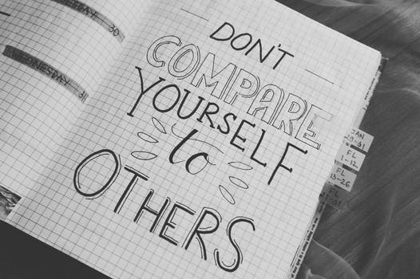
Write the vision, and make it plain upon tables, that he may run that readeth it. For the vision is yet for an appointed time, but at the end it shall speak, and not lie: though it will tarry, wait for it; because it will surely come, it will not tarry.

Write the FIRST draft of your vision statement?
____________________________________________________________________________________________________________________________________________________________________________________________________________________________________________________________________________________________________________________________________________________________________________________________________________

Write the SECOND draft of your vision statement?
____________________________________________________________________________________________________________________________________________________________________________________________________________________________________________________________________________________________________________________________________________________________________________________________________________

Write the FINAL draft of your vision statement?
__________________________________________________________________________________________________________________________________________________________________________________________________________________________________________________________________________________________________________________________________________________________________________________________________________________

NOW TIME TO MEMORIZE, POST UP IN YOUR HOME AND WRITE IN THE NOTES OF YOUR SMART PHONE

Next steps ….

Take your vision and turn it into action by setting goals….

READ 5 Reasons Why You Should Commit Your Goals to Writing: http://goo.gl/yhUSb

GOAL-SETTING
A goal is defined as the result or achievement toward which effort is directed; aim; end.

It’s important to ensure your goals are Specific, Measurable, Attainable, Realistic and Tangible.

Dr. Gail Matthews, a psychology professor at Dominican University in California, did a study on goal-setting with 267 participants. She found that you are 42 percent more likely to achieve your goals just by writing them down. Source: http://goo.gl/yhUSb

Review your vision and list below goals that you will commit to doing within the next 30, 60, 90 and 365 days. For example, for you to be hired at your dream company, you need to research their job openings, and speak with current or past employees. To brand yourself as a speaker, you need to map out specific topics and draft presentations and make cold-calls. To gain acceptance into college, you must complete the application, fill out the FAFSA, and obtain recommendation letters. To start a business, you should meet with the SBA SCORE office and begin to read stories of others who have done what you want to do. To travel the globe, you should look at travel websites and research the requirements. These are smaller goals that are part of the bigger vision.

Goal 1 (30 Days):
__________________________________________________________________________________________________________________________________
Goal 2 (30 Days):
__________________________________________________________________________________________________________________________________
Goal 3 (60 Days):
__________________________________________________________________________________________________________________________________
Goal 4 (90 Days):
__________________________________________________________________________________________________________________________________
Goal 5 (365 Days):
__________________________________________________________________________________________________________________________________
_________________________________________________________________
Lastly, the final step is for you to determine what you will need in order to accomplish these goals (personal, academic, professional, career, entrepreneurial, etc.). No one achieves anything alone.

MY RESOURCE LIBRARY
On this page, list all the available or needed resources that will help you reach your goals such as: friends, family, mentors, board of advisors, teachers, counselors, coaches, technology (computers, internet, programs, apps, serving on a volunteer board), clothing, books on a particular topic, stronger social media presence, and in parenthesis state how each source will help you, how you will obtain it, and how often you will use this resource. This list will grow and change.

Congratulations you now have a vision and set goals, you know what you need to achieve those goals – now it’s time to put this into action!

“Brands are built on what people are saying about you, not what you are saying about yourself.”
CEO, Guy Kawasaki

7 People You Need On Your Personal Advisory Board

By: Natascha F. Saunders

One mentor is not enough to guide, inspire, motivate, or challenge you to achieve your ultimate level of success. Getting a job is complex. Growing a business is complex. Navigating your next move is complex. As our society becomes more global, diverse and industries become more competitive, you cannot maximize your full potential without a team of advisors.

“Sure, your company has a board of directors, but shouldn't you have your very own board of directors too? Yes, absolutely,” says Square CFO Sarah Friar.

Having a personal board of advisors that you trust provides for you a group of people who push you beyond your perceived limits. The team you assemble will provide you with resources, objective opinions and with the emotional support you may need, should you reach a life changing situation such as getting fired, laid off, promoted, falling ill or facing workplace politics.

Who is on your team now? Do you need to reassess, promote, demote or recruit?

Here are 7 types of people you need if you want to maximize your potential, build your brand, grow your network and leave a legacy:

#1 Mentor – Your mentor should offer you a general perspective on life and career. This person should be significantly accomplished (professionally, academically, fiscally, and physically), easily trusted, models behaviors you want to emulate, dependable, authentic and an effective listener. It would also be helpful if this person has known you for a few years.

#2 Career Coach – Your coach should help you create a strategic plan of your career (past, present, future), help you create a vision and guide you in mapping out your goals with a timeline, be a respectable member of the community, have a strong brand, public testimonials, an extensive network of contacts, and can tell you exactly like it is and will hold you accountable for achieving your goals.

#3 Spiritual/Therapist Advisor – This is crucial in maintaining your balance and in fostering a belief in something greater than yourself. There are times when you may feel as though you have hit a brick wall and you don’t know where to turn. It’s at this point your spiritual advisor can guide you with wisdom.

#4 Money Advisor – Regardless of whether or not you make $15/hr or $150/hr, a money advisor will guide you to save actively, plan for retirement, question your spending habits and help you navigate your major purchases. There is a myth that when you make a million dollars, you will be more responsible. If you are not responsible over what you make now, your habits will carry over and impede your financial growth.

#5 Local Role Model – Who is the expert in your industry in your own city/town? Who is the expert in your particular craft that is often quoted in your local newspaper? Who is it that you may want to be like one day? This person is needed so you can visually see and touch what is possible. By speaking with someone over dinner whose career footsteps you’d like to tread, you can also establish your local reputation. This person can give you the playbook on how they accomplished their goals right in your own backyard.

#6 National Virtual Influencer – Being able to follow a person of influence on social media can help take your career to the next level. When you are faced with certain challenges, you can look up the leader you identify with and read what articles they have written to glean current input on similar situations. Some of these leaders even have social media ‘master-mind’ groups you can join.

#7 The Protégé – Having a younger advisor at least seven years your junior will keep you humble. You may realize you don’t know as much as you think you do. They will impart a renewed energy. They will tell you how they feel candidly. You’ll have the opportunity to bounce ideas off someone who may not have as much experience as you do, but they will share exactly how they feel, and that input can keep you current and help propel you into 21st century leadership.

Lastly, as you think about whom to approach, let them know why you are asking them and how their success has positively impacted you. Let them know what you hope to accomplish, and based on what you know about them, what you are willing to offer in return for their guidance.

It’s important to outline what will be required of them as far as length of time, the frequency of meetings, methods of meetings (in person or virtual), energy, resources, etc. It will give them something to think on, so they can appropriately decide if they can commit.

No matter their decision, always follow-up with a thank you and keep pushing ahead!

MY PERSONAL ADVISORY BOARD
- ______________________________________________________
- ______________________________________________________
- ______________________________________________________
- ______________________________________________________
- ______________________________________________________
- ______________________________________________________
- ______________________________________________________

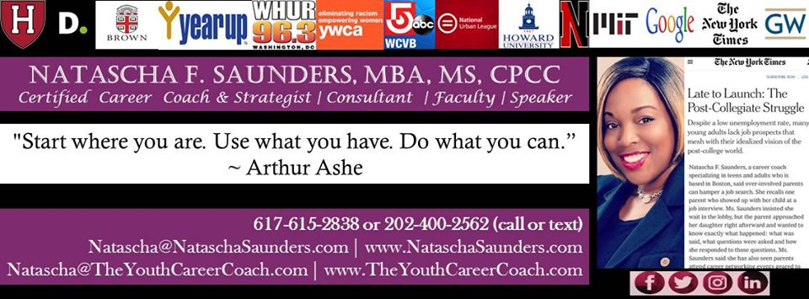

A few of Natascha’s Career Tips

- There is value in internships, volunteer work and/or working for someone else to gain experience that can be used in entrepreneurship, obtaining speaking engagements, getting into college, branding yourself as a subject matter expert.

- If you own or one day want to own a business there will be disappointments such as not getting a contract, client bounce checks, clients late on payments, so save and plan ahead and find a person you can vent.

- Even if you like to work alone you need many mentors. Find them by any means necessary.

- MUST HAVE: Resume/CV, Biography, Website, Flyer, Written Goals, LinkedIn, save your name on all social media handles – even if you don’t use them.

- Conduct informational interviews and set up meetings with anyone (no matter age, gender, race, income) you admire for their leadership, accomplishments, personality/energy, etc. and follow up with thank you notes.

Learn more hiring Natascha for specialized coaching and workshops
www.nataschasaunders.com (adults)
www.theyouthcareercoach.com (students)

