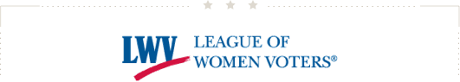
The League Update
September 28, 2017

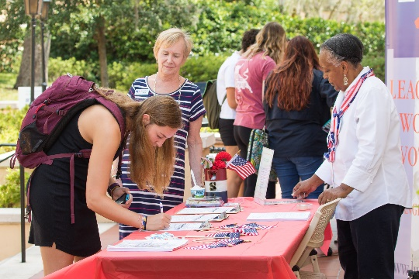
THE LEAGUE OF ORANGE COUNTY REGISTERING VOTERS AT ROLLINS COLLEGE ON NATIONAL VOTER REGISTRATION DAY

What a week to celebrate!
National Voter Registration Day was a huge success for the sixth year in a row. Thank you to the more than 350 Leagues who were out in force across the country registering new voters—ensuring we were once again the single largest on-the-ground partner for the day! If your League hosted a registration even on Tuesday, don’t forget to fill out your participation report here or by responding to an email you may have received from Brenda from the National Voter Registration Day team. Posting your results will help ensure the League is fully counted and credited for our incredible efforts as part of this day, and will help position us to leverage future opportunities.
ADDITIONALLY, we defeated the Senate health care bill! Thanks to leaders like you who called your members of Congress, the Senate will not be voting on the Graham-Cassidy bill to repeal Obamacare. This proposed legislation would have had devastating impacts including cuts to coverage, raised costs and ending Medicaid expansion.
As we look ahead to the fall and focus on local elections this year, I am encouraged by the success of our team and the power of this organization to have a meaningful impact on our democracy.
Chris

MAKING DEMOCRACY WORK CAMPAIGN
Supreme Court Rally to End Gerrymandering - October 3
On Tuesday October 3rd, the U.S. Supreme Court will hear arguments in the redistricting case Gill v. Whitford. This is promising to be a landmark case that could shape the national landscape for partisan gerrymandering. The League filed an amicus brief in Gill v. Whitford arguing that partisan gerrymandering violates the First Amendment and the Equal Protection Clause of the U.S. Constitution. At 10am on the morning of the hearing, we will participate in The Supreme Court Rally to End Gerrymandering! LWVUS staff will have branded signs available on site. If you're in the D.C. area, please spread the word and let us know if you are interested in rallying with us in front of the Supreme Court. Details about the rally can be found on the Facebook page HERE. For questions about League participation, please email the Communications Department at Communications@lwv.org.

Last Call: Nominations Close this Saturday - September 30
The Nominating Committee is searching for candidates for the 2018-20 LWVUS Board and LWVUS Nominating Committee and they need your help! Who do you know that would make a great nominee? Serving as a member of the LWVUS Board or Nominating Committee is an incredible opportunity! Don't miss this unique chance to lead the organization in a time when Making Democracy Work and protecting voting rights are more vital than ever. Specific qualifications are listed in a tri-fold brochure and handout, which are available online here. The deadline for applications is September 30. To nominate a League leader or yourself, please use this short online form.

New Resource Available: Webinar on Non-profit Governance
League leaders can access this 22-minute recorded session, which reviews board roles and responsibilities, any time. Created and presented by Robin Talbert, former president of the AARP Foundation and now licensed consultant for the Standards for Excellence Institute, the webinarreviews the key legal and governance responsibilities of a non-profit board. The session is a great tool for League boards to set common expectations and open dialogue about how to effectively work together.

News of the Week

Kristen de la Fuente participated in this interview with WTVY on the work of the Alabama League for National Voter Registration Day. Maggie Bush, LWVUS Programs and Outreach Director, participated in an interview for Independent Sector on how the League continues to improve elections on a local level.

The League of Colorado is putting a proposal on the ballot in 2018, calling for districts to be determined by an evenly-split team of democrats, republicans, and unaffiliated people.

In Austin, the League is seeking to combat voter suppression through collaboration and discussion of a new report shedding light on the city's legacy of segregation. Learn more about the community conversation and results of the report here.

ADVOCACY
League Files Amicus Brief in Gill v. Whitford
The League filed a brief in the historic partisan gerrymandering case, Gill v. Whitford, which will be heard by the U.S. Supreme Court on October 3rd. If you are interested in this case check out our latest blog post previewing the challenge at the center of the case and highlighting some of the history around partisan gerrymandering.

League Submits Brief in Husted v. A. Phillip Randolph Institute
LWVUS and LWVOH submitted an amicus brief to the U.S. Supreme Court in the case of Husted v. A. Phillip Randolph Institute. The case will be heard by the court on November 8, 2017. The amicus brief argues that the process used by Ohio to purge voters from voter rolls is illegal, inaccurate and unreasonable under the provisions established by Section 8 of the National Voter Registration Act (NVRA).

League Supports We the People Democracy Reform Act
The legislation has been introduced by in the House and Senate with Senator Udall (D-NM) and Representative Price (D-NC4) and offers a clear path forward for improving our democracy. This legislation will elevate the voices of the American people so we can be heard over the special interests and partisan bickering. This bill will strengthen our elections with automatic and online registration, enabling more voters to participate in our great democracy. Read statements endorsing the Act here.

Graham-Cassidy Health Care Proposal Rejected by U.S. Senate
The U.S. Senate’s latest attempt to repeal the Affordable Care Act failed this week. Graham-Cassidywould have eliminated affordable quality health care for millions of Americans by gutting the Affordable Care Act (ACA); slashed federal funding and destroyed Medicaid by turning its funding into per capita caps; eliminated the Medicaid expansion, and defunded Planned Parenthood health centers.

MEMBERSHIP
9-Month Countdown to Convention! June 28 – July 1, 2018 in Chicago
2018 is a national Convention year, and planning has begun to make this an event you won’t want to miss.
Delegates from Leagues across the country will convene to vote on national items such as program and budget, elect board members and more for the 2018-2020 biennium. As always we’ll work before Convention with Leagues from all over to build information sessions, workshops and events showcasing the best League ideas, projects, and advocacy. How to prepare? Later this Fall, our Convention webpage on the LWV forum will be developed. Bookmark this page and look for convention news as it emerges, including:
• The official First Call to Convention, and the Program Planners’ Guide.
• How and when to make hotel reservations at the Chicago Hilton on S. Michigan Avenue’s Museum Mile, a short walk from the Lake. Rooms blocked for the League’s use are $209 + tax per night, single, double or triple.
• This room rate will be available for a few days after July 1 for those who wish to spend 4th of Julyin this amazing city – described by residents and visitors as charismatic, diverse, cultured, and vibrant.
In February, you’ll be able to register as a convention delegate ($450 fee). This follows the January 2018 submission of your local League membership numbers. Your membership count determines the number of voting delegates you may have at convention. In the meantime, for guidance on how delegate representation is determined, see Bylaws Article IX.
Finally, be sure to read upcoming League Updates for more Convention news!

Update Your Membership Rosters
Please remember to make any changes to your League's leadership in the member database (CRM). It is essential that this information is diligently updated and kept current so that we have the most up-to-date leadership contact information in order to quickly communicate important information. Questions? Contact rostersupport@lwv.org

Reminder: Tax Filings Due November 15
IRS 990N tax filings are due the 15th day of the 5th month following the end of the fiscal year. If your League's (or education fund's) fiscal year ended on June 30, then your filing is due on November 15. More information about how to file is available here.

