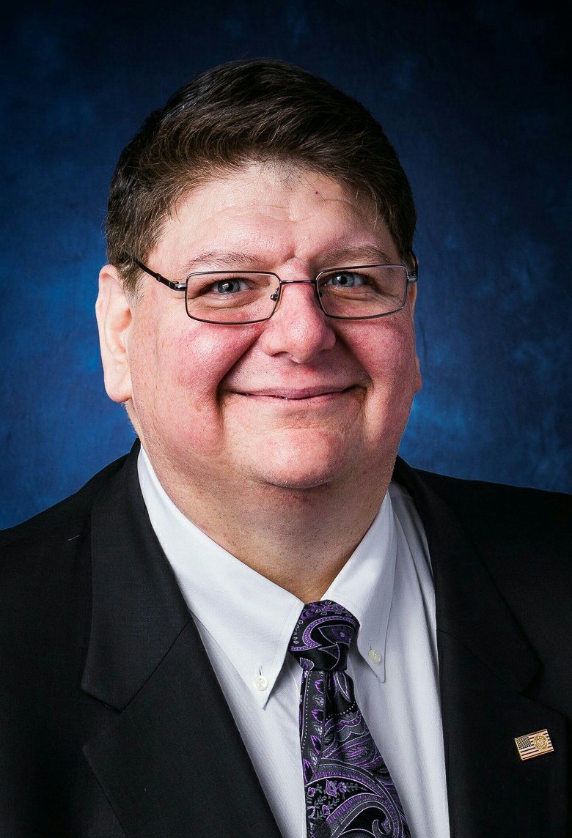**Professional Summary**

* Seasoned Information Technology (IT) practitioner with 30+ years’ experience and proven track record delivering complex enterprise technology initiatives and managing large enterprise operations.
* Experience in information engineering, database architecture, database app development, data warehouse, data marts, BI and Amazon Web Services (AWS).
* Experience in Data Architecture, Data Governance, Data Stewardship
* Expert Data modeling practitioner using Erwin, ER/Studio, and Data Architect.
* SDLC and methodology development expert providing agile leadership, configuration management, standards, standard operating procedures, requirements facilitation, scripting, training; systems analysis/, design, development, implementation, quality testing, and documentation.
* Highly experienced with Waterfall and Agile delivery e.g. XP, Scrum, KANBAN, DevOps, CI/CD
* Experience with Linux / Windows, Oracle (APEX) / SQL Server/ .Net and Java technology stacks.
* Experience with scripting and automation tools for CM, Deployment, DevOps and QA: Jenkins, Maven, Subversion, Git, HP Quality Center, Eclipse, Puppet, Red Hat CloudForms, JBOSS.
* Experience with Agile Lifecycle Management (ALM) Tools: Rally, Jira, Rational Jazz, Team Foundation Server (TFS), Git, BitBucket, Confluence, SharePoint. Also, Microsoft Project & Planview PPM Pro.

**CLEARANCE:** TOP SECRET SBPR EXP 2019-06-04

**EDUCATION**

Bachelor's Degree, Computer Information Systems Strayer University Washington, DC, June 1990

Honors: Summa cum Laude; GPA: 3.52 GPA

**CERTIFICATIONS/PROFESSIONAL AFFILIATIONS**

|  |  |
| --- | --- |
| * SPC4 – Expires 04/31/2018 | * Member PMI, DAMA, ACM, & Scrum Alliance |
| * PMP #2756523 – Expires 06/06/2019 |  |
| * CSM #000273632 – Expires 08/21/2018 |  |

**RECOGNITION & AWARDS**

* FBI Letter of Appreciation, Superior Performance for delivery of ISO/IEC based EDD, 2010.
* Enterprise Data Management Meritorious Service Award, DHS 2008.
* FDIC Chairman’s Award, 2004
* Project Award, Best Fielded AI Application, National Defense Transportation Association, 1992.
* Project Nomination, US Presidential Software Excellence Award, 1991.
* Recognition for helping Pragmatics to reach $200M in revenue.
* Several Bonuses for contribution to winning proposals.
* Enterprise Architecture Excellence Award from the nationally-recognized Zachman Institute for Framework Advancement to the Federal Deposit Insurance Corporation (FDIC) in recognition of the FDIC’s Enterprise Data Architecture and Corporate Data Sharing Program successes, 2004
* Letter, Recognition of Support, USMC Mobilization and Prepositioning Programs USMC, 1986.
* Certificate, Recognition of Desert Shield/Storm Support, Stanley Associates, 1991.
* Certificate, Commendation, Commanding General, 3rd Force Service Support Group, 1984.
* Certificate, Third Deployable Force Automated Service Center, Okinawa, Japan, 1984.
* Certificate, National Science Foundation Engineering & Engineering Design Projects LSU, 1981.

**PROFESSIONAL EXPERIENCE**

|  |  |  |
| --- | --- | --- |
| **Principal / Owner** | **Agile Associates [5145 Woodmire Ln, Alexandria, VA, 22311 (703) 998-1310]** | **05/2015-Present** |

* Provides wide variety of cradle to grave enterprise IT services including business requirements analysis, application development, data management, and security analysis.
* Provides as-is assessment, recommendations and implementation for systems architecture, enterprise data architecture, data modeling, data warehousing, data marts, & business intelligence.
* Provides Scaled Agile program & systems management support, training, mentoring, and coaching.

|  |  |  |
| --- | --- | --- |
| **SysOps Project Portfolio Manager** | **GRSi  [295 Westview Dr, Frederick, MD 21703 (240) 236-0800]** | **6/2018 – Present** |

* Managing a portfolio of over 50 projects, Systems Operations and Development Operations for the National Institutes of Health National Heart Lung and Blood Institute (NHLBI).
* Management of risks, priorities, schedules and quality of the portfolio.
* Maturing the Agile practice and DevOps for NHLBI.

|  |  |  |
| --- | --- | --- |
| **Project Lead – Oracle O&M** | **GRSi  [295 Westview Dr, Frederick, MD 21703 (240) 236-0800]** | **11/2017 – 6/2018** |

* Supporting System and Data Architecture and Agile transformation for Agile Software program supporting Federal Bureau of Investigation National Backstopping System (NBS).
* Developing and implementing new procedures and standards. Migration of the database application to an Oracle 12c Multitenant PDB. Performed the roles of DBA, PL/SQL Developer, Apex programmer and on-site manager.

|  |  |  |
| --- | --- | --- |
| **Principal Data Architect** | **Ariel Partners [1501 Broadway 12th Floor, New York, NY 10036 (646) 467-7934]** | **05/2017 – 11/2017** |

* Supporting System and Data Architecture and Agile transformation for Agile Software program supporting Federal Bureau of Investigation (FBI) Combined DNA Index System (CODIS), highly complex forensic analysis tool, built using SQL Server and .NET, used nationally by law enforcement agencies.
* Developing and implementing new procedures and standards to improve efficiency of software delivery platform, including tighter integration of tool suite. Implemented STIG on local and AWS database instances. Maintenance of scripts for deployment into AWS deployment pipeline.

|  |  |  |
| --- | --- | --- |
| **Program Manager / Task Manager** | **PrimesScape [510A Herndon Parkway Herndon, VA 20170 866.323.0188]** | **01/2016 – 01/2017** |

* Defined functional and data requirements for Office of Comptroller of Currency (OCC) Enterprise Data Warehouse (EDW) which houses data for human resources (HR) and financial institutions.
* Provided leadership in transforming program from waterfall to agile methodology.
* Built HR operational data store (ODS) and Large Bank Data Mart on STAR Schema.
* Lead development of standards used to define OCC data Architecture.
* Contributed to special Innovation team directing high level architecture of EDW, Data Marts, Cubes and Formula Engine Architecture; recommended adopting new or improving existing technology such as Data Cubes and Formula Engines OLAP of Large Banks.
* Drove functional, data, and security requirements for EDW and Business Intelligence initiatives.

|  |  |  |
| --- | --- | --- |
| **Principal Data Architect** | **Fulcrum IT [5870 Trinity Pkwy # 400, Centreville, VA 20120 (703) 543-2900]** | **07/2015 – 12/2015** |

* Defined functional and data requirements for replacement of complex SEC system.
* Analyzed redundancy in data submitted on various forms, result of stove-piped securities regulations implementation over time.
* Participated in analyses of specific technical topics to drive functional data requirements, physical storage, memory and topology.
* Analyzed shredding data from XML and XBRL sources to improve system performance.
* Performed deep analysis of security requirements for system modernization including decoupling of commissions organizational structure from application and security models.
* Provided expert written recommendations to stand up, sustain and use best practices for PMO.

|  |  |  |
| --- | --- | --- |
| **Sr. PM, Scrum Master/ Tech Lead** | **Pragmatics, Inc.  [1761 Business Center Dr. Reston, VA 20190 (703) 890-8500]** | **08/2012 – 05/2015** |

* Directed 35+ people (4 scrum teams), in the development of the Patent Trial and Appeal Board End to End (“PTAB E2E”) Case Management System based on Oracle 11g, Java and JavaScript.
* Provided technical leadership to team working in PTO’s CICM environment.
* Responsible for peer reviewing and quality scans of the PL/SQL, Java and JavaScript code.
* Using Rally as primary ALM tool, planned releases and iterations (sprints) with product owner to prioritize stories deployed in each increment.
* Developed original (green field) logical and physical data models for the Oracle 11g Database schema for the application.
* Led FDIC Enterprise Data Architecture team of data developers, data modelers, and data architects in development of enterprise data architecture.
* Led requirements analysis for Enterprise Reference Repository, EDW, and Metadata Repository.
* Served as Project Manager for Business Intelligence and Data Mart projects and applications supporting FDIC.

|  |  |  |
| --- | --- | --- |
| **Sr. PM,** **Sr. Enterprise Data Architect** | **KGS, Inc.  [2677 Prosperity Ave,  Fairfax, VA 22031 (703) 245-7350]** | **07/1994 – 08/2012** |

* Supported data stewardship and data governance for British Petroleum(BP).
* Supported FBI Enterprise Architecture (EA) and Technical Reference Model (TRM), enterprise data architecture, enterprise data repository and project management tasks; developed sophisticated hierarchical inheritance model to determine stewards responsible for specific technologies. Later re-developed using Oracle APEX.
* Supported DHS Chief Information Officer (CIO) Enterprise Data Management Office (EDMO) Data Management (DM) programs. Led Data Standards subgroup of DM Working Group. Participated in elaboration of NIEM standards. Developed data model to replace Data Assert Catalog with Data Asset Repository component of EA Information Repository. Contributed to revision of SDLC called System Engineering Life-Cycle (SELC) that broadened framework beyond software development to include systems and software engineering. Chaired data naming standards working group to standardize on naming conventions and data products to be reviewed at specific SELC gates.
* Provided Domain Models and Enterprise Vocabulary for Secretary of Air Force (SAF)-XC ontologies; represented in Ontology Web Language (OWL), Resource Description Framework (RDF) and Extensible Markup Language (XML). Facilitated identification and description of information assets and functional domains to support Air Force Smart Operations for 21st Century (AFSO21).
* Maintained Troux Metis repository to store EA metadata; Erwin models to reverse- and forward-engineer physical and logical database models to produce As-Is consolidated enterprise model of EPA’s water programs. Created To-Be model and transformation plans for new architecture.
* Provided policy, procedures, and standards used by data analysts and database administrators aligned with national and international standards for HHS Centers for Medicare and Medicaid Services. Created data models and managed metadata included in data dictionaries and repositories. Developed automated tools for metadata extraction and analysis; provided EA team with nomenclature and navigable taxonomy to control and classify atomic terms used to label data.
* Performed EIM support, data requirements analysis, business analysis, and data modeling. Created and validated logical data models and physical data models using Erwin, data directories and dictionaries, data flow diagrams, & business rules for FDIC.

|  |  |  |
| --- | --- | --- |
| **Sr. Computer Programmer** | **Computer Engineering Consortium** | **08/1991 – 07/1994** |

Provided software engineering and database development services to various Commercial and Government clients including: Discovery Communications, Inc., Resolution Trust Corporation; PRC, Inc., Mobil Oil Corporation

|  |  |  |
| --- | --- | --- |
| **Software Engineering Team Lead** | **Stanley Associates, Inc.** | **11/1986 – 08/1991** |

Supported DoD clients including:

* U.S. Marine Corps, multiple applications including CAEMS, awarded best-fielded AI in DoD
* Military Sealift Command, TOMS, MARS, - Center for Naval Analysis, fast sealift
* USN, multiple applications, - NCSC, multiple applications - MSC; multiple applications

|  |  |  |
| --- | --- | --- |
| **USMC** |  | **11/1983 - 11/1986** |

Provided Operations and Production Control for Military Logistics, Facilities & Equipment Maintenance, Supply, and Payroll. Developed Decision Support System (DSS), pre-dating business intelligence.

**AREAS OF EXPERTISE:**

|  |  |  |
| --- | --- | --- |
| **Project Management Tools:** MS-Office, Project, Visio  **SDLC Development Methodologies:** Agile Scrum, Agile KANBAN, RUP, Waterfall, Spiral  **ALM Tools**: Rally, Jira /Confluence, Rational Jazz, TFS  **AWS Services & Web 2.0 Technologies**  **Data Exchange Frameworks**: NIEM, XBRL, EDI, RDF  **Data Exchange Formats:** XML, JSON, CSV, DDL, HTML, XML, CSV  **Languages:** Ada, Assembly, Basic, C, C++, C#, Forth, Fortran, Paradox, Pascal, PL/1, SQL, PL/SQL & others | **Polyglot Database Architectures:** Relational, Hierarchical, Key-Value, Document, Column Family, Graph, NoSQL  **Data Modeling:** 3NF Modeling (OLTP), Dimensional Modeling (OLAP)  **Data Modeling Tools:** Erwin, ER /Studio, System Architect, Toad Data Modeler, Oracle Data Modeler  **Data Modeling Standards**: ISO 11179; ISO 25964  **Reference Data Standards**: ISO 3166-1  **Search and Search Appliances**:  **Document Management Systems**: CASANDRA, Open Text | **QA, CM, Deployment & DevOps Tools:** HP Quality Center, Eclipse, Puppet, Red Hat CloudForms, JBOSS, Jenkins, Maven, Subversion, Git  **Architecture:** Enterprise Architecture, Enterprise Data Architecture, Application Data Architecture, Systems Architecture, Solutions Architecture, Architectural Design & Design Patterns, Ontology Development, Knowledge Representation  **Professional Periodical Subscriptions**’ review, KM Review, GCN, Fed Computer News, CIO magazine |

**KEY ACCOMPLISHMENTS**

|  |  |
| --- | --- |
| * Management of a portfolio of more than 50 projects, System Operations and DevOps * Concurrent Management of multiple large scrum teams 25-35 people * Development of CAEMS (a loadmaster AI for the USMC) * Development and Deployment of the FBI TRM * Development and Deployment of the FBI Meta Data Repository | * Development of DHS Data Standards and contribution to the SDLC. * Development of the DHS Data Asset Repository * Development of the HHS CMS Data Terms Repository * Development of HHS CMS Data Management Standards. * Development of the Meta-Data Environment for Air Force Smart Operations for the 21st century |

**ADDITIONAL TRAINING:**

|  |  |
| --- | --- |
| * Amazon Web Services (AWS) Courses: Security, Job Roles, AWS Cloud, Database-Services, Disaster-Recovery, Core Services, Infrastructure-Services, Technical-Essentials, Core-Management, Disaster-Recovery, Source-Control, Other AWS Services Troubleshooting, Deployment & Delivery, AWS CodeDeploy, Advanced AWS Management - 2018 * AWS-SysOps-Associate: High Availability, Data Management, Monitoring, Metrics, Analysis, Deployment, Security and Networking 2018 * Scaled Agile Framework (SAFe) 4.0 Professional Consultant 2016 * Data Modeling, Advanced Data Modeling, Inteq, 2015 * Entrepreneurship Certificate, 2015 * Pragmatics Project Management Training, 2015 * Certified Scrum Master Training 2013 * PMI Boot Camp 2013 * George Mason University 2011. * INFOSEC Training, FBI, 2010, 2011, 2012, 2018. * IBM Optim Training, IBM, 2010. * Ascential World Conference, 2004 | * Next-Generation Data Warehousing Technologies and Best Practices, Ralf Kimball, 2006. * Introduction to Ascential (IBM WebSphere) QualityStage, 2005. * XML Basics, 2003. * ERwin Data Modeler, 2003. * Rational Rose Seminar, 1998. * Platinum Plus Seminar, 1998. * Unified Modeling Language Conference, 1998. * Microsoft SQL Server 7 Introduction, 1998. * Data Warehouse and Data Mining Conference, 1998. * Data Warehouse and Data Mining Conference, 1997. * Human Computer Interface (GUI) Seminar, Software Usability Seminars, 1994. * Electronic Data Interchange (EDI) Seminar, U.S. Professional Development Institute, 1990. * Re-engineering, Re-use, Repositories CASE Symposia, Extended Intelligence, Inc., 1990. * IBM 370 COBOL Operations, USMC Computer Sciences School, Quantico, VA, 1983 |

**REFERENCES**

|  |  |  |
| --- | --- | --- |
| **Name** | **Title** | **Contact Info** |
| Theresa A Fretz  (Terri) | Supervisory IT Specialist | eMail: [tafretz@fbi.gov](mailto:tafretz@fbi.gov)  Phone: (202) 324-9757 |
| Robert (Scott) Jack III | Senior Executive Service | eMail: [scottncarol@msn.com](mailto:scottncarol@msn.com)  Phone: (757) 344-5402 |
| Alyssa Krisko | Chief Data Officer | eMail: [akrisko@customsoftwaresystems.com](mailto:akrisko@customsoftwaresystems.com" \t "_blank)  Phone: (301) 938-5534 |