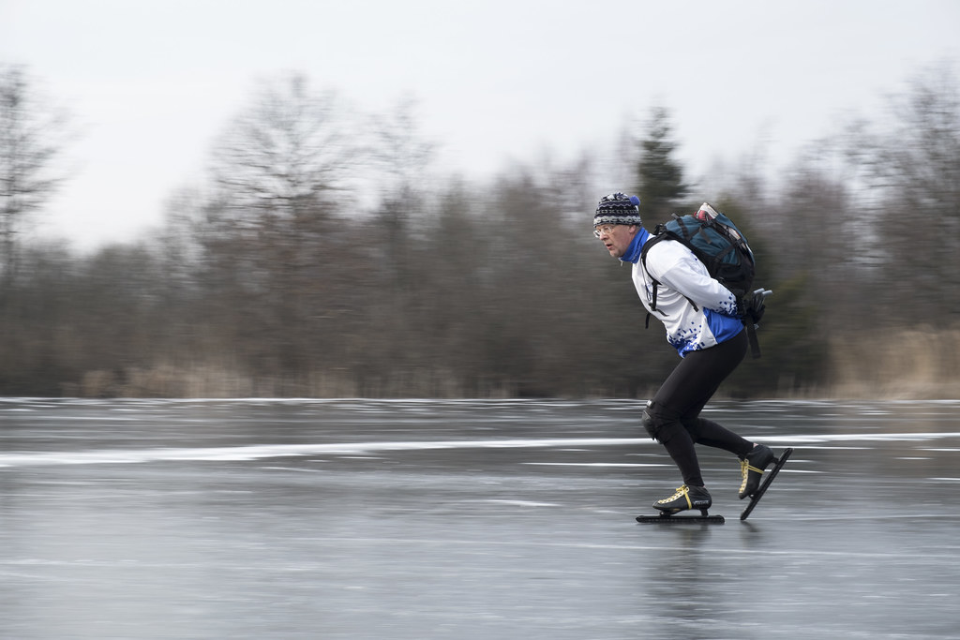
This Photo by Unknown Author is licensed under CC BY

Day 24. Skate Under the Stars
Skating is one of the most delightful sports of the winter season. Check out the clip called “The Spiritual Practice of Play” from the DVD, Spiritual Literacy. (Try YouTube) In the clip, a woman goes skating under the light of the moon as the child inside her emerges, and the result is sheer joy. The words to this selection are from Rick Bass’ Platte River.
Find a winter sport that is just right for you and let the child come out in you as you succumb to the sheer pleasure of physical exhilaration.

