Transportation Data Mining Report
WS\ST\DM
You can import the text file into data mining so you do not have to recreate this report.
Once in the data mining report change the range of the start date to the first day of school. (See attached .txt file)
Then run data mining report as an excel worksheet and update information.
Save as .CSV to desktop.

Transportation Skybuild Import
WS\AD\SB\IM\IF\IF
Add new file builder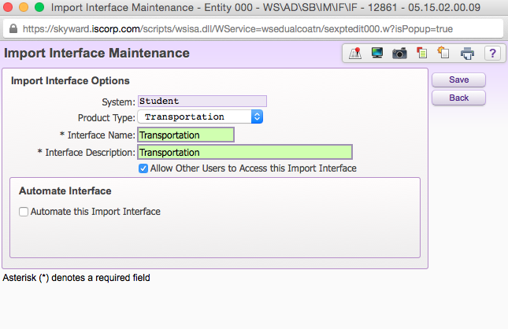
Select Transportation as Product Type, Name File, and allow others to use if you choose.
Click Save

Drop down arrow next to file
Click on Edit File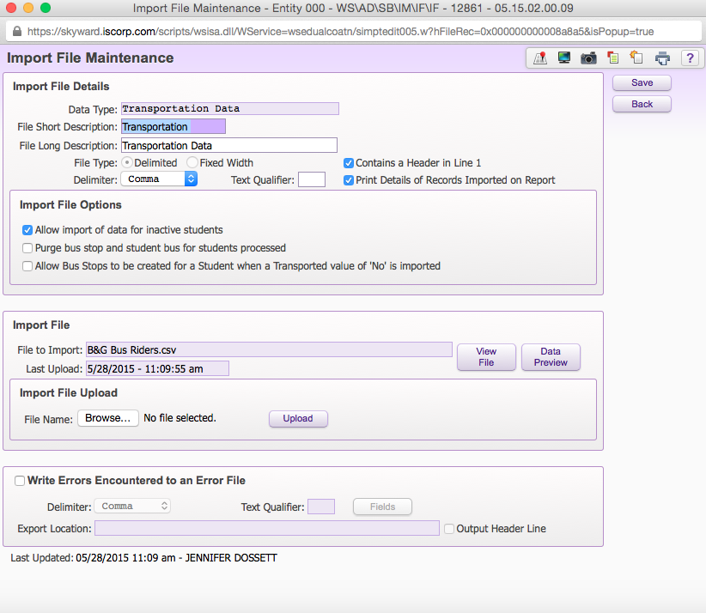
Select Data Type
Check Contains a Header in Line 1
Check Print Details of Records Imported on Report
Choose your Transportation Data Mining report from you desktop and upload.
Click Save

Expand All
Edit Selected Fields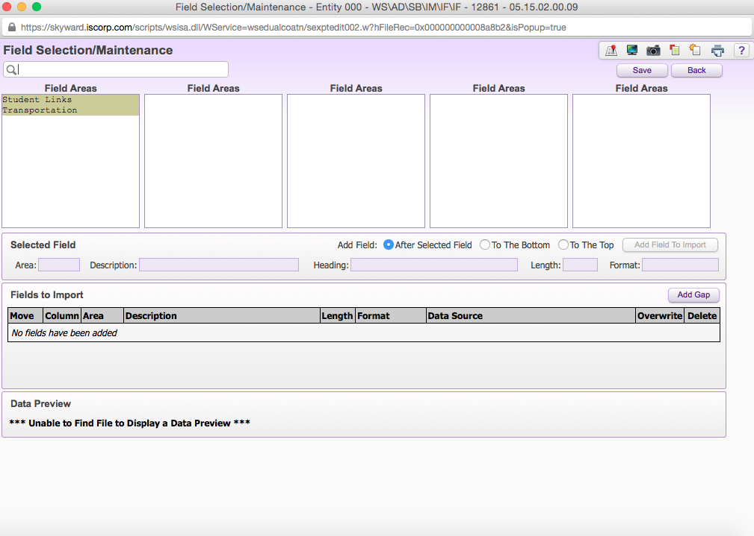
Use the search field and add each of the following fields:
Other ID
Student Frist Name
Student Last Name
Start Date
Transported
Miles Transported
AM Bus Number
PM Bus Number
Optional: Check to Overwrite for the following (this gives you the option to update exiting information):
Transported
Miles Transported
AM Bus Number
PM Bus Number
Click Save

Click Import
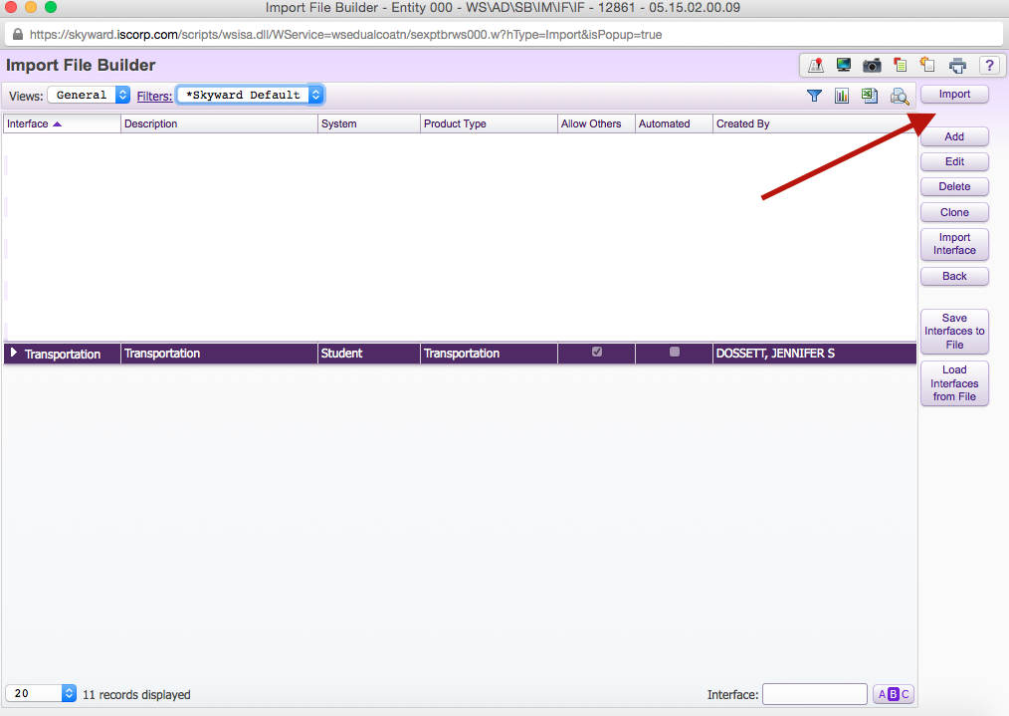

View report in print queue. This will show Errors, Created, and Updated student records.

