Mackayla Wallin
865 Elm Ave
Grant, NE 69140

April 12, 2023

Dear Anne Rexroth, NEBRASCOE Scholarship Committee Chair,

I am so greatly appreciative of this substantial opportunity you have provided me. Thanks to you, I will be able to put this scholarship money toward my college expenses, allowing me to focus more on my academics rather than my financial need.

This scholarship will not only help me pay for my dorm room, meals, and other costs, but by doing so, it will also reduce so much stress and pressure for me. It may not seem apparent, but this is an important contribution to my educational payments that will really help me long into the future. Rather than going into debt over my expenses of college, this scholarship will add to my payments, allowing me to not need a loan or other ways of paying for college that I would have to pay back after my education is completed. As I enter into the education field, I know that the salary is quite low, but this scholarship will assist me to not need to use a large portion of my meager salary to pay back student loans.

If you can’t already tell, I have a lot of pressure riding on my shoulders to become successful and make the most of my life post-high school and college. This benefaction you have offered me will aid me in more ways than one. I am beyond grateful for this grand opportunity you have given me.

With thanks and appreciation,

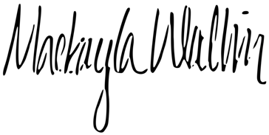

Mackayla Wallin

