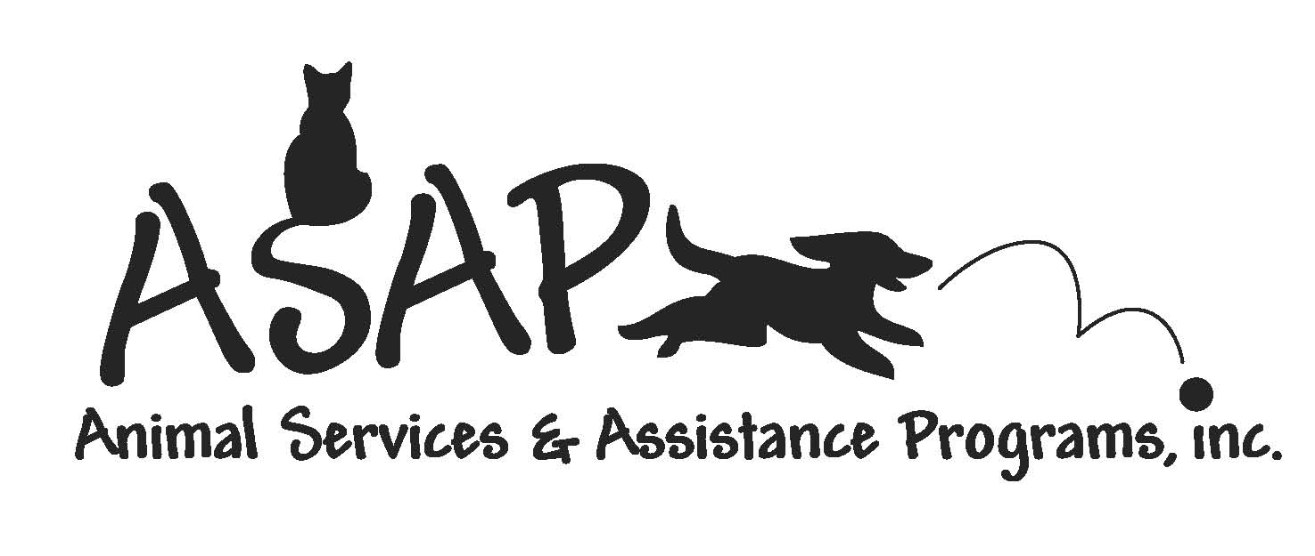 TNR PROGRAM

Trap-Neuter-Return (TNR) is a full management plan in which stray and feral cats already living outdoors in cities, towns, and rural areas are humanely trapped, then evaluated, vaccinated, and sterilized by veterinarians. Kittens and tame cats are adopted into good homes. Healthy adult cats too wild to be adopted are returned to their familiar habitat under the lifelong care of volunteers or placed in a barn home.

ALL APPOINTMENTS FOR FERAL CATS MUST BE MADE
PRIOR TO TRAPPING CATS.

SURGERIES ARE BY APPOINTMENT ONLY!

TO SCHEDULE APPOINTMENTS CALL ASAP at 815-568-2921 BEFORE 5PM.

FEE SCHEDULE

- Neuter/Spay fee for feral cats is $55
- Cats that are late term pregnancies will not be accepted (over 5 weeks)
- Should a cat be pregnant there may be additional fees charged.
- Late term fee $5.00 will be assessed to cover cost of anesthetic and exam cats will be returned without surgery and vaccinations.

ALL FEES MUST BE PAID BY AT TIME OF DROP OFF.

INSTRUCTIONS

- All cats must be trapped the night before and off food and water at 10pm
- Do not trap after dark
- Once cats are in trap place towel over trap to keep cats calm and move cats to a garage or out of the weather. ONCE CATS ARE IN TRAPS DO NOT TRY TO TRANSFER CATS TO CARRIERS OR CRATES!!!!
- NEVER LEAVE TRAPS UNATTENDED OUTSIDE OVERNIGHT
- All cats must arrive at the clinic the morning of their surgery at your appointed time.
- If you believe your cat is pregnant or nursing be sure to let us know and let the vet know when you drop off.
- All traps must have name and phone number where we can reach you if needed.
- All cats must remain in traps overnight post surgery.
- No food for any cats post surgery until the next morning. Water Only!

TNR PROTOCOL
- All cats must come in a humane trap.
- All cats will be ear-tipped to identify that they have been spayed or neutered, NO EXCEPTIONS.
- All cats will be vaccinated for rabies
- All cats will be vaccinated for DRC (Distemper, Rhino, Calici)
- All cats will be microchipped
- All cats will receive an injection of antibiotics
- All spays are done with absorbable sutures.

