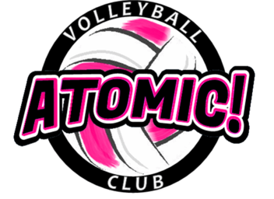
Atomic! Volleyball Club Summer Elem. Camp
For girls entering 1st - 5th graders in 2019-20 School Year
July 8th – July 11th from 9:00am - 10:00am
We are the only Volleyball Club that started Downriver.
_______________________________________________

Location: Brownstown Sports Center
Address: 21902 Telegraph Road, Brownstown, MI 48183

Camp Details: This camp is designed to give each athlete an opportunity to learn volleyball skills. We will go over the basic fundamentals of volleyball and have fun while doing it.
Please bring: Court shoes, knee pads and workout clothes, water bottle, good attitude, willingness to learn.

T-Shirt: Each camper will receive a camp t-shirt if registered by June 25th

Cost: $55 (payable to Atomic! VBC) includes a camp t-shirt.

Awards/ prizes: Awards every day of the camp for effort, hustle and attitude. In addition, a camp photo emailed to all players.

Contests: We will have contests throughout the week!!!!

Coach: Coach Yack, Atomic! Volleyball Director. I am the former head Varsity VB coach at Woodhaven HS. I have 23 years of coaching experience at the High School and AAU volleyball. I have been playing competitive indoor and beach volleyball for 28 yrs. I will have other talented Atomic coaches helping out throughout the week.

Other coaches will be on hand to coach as well.

Mail Registration form (payable to Atomic! VBC) : Atomic! VBC, PO Box 1381, Southgate, MI 48195
REGISTRATION DEADLINE to guarantee a t-shirt: JUNE 25, 2019

NOTE: THERE ARE LIMITED SPOTS AVAILABLE. SO REGISTER EARLY TO GUARANTEE A SPOT!
Questions: atomicvbc@gmail.com or 734-934-4064 (call or text)
----------------------------------------------------------------------------------------(keep top portion for your records)------------
Registration Form
Atomic! VBC Elementary Volleyball Camp, July 8 – July 11, 2019

Athlete’s Name: ______________________________Phone ______________________

Address:_____________________________________ City, Zip: ____________________

Phone: ____________________ Email (print clear) : _______________________________

Grade Level (Entering Fall of 2019) ______School Name: ______________________________

Emergency Contact Phone______________________ T-Shirt Size (youth): _____
I hereby authorize the staff of the Atomic! VBC to act on my behalf according to their best judgment in any emergency requiring medical attention if I cannot be reached. I, further, waive and release the Atomic! VBC and its staff from any and all liability for the injuries or illnesses incurred while involved in this camp. I have no knowledge of any physical impairment that would keep the above named athlete from full participation in this camp.
Parent or guardian signature ___________________________________Date __________________
Parent Name (Printed) ___________________________

