**BASEBALL RULES**

High School Rules (FHSAA) will be followed with the additions listed below:

FIELD DIMENSIONS (WHEN APPLICABLE):

**55 FT**. PITCHERS MOUND

**80 FT**. BASE PATHS

* All bats **MUST** meet the **BBCOR** Certification. (Drop3)

The **EH (Extra Batter)** may be used to allow for more player involvement.  
  
Unlimited Substitution will be permitted

Game time is an 1:45.

**LEAGUE RULES FOR A “TIE BREAKER”**

We will incorporate the following procedures to determine who participates in any League Championship if a “tie” exists at the end of the season:

Two-Schools Tied: these procedures will follow in order until the tie is broken:

1. Won-loss results of head to head competition between two schools
2. Won-loss record of the two schools versus the highest seeded school

(proceeding through the lowest seed if necessary-division contests first; mutual non-division contests if applicable)

1. Points allowed against the #1 seed. ***Except for Soccer where Goals Against for ENTIRE SEASON will be used as the final tie breaker
2. Coin Toss

Three or more schools tied: these procedures will be followed in order until the tie is broken:

1. Total won-loss record of contests played among the tied schools
2. Won-loss record of the tied schools versus the highest seeded school(proceeding to the lowest seed if necessary-division contests first: mutual non-division contests if applicable)
3. Points allowed against the #1 seed. ***Except for Soccer where Goals Against for ENTIRE SEASON will be used as the final tie breaker
4. Draw to eliminate one school

**MIDDLE SCHOOL/HIGH SCHOOL ELIGIBILITY(FHSAA)**

OBSERVE THE **24 HOUR WAITING PERIOD** BEFORE THEY MAY RETURN TO PARTICIPATE AT THE MIDDLE SCHOOL LEVEL. A PLAYER MUST PLAY IN 50% OF **MIDDLE SCHOOL LEAGUE GAMES TO BE ELIGIBLE FOR POST SEASON PLAY** (in the case of an uneven number of games we would round up. Ex: 5 games ,must play in 3).A PLAYER IS LIMITED TO PLAYING IN A TOTAL OF **THREE GAMES A WEEK.** THIS IS TO PREVENT A SCHOOL PLAYING IN THE CHAMPIONSHIP GAME WITH A DIFFERENT TEAM THAN THAT OF WHICH THEY HAD DURING THE SEASON

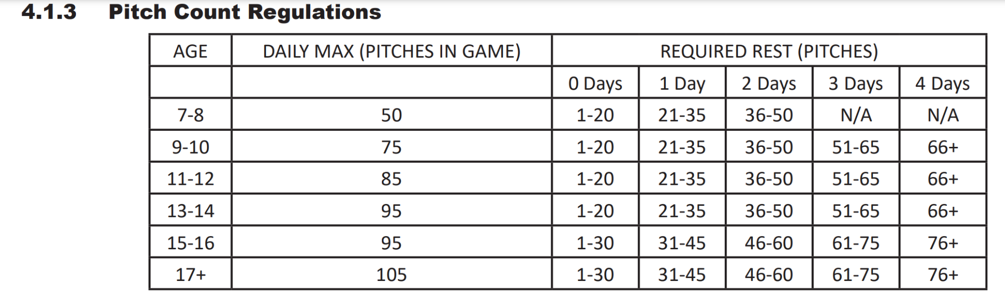

(1) Once the student-athlete reaches the maximum amount of pitches in the chart above, that student-athlete is ineligible to pitch from that point forward.

• A pitcher at either level (varsity/sub-varsity) shall be allowed to finish the batter when the pitch count limit is reached during an at bat, and must be replaced immediately when the at bat ends.

• Pitch Count is a daily count:

• Game is delayed in the 3rd inning and pitcher has 63 pitches; student-athlete is required to rest for three (3) days.

• If there is a violation of the chart above, Policy 6.1.3.3.1 will apply.

• The student-athlete will be permitted to play any other position during this mandatory rest period. The student athlete will be eligible to pitch on the eighth (8) day.

(2) Day of Rest - A day of rest is defined as a “calendar day”. If the game being played on the day of rest extends beyond midnight, it is not considered a new calendar day for the pitcher who is under required rest.