STRATHMERE IMPROVEMENT ASSOCIATION
Minutes of General Meeting
Friday, July 19, 2019

The meeting began with the flag salute led by Richard Omrod, Major General, USMC, ret. Board members present included Linda Bateman, President; Janice Connell, Vice-President; and Rosemarie Whelan, Secretary. Board members Donna Diefenderfer and Janet Mahley were excused for medical reasons. Including Board members, thirty-eight people were present at the meeting.

Secretary’s Report
The Secretary stated that the minutes of the August 18, 2018 meeting were posted on the SIA website, and that hard copies were available at tonight’s meeting. A motion to approve the minutes was made by Joseph Evancich and seconded by Sarah Boardman. The motion carried.

Treasurer’s Report
In the absence of Donna Diefenderfer, Linda Bateman gave the Treasurer’s report. An audit of the 2018 books was completed by Gary Riordan in early 2019.

Opening Balance – January 1, 2019: $9,158.92

Income:
Dues: $1,580.00
Donations: $570.00
Fundraising Revenue: $420.00
Miscellaneous: $300.00
Boat Ride Tickets: $490.00
Total: $3,360.00

Routine Expenses Include:
Officer Insurance, General Liability Insurance, Christmas Party gifts, Parade prizes and printing, PO Box renewal, website and email program, purchase of fundraising items, 501C3 renewal, copying

Other Expenses for 2019
Pontoon Boat rental, liability insurance for event, gift card, safety lights, donation to Strathmere United Methodist Church
Total Expenses: $4559.11

Current Balance:
$7,959.81

Bergus-Laurence Savings Account:
Purchase of 2019 Honor Roll Awards: $205.75
Balance: $391.87

A motion to approve the Treasurer’s Report was made by Joseph Evancich and seconded by Joyce Wilson. The motion carried.

Nominating Committee
Len and Joyce Wilson are chairs of the Nominating Committee for the positions of President, Vice-President, Treasurer, Secretary, and Member-at-Large. Elections take place in August. To nominate someone or to self-nominate, please email len.wilson@comcast.net.

Summary of Events
Our extremely successful events included the Christmas Party and the Fourth of July Parade. People who registered for the Pontoon Boat Ride were charged $5.00 to help defray the cost of the insurance.

Membership – Donations
Clip-on blinking lights were given to those who renewed their memberships.
A donation was made to the Strathmere United Methodist Church to offset winter expenses.

Off-Season Activities/Advocacy
Replacement of Welcome Sign – Our new sign was completely replaced after being damaged during the work on the bridge approach and is not in the original location. Concrete, not blacktop, was used to position the sign. We have a five-year guarantee with the sign company.

Newsletter Platform – Very soon, we will be using Mail Chimp which is designed for mobile apps to make reading on mobile devices easier.

Strathmere Stories – The Strathmere Improvement Association, now in its 68th year, has been gathering video stories from residents. Help is needed with the editing. We would like to have a movie premiere for our video, hopefully to be shown in our 70th year.

Mobi Mats – In keeping with the Americans with Disabilities Act (ADA), Upper Township purchased these mats and also equipment to sweep the mats and approaches. Actually, because of our advocacy and another resident’s, the mats were purchased. They exceed the ADA requirements.

Commonwealth Restriping/Pedestrian Walkway
Janice Connell commented that at a public forum, townspeople voted on the best pedestrian walkway. Parking on the bay side of Commonwealth Avenue was eliminated. Sea Isle City has provided us with two parking lots to make up for the loss of parking spaces. The issue is the enforcement of “No Parking.” Janice also noted that beginning this weekend, there will be “zero tolerance” in the no parking zones. State Police Lt. Henry stated that there have been regular weekend patrols. Also, a trooper drives through town at least once a day.

Status of New Township Building Ordinance
Janice Connell had suggested a town hall meeting which was rejected by the Township. They stated that they would follow the normal process which allows for notice of Planning Board and Township Committee meetings. Public input would be allowed at those meetings. Objections were made to proposed limitations on building lots over 8,000 square feet. The Township Committee returned the draft to the Planning Board to address these objections. On July 26, 2019, a new Strathmere Planning Group meeting will be held.
A committee, formed at the request of Citizens for Strathmere/Whale Beach and led by Brian Riordan, developed a list of Master Plan elements specific to Strathmere and Whale Beach. This project is currently on hold.
Janice advised those in attendance that to be placed on the email distribution list for receiving Township Meeting notices, please email Joann Herron at jherron@uppertownship.com . To receive notices about Planning Board and Zoning meetings, please email Shelley Lea at shelley@uppertownship.com.

Comments from Those in Attendance
An email was sent by an attendee to Upper Township regarding conditions at the playground. She stated that no response was received. Linda asked her to send a letter, rather than an email, to Hobie Young.
Another question asked was the possibility of having another Star Party. Linda replied that it is not scheduled.
Beach replenishment in the northern end will take place in October.

Next Meeting – Saturday, August 17, 10:30 a.m.
Dave Townsend and his wife, Karen, visited Normandy on the occasion of the 75th anniversary of D-Day and the Battle of Normandy, and Dave will share memories of the trip.
Students will be presented with silver dollars and certificates recognizing them as Strathmere honor roll students.
Election of officers will take place.

Adjournment
A motion to adjourn was made by Joe Evancich and seconded by Dick Omrod. The motion carried.
PROGRAM
Our program presenter, General Omrod, served our country as a marine for 35 years, most of that time as a fighter pilot. He is a trustee of the Strathmere Fishing and Environmental Club (SFEC) and spoke briefly about the Club, following that with a discussion about the SFEC’s osprey nesting program. The video is posted on the SIA website, http://www.strathmereimprovementassociation.org .

The Strathmere Fishing and Environmental Club was founded in 1985 as a social club dedicated to the sport of fishing and the environment. Today, there are about 175 members. Its activities include the Nightmare in Strathmere Boat Parade, Kids’ Tournament, 7 annual tournaments, Turtle Release Program, and environmental projects. We have accomplished 14 reef deployments, focusing on the reefs closest to Strathmere, namely the Ocean City Reef and the Townsends Inlet Reef.

THE OSPREY NESTING PROGRAM

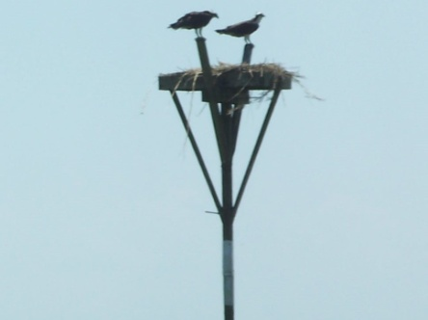
Ospreys are about 2 feet long with a wingspan of 5-6 feet. Their normal lifespan is 20 years. They mate for life, but migrate separately. They return to the same nest every year in mid-March. Incubation for chicks is 51-54 days, usually in early June. Their first flight takes place in 7-8 weeks. The female does most of the incubation, but the male helps, and the male provides most of the food.
The parents train the chicks, and then the parents leave around the end of August. The young remain through September. All head south, most of them to South America, 2500-3000 miles one way. The trip usually takes about two weeks. The young will remain in South America for 18 months; the older birds return the following March.
At the present time, we have 26 platforms, from the Russ Chatin Bridge to Sea Isle City. Tomorrow, 2 more will be installed. Sites selected are in the vicinity of homeless birds. Hurricanes destroyed 2 of the platforms, and 1 was lost to an errant boat. We moved 2 platforms because the birds wouldn’t use them, but they were quickly occupied after the move. Platforms must be the highest item in the vicinity, not near nesting birds.
Each year, peregrine falcons occupy one of our platforms. All they eat are other birds. The marsh is a target-rich environment.
In the fall after the osprey leave, it is not unusual to see bald eagles using the platforms as perches. You can see them at the Russ Chatin Bridge, the boat ramp, and at Whale Creek. You will need binoculars.
The Club solicits sponsors for each of the platforms. All of our platforms have memorial plaques. This year’s platforms have sponsors. However, if you are interested in sponsoring a nest next year, please contact me at omrod105@comcast.net .

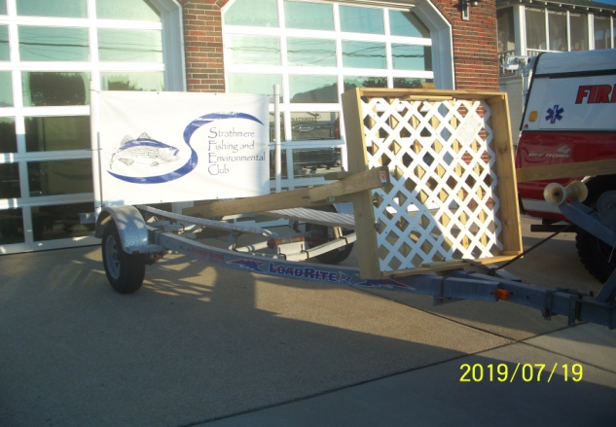
Two nests will be installed on Saturday, July 20, 2019.

Rosemarie Whelan, Recording Secretary

