GEN-1100 (120V-3000W-60Hz-13.2kW-16yr) | Geneforce Emergency Power System  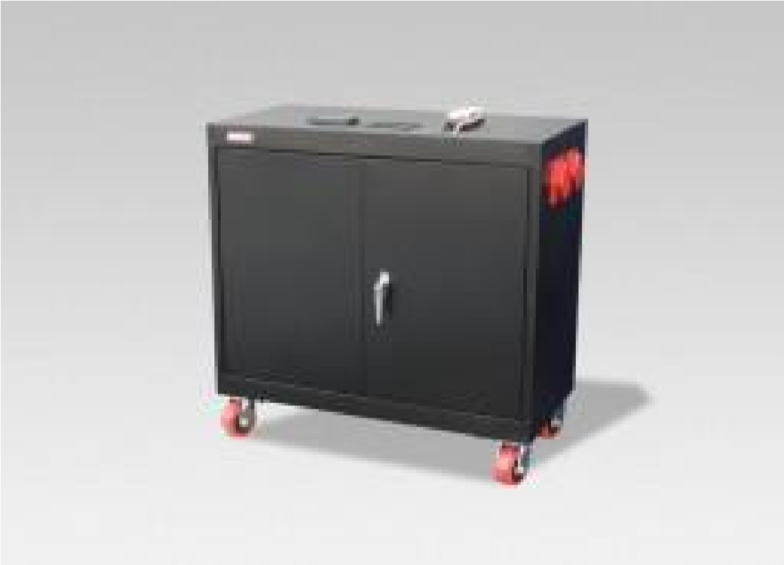
Product Features
Silent operation. Safe for indoors. No gas or emissions.
No Installation; No Maintenance; No Permits required
Automatic & one-touch start.
Advanced System Control Panel with Graphical 128 x 64 pixel, backlit LCD display that allows for setup and monitor of entire system including multiple solar charge controllers and auxiliary battery banks. Panel displays power reserves, amp hours consumed, fault conditions, solar panel output, charging, power consumption.
Pure Sine Wave and Built-in voltage regulation system provides clean output for sensitive electronics.
Overheat Temperature Sensor & automatic shutdown feature.
Built-in (120V/30A) Automatic A/C transfer switch.
Built-in 60A solar charge controller for solar panel charging.
May connect directly to a Breaker Panel. *optional
Electrical Specifications | GEN-1100 (120V)
Output power (continuous at 40̊C) | 3,000 W
Surge power (AC amps) | 6,000 W
Peak Output Current | 80A
Output frequency regulation | 60 Hz
Output Voltage | 120 Vac
Output wave form | Pure Sine Wave
Service Life (No Maintenance) | 12-16 Years
Stored Electrical Energy | 13.2 kW (13,200 Watts)
AC output receptacles | Four (20A/120V) outlets & one (30A/120V) *customizable
12 Volt Power Outlet (optional - not included) | One 12 Volt Auxiliary Receptacle
AC input plug | One (30A/120V) input plug *(20A/120V) input plug optional
AC Automatic transfer switch (included) | (120V/30A)
Charge rate (3-stage) | 150 A DC
AC input voltage range | 90 - 130 VAC
Charger | 3-stage (Bulk, Acceptance, Float)
Solar Charge Controller (Man be used with 12V or 24V Solar Panels) | (60A/12V-24V)(~800W per hour of sunlight) *(80A/150V)optional
General Specifications
Optimal operating temperature range | 32°F – 104°F (0°C – 40°C) *derated below 0°C and above 40°C
Monitor | LED Display (Reads V, Amps, DC amps, State of Charge, etc.)
Dimensions (H x W x L) | 36" x 18" x 36"
Construction | Four Heavy Duty Casters, Heavy Steel Enclosure, Color - Black
Weight | 950 lbs.
Warranty | 2 Year on Components; Up to 4 years on Cells
Part numbers | GEN-1100-120-3000-16YR
Regulatory Approvals & Protection
Safety - UL Listing | Components ETL certified to CSA 107.1, UL458, FCC Part 15, Class B
Voltage Regulation | Over voltage and under voltage protection
Temperature | Over-temperature protection
Output | Overload Protection
Electrical | Short circuit protection
Price | $9,997
Geneforce Incorporated www.geneforcepower.com (305)215-5443 email: sales@geneforcepower.com

