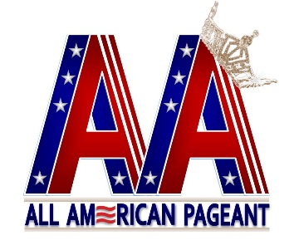
All American Pageant/Mrs. All American Pageant

Optional Talent Stage Sheet
This is for the MC to have something to talk about while you are on stage.

Contestant Name: ___________________________________________________

State Representing: __________________________________________________

Talent: ____________________________________________________________

Introduction to your performance:
______________________________________________________________________________________________________________________________________________________________________________________________________
______________________________________________________________________________________________________________________________________________________________________________________________________
________________________________________________________________________________________________________________________________________________________________________________________________________________________________________________________________________________________________________________________________________________________________________________________________________________________________________________________________________________________________________________________________________________________________________________________________________________________________________________________________________________________________________________________________________________________________________________________________________________________

For office use only:
Contestant No. _____
Talent No. ______

