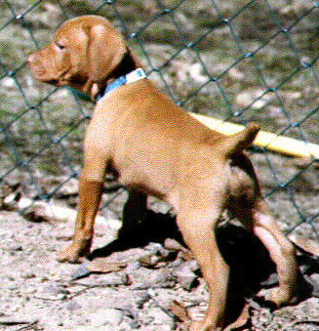
Questionnaire for Prospective Puppy Owners

Sumer Lake Vizslas

Your completion of this questionnaire will assist me in evaluating whether a vizsla is the right breed for you. Vizslas are extremely active and needy, and this breed is definitely not right for everyone. Your responses also give me insight as to the type of puppy personality you seek and help me match each family with the right puppy.

GENERAL INFORMATION

Name: _______________________________________________________

Address: ______________________________________________________

Telephone: ________________________ Cell phone:_________________

E-Mail: _____________________________________________________

- How many people live in your home?_________________________
- Does anyone in your home have any reservations about adding a vizsla puppy to the family at this time? If yes, please describe____________________________________________________
- Age/Sex of children in your home____________________________
- Do you presently have any dogs/cats/other animals?__________ If yes, what types/breeds/ages________________________________

___________________________________________________________
- Have you ever raised a vizsla puppy or owned a vizsla?______If yes, is that vizsla still alive, or how and at what age did (s)he die? ______________________________________________________________

______________________________________________________________
- How did you hear about us? _______________________________________

TYPE OF PUPPY DESIRED

- I want to add a puppy to my family at this time because _____________________________________________________________________________________________________________________________________________________________________________________________

- The reasons I have selected the vizsla breed are _____________________________________________________________________________________________________________________________________________________________________________________________

- Specify if you have a sexual preference for your puppy and why, and whether you are flexible on the sex of your puppy_______________ ______________________________________________________________________________________________________________________________

Male_______ Female_______ No Preference_______

- Do you intend to spay or neuter your puppy? _______ If not, do you intend to breed your puppy? ________ If you intend to breed, will you agree not to breed until your puppy has been OFA certified after the age of two years, and to breed only with a purebred vizsla who has likewise been OFA certified? _______________________________________________________________

- Specify the type of personality you desire in your puppy (for example, would you prefer a puppy with a very active and curious temperament or a puppy that is more laid back; a very independent or a more needy puppy, etc.) ____________________________________________________________________________________________________________________________________________________________________________________________________________________________________________________________

- Specify any particular physical characteristics that you would emphasize as desirable in your puppy (For example, head structure; taller or shorter in size; heavier or lighter in bone; lighter or darker in color)________________________________________________________________________________________________________________________________________________________________________________________

HOME ENVIRONMENT

- Describe where the puppy will live ___________________________ ______________________________________________________________________________________________________________________________

- Describe where the puppy will sleep__________________________________

______________________________________________________________________________________________________________________________

- Describe where the puppy will stay when you and your family are away from the house_______________________________________________________

_______________________________________________________________
- How many hours in a typical day will the puppy be alone? ____________________________________________________________

- If you work full time out-of-the house, how will the puppy be cared for during the day?_______________________________________________
____________________________________________________________

- Do you plan on crate training your puppy and confining the puppy when you are away? ________________________________________________

- Do you understand that vizslas are very active, outgoing dogs requiring a great deal of exercise on a regular basis?_____________________________

- Describe the kind of activity level/exercise requirement you expect, and how you intend to exercise your puppy_______________________________________________

_______________________________________________________________________________________________________
- Describe the kind of activity level/exercise requirement you expect, and how you intend to exercise your dog when he/she grows up ____________________________________________

_______________________________________________________________________________________________________

Is your yard fenced? If not, where will you exercise the puppy?_____________________________________________

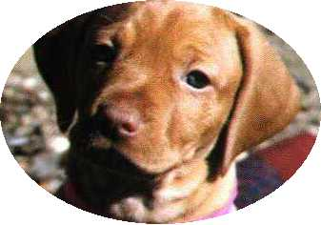
MISCELLANEOUS

- Have you ever raised a puppy of any breed through puppyhood (in other words, are you prepared for the difficult process of raising a puppy - the frequent trips outside during the housetraining routine, household accidents, puppy chewing and destructive behavior, discipline, etc.)? If yes, please specify the breed and how recently your raised a puppy__________________________________________________________

_______________________________________________________________

_______________________________________________________________

- Have you ever had a dog that you had to give away or place? ___________ If yes, please describe the circumstances______________________________

______________________________________________________________________________________________________________________________

- Specify YES for any of the following activities in which you intend to participate with your puppy:

_____Conformation Shows ____Hunting Tests _____Field Trials

_____Personal Hunting Dog _____Obedience Trials _____

_____Agility Trials _____Personal/Family Companion

_____Therapy Dog _____Breeding _____Other (Specify_________)

- Miscellaneous: Specify any other information which you think may be important_______________________________________________________
____________________________________________________________________________________________________________________________________________________________________________________________________________________________________________________________

Please do not hesitate to contact us if you have any questions.

Mark and Julia Eidelman

summerlake.vizslas@gmail.com

