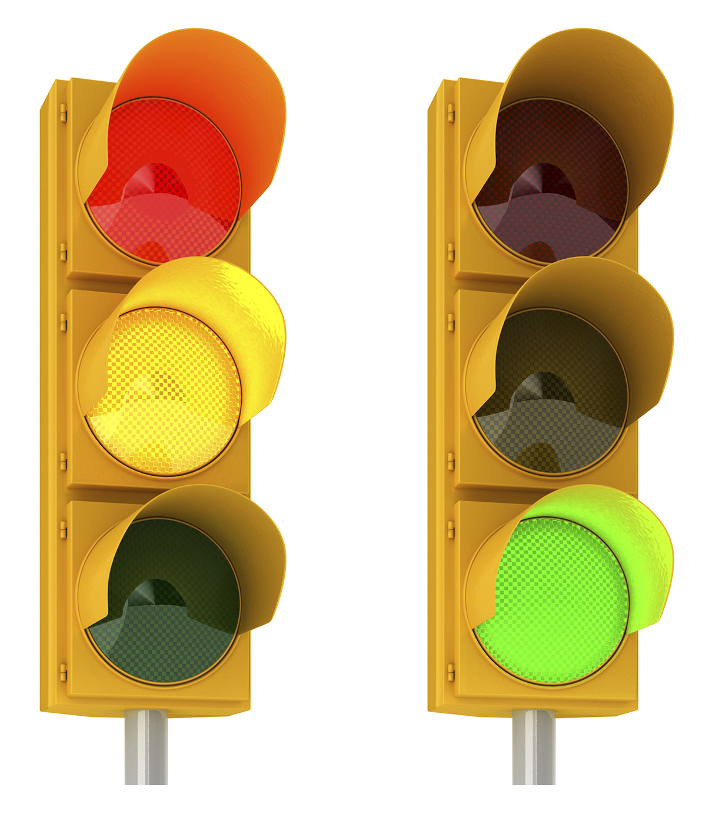

UFit • UMove • UBeat • UFuel • UPlusOne • URest UBreathe • UBody • Ucents • U&YOURS • UBALANCE

Just part of your comprehensive wellness program. Find out more at www.empowerlinc.com or call a health coach today at 888.882.LINC (5462).



Fun and effective programs to help u live healthy

WILL U

MAKE A

CHANGE?