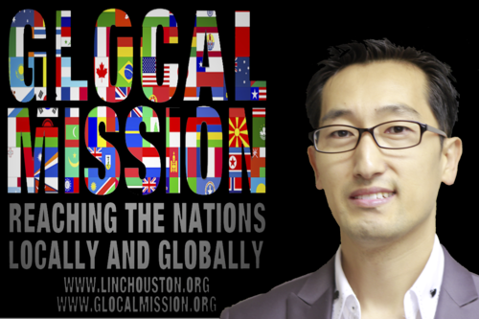
2016 Conference Presenter
Dr. David Kim
Mission Director – LINC Houston
Founder/Owner – glocalmission.org
Biography
David Kim was born in S. Korea and one of the founding members of FiveTwo and the Cross-Cultural and Multi-ethnic Mission & Church Planting Coach, Trainer & Consultant for LCMS and mission organizations. He was a Mission & Church Planter in Ecuador for 12 years from 1989 to 2001. He is also a co-founder of Renuevo Elementry & Junior High School which currently enrolls 420+ students with 30+ full time staff in Quito, Ecuador. Under his glocal-missional leadership, numerous indigenous and missional churches are being planted, Schools of Theology and Missions/Schools of Glocal Mission are being established, and thousands of pastors/leaders are being trained in Ecuador, USA, Honduras, Mexico, Korea, DP. Congo, Eritrea, Nigeria, India, Nepal, Panama, Nicaragua, and in many more countries Glocally. He also serves as the Mission Director at LINC Houston wherein he serves as supervising and coaching pastor over 25+ mission congregations composed of 35+ nationalities and in 15+ different languages for worship services and leads holistic community outreach & development. As a LC-MS pastor he also serves as a Board member of Mission Administration of the Texas District. He is the owner & founder of www.glocalmission.org. He serves as adjunct professor, regional coordinator, and mentor for Center for Hispanic Studies as well as mentor for EIIT at Concordia Seminary, in St. Louis.
He holds a B.A. in Theology through Seminario Nazareno Teológico Sudamericano, Quito, Ecuador and a M.A. in Theology and Culture through Concordia University, Irvine, CA and is certified for pastoral ministry by Concordia Seminary, St Louis. Rev. Kim received his Doctor of Ministry Degree from Houston Graduate School of Theology. In 2001, he married to Juhee Kim in Ecuador.
He enjoys preaching, teaching, guest-speaking, assessing, strategizing, coaching, mentoring, consulting, and training on Glocal-Missions & Evangelism, Glocal-Missional Church Plantings, Leadership Development, Community Empowerment/Development, Holistic Discipleship, Integral Missions (Holistic Ministry), Urban Ministries, Language specific or Multi-ethnic Mission plantings, and Cross-cultural Ministry. You can follow him on Facebook (davidkim.pastor) and on Twitter (@davidkim_), or contact him at davidkim@linchouston.org.
“I consider my life worth nothing to me, if only I may finish the race and complete the task the Lord Jesus has given me the task of testifying to the Gospel of God’s grace.” (Acts 20:24)
Overview of the Conference Theme
Dr. David Kim refers to “Catalyst Disciples” as those who are committed to the task of leading people into God's mission of seeking the lost; discipling of the found/saved; multiplying disciple-makers and churches glocally (globally and locally).
They are humble (broken), teachable, available, and accountable to each other in the task of being and making disciples of Jesus. “We don’t want to just disciple people and have the process end,” states David. “We desire to make disciples that are equipped and excited about becoming disciple-makers.”
While many Christians claim to know what the Great Commission of Jesus is, when asked the following, few would be able to respond with a strong yes to each:
- Have I evangelized and discipled someone within the last month?
- Are you being discipled by someone and are discipling someone? (Tell me their names)
- Do leaders in your church lead people to faith and disciple them?
- Are you, like Jesus, committed to the ultimate purpose of seeking the lost and discipling the found and multiply disciple-making leaders glocally?
Why has Dr. Kim dedicated his life to this work?
“[I have dedicated my life because of] the amazing grace of Jesus that saves me, the compelling love of God and seeking the lost of making disciples in the fellowship of the Holy Spirit,” Kim said. “The God I know from the Bible and my experiences is a SEEKING, SAVING, and SENDING God.”

