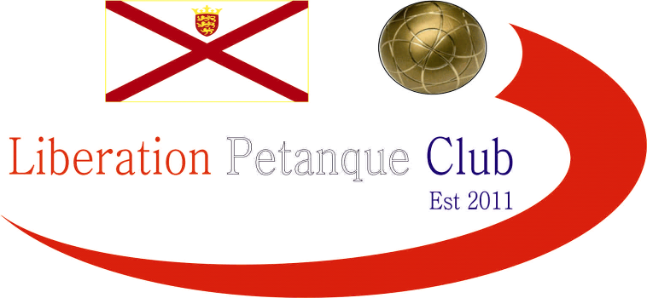

Summer 2016
End of Season
Report
What a record breaking season its been, not only did every single league title go down to the last match of the season but several players achieved their first title successes.
Premier League Double Champions
Matt Pinel & Richard Nevitt
Matt & Richard became the first team in four seasons to topple the most successful doubles team in the clubs history (Ross & Antony), although Ross & Antony were the only team to beat Matt & Richard.
Commiseration to those relegated, Colin Myers & Steve Simpkin, Alan Oliveira & Craig Kelly, Keith & Sue Pinel.
Division 1 Double Champions
Ian Black & Luke Knightingale
Division 1 Doubles was won by Ian & Luke with Alice & Brigitte finishing second despite beating Ian & Luke to play in the Premier League next Summer. John & Nick finished 3rd despite not playing 3 of their 8 matches.
No relegations from this division this year due to withdrawals of two teams.
Singles Division 2 Champion
James Mold
James was playing his first season with the club and remained undefeated all season and would have had a bigger points total had it not been for a number of withdrawals in this division.
Rob Gregory playing his 3rd season finished 2nd to also get promoted with Val Quemener 3rd.
No relegations from this division this year due to withdrawals of three players.

Singles Division 1 Champion
Brian Harris
Brian just pipped Andrew Limbrick to the title on points difference but there was a big difference in this. David Ibitson finishing in 3rd to also make the step up to the Premier League next Summer.
Commiseration to those relegated Nathan Wheller, Lorna Limbrick and Cassie Stewart.
Premier League Singles Champion
Andrew Bellamy-Burt
It went down to the last match and with Andrew drawing with Matt Ryan to win back to back Summer titles. Both of these titles have been on points difference, but this time Andrew remained unbeaten just taking the title from Geoffroy Buffetrille. Ross Payne finishing 3rd.
Commiseration to those relegated Joey Le Clech who failed to win a single match, James Gennoe and David Siouville who spend just one season in the top flight before dropping back down proving how tough the step up is.

Summer 2016 Player of the Season
Ian Black
Singles Cup Champion
Matt Pinel
Doubles Cup Champions
Ross Payne & Antony Di Santo
Doubles Open Champions
Ross Payne & Antony Di Santo
Charity Triples Open Winners
Colin Myers, Steve Simpkin & Matt Ryan
Singles Open Winner
Matt Buesnel

All end of summer season tables and results are on the website along with updated Record Breakers and Fanny Certificate Records.

I hope you all enjoyed the season and are looking forward to another great winter of petanque.

Club email address - liberationpc@gmail.com

Club Website - www.liberationpetanque.co.uk

Kind Regards

Report Editor

Liberation Petanque Club

SPONSORED BY

