MEDITATION FOR ALIGNMENT

**by**

**Marguerite dar Boggia**

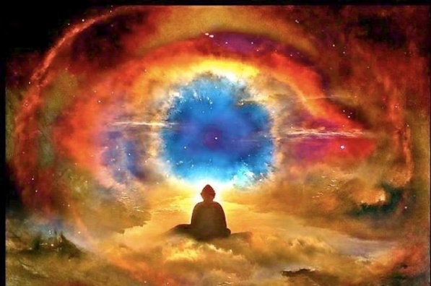 Meditation is a technique of the mind which eventually produces correct, unimpeded relation- ship. This is another name for ALIGNMENT. It is, therefore, the establishment of a direct channel, not only between the one source, the Monad, (the Spirit, the Real Self) and its expression, the purified and controlled personality, but also between the seven major centers in the human etheric vehicle1. This is, perhaps a surprise to you, putting the results of meditation on the basis of physical, or rather of etheric, effects, and may be regarded by you as indicating the very lowest phase of such results. This is due to the fact that you lay the emphasis upon your mental reaction to the produced alignment, on the satisfaction you acquire from such an alignment, in which you register a new world or words of phenomena, and on the new concepts and ideas which consequently impinge upon your mind; but the true results (as divine and esoterically desirable) are correct alignment, right relationship, and clear channels for the seven energies in the microcosmic system, thereby bringing about eventually a full expression of divinity.2

All the seven centers in the etheric vehicle of Christ were rightly adjusted, correctly aligned, truly awakened and functioning, and properly receptive to all the seven streams of energy coming from the seven planetary centers. These put Him en rapport, therefore, and in full realized contact, with the ONE in Whom He lived and moved and had His being. The physiological result of this complete "esoteric surrender of the seven" (as it is sometimes called) to the incoming spiritual energies, in their right order and rhythm, was the appearance in the Christ of a perfect endocrine system. All His glands (both major and minor) were functioning correctly. This produced a "perfect man"--physically perfect, emotionally stable and mentally controlled. In modern terms, the "pattern of the behavior" of the Christ--due to the perfection of His glandular system, as an effect of correctly awakened and energized centers--made Him an expression of divine perfection to the entire world. He was the first of our humanity to arrive at this point in evolution, and "the Eldest in a great family of brothers," as St. Paul expresses it. The current pictures of the Christ testify to their own complete INACCURACY, for they bear no witness to any glandular perfection. They are full of weakness and sweetness, but show little strength, alert power and aliveness. And the promise has gone forth that as He is, so may we be in this world.

This is a promise which lies behind the right understanding of the science of the centers. The factual reality of the centers will be proven to all men when the centers are gradually brought under control of the soul, are correctly and scientifically energized and brought to a condition of true "livingness," and begin to condition the entire area of the body in which a center is found, and --between them--bringing every part of the human body under their radiatory and magnetic influence. It is the centers which hold the body together and make it a coherent, energized and active whole.3

Related to these centers, and reacting in strict unison with them, is the endocrine or glandular system, through which system--during incarnation--life or energy flows unimpeded and under right direction in the case of the highly developed human being, or impeded and imperfectly directed in the case of the average or undeveloped human being. Through this system of glandular control, the human form responds or does not respond to the surrounding world energies. A person can be sick and ill or well and strong, according to the state of the centers and their precipitation, the glands. The centers are the **major agency** upon the physical plane through which the soul works, expresses life and quality, according to the point reached under the evolutionary process. The glandular system is simply an effect--inevitable and unavoidable--of the centers through which the soul is working. The glands therefore, express fully the point in evolution of the man, and according to that point are responsible for defects and limitations or for assets and achieved perfections. The human being's **conduct and behavior upon the physical plane is** **conditioned, controlled and determined by the nature of his glands**, **(which affects character)** **and these are conditioned, controlled and determined by the nature, the quality and the livingness of the centers.** These, in their turn are conditioned, controlled and determined by the soul, in increasing effectiveness as evolution proceeds. Prior to soul control, they are conditioned, qualified and controlled by the **astral** **or emotional body, and later by the mind**. the goal of the evolutionary cycle is to bring about this control, this conditioning, and this determining process by the soul.4

Human beings are today at every imaginable stage of development within this process. A human being is what his glands make him, but they, in their turn, are only the effects of certain inner potent sources of energy5.

∆ ∆ ∆

*Marguerite dar Boggia* presently serves as Secretary and Membership Chairperson of ISAR (the International Society for Astrological Research). She formerly served as publisher of *Kosmos*, the ISAR Journal and as Secretary and Director of ISAR and UAC, (the United Astrology Congress). She was a co-founder of UAC. Her articles are published in the ISAR journal and in other publications. At this time she offers **FREE** of charge **three pages weekly online** of the Ancient Wisdom Teachings as was known by **Pythagoras.** She can be contacted through her website which she created at the age of 90: [**www.FreePythagorasTeachings.com**](http://www.FreePythagorasTeachings.com)

References:

1Bailey, Alice A. *Esoteric Healing*, Lucis Publishing co. 1953, pp. 72, 548, 628 **The etheric body is composed entirely of lines of force and of points where these lines of force cross each other and thus form, in crossing, centers of energy. 72 These Centers of energy are also known as 'chakras.' They are vortices of force which appear as the petals of a lotus, or spikes of a wheel. The seven major centers control definite areas of the body via the nadis, the nerves, the endocrine system and the blood stream. p. 548 The blood stream is the recipient of streams of living energy from the endocrine system, via what are called the hormones p. 628**

2Ibid p. 620-621

3Ibid pp. 621-622

4Ibid pp. 623-624

5Ibid pp. 625-626