What is it?
A fun competition for skaters to show off their skills! Skaters will compete against others at their level in small groups of 3 or 4. Everyone in each group will receive a medal (gold, silver or bronze). This is a great way to introduce skaters to competition in a low stress & fun environment.

Who Can Compete?

- Any skater in any level of the learn to skate program (snow plow Sam to Basic 1-6)
- Any USFS skater who has not yet passed the pre-preliminary USFS test

What are the events?
There are 2 events skaters may participate in:

- Skills competition: Skaters will show individual skills at their level

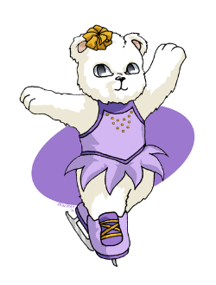
- Free Skate Competition: Skaters will perform a short solo routine to music (this is optional and will require working with a coach to learn the choreographed routine). More information will be provided about coaches, costumes, song choice, etc. after sign ups.

What is the cost?
The cost is $40 for the skills competition or $55 for both events

How do I sign up?
Fill out the attached form and put it in Jamie Bannon’s mailbox (top drawer file cabinet)
OR
Sign up at the Learn to Skate table on Tuesdays, Thursdays & Sundays in January

Any questions please e-mail ptjamie01@gmail.com and put LTS in the subject line.

