April 2019 Lunch 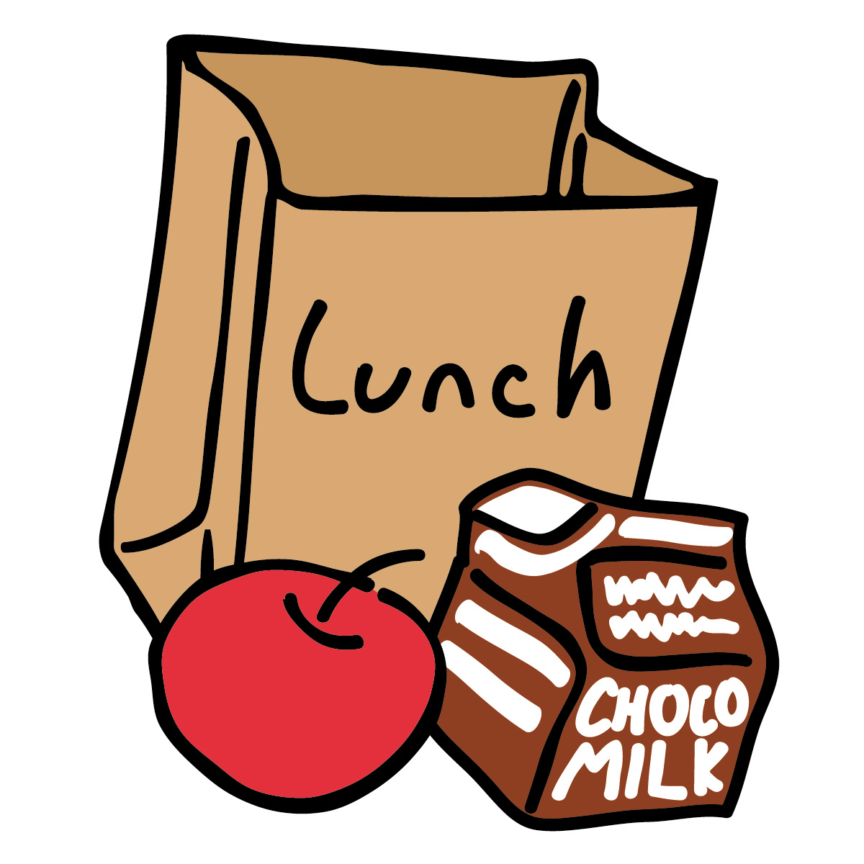
Sunday | Monday | Tuesday | Wednesday | Thursday | Friday | Saturday
Week 5 | 1  Grilled Chicken  Carrots  Pears  Milk | 2  Salisbury Steak  Mashed Potato  Mixed Fruit  Milk | 3  Chicken and Noodles  Oranges  Milk | 4  Hamburger Mac  Green Beans  Banana  Milk | 5  Pizza Casserole  Salad  Pears  Milk | 6
7  Week 6 | 8  Chicken Taquito  Corn  Applesauce  Milk | 9  Lasagna  Green Beans  Oranges  Milk | 10 Chicken Enchiladas  Salad  Baked Apples  Milk | 11  Beef Stroganoff  Peas  Pears  Milk | 12 Mac and Cheese  Mixed Veggies  Oranges  Milk | 13
14  Week 7 | 15 Chicken Quesadilla  Peas  Baked Apples  Milk | 16  Shepard’s Pie  Mashed Potato  Pears  Milk | 17 Chicken Sandwich  Corn  Oranges  Milk | 18  Spaghetti  Green Beans  Banana  Milk | 19  Grilled Cheese  Carrots  Strawberries  Milk | 20
21  Week 8 | 22  Chicken Fritter  Corn  Pineapple  Milk | 23  Pepperoni Pizza  Salad  Pears  Milk | 24  Chicken Salad  Mixed Veggies  Pears  Milk | 25  Tuna Casserole  Peas  Oranges  Milk | 26  Tator Tot Casserole  Strawberries  Milk | 27
28  Week 1 | 29 Scalloped Potato/Chicken Casserole  Peaches  Milk | 30  Pepperoni Pizza  Salad  Pears  Milk

