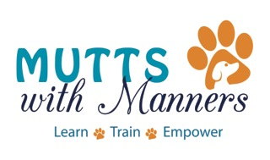

WAIVER, HOLD HARMLESS, AND
ASSUMPTION OF RISK AGREEMENT

I, , a participant of a training session from Mutts with Manners, LLC at Camp Bow Wow, including group classes, private lessons, behavior counseling services, and socialization sessions, understand that there may be some risk involved with this training, including but not limited to exposure to environmental elements, abrasions, and bites.

I also understand that, in conjunction with my request to have my dog participate in training from Mutts with Manners, LLC at Camp Bow Wow, I hereby agree to release, discharge and/or hold Mutts with Manners, LLC or Camp Bow Wow, its employees, officers, members, agents, and associates harmless from any and all claims, causes of actions or demands growing out of or arising by reason of obedience training my dog(s) use of Camp Bow Wow’s facilities, or any participation in any of the training programs offered by Mutts with Manners, LLC.

I have read and under the above agreement.

Owner’s signature Date

