REGULAR MEETING
NOVEMBER 16, 2023

The Regular Meeting of the Town Board of the Town of Hampton, County of Washington and the State of New York was held at the Town Hall, 2629 State Route 22A, Hampton, New York, on the 16th day of November, 2023.

PRESENT: David K. O’Brien------------Supervisor
Donald Sady----------------- Councilman
Tamme Taran----------------Councilwoman
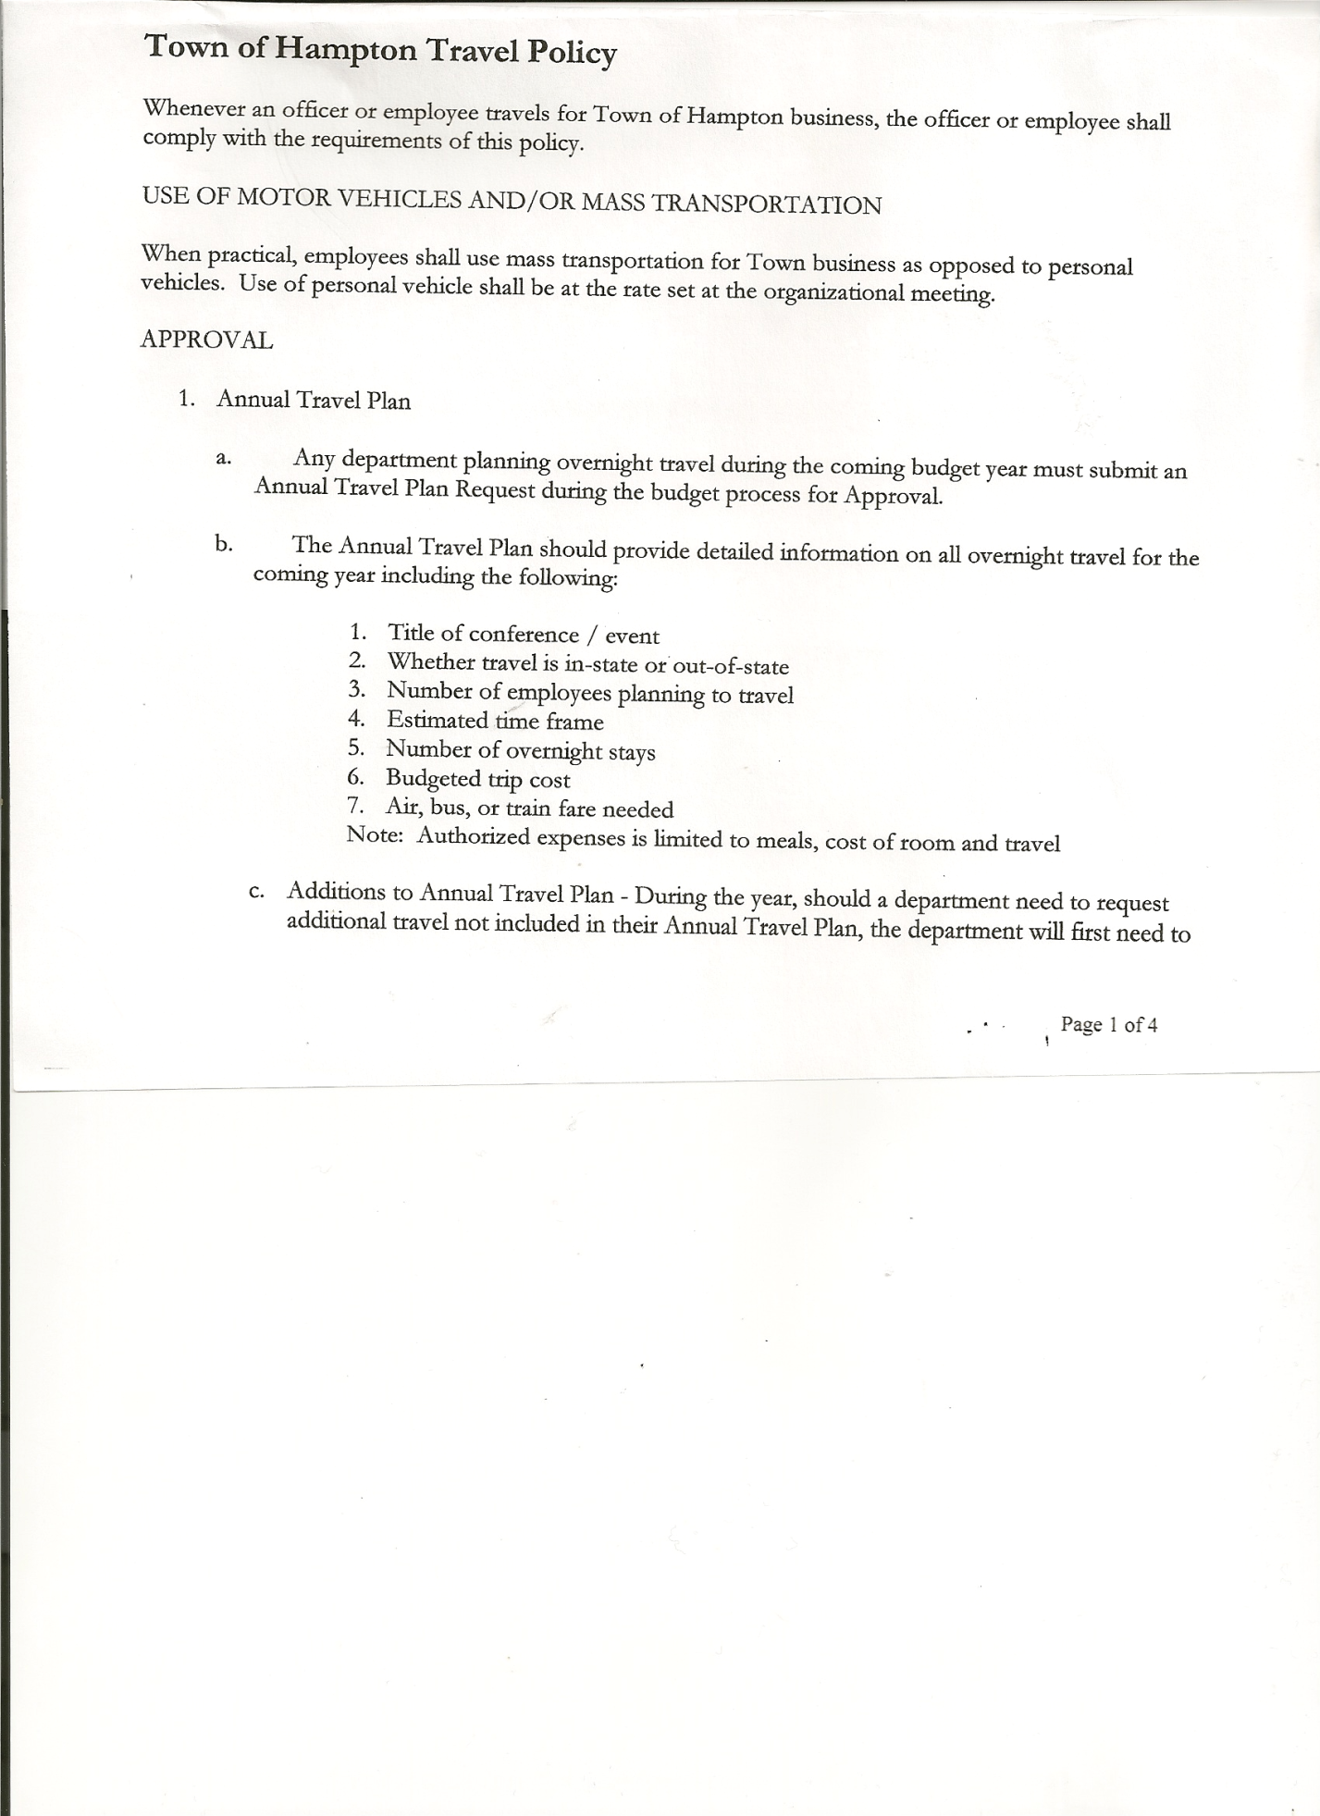
Michael Pietryka------------Councilman
Andrea Kugler---------------Councilwoman
Rebecca Jones---------------Town Clerk
Camilla Shaw----------------Deputy Town Clerk
Tyler McClure---------------Highway Superintendent

Planning Board Member (s):… Bonnie Hawley, Chair; Richard Cole, Ginny Kinsey, Matthew Pratt and Rene Rountree
Others present at the Town Hall: see attached sheet

The Regular Meeting was called to order by Supervisor O’Brien at 7:30pm, followed by the Pledge of Allegiance. Location of Fire Exits were given. Quorum of board members present.

RESOLUTION NO. 96-2023
APPROVAL OF THE MINUTES
On a motion of Councilwoman Taran, seconded by Councilman Sady, the following resolution was ADOPTED: AYES 5 O’Brien, Sady, Taran, Pietryka, Kugler
NAYS 0
RESOLVED, that the Regular Town Board Meeting Minutes for October 19th, 2023 are approved.

Dog Control Report….no report

Tax Collector Report…..no activity. The Town Clerk/Collector had Board Members review and sign bank reconciliation statements for the Tax Collector Account October 31st, 2023.

Bonnie Hawley, Chair Planning Board…. There was another Public Meeting on November 8th at 7:00pm at the Town Hall for any further questions regarding the Ag Plan.

Tyler McClure, Highway Superintendent submitted his report, copy of which, is attached.
In August an Excavator owned by Tim Havens was used for a job, it sustained damage which the Town’s insurance company paid. The Town had to pay the deductible which was $1000.00.

TOWN BOARD MEETING
NOVEMBER 16, 2023 PAGE 2

SUPERVISOR’S REPORT/COUNTY UPDATES/COMMUNICATIONS

RESOLUTION NO. 97-2023
APPROVAL OF SUPERVISOR’S MONTHLY REPORT
On a motion of Councilwoman Taran, seconded by Councilman Sady, the following resolution was ADOPTED: AYES 5 O’Brien, Sady, Taran, Pietryka, Kugler
NAYS 0
RESOLVED that, the Supervisor’s Monthly report be accepted as submitted for OCTOBER
09/30/23 10/31/23
ACCOUNT BALANCE RECEIPTS DISBURSEMENTS BALANCE
General Fund $ 67,260.93 $ 1,445.21 $ 5,796.29 $ 62,909.85
Highway Fund $158,402.28 $ 823.91 $ 33,145.70 $ 126,080.49
Equipment Reserve$149,987.86 $ 3.82 $ 0.00 $ 149,991.68
Fire #1 $ 23,185.50 $ 0.00 $ 0.00 $ 23,185.50
Fire #2 $ 7,680.50 $ 0.00 $ 0.00 $ 7,680.50
Cemetery $ 2,024.92 $ .84 $ 0.00 $ 2,025.76
Totals $408,541.99 $ 2,273.78 $ 38,941.99 $ 371,873.78
All Board Members present signed Supervisor’s Report.

County Budget…..going up 3% for 2024, Medicaid and Retirement are the main reasons for the increase.

Supervisor O’Brien went over the Town Budget for 2024 line by line. The Town Budget increase is 14.82% mainly due to the hiring of an additional Town Highway Employee.
RESOLUTION 98-2023
APPROVAL OF THE 2024 BUDGET
On a motion of Councilman Pietryka, seconded by Councilwoman Kugler, the following resolution was ADOPTED:
By Roll Call Vote: Supervisor O’Brien AYE
Councilman Sady AYE
Councilwoman Taran AYE
Councilman Pietryka AYE
Councilwoman Kugler AYE
RESOLVED that, the 2024 Town Budget for the Town of Hampton is adopted.

Fire Company Contracts given to Fire Co….need a signed copy returned.

Following a discussion regarding the Assessor position, the following resolution was introduced.
RESOLUTION 99-2023
ASSESSOR POSITION
On a motion of Councilwoman Taran, seconded by Councilman Sady, the following resolution was ADOPTED: AYES 5 O’Brien, Sady, Taran, Pietryka, Kugler
NAYS 0
RESOLVED, that Arek Gordon remain as the Town of Hampton Assessor.

RESOLUTION 100-2023
END OF YEAR MEETING
On a motion of Councilwoman Taran, seconded by Councilman Sady, the following resolution was ADOPTED: AYES 5 O’Brien, Sady, Taran, Pietryka, Kugler
NAYS 0
RESOLVED, to set the End of Year Meeting for 2023 for Thursday, December 28th, 2023 at 7:00pm.

TOWN BOARD MEETING
NOVEMBER 16, 2023 PAGE 3

RESOLUTION 101-2023
ORGANIZATIONAL MEETING
On a motion of Councilman Sady, seconded by Councilwoman Kugler, the following resolution was ADOPTED: AYES 5 O’Brien, Sady, Taran, Pietryka, Kugler
NAYS 0
RESOLVED, to set the Organizational Meeting for 2024 for Wednesday, January 3rd, 2024 at 7:00pm.

Presentation of Ag Plan by Richard Cole, Planning Board member.
- A $25,000.00 grant was received.
- Surveys were sent out, approximately 120 responded to the survey
- Held two meetings with Ag people
- Held numerous meetings with other organizations
- Hired a consultant, Nan Stolzenburg, Community Planning & Environmental Associates to help develop a Town Agricultural and Farmland Protection Plan
- Completed a Draft Plan
- Held two more meetings open to the Public to discuss the plan and ask questions
Concern over regulations to farmers. The plan has no zoning, laws or rules.

RESOLUTION NO. 102-2023
AUDIT OF CLAIMS
On a motion of Councilwoman Taran, seconded by Councilwoman Kugler, the following resolution was ADOPTED:
AYES 5 O’Brien, Sady, Taran, Pietryka, Kugler
NAYS 0
RESOLVED that the bills have been reviewed by the Town Board and are authorized for payment in the following amounts.
General Fund No.123 through No. 136 $ 11,072.48
Highway Fund No.120 through No. 134 $133,462.74
Total both funds $144,535.22

The Town Clerk’s report for October 2023 was submitted to the Board. The Town Clerk had Board Members review and sign bank reconciliation statements for the Town Clerk Account and Special Clerk Account dated October 31st, 2023.

PUBLIC/COUNCIL COMMENTS
Hampton Fire Co….Thank You to Tyler and Highway Dept for putting sand down at the Hampton Firehouse after a diesel spill.

RESOLUTION NO. 103-2023
MEETING ADJOURNED
On a motion of Councilman Sady, seconded by Councilwoman Kugler, the following resolution was ADOPTED: AYES 4 O’Brien, Sady, Taran, Pietryka, Kugler
NAYS 0
RESOLVED that the meeting adjourned at 8:36pm.

Respectfully submitted,

Rebecca S. Jones, RMC
Town Clerk

