CAEW Logistics Handbook
Introduction
Fundamentally, we are all here to serve our Lord during this Emmaus Walk, as well as the Conference Room Team and Pilgrims. At our Walks, we were blessed and we have come back to share our Agape Love so that the Pilgrims may be blessed also. We are doing this in the area of Logistics. This is behind the scenes. No pilgrim will know what you have done, nor will many of the Team. But, we are servants and need to always work as unto the Lord. Logistics is a vital part of the overall operations of a Walk. If it does not work well, the Walk will not work well. It is not the only vital area and other work areas are equally vital to the success of the Walk.
Three functions of the Logistics Area
- We deliver the supplies to each area before the walk. Each tote box, piece of furniture, or equipment should be marked or labeled for the specific area of use (Agape, Worship, etc.).
- We pick up supplies from each area at the end of a walk as the work area chairperson notifies us that they have items ready to return to storage. All items should be stored neatly by work area in the Emmaus storage shed.
- We also help as requested by the Lay Director and the ALDs wherever we are needed.
Remember, even though we are there to work Logistics, we also should be ready to assist other work areas that may need our assistance. Even though Logistics is not responsible for items that have been placed in the wrong tote box, we are sometimes called upon to assist in finding the items.
IMPORTANT: "It is always better to be kind, than to be right." Our foremost purpose is to be the hands, feet, and face of Christ to all.

LOGISTICS TEAM RESPONSIBILITIES
The Central Alabama Emmaus Community Board of Directors member responsible for the Logistics work area will:
- Contact the cluster lay director of the primary support cluster responsible for the Walk to identify a member of the community who will commit to chairing the Logistic work area for the Walk. The chairperson must have previously worked as a logistics team member. Ideally that person will have experience working logistics each day of the Walk and is committed to be at the Walk site for all four day of the Walk.
- Provide the chairperson with a copy of the Logistics Handbook if they cannot download the document from the CAEW web site. The Board member should also provide advice, training, and assistance to the chairperson as necessary before and during the Walk.
RESPONSIBILITIES OF THE LOGISTICS CHAIRPERSON
- Recruit and schedule a sufficient number of team members to work each day of the walk. The following is a suggested number of person for each day of the walk:
- Day One (Wednesday) – at least 6-8 including the chairperson. (This usually begins between 8 and 8:30 a.m. You will need a pickup truck, preferably with four-wheel drive, capable of pulling a 14-foot trailer with a trailer hitch. The four-wheel drive is needed if it is raining or has been raining because of the slick drive down to and up from the storage building. A second pickup and trailer is best and will facilitate getting things unloaded and delivered in a speedy manner and will assist in getting things put away and packed up on the last day.
- Day Two (Thursday) – 2, preferably including the chairperson. A pickup truck should also be available.
- Day Three (Friday) – At least four plus the chairperson. A pickup capable of pulling a trailer.
- Day Four (Saturday) – At least 6-8 including the chairperson. A pickup truck capable of pulling a trailer, two is better, with four-wheel drive.

- Attend the first team training session for the Walk, and encourage logistic team members who have not worked logistics or have not worked logistics recently to attend so that you can train them.
- Exchange cell phone numbers with Lay Director (LD) and a designated Assistant Lay Director (ALD) who will be your main contact person during the walk. Often discrete communication with the Conference Room leadership occurs by means of text messages.
- Make sure that the following equipment is available to use during the Walk:
- At least one pick-up truck with trailer hitch and four-wheel drive if possible.
- Flash light(s)
- Tool box with basic tools (screwdrivers, pliers, hammer, etc.)
- Trailer
- For Men Walks only, the Logistics team should be available to assist the Agape workers empty trash cans in the male pilgrim's and table leader rooms if requested. While the pilgrims go to morning chapel or during the breakfast/lunch time seem the most logical time. Also make sure there is sufficient Bathroom Tissue in each room and in the two bathrooms of the lobby (this should be for both women and men walks).
- Keep a running list of issues with the physical plant of the camp (ex. loose toilets, non-working outlets, broken doors, windows, etc.) At the end of the walk email (mwells3204@yahoo.com) or hand the list to Mike Wells.

CAEW Logistics Summary
Day One Tasks - Wednesday
7:30 am Meet in Kitchen area of Conference Center
8:00 – 11:00 am Prepare Conference Center #1 - #8
Unload Storage Shed # 9 - #11 and #16 - #20
Set up Indoor Chapel #12 - #15
Setup of Conference Room #21 - #28
Setup Dinning Room for Send-Off #29 - #31
Setup Outdoor Chapel #32 - #34
7:30 pm Dining Room Setup after Send-Off #36 - #41
Day Two Tasks - Thursday
9:00 am Photography Setup at Outdoor Chapel #46
Through out the day empty trash cans when pilgrims are at meals
Day Three Tasks - Friday
8:00 am Setup tables for the Book table #49
9:00 am Setup for Dying Moments at Indoor Chapel #50 - #56
12:30 pm Setup Chairs for Prayer Circles #58
1:30 pm Dismantle Dying Moments #59 - #62
2:30 pm Setup for Candle Light Ceremony #63 - #69
3:30 pm Start moving packed materials to Storage #70
9:00 pm Dismantle Candlelight Communion and chairs #73
Through out the day empty trash cans when pilgrims are at meals
Day Four Tasks - Saturday
7:00 am Help with and participate in Serenade #74 - #75
8:30 am Setup for Closing Ceremony #77 - #79
10:00 am Start moving items to Storage #80
1:00 pm Dismantle Dining Room Tarps #81
1:50 pm Dismantle Conference Room and Prayer Chapel #83 - #84
2:30 pm Setup for Cross Ceremony #85
6:00 pm Dismantle Closing Ceremony #86 - #91
Through out the day empty trash cans when pilgrims are at meals
Go to the specific number(s) on the following pages for the details of the task(s).

Day One Tasks - Wednesday
Meet in the kitchen area for prayer and task assignments at 7:30 a.m. Have each Logistics volunteer sign-in a work area sheet with their names and original Walk number. Retain this sheet for use as others come and work in Logistics throughout the weekend. Following the walk email the list of names/walk #s to Rita Carswell at ritacarswell14@yahoo.com or mail to Rita Carswell 538 Winding Road, Dadeville, AL 36853
CONFERENCE CENTER PREPARATION
- If the Camp staff has not already done so, use a leaf blower (if available) to blow off the sidewalks and entrance areas surrounding the conference center (including kitchen area), the indoor chapel, and the agape/worship area. This will help avoid tracking leaves, dirt, and pine needles into the buildings. Also blow off the pavilion where candlelight and closing are held.
- As one turns on the heat/air in the pilgrim rooms, conference room, and dining hall, check the lights in each room/area. The thermostats for the conference room are located near the doors to the two restrooms located in the foyer. The thermostat for the dining room is located on the left wall of the dining room. Most bedrooms in the conference center have window units that provide both heat and air. For cooling, the higher the setting on the unit, the cooler the room. For heating, the lower the setting the warmer the room. If there is a space heater in the room, make sure that it is working. If this is a women's walk, please remind the Lay Director and/or one of the ALDs to caution the ladies about using hairdryers and curling irons. Too many can cause the circuits to be tripped. The circuit boxes are located in the rear of the dining room in the set of double doors closest to the kitchen. Additional heaters are in the closets at the back of the dining hall in case one of the rooms needs one. If you cannot find enough heaters or if any of the heaters/air units don't work, contact the Camp Ranger.
- If chairs are set up in the conference room, stack them up along the wall. Replace light bulbs as necessary. Ask Camp Ranger where replacement bulbs and ladder are located, if you do not already know.
- Vacuum if necessary.
- Prepare the dining room for Send-Off setup. Stack up chairs. Move tables to the right side of the room; fold them and stack them on their side several deep. Sweep/mop if necessary. Replace florescent bulbs as needed. Bring in one eight-foot table, two six-foot tables, and one four-foot table from the metal storage shed located outside the dishwashing area of the kitchen. The six-foot table is placed folded against the left wall of the dining room near the corner leading to the kitchen. . The other eight-foot table is located in the Meal Service area in the rear of the dinning hall. The four-foot table is put in the Meal Service area for the Speaker’s Prayer Chapel personnel to eat.
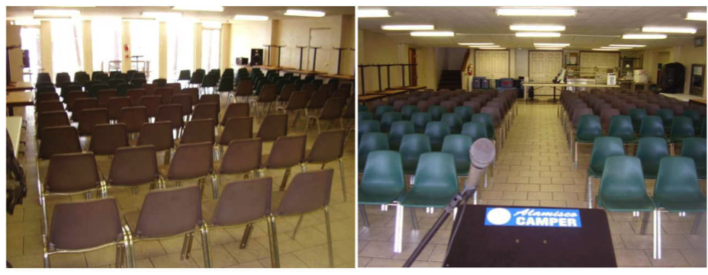
- Set up chairs for Send-Off. Begin at the front of the dining hall making sure that there is enough room for the speaker podium in from of the glass wall. Ensuring there is a 4 to 5 feet wide center aisle" place rows of chairs on both sides with approximately 8 chairs in each row. Do not block the door on the left side of the dining hall nearest the windows. You will need at least 100 chairs. Some of the chairs may be located outside and if you bring them in, please make sure they are wiped down for they may have dirt and pollen on them. Make sure that a music stand is placed in the front of the dining hall. Another individual will be responsible for setting up the sound equipment.

- Set up another eight-foot table in the Refreshment area of the kitchen, which is located in the right rear area near the window and the door leading to the washer/dryer.
- Move mattresses, bed frame, and bedding out of Room #1 of the wing of rooms located to the left of the Conference Room. This will be the Prayer Chapel. Put these into Room #5 on the backside of the wing. On some walks, Room #5 will be used by one of the Spiritual Team. If that is the case, place the mattresses, and bed frame in the breezeway between the Conference Room and wing. Always check with the Lay Director (LD) to determine the placement of the items. Leave Room #2 as is; it will be used as a dressing room for the Speakers.

UNLOADING THE STORAGE SHED
You are now ready to move all of the furniture and supplies from the Storage Shed to the areas where they will be used during the walk. The tote boxes, furniture and equipment should be labeled. If more than one trailer is available split the logistics volunteers into two groups, (1) Nature Center/Pavilion group and (2) Conference Center/Kitchen group. Each group will utilize a trailer. Move the Nature Center/Pavilion group trailer in front of the storage shed first. Procedures for the Conference Center/Kitchen group begin on page 10.
NATURE CENTER/PAVILION LOADING/UNLOADING
- When you open the Storage Shed, the first items you see will probably be the podium, kneeling benches, alter table, etc. that were used at the Closing ceremony for the previous walk. Load these into your truck/trailer first. They will be unloaded at the pavilion and placed up against the front wall near the Camp Offices. Continue to load that trailer with tote boxes labeled for Agape, Worship, Book Table, Serenade, Indoor Chapel, Dying Moments, and Candlelight. These items are usually located on the left side and back of the storage shed. These items along with four plastic shelving units for agape, the large Jesus cutout, and the "Dying Moments" and "I've been expecting you" banners will be taken to Nature Center. More than one trip will be required.
- Remember the larger kneeling benches, alter table, podium, and sound system (large speakers with stands, amplifier, and green sound system tote boxes are unloaded on the north side of the pavilion. The Candlelight tote boxes are placed on the south end (closest to the fire truck) of the pavilion. If possible place those tote boxes inside the double doors on the right side. The "Have you seen Jesus" banner and the CAEW gray banner go to the pavilion for use during Candlelight and Closing.
- Move all items for Agape, Worship, Book Table, and Serenade to the Nature Center (right side of breeze way). Place Agape in back right, Worship to left around the counter, Serenade on the Counter, and Book Table on the counter. There will also be four (4) plastic shelving units for agape. The photos at the top of the next page give you an idea of where to place the tote boxes and storage racks.

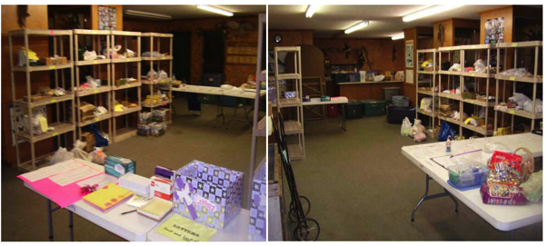

INDOOR CHAPEL SET UP
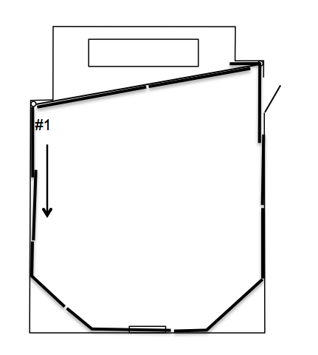
- In the Indoor Chapel/Dying Moments Room, hang the tarps from the “Inside Dying Moments” tote box along the perimeter of the room. The cable will already be up. The tarps should be numbered. Begin with #1 on the wall with the double doors and continue hanging to the left all around the room. Make sure you overlap two grommets as you go around the room. To hang the tarps along the back of the room to hide the counter and kiln string the wire cable from the hook by the back double door (north) and attach it to the hook on the outside corner near the entrance to the chapel. Hang the remaining two black tarps. Use black duck tape or large binder clips to hold the edges of the tarps together.

- Place the empty tote box behind the back tarps along with the large one labeled “Outside Dying Moments”. Those black tarps will be put up in the porch area Friday morning.
- Move 66 of the white chairs to the indoor chapel from the storage room on the south side of the pavilion.
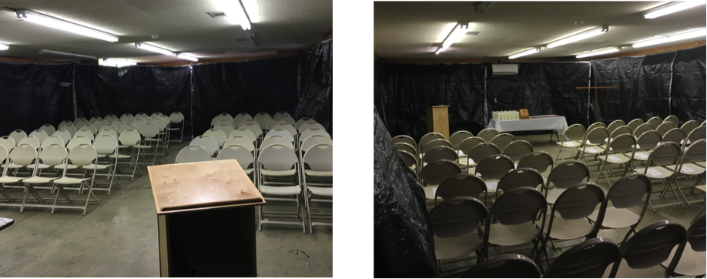
- Set up the indoor chapel for Sponsor's Hour by placing a six-foot folding table in the front center (left end as you enter the room) leaving enough room for the Sponsor's Hour chairperson to walk behind the table to light the candles. Place the cross that will hold the Pilgrim's crosses to the right of the table and the small wooden podium to the left of the table. Arrange chairs facing the table (lakeside) with enough room on the side and down the middle to walk. Usually this will mean five chairs to a row on each side of the center aisle. Make sure the air conditioning or heat is on in the room. The thermostat is located on the back wall to the left (lakeside) above the shelves.

CONFERENCE CENTER/KITCHEN LOADING/UNLOADING
- The Conference Room/Kitchen group will load their trailer with the tote boxes and items labeled Conference Room, Speaker Prayer Chapel, Refreshments, Food Prep, and Meal Service. Also load the small wooden kneeling bench with cushion, the white, green and stainless steel racks (right side of shed), boxes of plates, cups, yellow ladder, box of umbrellas, plastic storage cabinet, etc. Since more than one trip will be required, be sure to load the Conference Room, Speaker Prayer Chapel materials and if possible the various racks first.
- Unload the Conference Room tote boxes, round tables, and small tables first. Take them into the conference room. Take the tote boxes labeled for Speaker's Prayer Chapel to Room #1 at left side of Conference Center as well as the small kneeling bench with needlepoint cushion, a folding table, a round table with pedestal, and two folding chairs. Move the clothing rack to Room #2, the Speakers Dressing Room. Move the box of umbrellas and yellow ladder to the breezeway on the left side of the Conference Center.
- Back the trailer down the access road on the left side of the Conference Center to the kitchen door. Move all white and stainless shelving units into the kitchen. All tote boxes labeled Food Prep and canned goods will be taken to the kitchen. The kitchen volunteers will help direct their placement.
- Move the green shelving units and the Meal Service tote boxes into the rear of the dining room plus all boxes containing plates, cups, eating implements, cereal, condiments, coffee, sugar, and creamers.
- Move all Refreshment items to the back of the kitchen under the window.
CONFERENCE ROOM SETUP
- Place the podium front, center on the raised platform in the Conference Room. Position a four-foot table which will be used as the alter on the floor in front of the podium. Close blinds on the windows and door. Hang the Walk to Emmaus Banner to the right of the pull down screen. Set up six round tables in the conference room, placing three on the right side and three on the left side. Place tables so that open end of table legs faces the podium. This is where the Table Leader will set and he/she doesn't get to scramble so we want them to be comfortable in terms of legroom. Place eight chairs around the tables. Make sure the chairs are stable and in good shape. Set up two eight-foot tables and one six-foot table at the back of the room for the conference room team. Set up 10 chairs behind these tables. For the Board Representative, place another six-foot table against the wall on the left side of the conference room near the tables used for the conference room team. For craft supplies and other needs, place another six-foot table against the left wall near the stage. All of the extra tables are located in the small storage building behind the kitchen area. The extra chairs are stacked against the back wall behind the table and chairs of the conference room team.

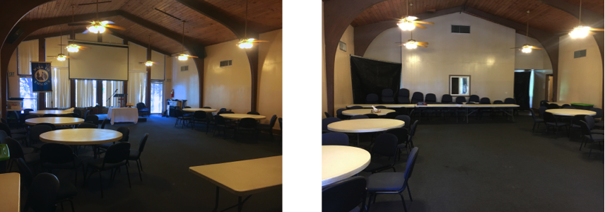

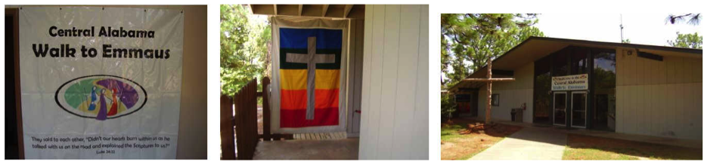
- Place black tarps across both back (away from the lake) entrances to the conference room. You may need to hang the cables. If so, they should be in the box with the tarps.
- Hang the "Welcome to CAEW" banner over the entrance to the Conference Center. Hang the" Central Alabama Walk to Emmaus" banner over the glass fronted display case in the conference center foyer. Hang the gray cross with rainbow background from the hooks on the eve between the breezeway and Room #1.
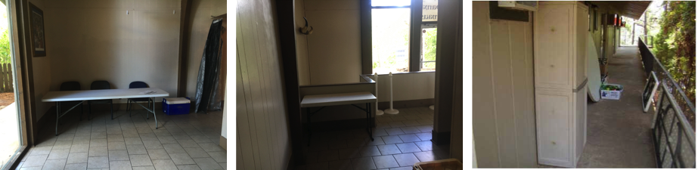
- Place one eight-foot table in the foyer, on the left wall with at least three chairs behind it for Housing and Registration. For coffee, place a four-foot table in the corner just before the entrance to right side wing of pilgrim’s rooms. Place a large trashcan with liner near the drinking fountain.

- Move the Rubbermaid cabinet just around the right front corner of the Conference Center, on the walkway. If there are tote boxes with full drink bottles also place those beside the cabinet. Lean two additional eight-foot tables against the walkway railing.
- Move the extra round table just beyond the Rubbermaid cabinet along with an eight-foot or six-foot table. The Book Table volunteers will use these tables.
- Place portable floodlights in the right front of the conference center with extra extension cords. This may be used, if needed, on the first night as pilgrims arrive and during the post-candle light party.
- Place the "Designated Smoking" sign and yellow bucket and "Park only in the Designated Areas" signs in the appropriate areas outside the conference center.
DINING ROOM TARP SETUP
- If it is the first of a season, string the tarp cable from the hook near the left side of the door leading to the downstairs wing of pilgrim bunk rooms across the dinning room to the hook near the outside corner leading to the kitchen area. The third part of the cable system is attached to a hook where the stairs meets the ceiling. To eliminate any gap in the cable near the stairs, hook the cable over the two screws where the stair wall meets the ceiling (see the picture on page 14.) Twist one or more of the turnbuckles to remove any slack in the system.
- Hang the tarps across the back of the dinning hall and to the stairs. Start with attaching the corner of tarp label #1 to the turnbuckle on the outside corner nearest the kitchen with shower curtain clips. The black side of the tarps should face the dinning area. Continue to hang tarps #2 through #5 overlapping one grommet, except between tarps #1 and #2. Tarp #4 will create a corner as it follows the cable towards the stairs. The use of a short tarp section after #5 is used to fill in the gap between the stairs and the ceiling. The right side of tarp #1 and the left side of tarp #2 will be the entrance between the meal service area and the dinning room. These sides are held together with several large black clips. Finally, a smaller width tarp is attached to the short length of cable near the door to the pilgrims’ rooms. See page 16 for pictures.

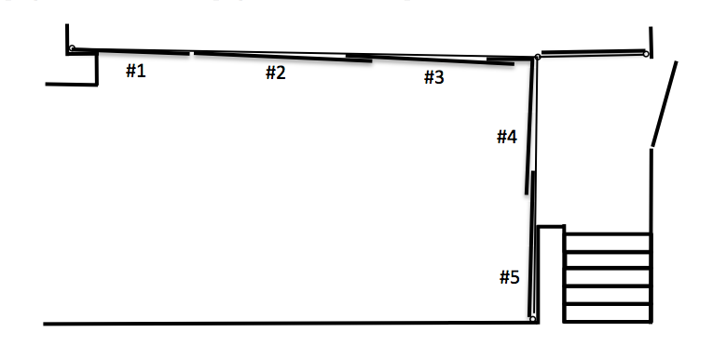

- Once all the tarps are in place, slide #1 through #5 against the wall nearest the kitchen, using the large trash can to hold them against the wall. Move the smaller tarp to the right against the right wall and use a stacked table to hold it back. The tarps will be moved back into position after the pilgrims and sponsors have left after Send-Off.
OUTDOOR CHAPEL SETUP
- Take a microphone to the Outdoor chapel. Inside the podium cabinet, is the sound equipment. Make sure the speakers are connected and connect the microphone to the mike wire (usually #8). Turn on the system using the rocker switches at the top and bottom of the system (see photo below.) to make sure it is working. Later that day, locate the Worship Chairperson and/or an ALD and show them how to turn on the lights and the sound system.
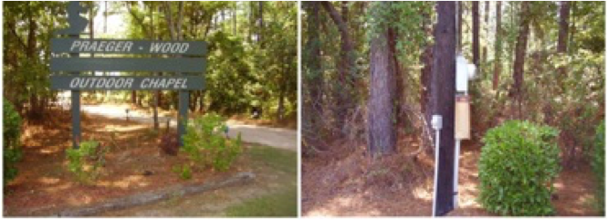
- Know how to turn on the lights. There is a power box on the left side of the entrance to the Outdoor Chapel. The switch turns on the path lights. There is a light pole on just to the left and in front of the podium at the rear of the Outdoor Chapel. There are dimmer switches for the floodlights.

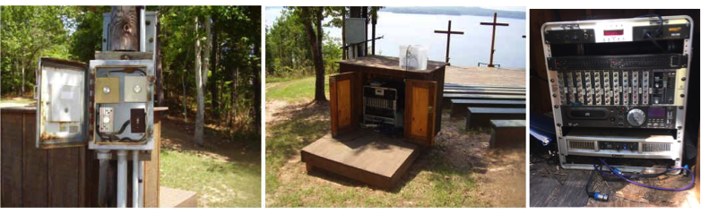

- Check to see that Mike Wells has placed the Emmaus Road Sign up at the entrance to Camp Alamisco.
- Go to lunch with the Logistics volunteers at Popular Dawgs. After lunch, get settled into your quarters, if you are staying at the camp. Rest and as you find work area chairpersons arriving, invite them to go through their area things and make sure all items are present. You may need to help them locate items that may have been misdirected. Check with the Worship Chair to see if your help will be needed on Thursday morning and if so what time you should meet in the Agape Room.
DINNING ROOM SETUP AFTER SEND-OFF
- Arrive back at the Conference Center at least 30 minutes before send-off (7:00 pm).
- With the help of the Meal Service team, as quietly as possible stack all the chairs against the left wall (kitchen side.)
- Place three eight-foot tables across the front of the dinning hall (lakeside). Place enough chairs (backs to lakeside) to accommodate the Conference Room Team [Lay Director, 4 ALDs, Spiritual Director, 4 ASDs, Media, Board Rep., and Music (2 to 3)].
- Place three rows of eight-foot tables perpendicular to the row of the head table. Be sure the rows are centered in the dining room have sufficient room on each side of the table for the chair and movement of the servers during meals. There should be ample room between the head table and the beginning of the tables for the pilgrims. Place eight chairs on each side of a row of tables. Group them so that there are two groups of four towards the end of each row and the middle is without chairs. This configuration allow for six groups of pilgrims, representing the six table groups.

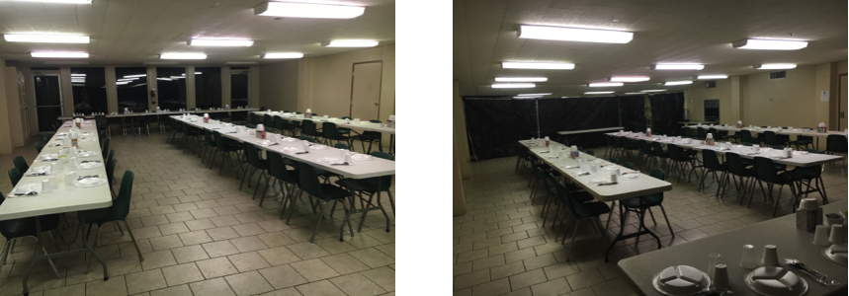

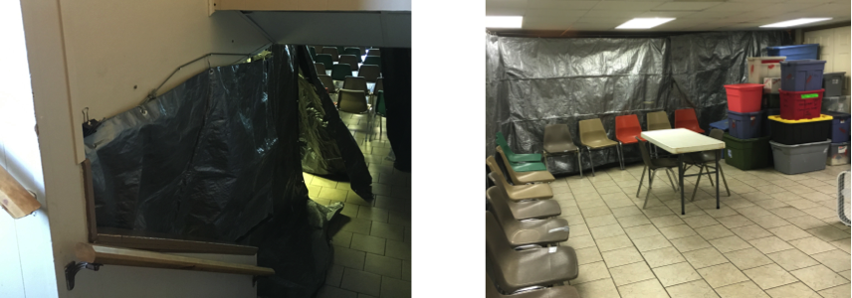

- Move the eight-foot table that contained the snacks for Send-Off towards the lakeside of the tarp cable line. Place a four-foot table for the Prayer Chapel team in the Meal Service area. Set up the six-foot table that is leaning against the wall; it will be used for coffee pots.
- Reposition the tarps to the places they occupied earlier in the day during set up. Fold the excess length inside the Meal Service area. Place the extra chairs (10-12) with their backs against the tarps.
- Move the sound equipment and the podium to the pavilion and store it in the Camp office (the windowed door on the left side.)
- Either attend the team meeting on Wednesday night (usually at 10 p.m. at the Indoor Chapel) or better have a designated ALD call or text you afterwards with any needed items or instructions.
Day Two Tasks - Thursday
- Logistics volunteers should arrive outside in the kitchen area about 7:30 a.m. unless requested earlier by one of the ALDs or the Worship chair.
- Following breakfast, check outdoor chapel to blowout candles, if necessary, to turn off lights and sound equipment, and stow the microphone in the equipment box. Assist the worship volunteers in moving the worship tote boxes back to the nature center.
PHOTOGRAPHY SETUP
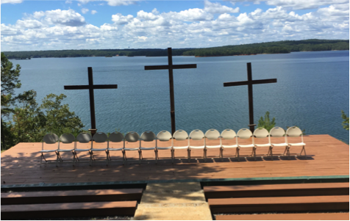
- Move 16 folding chairs from the storage room on the south side of the Pavilion to the stage of the outdoor chapel for the Photography session. These need to be in place by no later than 10:00 a.m. A pickup truck is helpful. Place them in a centered single line about half way back on the stage. Text the designated ALD that the chairs are set up. After the photography session, move the chairs back to the storage room in the Pavilion.

- While the pilgrims are at the Outdoor Chapel having photos taken, stack 24 plastic chairs from the outside (lakeside) corners of the dining room to the balcony above, placing them against the outside wall facing the lake. These will be used for Friday prayer groups. Work quickly; the pilgrims will return by 10:50 a.m.

- While the pilgrims are eating lunch, empty the large trash can outside the double doors, the trash cans in the two restrooms on either side of the media room, and the trash can by the water fountain. Black plastic bags are located in the kitchen area. If it is a men’s walk, be available to help Agape empty the trash cans in the pilgrim’s and TL bunk rooms. Replenish toilet paper, and paper towels if needed.
- Check with Food Prep and Meal Service to see if they have any items that can be returned to the storage shed.
- Before dinner, check with an ALD to see if one or both of the Chapel services will be held in the Conference Room instead of the Outdoor Chapel. Volunteer to help the Worship chair to move the needed worship tote boxes to the conference room foyer.
- Check with the Worship Chair to see if your help will be needed Friday morning and if so what time you should meet in the Agape Room.
- While the pilgrims are at dinner empty the trash cans in the foyer restrooms, by the water fountain, and outside the conference center, if needed. Make sure there is sufficient toilet paper and paper towels in those restrooms. There should be bags in the closet located in the foyer.
- Either attend the team meeting on Wednesday night (usually at 10 p.m. at the Indoor Chapel) or better have a designated ALD call or text you afterwards with any needed items or instructions, specifically the set-up instructions for Dying Moments, chair placement for group prayers on Friday afternoon, Candlelight, the Cross Ceremony, and Closing.
Day Three Tasks - Friday
- Logistics volunteers should arrive outside in the kitchen area about 7:30 a.m. unless requested earlier by one of the ALDs or the Worship chair.
- While the pilgrims are at breakfast, check bathrooms in foyer, replenish supplies, empty trash cans as needed, check large trash can in foyer and empty as needed. Remember black trash bags are in the kitchen.
- After breakfast, set up book tables (one round and a rectangle) to the right of the side walk in front of the Conference center. If raining or if it is too cold, ask ALDs if they prefer the tote box be sent to the foyer for them to set up. Make sure there are at least two chairs at the book tables.
DYING MOMENTS CHAPEL SETUP
- Go into the indoor chapel and adjust thermostat as necessary. Remember there will be 63 people in that room.
- Get the large painting of Jesus out of the Agape room, plus a 4-foot table and put out on the porch.
- Retrieve the large Outside Dying Moments tote box from behind the back tarp in the inside chapel. Begin putting up the tarps around the porch of the Nature Center. Within the tote box, the tarps should be stacked in order with #1 on top. The #1 tarp begins at the left side where the tarp attaches to the building tucked under the eve and continues around to the right. Make sure you overlap two grommets. A detailed layout of the tarp order is taped to the inside cover of the tote box as well as on the next page. Please do not move any hooks. If the grommets and hooks do not line up, it is a good indication that the tarp is positioned incorrectly. Secure the bottom of the tarps with rocks, bricks, etc. to keep them from blowing in the wind.
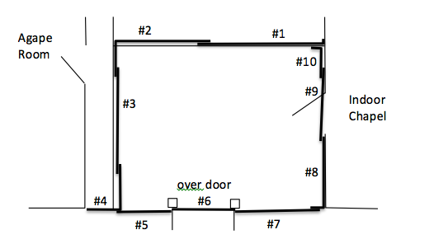

- Hang the "I've been expecting you" banner outside front of the foyer area just to the left of the entrance.
- Reconfigure the indoor chapel from Sponsor's Hour to the Dying Moments chapel. Move the podium to the Pavilion for Candlelight, unless otherwise instructed. Arrange 6 rows of chairs containing 8 chairs each. Make sure there is sufficient room at both ends of the chair rows for movement. Remember to make the necessary adjustments to the configuration to reflect the current number of pilgrims on the walk. Not sure? Check with an ALD by text. There should be 10 folding chairs along the back tarps.
- Hang the Dying Moments banner to the right of the table holding the candles. Clamp the spotlight to the end of one of the light fixtures and position it to shine on the banner. Take some folding chairs to the Agape Room for their use. Usually 6 are sufficient. Return rest of the folding chairs to the pavilion for use during candlelight.
- Dying Moments, including Worship’s set up should be complete by 10:30 a.m. Text an ALD when the Dying Moments set up is complete.
- While the pilgrims are at Dying Moments, empty the trash cans in the foyer restrooms, by the water fountain, and outside the conference center, if needed. Make sure there is sufficient toilet paper and paper towels in those restrooms. There should be bags in the closet located in the foyer. If it is a men’s walk, also empty the trash cans in the pilgrim’s and TL’s rooms. Replenish toilet paper, if needed.
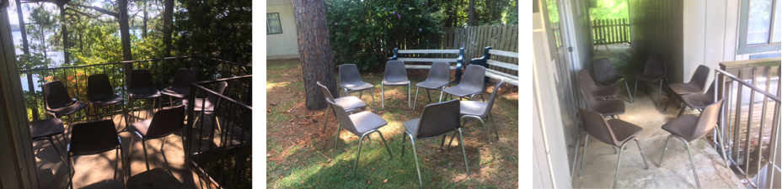

- While the conference room it at lunch, set up three circles of eight chairs each for the afternoon prayer groups. Make sure you have gotten directions from the LD or an ALD as to where they want the chairs put. Usually two groups of chairs are placed on the outside balcony corners of the Conference Center (above left). The remaining group of chairs is placed between the benches and tree in the front of the Conference Center (above center) or at the corner created by the backside balcony of the wing of rooms and the Conference Center breezeway (above right).
- After lunch, return to the indoor chapel to reconfigure for serenade. Take down outside tarps in the reverse order you put them up so that #1 is on top. Fold them and place them in the Outside Dying Moments tote box so that the number is shown. Take down inside tarps in the reverse order you put them up so that #1 ends up on top. Make sure you fold them so you can see the number of the tarp when you put them in the Inside Dying Moments tote box. If there is another walk the next week, the tarps may be left up in the indoor chapel. Check with Mike Wells or the camp ranger if you are not sure.
- Load onto a truck or trailer the two tarp tote boxes, the "I've been expecting you" banner area, the "Dying Moments" banner, the spotlight, the Jesus painting, any Worship tote boxes from Thursday and Friday morning. Ask Agape if any tote boxes and shelves can be loaded as well. Take these items to the storage shed. Remember Agape materials are placed in the back left and the Worship materials to the left side.
- Move all white chairs and the podium back to the pavilion for use during candlelight.
- Sweep the room and set up two large tables from the back of the room for use by Serenade team the next morning. Leave the table with the candles in place.
CANDLELIGHT SETUP
- Go to the pavilion and set up for Candlelight services. Place the kneeling benches on the "foul line", leaving room in the middle for the communion table and for a three-foot walk space to the left and right of the communion table. Place a four-foot folding table between of the benches as a communion table.
- Set up the chairs beginning eight feet from the kneeling benches. Set up rows of 10 chairs on each side of a eight foot aisle down the middle. There should be enough white folding chairs to have ten or eleven rows on each side. The white chairs are on a rack and stacked in the middle storage room (double doors) to the rear of the pavilion. Use the depth of a chair between rows so people have sufficient room to get into their seats. Use all of the chairs that are available.
- Set up the sound system, placing the speakers on the raised black poles in the front of the pavilion, one on the left and one on the right. Put the wooden podium to the left and behind the kneeling benches along with a microphone stand and microphone.
- Set up a table to the side of the Tennis Courts for the “Pilgrim Candles” and a table in front of that adjacent to the communion table for the Media Person to set up the projector.

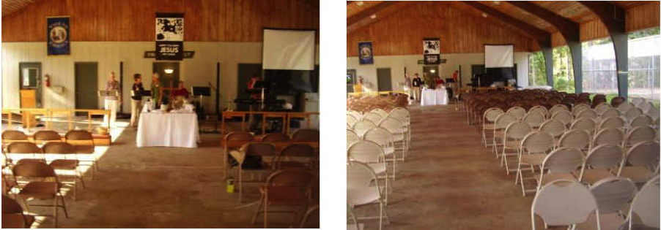

- Hang the "Have you seen Jesus" and the "Walk to Emmaus" banners on the wall behind the benches. You will need to get the Walk to Emmaus banner from the Conference Room. Place the white pole lamp below the "Have you seen Jesus" banner so that one of the lights shines on the banner.
- Expand the large screen and hang it from the two hooks on the pavilion wall to the right of on the banners. Set up a four-foot white folding table for the candlelight media people.
- The light switch for the pavilion is also located in that room to the left of the double doors and on the wall to the left as you enters the Camp Office.
- Check that the bathrooms are clean and stocked. Empty trash cans in the pavilion. Black trash can liners are located in the kitchen.

- Check with the other food prep and meal service to see if they have any items that can be returned to the storage shed. Remember that the Meal Service items are place in the back right of the storage shed and the Food Prep items are place in the right front area of the shed. Encourage them to get things packed up so you can store them as soon as possible. While pilgrims are eating dinner, return chairs used for prayer groups to the balcony against the wall outside the conference room. If there is a walk the next week you may leave the chairs on the balcony behind the Conference Center.
- After dinner, return to the pavilion and assist Candlelight Team as necessary.
- Show them where the light switches are located and where the chairs are stored. Remind them to leave outside lights on for people arriving. All of the lights must be turned off before pilgrims arrive.
- Remind the Candlelight chairperson that when communion is over they must request those seated in the first two rows of chairs on each side of the aisle place the chairs outside of the pavilion. When the Candlelight Chairperson calls for the chairs to be put up. Logistics will roll out the cart in the back of the pavilion, hang the white chairs on it, and return it to the room. Those seated in the remaining white chairs should fold them up and assist putting them on the rack and help store them in the middle room. The chairs should be stacked from the back left of the room to the front in three rows. Then move in the rack of chairs.
Day Four Tasks - Saturday
- Logistics volunteers should arrive at the Indoor Chapel by 7:00 a.m. unless requested earlier by one of the ALDs or the Worship chair. Assist in setting up for Serenade if needed. Place orange cones across road just before the crest of the hill. Ask all to park their cars out of sight of the pilgrims. Make sure that the Serenade people know where the broom and dust pan is located so they can sweep the room when they clean up. These are located in the closet to the right of the door leading into the room.
- Participate in Serenade.
- After breakfast, go to the Indoor Chapel and make sure it is clean. Put away camp tables in the back of the room. Empty wastebaskets and turn off heat/air and lights.
CLOSING CEREMONY SETUP
- Place the kneeling benches at the "foul line" with the communion table in the center just like Candlelight. Podium is placed on the right (tennis court) side of the pavilion near the out of bounds line.
- Set up three rows of white folding chairs for the pilgrims several feet behind each set of kneeling benches. Angle each row slightly (a couple of feet) so that the chairs are slightly facing the podium. Each row should have eight chairs unless otherwise instructed by an ALD. Put fifteen chairs along the wall behind pilgrims for the Conference Room. Help the Worship volunteers place the striped covers on the backs of the chairs. Put a row of about five to six chairs behind the podium on the tennis courtside facing the road so the pilgrims can sit there waiting to speak.
- Sound equipment is placed in the back of the pavilion facing the pilgrims. You will need to run a long sound cord from the amplifier to the podium. Place community chairs in rows of eight beginning about 20 feet in front of the kneeling benches. Leave a eight-foot aisle down middle. Leave plenty of room between rows. You should only need about 70 to 80 chairs. If you need more you can them from storage room as needed.
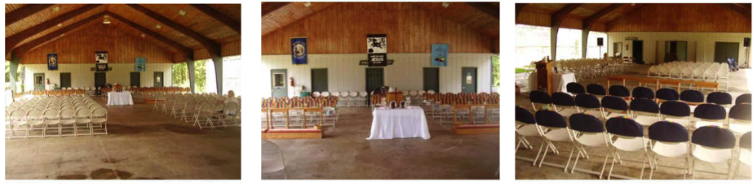

- As each work team packs up their areas, begin returning all items to the storage shed. Try to return the shelving from Agape, Refreshments, Food Prep, and Meal service first so that cardboard boxes and other items can be stacked in them as they are returned to the shed. When packing the shed, try to keep work area items together as much as possible.
- Agape is placed in the back left
- Worship is placed on the left side
- Meal Service is placed in the back right
- Food Prep is placed in the front right
- Conference Room is placed on the left
- Closing Ceremony is placed front center since it is the last packed.
- After lunch, go to the dining room. Take down the tarps in the reverse order you put them up so that #1 is on top. Make sure you fold them so you can see the number of the tarp when you put them in the Dining Room Tarps tote box. Take down the cable system and place it on top of the tarps in the tote box if it is the last walk of the season. If there is another walk the next week the tarps may be left up in the Dining Room. Check with Mike Wells or the camp ranger if you are not sure.
- Continue moving work area tote boxes and materials to the storage shed.
- When the pilgrims return to their rooms to begin reading their letters (about 2 p.m.), the Conference Room Team should be ready to assist in breaking down the Conference Room. Check with an ALD for the go ahead. All round tables and rectangle tables with CAEW written on them should be returned to the Storage Shed. Remember any tables belonging to Camp Alamisco should be returned to the small shed behind kitchen. Move all furniture belonging to Emmaus from Conference Room (podium, cross, etc.). Be sure to take down the tarps, fold them, place them in their tote box, and load them on the trailer. Make sure all banners and signs are taken down and loaded. Take down the parking and smoking signs and load them along with the yellow bucket for storage. Also load the box with the umbrellas, the floodlight, extension cords, and the Rubbermaid storage cabinet. Any unopened drinks should be taken to the cooler in the kitchen for the next walk unless otherwise instructed.
- Move out the items from the Speaker's Prayer Chapel to the trailer then set up the bed in that room. Do not forget to load the clothing rack in the Speaker’s Dressing Room.
CROSS CEREMONY SETUP
- Stack chairs along back wall and vacuum the room. After room is vacuumed, move cross containing the Pilgrim Crosses from Speakers Prayer Chapel to the raised platform in the conference room. About eight feet beyond the raised platform, begin putting six rows of eight chairs. Check with an ALD to determine if the arrangement of chair needs to be modified. Open all blinds. This is for the Cross Ceremony.
- After unloading the trailer at the Storage Shed, back the trailer up to the pavilion near the Camp Office door. This will allow the Logistics volunteers to safely and quickly load the remaining CAEW furniture, equipment, and other materials.

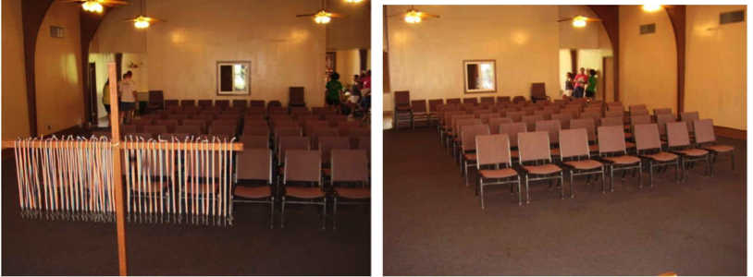

- After the pilgrims have left the room going to Closing bring the cross up to the back of the pavilion. After Closing, load it on the trailer.
- Attend Closing.
- After Closing is complete, return white chairs to the racks and stacked in the middle storage room. Load the trailer with the remaining CAEW furniture, equipment, large wooden cross, and other materials to the storage shed.
- Return to the Pavilion and make sure all the lights are off, including the restrooms on the side. Go to the Nature Center make sure there is no equipment left, turn off lights.
- Mike Wells will remove the Emmaus sign from entrance.
- Once all the pilgrims have left, go to Conference Center and make sure there are no items left in the Conference Room, the Prayer Chapel and in the pilgrim rooms. Make sure lights and heat/air is turned off. Walk through the Alamisco Inn, all cabins, and bathhouse. Turn off lights, heat/air, and empty trash cans, including those at the Nature Center and Pavilion. As an alternative to this step, get a volunteer to come back on Sunday or Monday to do the final walk through of the camp facilities.
- Remember to give or email Mike Wells the list of camp physical plant issues that occurred during the walk.
Thank everyone who assisted and make sure they have signed the list. Don't forget to email the list of workers to the Rita Carswell at ritacarswell14@yahoo.com or mail to Rita Carswell 538 Winding Road, Dadeville, AL 36853

THANK GOD FOR GIVING YOU AND THE TEAM THE OPPORTUNITY OF SERVING AND HOPEFULLY SHOWING GOD'S LOVE TO ALL INVOLVED

