Four Wheel Drive—The Case For Trekking Poles

If you're a young 20-year-old squirt with excellent balance, you probably won't find trekking poles as useful as I do. But I haven't been 20 years old for quite some time now . . ..
—unknown backpacker

My poles have extended my hiking day significantly, on the order of 5 miles and 3 hours. I'm talking about a reduction in overall fatigue, back strain, sore feet, and lactic acid build-up, a.k.a. 'the burn'. When my days used to wrap up at 2pm after 10 miles, I'm still going strong at 6pm after 15 or more. That puts more real estate within my range, allowing me to venture further off the beaten path and leave the heavily impacted frontcountry trails for the slackpackers. Poleless hiking is great for the slackpacker, the guy who keeps his days short and rushes to get to his SUV when the sun starts to go down. But the hiking community actually consists of a wide range of outdoorsmen, some quite capable and dedicated, . . . [who desire] the comfort, safety and versatility of their trekking poles.
—MacPhail, veteran outdoorsman, guide and
instructor, slackpacker.com, June 2006

Central Issues Addressed in This Article
What are the advantages and disadvantages of using trekking poles for hiking, backpacking and climbing? Assuming trekking poles are used, what style and design is best for me? Should I use one or two poles? Collapsible poles? Poles with or without wrist straps? Use pole baskets? What is unique about Nordic Walking with specially designed Nordic poles compared to standard hiking with trekking poles?

Introduction
Foot travel with poles and staffs is not a recent phenomenon. Humans have been using various types of support in their travels probably forever, especially when skiing, traversing rough terrain, if old and frail, if disabled or carrying a heavy burden. What is relatively new is the use of specially designed lightweight “trekking” or “Nordic Walking” poles for general recreation and exercise. This phenomenon has gained popularity in just the last decade or two. For example, there now are Nordic Walking associations and clubs throughout the world. [Note: The difference between Nordic Walking and hiking with trekking poles will be explained later in this article.]
There are many different designs and types of poles. Check out the short article on this website “Pole Styles and Designs” for a comprehensive list of current options. There are also many phrases used to refer to this topic: Nordic Walking poles, fitness poles, hiking poles, trekking poles, ski poles, wooden staffs, alpine stocks, walking sticks and canes. In what follows, the phrase “trekking poles” or simply “poles” will be used to reference all of these phrases, except when noted.
The main thrust of this article is to examine the pros and cons of pole use for hiking and backpacking with an obvious bias in their favor. After discussing the advantages and disadvantages, some issues connected with their use will be examined.

Arguments in Favor of Trekking Poles
Poles are an interesting piece of hiking equipment: many love them and many hate them. There is often little space in between. For those who haven’t formed a solid opinion, here is a comprehensive list of arguments in favor of trekking poles. The first list is a summary of high priority uses (arguments based upon personal experience and research). The second list is a summary of other uses suggested by other pole users. After sharing these two lists of pro arguments, a critique of common arguments against poles will be offered for your consideration.

Highest Priority Uses for Poles (PRO Arguments)

Four Wheel Drive: Poles add traction and power by getting both the upper and lower body involved in ascending and descending both trails and off-trail slopes. It is like having four-wheel drive as opposed to just two-wheel drive. Human use of poles mimic mammals that travel on four legs, not two.

Increased Stamina: By using my whole body, I hike more efficiently and with less whole body fatigue. This efficiency comes partly from alternately using the upper body more going up and down hills, with the lower body used more on the relative level. Though I expend more total energy with this whole body technique than someone without poles to go the same distance (all else being equal), I will usually have more stamina, especially towards the end of a long hiking day.

More Efficient Breathing: Proper pole use maintains a more upright posture while carrying a pack, resulting in more efficient breathing and improved circulation.

Balance and Stability: Poles improve my balance and stability thereby preventing falls, especially in steep terrain and on slippery logs and rocks. By providing better balance and stability, poles further reduce fatigue and increase stamina.

Reduced Stress on Body: The arms and shoulders and poles, viewed as a unit, act like shock absorbers to reduce the impact on joints and muscles. Some experts (especially those in the Nordic Walking community) estimate that poles, properly used, reduce the load on the lower extremities by 10-20 pounds per step, even on relatively flat ground. If one has a strong upper body and is using the poles to the fullest (especially downhill), this stress reduction could potentially be even greater. This during-the-hike stress reduction will ordinarily carry over to a reduction of posthike soreness.

Upper Body Conditioning: Vigorous and aggressive use of poles provides great upper body exercise. It especially conditions arms, shoulders and back muscles. Poles provide additional aerobic conditioning compared to hiking without. Using trekking poles is great conditioning for cross-country skiing in the winter. This upper body workout is especially good for those who spend a lot of time at computer workstations.

Rhythmic Hiking Movement: When using proper pole technique, a rhythmic arm swing and body movement is developed, somewhat like dancing down the trail or the pole-glide rhythm of cross-country skiing. Poles can enhance the fluidity and efficiency of my walking. When I get into the zone (I know, a cliché), I have more fun and get additional enjoyment from my hiking and backpacking.

Pole Vaulting: Poles are useful for jumping across small streams and gullies and over other obstacles.

Trail Clearing: Poles can be used to knock water off of rain soaked limbs and bushes, to push aside spider webs and overhanging branches, and to clear trails of small blow down without bending over.

Doing Double Duty: I regularly use poles to support my nylon shelters. Poles can also be used as canes in case of injury, as splints for broken arms and legs and as camera or binocular mounts.

Traversing Moderate Snow Slopes: Poles can be used to traverse moderate snow covered terrain more safely. Two poles used as a brake on one side allows safer sitting glissades down snow slopes. Poles should not substitute for an ice axe on steeper snow, but they can be quite useful on more moderate slopes.

Hike Into Old Age: The combination of many of the these uses of trekking poles should allow hiking into my 80s and beyond, something I look forward to.

Additional Uses Suggested by Pole Users:
- lessens the damage and discomfort to already injured back, knees and ankles
- helps in losing weight by raising my heart rate and burning more calories
- the clicking noises of the poles will scare off predators, especially snakes
- good chance a snake will strike at a pole rather than leg
- waving my poles around will make me look bigger to four-legged predators
- poles increase blood circulation in the arms and are the best way to overcome the problem of swollen hands
- able to walk and look at the views at the same time
- good feelings generated by using a personalized pole or carved wooden staff
- prop for pack
- lean on when resting
- back-scratching tool.

Arguments Against Pole Use
Even though the above sections express a strong bias for using poles most of the time, there are substantial arguments against them (even to the point of some actually hating them). Here is a short list of CON arguments with some rebuttals.

Con Argument #1 – Becoming Dependent
Being a mountain traveler certainly means you need to have a sense of balance. The more technical the terrain the more honed that balance needs to be. Being regularly dependent on poles or ice axe simply equates to a need for dependence on those tools. You will without question be able to tell the best snow climbers by the limited use of the ice axe or other tools for ascent. Stay in shape, don't carry too much in the old pack and don't lean on stuff.
—Roger Beckett, climbersgroup@yahoogroups.com

Rebuttal: I agree with the basic points of this critique: that depending on poles too much can reduce the sense of balance and that a well-developed natural sense of balance is very important. However, there are a number of ways to maintain (develop) a good sense of balance: special balance exercises, walking a lot on uneven ground with or without a pack, with or without poles. I find that trail running without poles is a good way to hone my balance skills. It is also good to put the poles away at times, especially in brushy areas or in more technical terrain. No one advocates using them all the time. Many of us carry collapsible poles and an ice axe. I also agree that it is great to always be in shape, carry a light pack, not pack extra body fat and have good balance, but this isn’t always the reality, especially as we get older. Another strong line of counterargument is that any loss of two-footed stability and balance is offset by substantial gains in four-footed stability and balance. This is especially true for those with heavier packs who do not have the balance and agility of the natural athlete.

Con Argument #2 – Poles Get in the Way
Poles get in the way when stopping to complete other tasks (map reading, eating, drinking, peeing, etc.). I like to keep it as simple as possible. Poles are just one more piece of equipment to deal with.

Rebuttal: This argument is similar to saying that one’s pack is another piece of equipment to deal with; it would be simpler without it. Poles have so many uses and advantages (detailed in earlier sections) that they are worth small inconveniences. On a practical level, why be in such a hurry. Taking care of your poles is not a big time waster. One way to ease this problem is to use poles without hand loops or with snap off hand loops.

Con Argument #3 – Require More Energy
Poles add extra stress to the upper body and require more energy to swing and place.

Rebuttal: I suspect this line of argument originated when most of the available trekking poles weighed 20-30 ounces per pair and hikers were not so weight conscious. Therefore, one solution to the energy problem is to purchase lightweight poles (e.g., 6-10 ounces for a pair of fixed length, carbon fiber poles). This argument has some weight (pun intended), but the obvious question is whether the extra stress and energy expended in using poles is offset by the reduced stress and energy when using them correctly. In my experience, the tradeoff comes out well in favor of using poles. The overall reduction of stress to the whole body and the increased walking efficiency far outweigh the small increase in stress and energy output caused by swinging the poles (see the “Increased Stamina” argument stated earlier). In addition, the extra stress will strengthen the upper body over time—a plus. In fact, many use poles as a form of body conditioning. Another obvious solution to the upper body stress problem (if it is a problem) is to use them more for balance and stability and less for speed and power.

Con Argument #4 - Poles Speed Up Erosion
The tips of poles dig up trails and speed up erosion. Perfectly good trails are being scoured and defaced.

Rebuttal: I have never experienced this, but I suppose it could be true on heavily used trails with soft surfaces. The obvious answer here is either not to use these trails or to use rubber pole tip covers (“paws”). On another line of reasoning, pack animals and heavy boots do the same thing. However, on many lightly used backcountry trails, horse packers and hikers have made these trails easier to follow. Pole users can assist in this process.

Con Argument #5 – Awkward to Use
I find poles awkward to use most of the time. I have to continually worry about where I place the tips (along with where to place my feet). They work okay going uphill, but the rest of the time poles are a nuisance.

Rebuttal: First, regarding tip placement, good poling technique recommends keeping them angled back so that the tips are placed close to the rear of the opposite foot. Doing this will mean that one doesn’t worry about placement. If the pole doesn’t get a good set, it is not a big deal. Learning good pole technique results in a fluid and natural motion.

Con Argument #6 – It Works Better Without
I like it better without poles; it works better for me without them.

Rebuttal: So? No one is claiming that pole use is mandatory. However, this is basically an emotional argument and not a logical argument. If there are other reasons (besides those given in the previous Con arguments) why it works better without poles, seek out experienced pole users on whom to test your objections before logically concluding what works best.

______________________________________

This covers most of the arguments against pole use. Can you think of others? After reading each argument and its critical evaluation, what do you think of the logic of such arguments? Are there any deal breakers here?

Reader Participation: Prioritizing Advantages and Disadvantages
Consider going back over the various pro and con arguments presented above and circling those having the most weight for you.

Poling Techniques
Consider reviewing the website article, “Maximizing the Effectiveness of Trekking Poles,” for an in-depth treatment of this subject. This article summarizes the pole techniques recommended by Nordic Walking instructors but they are easily applied to hiking and backpacking with trekking poles.

Nordic Walking Techniques and Hiking with Poles
Nordic Walking (hereafter “NW”) and hiking with trekking poles are two closely related, but somewhat different activities. A narrow, but commonly accepted definition of NW, is: “Nordic Walking is . . . Walking with a pair of specially designed poles, used for forward propulsion. Poles are planted alternately with each step in a natural walking rhythm to enhance health benefits.” (Malcom Jarvis, editor, Nordic Walking News Weekly #11)
Nordic walkers usually use poles with specially designed grips and wrist straps whereas hikers using trekking poles select one or two poles, with or without ordinary wrist straps. NW wrist straps are often designed with a half-glove (a right and a left) that enables the walker to get more push with the wrists and forearms rather than gripping the poles while hiking. These half gloves also allow the walker to get a full swing to the back releasing the pole at the end of each stroke (i.e., the pole is held only by the glove with an open hand). NW places a lot of emphasis on proper technique whereas most hikers are pretty casual in their pole use, sometimes carrying them, something a NW would seldom do. There are certified NW instructors in many countries to assist Nordic Walkers in developing their technique. NW poles typically have a removable rubber tip or “paw” on them to allow use on hard surfaces without slipping. NW poles are great for exercise on streets, sidewalks, grass and paths whereas “trekking” poles are designed more for rough trails and uneven terrain. The strong emphasis on proper NW technique is much easier to accomplish on relatively even terrain. In contrast, trekking poles are commonly used when carrying heavy backpacks; NW is ordinarily focused on day walking activities. Some see adjustability as a defining difference between NW and hiking with poles. In fact, proponents of both activities use rigid and adjustable poles. In summary, there are substantial differences (overdrawn above for clarification) between NW and trekking or hiking with poles, but they have a lot in common and are closely related. Most importantly, hikers and backpackers have a lot to learn from the Nordic Walkers.
Whether you call it Nordic Walking or fitness walking with poles, walking and hiking with poles is a great way to develop whole body fitness and have fun in the process. There are NW associations, clubs and events all over the world (especially in Europe) which promote NW as a form of exercise as well as for fun and recreation.
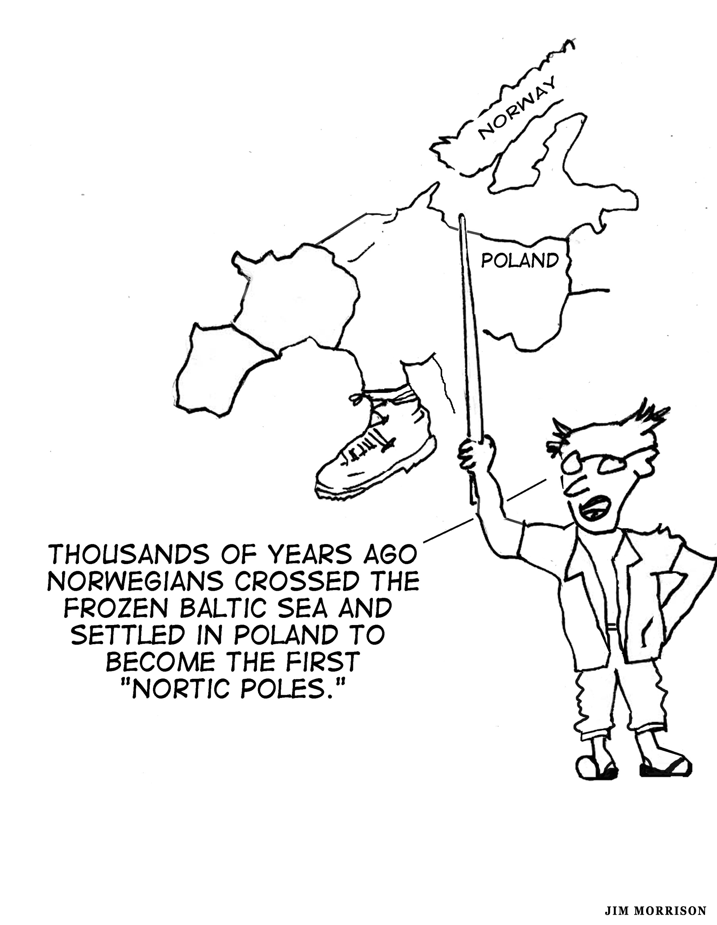

Author’s Experience Using Trekking Poles
Following years of habitually carrying an ice axe for mountaineering purposes, I got into the habit of taking my ice axe on day hikes and backpacking trips. One day I accidentally left my favorite hickory handled 1950s era ice axe at a trailhead. Not long after, I purchased a single Leki brand aluminum walking pole with a rounded palm knob to replace my ice axe (for hiking but not for mountaineering). This was well before pole use became a fad among many hikers. I grew very attached to that piece of equipment and would take it everywhere. A few years ago, I suffered a broken ankle that took several months to heal properly. After tossing away my crutches, I purchased a pair of “trekking poles” to increase stability and avoid further injury during my rehabilitation period. I have never looked back. I now take one of my several pairs of trekking poles everywhere. They have become as much a part of me as my boots and backpack.
I take my fixed length fiberglass poles when doing mostly trail travel and adjustable poles when going off-trail or alpine scrambling. The more I use them, the more reasons I seem to find to justify their use. I recently received a highly ornate wooden walking staff as a gift. I am looking forward to developing a close relationship with my walking staff on casual walks. So far, I have elicited admiring comments on every outing with my handsome walking staff in hand.

Some Issues Regarding Pole Design and Use
How Important Is Adjustability?
Trekking or Nordic Walking poles come as either non-adjustable fixed length or adjustable and collapsible two or three section poles. Which is best? The short answer is to start with adjustable poles to develop your poling techniques, to get a feel for the desired length(s) in different situations and to see which uses are most important. If you travel using public transportation, use them off-trail in brushy situations, use them for scrambling or climbing, or use them in place of tent poles, then adjustables are usually best. If your use is mostly on trails or you seldom need to adjust them, then fixed length poles will be lighter and will work well. They will not require any maintenance. Ideally, you will have more than one set of poles to pick from.
My personal experience is that I seldom feel a need to adjust my poles. However, I do change my technique a bit to apply the fixed length to the specific situation. I really like the feel of my super lightweight (5 ounces for the pair), carbon fiber, non-adjustable poles. I prefer them when they are a reasonable choice.

Baskets or No Baskets?
Using baskets on poles is a surprisingly controversial subject, except when there is significant snow cover. In terrain with a significant amount of soft snow, 3.5-4.5 inch diameter baskets are best. Even though largely a matter of personal taste and habit, a good case also can be made for attaching baskets in two other situations: (1) traveling off-trail on uneven surfaces; (2) traveling over significant amounts of mud or soft ground. On most three-season trips on varied terrain, small two-inch diameter baskets of minimum weight are a good compromise.
Regarding the first situation (off-trail), using a basket keeps the tips from getting caught in tight spots thus decreasing the risk of a breaking a tip as you walk past the pole and try to leverage it out. This is especially important on rocky surfaces. It is even more important with carbon fiber poles than with aluminum. Regarding the second situation (soft ground), baskets prevent the annoyance of repeatedly having to yank the pole out of crud. In either situation, baskets prevent the tips from going down too far, thus reducing the pole height and causing loss of efficiency or balance. Having said this, a good case can be made for going totally without baskets in more compacted snow conditions: “they disallow the pole’s use as a probe to determine snow density or snow bridge thickness, or to find air-filled ‘moats’ around rocks and trees” (Andrew Skurka, well known long distance hiker).

Use of Wrist Straps
There does not seem to be a consensus among experienced polers on this issue. However, some generalizations are in order. The more experienced one becomes in poling techniques, the more advantageous wrist straps can be, especially on relatively level ground. Straps can also be useful when there is a lot of uphill (using the straps rather than hand grip to lever oneself upward). Straps are quite useful when doing some hand-over-hand scrambling on steep terrain. However, even experienced polers find it difficult to fully utilize the wrist straps on relatively uneven terrain. Over long distances straps add some weight, another consideration. I own poles with and without straps and make my choices based largely on the terrain to be traveled.

One or Two Poles?
Stream crossings with strong, deep currents definitely favor two poles as do narrow log crossings. Trails with lots of brush favor one or no poles. Relatively level and smooth trails favor the rhythm of two poles (if proper poling techniques are used). Uneven off-trail terrain dictates two poles. A heavy load on relatively even terrain favors two poles. Steep side hilling favors one pole. Carrying an ice axe in addition to poles favors one pole or no poles. Ultralight hikers tend to favor no poles (although a pair of carbon fiber poles without straps or baskets can weigh less than six ounces per pair). The obvious conclusion to draw from this analysis is not to get fixated with carrying and using poles. Sometimes they can be quite useful and sometimes a real pain. Sometimes both poles go onto my pack. Sometimes I carry both in my hands, using neither. Sometimes I carry one and actively use one. Generally, using two poles is the most efficient and effective technique for most of my trips. To me using no poles or only one pole for hiking would be similar to using this combination for cross-country skiing (i.e., awkward). However, hike your own hike! Try different combinations. Be flexible!

Pole Weight and Strength
A pair of poles can weigh from five to twenty ounces or more. Weight depends primarily on the accessories and materials used in construction. Selecting a set of poles with regard to weight and strength is largely a subjective matter and also subject to economics, but there are some objective components to take into account: amount of off-trail travel; weight of the user; athleticism, agility and aggressiveness of the user. Most of these components (except athleticism and agility) potentially dictate choosing heavier and stronger poles. My personal experience suggests that a lightweight set of quality poles (5-10 ounces) is more than adequate for most users. If a pole breaks, it is usually not a disaster (unless one is an aggressive hiker doing some leaping and jumping with their poles). I personally love the feel, action and durability of my five-ounce poles.

Priorities For Pole Design
If the arguments in favor of using poles outweigh the cons (for at least some outings), check out the short article “Pole Styles and Designs.” In evaluating these designs, assume you might grow to like your poles so much that you eventually will have two or more sets of poles for different purposes.

Additional Issues for Reflection
- Is pole use in the backcountry mostly a matter of personal preference or are there good logical arguments on one side or the other?

- How important is poling technique? Is it more important on relatively even terrain and less so in rough terrain?

- When should I take poles and when is it best to leave them home? Are adjustable poles that will fit into or tie onto my pack the best compromise?

- How important is adjustability, especially after learning what pole length is optimum? How much maintenance is required with adjustable poles?

- What is the comparative strength of wood, aluminum, carbon fiber and titanium in trekking poles and staffs?

- How important is a lifetime warranty provided by some manufacturers? Are terrain, body weight and physical coordination critical factors in pole strength?

- How important is the swing weight of a set of poles? Do the lightweight carbon fiber poles have a distinct advantage in this area? How durable are fiberglass poles? Is durability more important than swing weight?

- What about ergonomically designed (usually angled) pole grips? What about poles that are right and left hand specific?

- What about wrist straps? What are their drawbacks? Best to have and use them most of the time? Best to have wrist straps that are easily removed?

- How important is pre-trip conditioning for poling? What kinds of upper body conditioning will transfer best to hiking with poles?

- Is it best to remove the baskets in most terrains, especially when there are no large amounts of snow, mud or sand?

