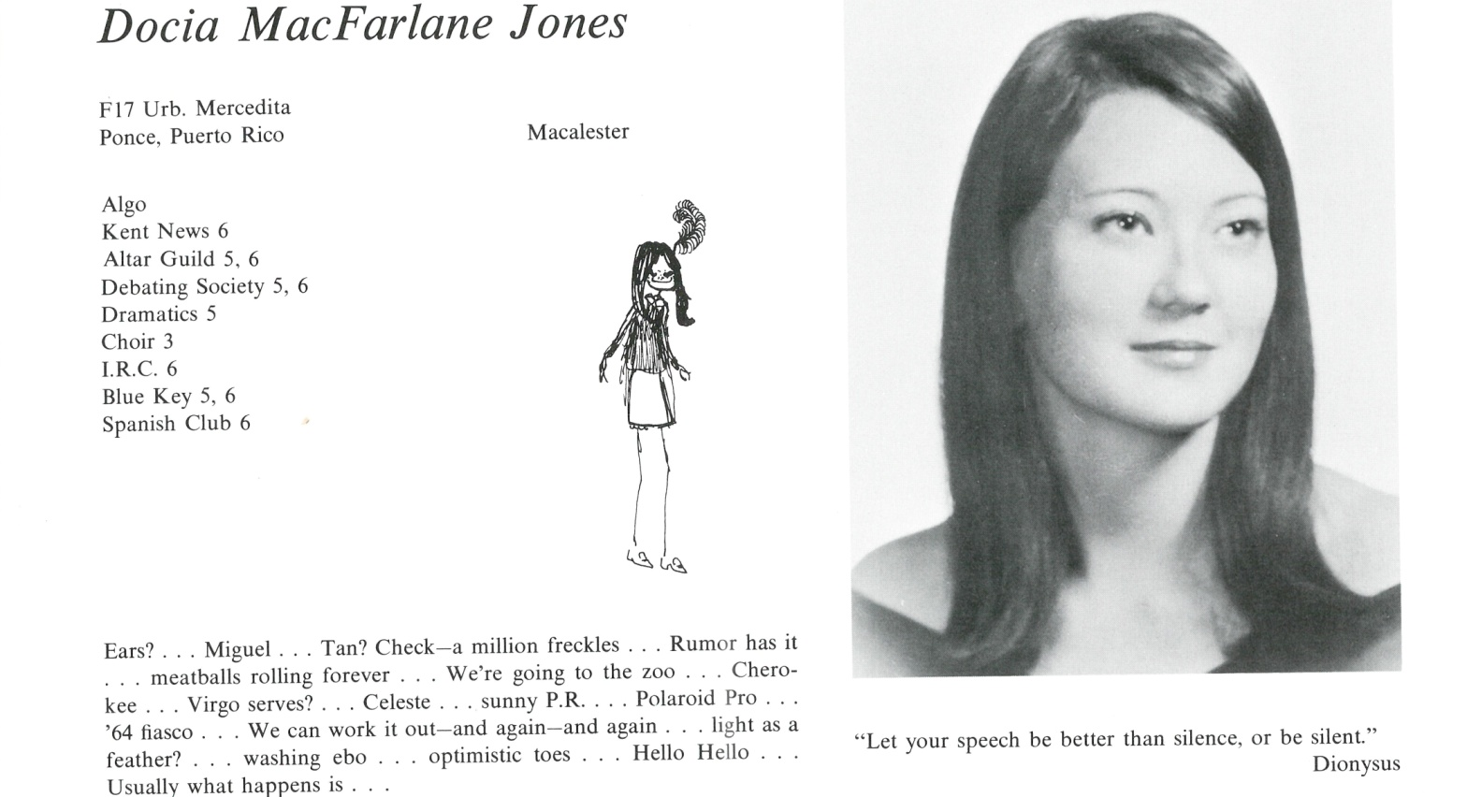

Docia M. Jones Reed

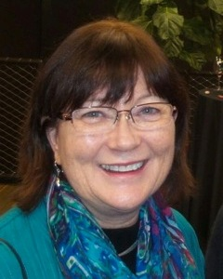It’s hard to believe that 50 years ago we were all lined up in our Kent blue blazers receiving our diplomas and then scattering to the four winds. 50 years in a nutshell? I’ll hit the highlights here, and we can swap details at the reunion.

After college in Minnesota (Macalester) I joined my family in Beirut, Lebanon. My subsequent 40+ years working in elementary education began with a teaching job in Jeddah, Saudi Arabia. After this life-changing desert experience, I hungered for a lush green European landscape; I met my first husband in Kaprun, Austria. Bitten by the same travel bug, we returned to the USA to save money for another lengthy adventure overseas. This time we headed west to Asia and eventually made it to Thailand.

I taught Third Grade at the International School in Bangkok, and my husband worked in a Thai-American law firm. After our daughter was born in 1979, we moved to Seattle where I taught kindergarten and co-directed a small growing school for many years. We divorced when our marriage could not adapt to our changes in lifestyle.

I later remarried, and by the time I was 50, I decided to refresh my education credentials at Harvard Graduate School and get my M. Ed. in Literacy Learning Disabilities. I somehow survived that intense experience as a middle-aged full-time student (thank-you Kent School grit), and after a grim year of family deaths and a crumbling marriage, I relocated permanently to New England.

For 16 years I have been enjoying my job as the Lower School Learning Resources Director at Shady Hill School in Cambridge. My daughter, Eudocia, lives in Minneapolis where she is attending graduate school for a degree in music therapy. Alas, no grandchildren, unless you count a furry feline (she’s cute!).

I continue to have a hefty wanderlust. Whenever retirement comes, I hope to indulge that passion more frequently. It’s true, sliding inexorably into “the next chapter” is daunting. Let’s stay grateful, hopeful, mirthful and sane!

Where to go next? … Suggestions are welcome!



______________________________________________________________

______________________________________________________________ ______________________________________________________________ ______________________________________________________________ ______________________________________________________________ ______________________________________________________________ ______________________________________________________________ ______________________________________________________________ ______________________________________________________________

Attach Picture in .jpg Format

______________________________________________________________

______________________________________________________________

___________________________________________________________________________________ _________________________________________________________________________________________________________________________________________________________________________________________________________________________________________________________________________________________________________________________________________________________________________________________________________________________________________________________________________________________________________________________________________________________________________________________________________________________________________________________________________________________________________________________________________________________________________________________________________________________________________________________________________________________________________________________________________________________________________________________________________________________________________________________________________________________________________________________________________________________________________________________________________________________________________________________________________________________________________________________________________________________________________________________________________________________________________________________________________________________________________________________________________________________________________________________________________________________________________

___________________________________________________________________________________