Eco Orca Class JUNE 2025 Ocean and Fantasy
SUNDAY |  |  | MONDAY | TUESDAY | WEDNESDAY | THURSDAY | FRIDAY | SATURDAY
 |  | 1 | 2 | 3 | 4 | 5 | 6 | 7
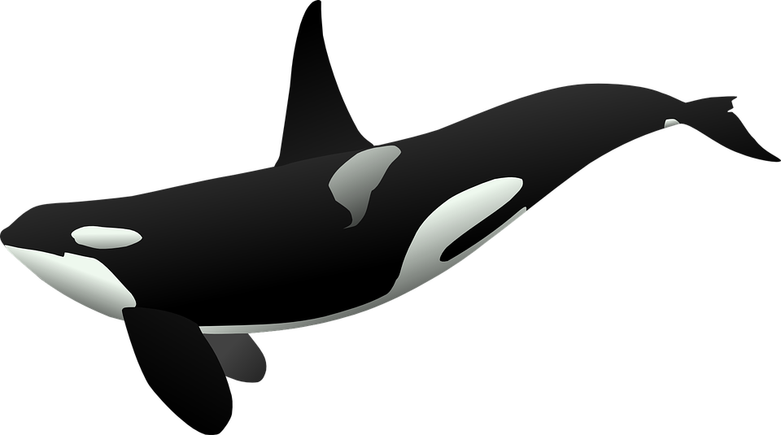 |  |  | Aylard Farm Beach | Coles Bay Beach | Willows Beach  Picture Day | Bamberton Beach | Butchart Garden $5
 | 8 |  | 9 | 10 | 11 | 12 | 13 | 14
 |  |  | Langford Water Park | Pirate Day  Gyro beach | Albert head  Beach | Super Hero Dress Up Day  Cook St Park | On site Water Play Day | 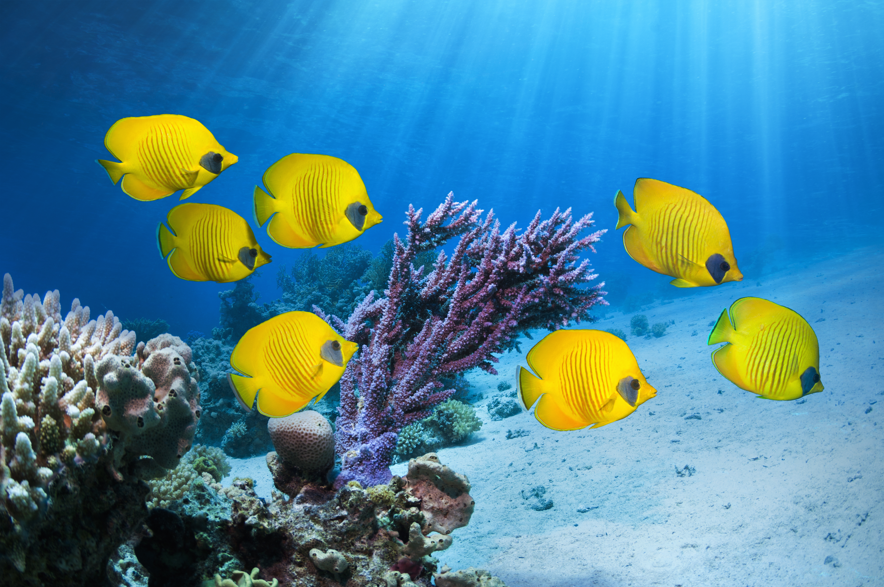
 | 15 |  | 16 | 17 | 18 | 19 | 20 | 21
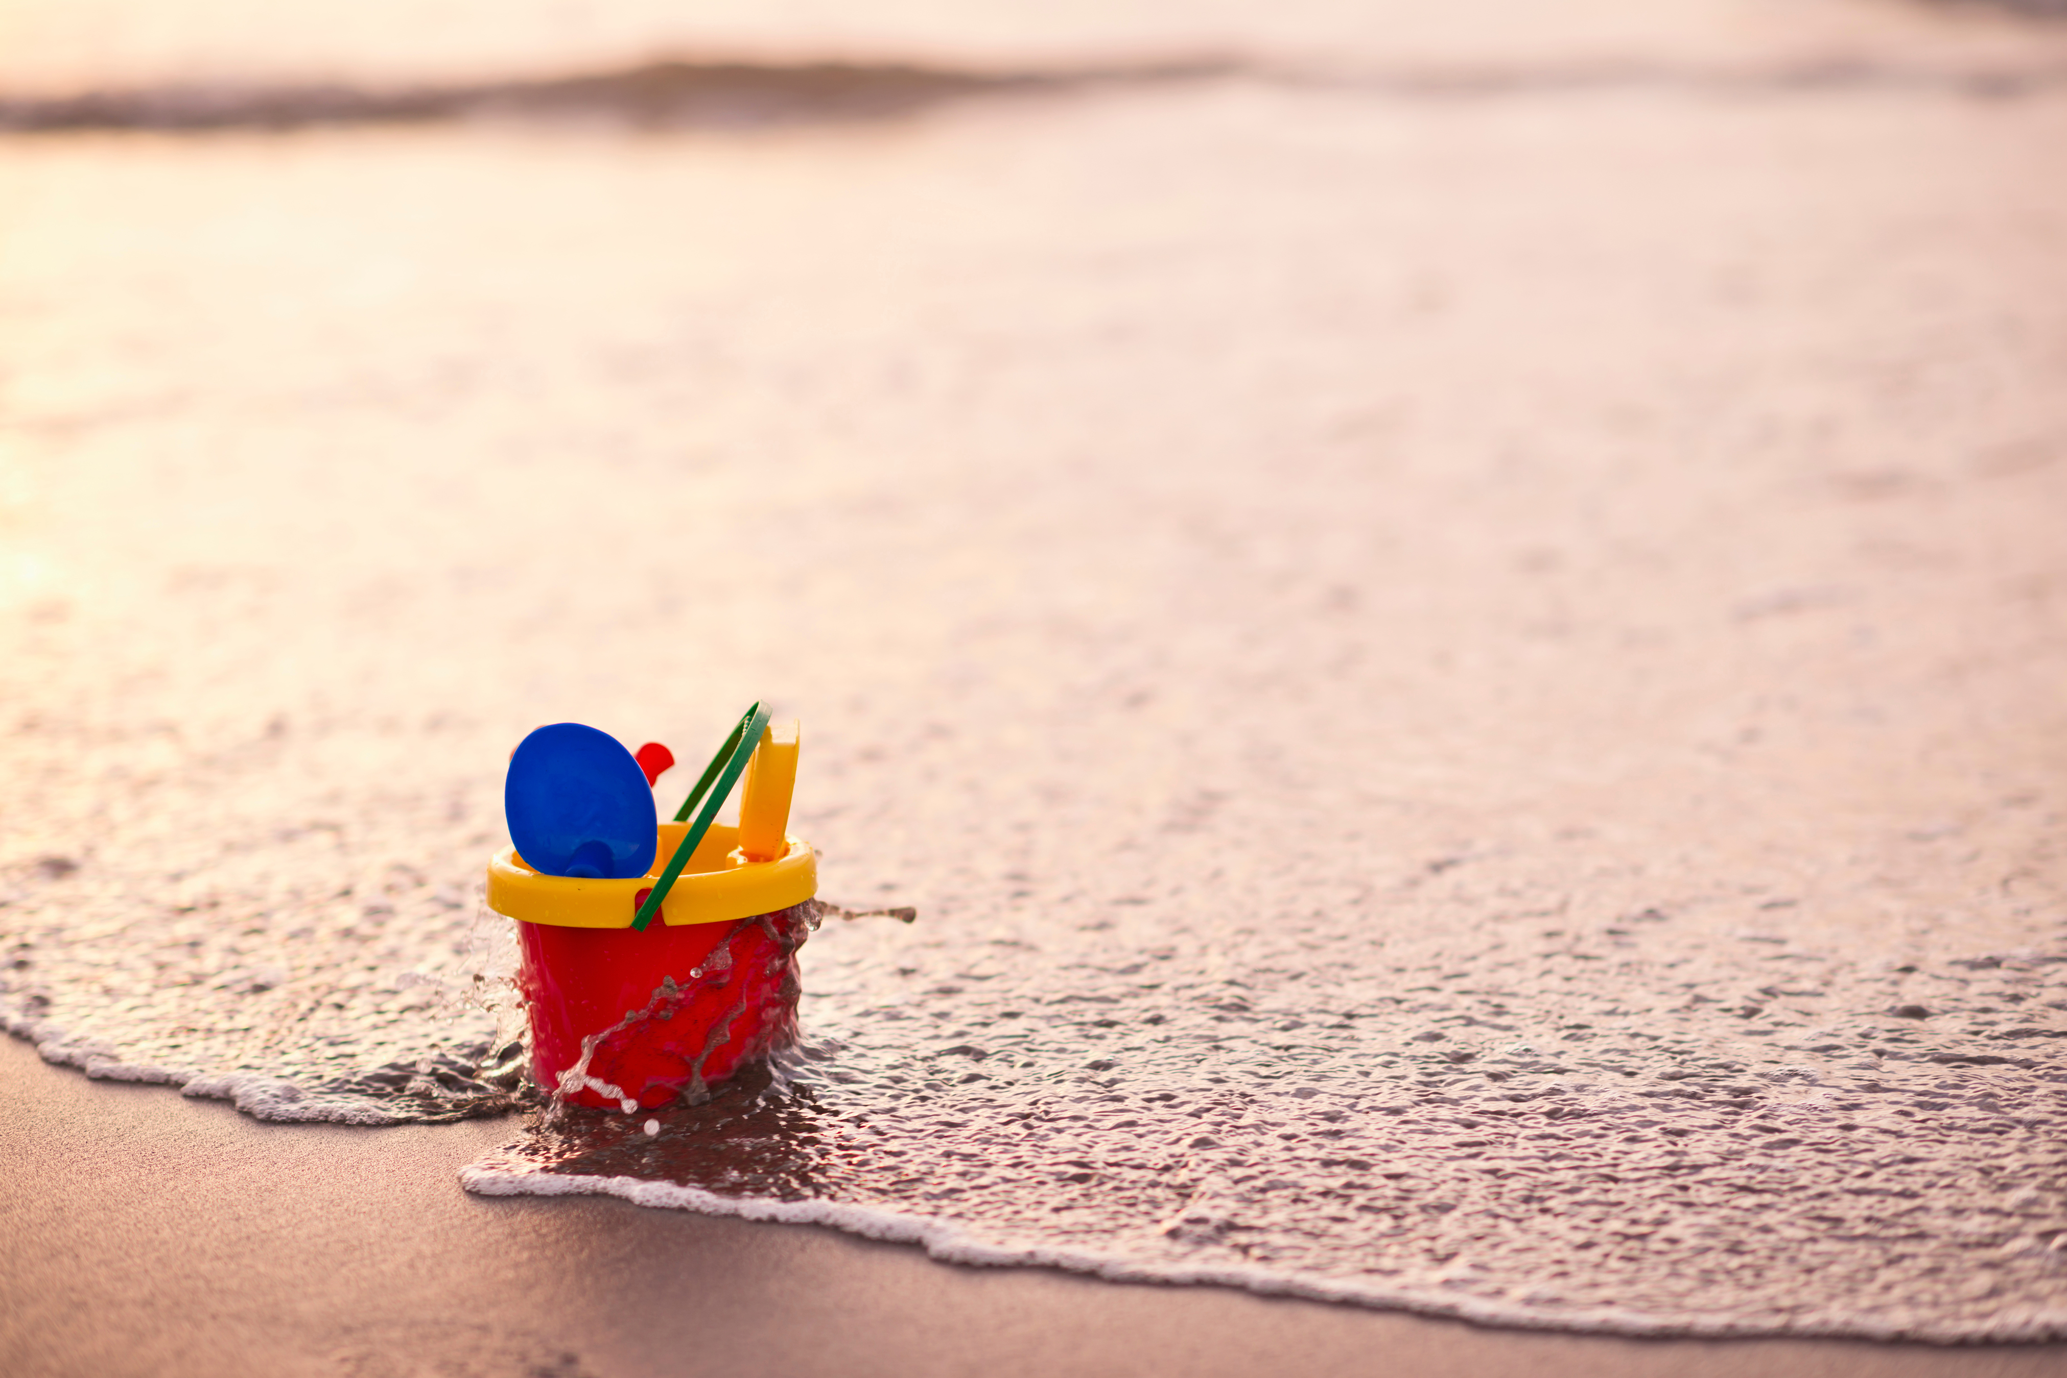 |  |  | Esquimalt Water Park | Royal Bay Beach and Park | Cloverdale Water Park | Ocean Discovery $5 | Fantasy Dress Up Day  Craigdarroch Castle $5
 | 22 |  | 23 | 24 | 25 | 26 | 27 | 28
 |  |  | Peter Pan Water Park | Central Saanich  Hotdog Day | Walking Trip | Graduation Day!  1PM | No Class  Pro-Day | 
 | 29 |  | 30 | 1 | 2 | 3 | 4 | 5

