**WELCOME TO**

**HOLY SPIRIT LUTHERAN CHURCH**

A Member of the Evangelical Lutheran Church in America, New Jersey Synod

1220 Bayshore Rd., Villas, NJ 08251, 609-886-2414,

holyspiritlutheran@comcast.net, holyspiritvillas.com, facebook.com/holyspiritvillas

Vicar Vince Piekarski can be contacted at any time for conversation or prayer through call or text at 412-225-0287, or through email at vpie8282@gmail.com.

**SUNDAY, MAY 18TH, 2025**

**FIFTH SUNDAY OF EASTER**

**10:30AM WORSHIP SERVICE WITH HOLY COMMUNIO****N** 



**MISSION STATEMENT**

We, the Evangelical Lutheran Church of the Holy Spirit, are People of God, who

are called by the Holy Spirit to pray, worship, joyfully proclaim Jesus Christ,

and compassionately witness and serve others in Christian Love.



We are glad that you joined us for Worship today! Thank you for enriching our time together! We would like to get to know you better, and we would like for you to get to know us better too. Brochures, welcome gifts, prayer shawls, Bibles, and other items are available at our welcome areas. Church members are happy to show you around and share about our ministries. Please don’t hesitate to speak up and ask questions. Please make sure you sign-in on our clipboard on the podium in the lobby.



Our Worship Services are conducted in coordination with our Conference Call.

Join us at 657-390-7423, and if that does not allow you to gain access utilize

701-802-5170, with access code 8221190#. You may need to dial 1 first depending on your phone plan. After logging in please announce your name and feel free to talk with others until we get started with our Worship Service.

**CANDLE MEMORIALS**

Candles cost $10 each. Sign-up sheets are located on the bulletin board between the church offices. Please feel free to see Vicar Vince with any questions.

**SANCTUARY CANDLE**

May’s is given to the Glory of God & in memory of

JEAN FARINA & WALT MILLER by Jean, Phil, & Bob Zimmerman.

**ALTAR CANDLES**

May’s are given to the Glory of God & in memory of

CATHY DAILY by Fran Green & Family.

**CONFERENCE CALL CHECK-IN**

(Roll Call and Attendance.)

**WELCOME & ANNOUNCEMENTS**

(Offered by Vicar, Assistant, and Congregation.)

**INTRODUCTION**

A. Easter initiates a new day. It anticipates a new heaven and a new earth. The risen

Christ is making all things new. In the mystery of holy baptism God has made

new people of us. Today Jesus invites us to see everyone in a new light—

through the lens of love.

(Assistant lights Altar Candles from the Paschal Candle.)

**PRELUDE**

(Music offered by our Organist before the start of our Worship Service.)

**Wonderful Words of Life**

**CHIMES**

(Music offered by our Organist before the start of our Worship Service.)

**Blessed Assurance**

(We invite you to stand as you are able.)

**THANKSGIVING FOR BAPTISM**

(All may make the sign of the cross, the sign that is marked at baptism.)

V. Alleluia! Christ is risen.

**C. Christ is risen, indeed. Alleluia!**

V. In the name of **☩** the One

who was, who is, and who is to come.

**C. Amen.**

V. Baptized into Christ’s death and resurrection,

and called to live the baptized life,

let us give thanks for the gifts of baptism.

V. Holy God,

we give you thanks for the waters of baptism,

waters that make a people your own,

that restore to wholeness,

and empower us to be witnesses in your name.

Baptized into you, O Living One,

**C. make us one as you are one.**

V. We give you thanks for the waters of baptism,

waters that strengthen believers

and give new life to beloved servants of your church;

waters that extend your boundless love

and cross barriers of our own making.

Baptized into you, O Living One,

**C. make us one as you are one.**

V. We give you thanks for the waters of baptism,

waters that open the hearts of believers

and give a voice in the night to those in captivity;

waters that set your people on a new path,

rejoicing in the Spirit’s power.

Baptized into you, O Living One,

**C. make us one as you are one.**

V. Grant us grace, love, and life, O Living One,

that our every day is shaped by these waters

that give us our very lives in you.

We ask this in the name of Jesus, the Crucified and Risen One.

**C. Amen.**

**BRIEF ORDER FOR CONFESSION AND FORGIVENESS**

V. God hears us when we cry, and draws us close in Jesus Christ. Let us return to

the one who is full of compassion.

(Silence is kept for reflection.)

V. Fountain of living water,

**C. pour out your mercy over us. Our sin is heavy, and we long to be free.**

**Rebuild what we have ruined and mend what we have torn. Wash us in your**

**cleansing flood. Make us alive in the Spirit to follow in the way of Jesus, as**

**healers and restorers of the world you so love. Amen.**

V. Beloved, God’s word never fails. The promise rests on grace: by the saving love

of Jesus Christ, the wisdom and power of God, **☩** your sins are forgiven, and God

remembers them no more. Journey in the way of Jesus.

**C. Amen.**

**GATHERING HYMN**

(We invite you to sing along with the music offered by our Organist.)

Lutheran Book of Worship—Green Book

**175—Ye Watchers and Ye Holy Ones**

**APOSTOLIC GREETING**

V. May the grace of our Lord Jesus Christ, the love of God,

and the communion of the Holy Spirit be with you all.

**C. And also with you.**

**KYRIE**

V. In peace, let us pray to the Lord.

**C. Lord, have mercy.**

V. For the peace from above, and for our salvation, let us pray to the Lord.

**C. Lord, have mercy.**

V. For the peace of the whole world, for the well-being of the church of God,

and for the unity of all, let us pray to the Lord.

**C. Lord, have mercy.**

V. For this holy house, and for all who offer here their worship and praise,

let us pray to the Lord.

**C. Lord, have mercy.**

V. Help, save, comfort, and defend us, gracious Lord.

**C. Amen.**

**HYMN OF PRAISE**

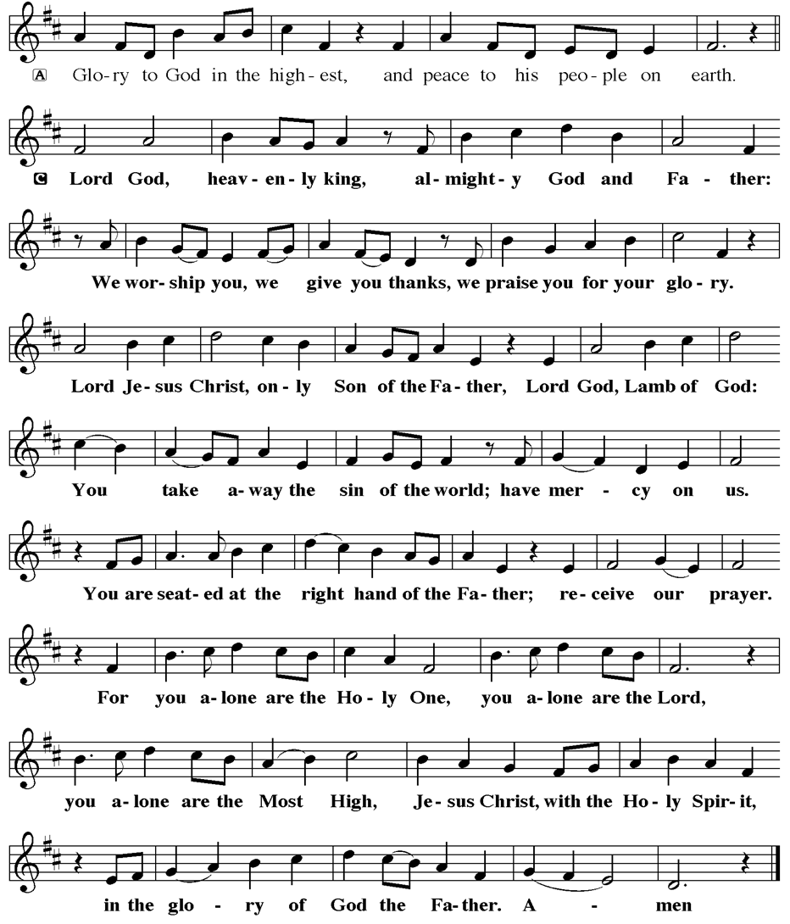

**PRAYER OF THE DAY**

V. The Lord be with you.

**C. And also with you.**

V. Let us pray,

O Lord God, you teach us that without love, our actions gain nothing. Pour into

our hearts your most excellent gift of love, that, made alive by your Spirit, we may

know goodness and peace, through your Son, Jesus Christ, our Savior and Lord,

who lives and reigns with you and the Holy Spirit, one God, now and forever.

**C. Amen.**

(We invite you to be seated for our Readings and Psalm.)

**FIRST READING**

In defense of his earlier baptism of non-Jewish believers, Peter demonstrates to

the members of the Jerusalem church that God’s intention to love Gentiles as

well as Jews is revealed in Jesus’ testimony. In this way the mission to the

Gentiles is officially authorized.

R. Our First Reading is from the 11th Chapter of Acts (Verses 1-18).

R. 1 Now the apostles and the brothers and sisters who were in Judea heard that the

gentiles had also accepted the word of God. 2 So when Peter went up to

Jerusalem, the circumcised believers criticized him, 3 saying, “Why did you go to

uncircumcised men and eat with them?” 4 Then Peter began to explain it to them,

step by step, saying, 5 “I was in the city of Joppa praying, and in a trance I saw a

vision. There was something like a large sheet coming down from heaven, being

lowered by its four corners, and it came close to me. 6 As I looked at it closely I

saw four-footed animals, beasts of prey, reptiles, and birds of the air. 7 I also

heard a voice saying to me, ‘Get up, Peter; kill and eat.’ 8 But I replied, ‘By no

means, Lord, for nothing profane or unclean has ever entered my mouth.’ 9 But a

second time the voice answered from heaven, ‘What God has made clean, you

must not call profane.’ 10 This happened three times; then everything was pulled

up again to heaven. 11 At that very moment three men, sent to me from

Caesarea, arrived at the house where we were. 12 The Spirit told me to go with

them and not to make a distinction between them and us. These six brothers also

accompanied me, and we entered the man’s house. 13 He told us how he had

seen the angel standing in his house and saying, ‘Send to Joppa and bring

Simon, who is called Peter; 14 he will give you a message by which you and your

entire household will be saved.’ 15 And as I began to speak, the Holy Spirit fell

upon them just as it had upon us at the beginning. 16 And I remembered the word

of the Lord, how he had said, ‘John baptized with water, but you will be baptized

with the Holy Spirit.’ 17 If then God gave them the same gift that he gave us when

we believed in the Lord Jesus Christ, who was I that I could hinder God?”

18 When they heard this, they were silenced. And they praised God, saying,

“Then God has given even to the gentiles the repentance that leads to life.”

R. This is the Word of the Lord.

**C. Thanks be to God.**

**PSALM**

R. Our Responsorial Psalm is from the 148th Psalm.

**C.** **The splendor of the Lord is over earth and heaven.** (Ps. 148:13)

R. 1 Hallelujah! Praise the Lord from the heavens;

   praise God in the heights.

  2 Praise the Lord, all you angels;

   sing praise, all you hosts of heaven.

  3 Praise the Lord, sun and moon;

   sing praise, all you shining stars.

  4 Praise the Lord, heaven of heavens,

   and you waters above the heavens.

  5 Let them praise the name of the Lord,

   who commanded, and they were created,

  6 who made them stand fast forever and ever,

   giving them a law that shall not pass away.

**C. The splendor of the Lord is over earth and heaven.** (Ps. 148:13)

R. 7 Praise the Lord from the earth,

   you sea monsters and all deeps;

  8 fire and hail, snow and fog,

   tempestuous wind, doing God’s will;

  9 mountains and all hills,

   fruit trees and all cedars;

  10 wild beasts and all cattle,

   creeping things and flying birds;

  11 sovereigns of the earth and all peoples,

   princes and all rulers of the world;

  12 young men and maidens,

   old and young together.

**C. The splendor of the Lord is over earth and heaven.** (Ps. 148:13)

R. 13 Let them praise the name of the Lord,

   whose name only is exalted, whose splendor is over earth and heaven.

  14 The Lord has raised up strength for the people and praise for all faithful

servants, the children of Israel, a people who are near the Lord. Hallelujah!

**C. The splendor of the Lord is over earth and heaven.** (Ps. 148:13)

**SECOND READING**

John’s vision shows us that in the resurrection the new age has dawned; God

dwells with us already. Yet we wait for the time when the tears that cloud our

vision will be wiped away. Then we will see the new heaven, new earth, and new

Jerusalem.

R. Our Second Reading is from the 21st Chapter of Revelation (Verses 1-6).

R. 1 I saw a new heaven and a new earth, for the first heaven and the first earth had

passed away, and the sea was no more. 2 And I saw the holy city, the new

Jerusalem, coming down out of heaven from God, prepared as a bride adorned

for her husband. 3 And I heard a loud voice from the throne saying,

  “See, the home of God is among mortals.

  He will dwell with them;

  they will be his peoples,

  and God himself will be with them and be their God;

  4 he will wipe every tear from their eyes.

  Death will be no more;

  mourning and crying and pain will be no more,

  for the first things have passed away.”

5 And the one who was seated on the throne said, “See, I am making all things

new.” Also he said, “Write this, for these words are trustworthy and true.” 6 Then

he said to me, “It is done! I am the Alpha and the Omega, the Beginning and the

End. To the thirsty I will give water as a gift from the spring of the water of life.”

R. This is the Word of the Lord.

**C. Thanks be to God.**

V. I invite you to stand as you are able, and I invite you to announce the Gospel

Acclamation with me.

**GOSPEL ACCLAMATION**

**C.** **Alleluia. Everyone will know that you are my disciples if you have love for**

**one another. Alleluia.** (John 13:35)

**GOSPEL READING**

After washing the disciples’ feet, predicting his betrayal, and then revealing his

betrayer, Jesus speaks of his glorification on the cross. This deep complicated

love of Jesus, even to death on the cross, will be the distinctive mark of Jesus’

community.

V. The Holy Gospel According to John, the 13th Chapter (Verses 31-35).

**C. Glory to you, O Lord.**

V. 31 When he had gone out, Jesus said, “Now the Son of Man has been glorified,

and God has been glorified in him. 32 If God has been glorified in him, God will

also glorify him in himself and will glorify him at once. 33 Little children, I am with

you only a little longer. You will look for me, and as I said to the Jews so now I

say to you, ‘Where I am going, you cannot come.’ 34 I give you a new

commandment, that you love one another. Just as I have loved you, you also

should love one another. 35 By this everyone will know that you are my disciples,

if you have love for one another.”

V. This is the Gospel of the Lord,

**C. Praise to you, O Christ.**

**SERMON**

(Delivered by Vicar Vince Piekarski.)

(Following the Sermon, we invite you to stand as you are able.)

**HYMN OF THE DAY**

(We invite you to sing along with the music offered by our Organist.)

Evangelical Lutheran Worship

**437—On Jordan's Stormy Bank I Stand**

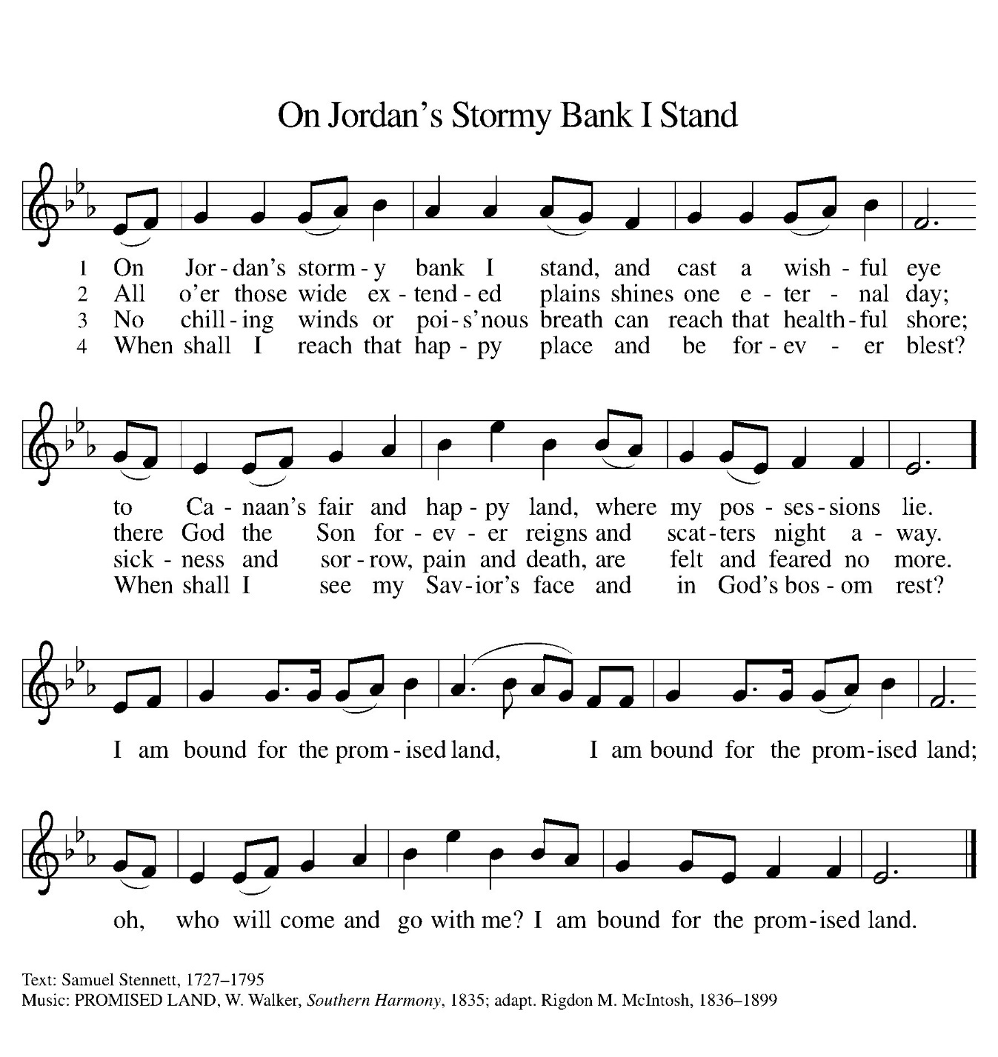

**APOSTLES’ CREED**

V. God has made us his people through our Baptism into Christ. Living together in

trust and hope let us confess our faith together using the Apostles’ Creed.

**C. I believe in God, the Father almighty,**

**creator of heaven and earth.**

**I believe in Jesus Christ, God’s only Son, our Lord,**

**who was conceived by the Holy Spirit,**

**born of the Virgin Mary,**

**suffered under Pontius Pilate,**

**was crucified, died, and was buried;**

**he descended to the dead.**

**On the third day he rose again;**

**he ascended into heaven,**

**he is seated at the right hand of the Father,**

**and he will come to judge the living and the dead.**

**I believe in the Holy Spirit,**

**the holy catholic church,**

**the communion of saints,**

**the forgiveness of sins,**

**the resurrection of the body,**

**and the life everlasting. Amen.**

**PRAYERS OF INTERCESSION**

(The prayers are prepared locally for each occasion.)

V. God of resurrection and new life, we come before you in prayer for the church, the

world, and all who are in need.

(A brief silence.)

A. Fill the church with the spirit of your redeeming love. Make us steadfast in our

proclamation of your grace for all people without exceptions, especially those

often overlooked in our communities. Hear us, O God.

**C. Your mercy is great.**

A. Awaken joy in the beauty and abundance of your creation. Show us the wonder of

your presence from the smallest flower to the tallest tree. Recommit us to

preservation of wild places. Hear us, O God.

**C. Your mercy is great.**

A. Instruct all world leaders to protect the most vulnerable among us. Guide those in

power toward equitable and just economic policies, so that all might have

sufficient resources to live safely and with dignity. Hear us, O God.

**C. Your mercy is great.**

A. Pour out your love on all in need of care: those mourning losses, enduring

trauma, experiencing broken relationships, yearning for companionship, or facing

illness; especially:

BettyAnn Rich-White (Church Member)

Chip & Marie Hand (Church Member)

Lynn Bargstadt (Church Member)

Frank & Sharon Ford (Church Member)

Carol Amundsen (Church Member)

Kim McGinley (Church Member)

Judy Brannan (Church Member)

Blanche Cameron (Church Member)

Joan Sommerman (Church Family)

Arleen Kinka (Church Family)

Rick Lang (Church Family)

Suzie Clark (Rose Lang's Friend)

Francis Clock (Dianna DeNote’s Family)

Andrew Hudak (Rose Lang’s Friend)

Viena Murtha (Bob Fritsch’s Friend)

Sharon Waicus (Skip & Bonnie Millard's Friend)

Karen O'Brien (Paul Bowker's Friend)

Dustin Irizzary (Mary Melnicoff's Family)

The Bryan Family (Wanda Bryan's Family)

Craig Brearey (Judy Brannan & Mary Melnicoff's Friend)

Sarah Dutton (Frank & Sharon Ford's Family)

Christina McNasby (Fran Green’s Family)

The Kinkson Family (Judy Brannan's Friends)

Mark Stephen Dennis (Diana DeNote's Family)

Bill Lodge (Skip & Bonnie Millard's Friend)

Patrick & Denise Brannan (Judy Brannan's Family)

Ron Anderson (Bill Kelly's Friend)

Pat Labrae (Kathy Poehler's Friend)

Bud Brearey (Judy Brannan & Mary Melnicoff's Friend)

Mary Skain (Kathy Poehler's Friend)

Bill Rand (Wayne & Eleanor Rand's Family)

Kevin Naylor (Vicki Rinier's Friend)

Robert Chaplin (Mary Melnicoff's Friend)

Jack Wieckouski (Theresa & Kim McGinley's Family)

Carolyn Santarpio (Bob Fritsch's Friend)

Cathy Hines (Rose Lang's Friend)

Ken Mortensen (Del McKenna's Family)

Harry (Judy Brannan's Friend)

Janet K (Philomena Noak's Friend)

Michael Hart (Diana DeNote's Friend)

Rocco Leonard DeNote (Diana DeNote's Family)

Julie Schlereth (Diana DeNote's Friend)

Al Singer & Family (Frank & Sharon Ford's Friends)

Sherri Lynn (Bob Fritsch's Friend)

John Bannco (Bob Fritsch's Friend)

Nancy Pazarinie (Bob Fritsch's Family)

Jane & Paul Eiben (Rose Lang's Friend)

Joe DiMassimo (Judy Brannan & Mary Melnicoff's Friend)

Tommy Stanford (Sue Waltz's Family)

Audrey McAlister (Sue Waltz's Family)

Joe Waltz (Sue Waltz's Family)

Ronald Velli (Kathy Poehler's Friend)

Denny Papst (Rose Lang’s Friend)

Mike Rhoades (Rose Lang’s Friend)

Jannet Paynter (Leon Stitt’s Friend)

Chris (Judy Brannan's Friend)

Carla Krouse (Skip & Bonnie Millard's Friend)

Helen Ehlers (Judy Brannan's Friend)

Hailey (Fran Green's Friend)

Emily Delaney (Kathy Poehler's Family)

Leanne Bueth (Joan Kilcoyne's Family)

Janett MacFarlane (Carol Amundsen's Friend)

Joe Smith (Heather & Vicar Vince Piekarski’s Family)

Mark DeFrancisis (Vicar Vince Piekarski’s Friend)

Patrick Davenport (Sue Waltz's Friend)

Sonja Anderson (Theresa & Kim McGinley's Family)

Thish Kelly (Theresa & Kim McGinley's Family)

Chuck (Community Member)

Susan Callahan (Skip & Bonnie Millard's Family)

Bill Garrison (Mike Millard's Friend)

Joanne Shipper (Del McKenna's Family)

Edward Chapleski (Allison Call's Family)

Paul Cibiliew (Vincent Bruno's Friend)

Rob Rech (Heather Piekarski's Friend)

Mary March (Skip & Bonnie Millard's Friend)

Scott Levin (Rose Lang's Friend)

Anthony DeLuca (Church Member)

(Additional Names Added Prior to the Worship Service.)

A. Wipe away every tear. Hear us, O God.

**C. Your mercy is great.**

A. Abide with all who are victims of racism, especially people who are doubly

marginalized because of gender, sexuality, or ability. Destroy all forms of

systemic oppression, and renew our commitment to healing the wounds of our

collective body in this community and beyond. Hear us, O God.

**C. Your mercy is great.**

A. We give thanks for all the saints whose lives bear witness to your redeeming love.

Guide us by their example, until we join them in your eternal home. Hear us, O

God.

**C. Your mercy is great.**

(Here other intercessions may be offered.)

V. Watch over all of us who are worried and suffering, and especially those whose

names we now say aloud or hold within our hearts (pause). Hear us, O God.

**C. Your mercy is great.**

V. We commend these and all our prayers to you, O God, trusting that you are

always with us; in the name of Jesus Christ, our risen Savior.

**C. Amen.**

**SHARING OF THE PEACE**

V. May the peace of the Lord be with you always.

**C. And also with you.**

V. Let us share God’s Peace with one another.

(Please remain in your pews and offer the sign of peace with a peace sign or wave.)



(Following the Sharing of the Peace, we invite you to be seated.)

**OFFERING**

V. We now worship God with our tithes and offerings, wine and bread for use in holy

communion, and monetary gifts to support our ministry for service in God’s name.

Our Ushers will be around to your pews to pass the Offering Plates.

(Ushers come forward to get the Offering Plates from the Assistant.)

(Vicar and Assistant prepare the Altar for Communion.)

**OFFERING SONG**

(We invite you to sing along with the music offered by our Organist.)

Evangelical Lutheran Worship

**857—Lord, I Lift Your Name on High**

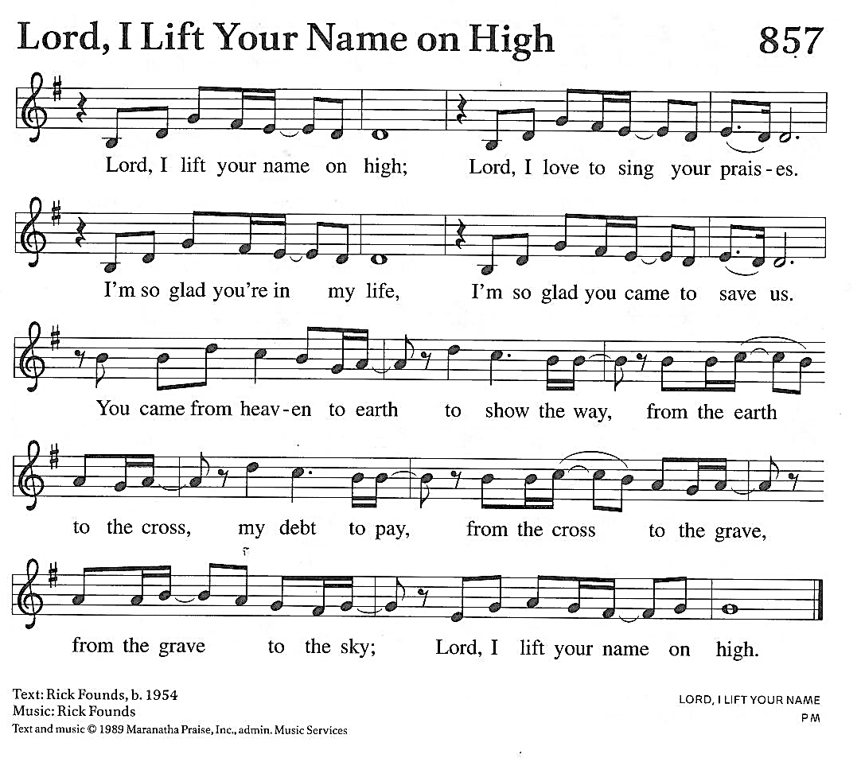

(Usher(s) brings the Tithes and Offerings up front to the Assistant.)

(We invite you to stand as you are able.)

**OFFERING PRAYER**

V. Let us pray,

Risen One,

you have gathered us around your table of grace

along with these gifts we bring.

Come among us again,

breathe your life into us,

and enliven us with this meal,

that we may live as your risen body in the world.

**C. Amen.**

**GREAT THANKSGIVING**

V. The Lord be with you.

**C. And also with you.**

V. Lift up your hearts.

**C. We lift them to the Lord.**

V. Let us give thanks to the Lord our God.

**C. It is right to give him thanks and praise.**

V. It is indeed right and salutary that we should at all times and in all places offer

thanks and praise to you, O Lord, holy Father, almighty and everliving God. But

chiefly we are bound to praise you for the glorious resurrection of our Lord; for he

is the true Passover Lamb who gave himself to take away our sin, who by his

death has destroyed death, and by his rising has brought us to eternal life. And

so, with Mary Magdalene and Peter and all the witnesses of the resurrection, with

earth and sea and all their creatures, and with angels and archangels, cherubim

and seraphim, we praise your name and join their unending hymn:

**SANCTUS**

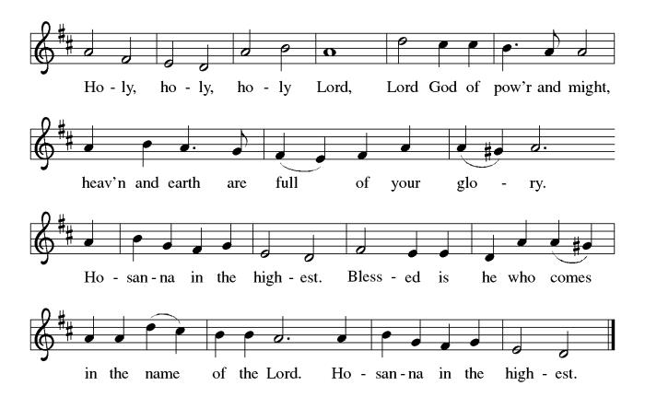

**THE EUCHARISTIC PRAYER**

V. Blessed are you, Lord of heaven and earth, in mercy for our fallen world you gave

your only Son, that all those who believe in Him should not perish, but have

eternal life. We give thanks to you for the salvation you have prepared for us

through Jesus Christ. Send now your Holy Spirit into our hearts that we may

receive our Lord with a living faith as He comes to us in His holy supper.

**C. Amen. Come, Lord Jesus.**

V. In the night in which he was betrayed our Lord Jesus took bread,

he gave thanks; broke it, and gave it to his disciples, saying:

*Take and eat; this is my body, given for you.*

*Do this for the remembrance of me.*

V. Again, after supper, He took the cup, he gave thanks,

and gave it for all to drink, saying:

*This cup is the new covenant in my blood,*

*shed for you and for all people for the forgiveness of sin.*

*Do this for the remembrance of me.*

**THE LORD’S PRAYER**

(We ring the bell throughout the Lord’s Prayer at all services to

invite those in the community to join in praying the Lord’s Prayer.)

V. May we now join with one another and pray together as Jesus has taught us.

**C. Our Father, who art in heaven, hallowed be thy name, thy kingdom come,**

**thy will be done, on earth as it is in heaven. Give us this day our daily**

**bread; and forgive us our trespasses, as we forgive those who trespass**

**against us; and lead us not into temptation, but deliver us from evil. For**

**thine is the kingdom, and the power, and the glory, forever and ever.**

**Amen.**

**LAMB OF GOD**

**C:\Users\Vince and Heather\Downloads\Lamb of God, ELW Setting Four (Melody).tif**

(We invite you to be seated.)

**HOLY COMMUNION**

V. Communion here is pretty simple, and all who believe in Jesus Christ are

welcome at this very table.

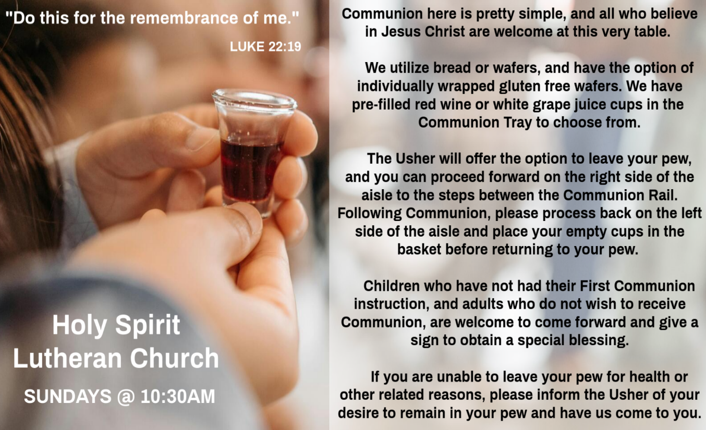

**INVITATION TO COMMUNION**

V. Come to the table of grace. Receive the gift of new life.

**C. Amen.**

(Distribution of Holy Communion)

**COMMUNION HYMN**

(Please enjoy various music offered by our Organist during your

quiet time, prayer, and reflection following Holy Communion.)

(Vicar and Assistant remove Communion Vessels from the Altar.)

(We invite you to stand as you are able.)

**POST COMMUNION BLESSING**

V. May the body and blood of our Lord Jesus Christ strengthen us and keep us

always in His grace.

**C. Amen.**

**POST COMMUNION CANTICLE**

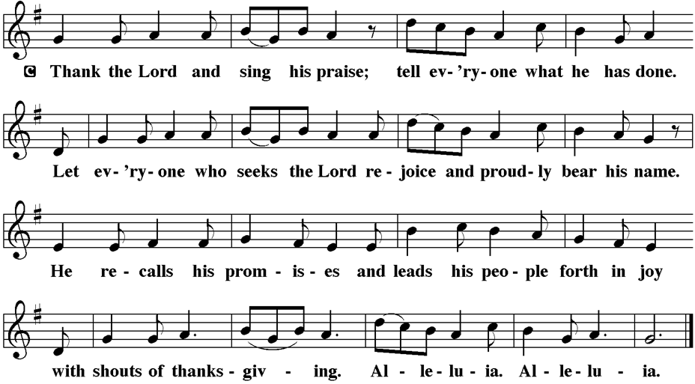



**PRAYER AFTER COMMUNION**

A. Let us pray,

Living One,

in this feast you have made yourself known to us.

Send us now to tell of your wonders,

sing of your glory,

and proclaim your risen life

to a wounded and weary world.

**C. Amen.**

**BLESSING**

V. The triune God,

who was, who is, and who is to come,

Sovereign, **☩** Savior, and Spirit,

light your way with resurrection dawn,

now and always.

**C. Amen.**

**SENDING HYMN**

(We invite you to sing along with the music offered by our Organist.)

Evangelical Lutheran Worship

**453—Baptized and Set Free**

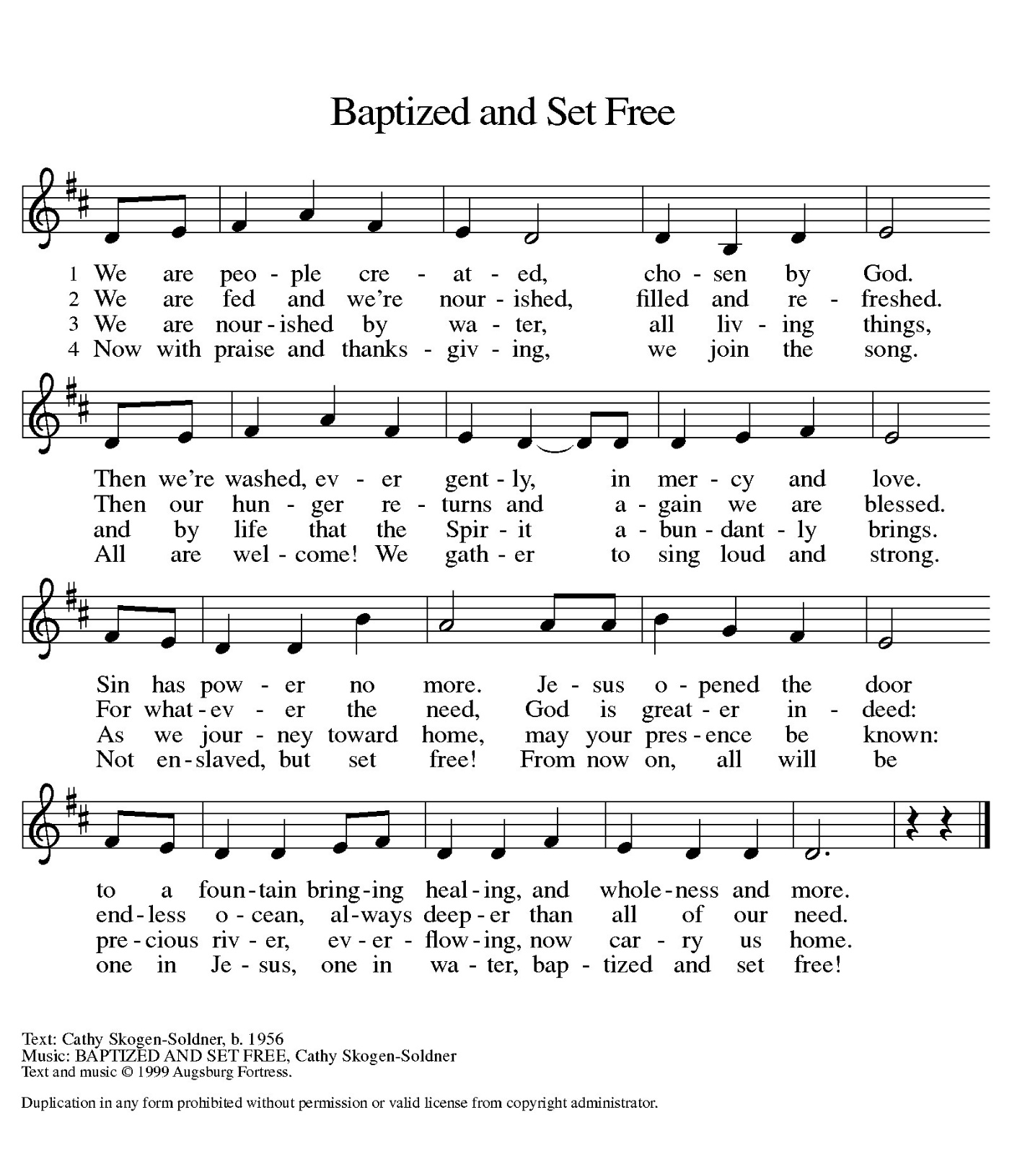

(Assistant extinguishes only the Altar Candles half way through the Sending Hymn.)

(The Paschal Candle remains lit.)

(Vicar processes out once the Altar Candles have been extinguished.)

(We invite you to be seated.)

**BIRTHDAYS, ANNIVERSARIES, & ANNOUNCEMENTS**

(Offered by Assistant and Congregation.)

**BIRTHDAYS**

18th Colin McGinn

22nd Fran Green

**DISMISSAL**

A. Alleluia! Christ is risen.

**C. Christ is risen indeed. Alleluia!**

A. Go in peace. In Christ you are made new. Alleluia! Alleluia!

**C. Thanks be to God. Alleluia! Alleluia!**

**POSTLUDE**

(Music offered by our Organist as we depart following our Worship Service.)

**Trust and Obey**

**LICENSES & EXPIRATION DATES**

Worship Service Content is used via permission through Augsburg Fortress Liturgies Annual License #SB144368. The next Subscription Renewal Date is 2/28/2026.

Our Hymns and Worship Music are used via permission through CCLI One

License #11327166. The next Subscription Renewal Date is 1/31/2026.



|  |  |
| --- | --- |
| **2025 FINANCIAL STANDING** | |
| **APRIL INCOME** | $4,528.00 |
| **APRIL SPENDING** | $7,167.69 |
| **APRIL GAIN OR (LOSS)** | ($2,639.69) |
| **2025 INCOME** | $24,664.00 |
| **2025 SPENDING** | $29,570.12 |
| **2025 GAIN OR (LOSS)** | ($4,906.12) |
| **ED GREEN CAPITAL IMPROVEMENT FUND** | $12,500.55 |
| **FOOD PANTRY FUND (SOCIAL MINISTRY)** | $12,435.72 |
| **CD** | $25,746.74 |
| **75TH ANNIVERSARY** | $3,122.41 |



**WHAT IS THE EVANGELICAL LUTHERAN CHURCH IN AMERICA?**

The ELCA was formed in 1987 by the merger of three Lutheran Church bodies –

the ALC (American Lutheran Church), the LCA (Lutheran Church in America),

and the AELC (Association of Evangelical Lutheran Churches).

To learn more, go to the ELCA's website at www.elca.org.

**WHAT IS THE NEW JERSEY SYNOD?**

The New Jersey Synod is a geographical grouping of Evangelical Lutheran Church in America (ELCA) congregations that share the mission and ministry of the Church on the New Jersey territory. It is one of 65 synods in the ELCA. The NJ Synod is comprised of 146 congregations, which include over 45,000 baptized members.



**WORSHIP MINISTRY**

The most important thing we do each week is gather together as God's people to worship. God is the center and focus of everything we do. Participating in worship is active. Liturgy means the work and actions of the people gathered. Everything we do during the week to prepare for worship, and everything we do as we assist in leading worship is important. We are thankful for all the wonderful work being done. If you are interested in any position let Vicar Vince know so a training can be set-up.

Sign-up sheets are located on the bulletin board between the church offices.



**COFFEE HOUR**

The Women of the Church will be hosting our monthly Coffee Hour **TODAY,** **Sunday, May 18th**, following our Worship Service. See Judy or Kathy for more info.

**CHURCH COUNCIL**

Share your comments, concerns, questions, or joys with one of our Church Council Members who can bring them back to our meetings. Visitors are always welcome to attend and listen to what is going on in and around the church. Join us In- Person or on our Conference Call at our next Meeting on **Tuesday, May 20th, at 6PM**.

**BULLETIN ENTRY DEADLINE**

The Bulletin will be printed on **TUESDAY** during Church Office Hours. Changes

need to be submitted to Vicar Vince or Heather no later than **TUESDAY by 4PM**.

**CHURCH OFFICE**

Open **TUESDAY from 6PM to 8PM** to serve the Congregation, the Community,

and to continue handling the business of the Church. Feel free to stop in to talk,

pick-up or drop off something, pray in the Sanctuary, or for whatever reason.

**FOOD PANTRY**

**Open every Thursday**, and the **last Saturday of every month**, from **10AM to 1PM**. 75 people were served in April. 309 people have been served in 2025. Donations can be dropped in the basket in the Narthex, placed in the outdoor drop-box by the Church Office door, placed in the money jug in the back of the Church, mailed into the Church Office, or placed in the Offering Plate. Volunteers are needed each week. Sign-up sheets are located on the bulletin board between the church offices. If you have questions or need training see Heather, Vicar Vince, or Bonnie.

A special thank you goes out to all who donate, pray, and help in any way!

|  |  |  |
| --- | --- | --- |
| **Thursday, 5/22** | **Thursday, 5/29** | **Saturday, 5/31** |
| Tori & Garnet | Vince (Solo) | Vince & Bob |

**COMMUNITY FOOD DONATIONS, DELIVERIES, & MORE**

Our local North Cape May Acme provides us with Expiring Soon, Recently Expired, and Slightly Damaged Food and Items weekly. Kathy helps those in need by delivering items each Saturday in the community, brings leftover items to the Church for church members in need, and those who visit the food pantry during the week. Additional items are taken over to the Branches Outreach in Rio Grande on Monday.



**ANNUAL CHURCH RUMMAGE SALE**

Join us on **Saturday, May 31st, from 7AM to 12NOON**. Bring your items you would like us to sell into the Fellowship Hall and place them under the tables for sorting.

We look forward to this event raising funds for our 75th Anniversary.

**DONATION STATION**

Get on the train and place all purchased items in the specified project donation bins located on the counter by the front doors. See Heather for more information.



**75TH ANNIVERSARY**

As we continue with our creative ideas and planning, we determined that we needed a sub-committee. If you are interested in planning and crafting our Banner please join us at our meeting on **Sunday, June 1st, following our Worship Service**.

**WOMEN OF THE CHURCH**

The next monthly meeting will be held on **Monday, June 2nd, at 6PM**. New members are always welcome to attend! Contact Judy for more information.

**37TH NJ SYNOD ASSEMBLY**

Behold! I Make All Things New. (Revelation 21:5) Assembly transitioned from a one to a three-day event due to the election of a new Bishop, and other business. Vicar Vince and Heather will be attending at the Hilton East Brunswick Hotel - 3 Tower Center Blvd, East Brunswick, from **Thursday, June 5th to Saturday, June 7th**.

Please pray over the process of discernment and election our new Bishop.

**PREACHING AT BROOKDALE**

Vicar Vince will be Preaching at Brookdale Senior Living in Cape May Court House

on **Sunday, June 8th, at 1PM**. Holy Communion will follow the service.

**SPECIAL PREACHER ON FATHER’S DAY**

Chip Hand has been confirmed and is happy to be here and Preaching on

**Sunday, June 15th**, while Vicar Vince and Heather are on Vacation in Virginia. Please note that there will not be Holy Communion that Sunday as a result.

**THEOLOGICAL EDUCATION FOR EMERGING MINISTRIES**

Vicar Vince will be back in Gettysburg, PA at United Lutheran Seminary for Lutheran Heritage, Biblical Foundations, & Lutheran Leadership for Mission intensive classes from **Sunday, June 22nd, following Worship Service, to Saturday, June 28th.**

**SPECIAL PREACHER FOLLOWING SEMINARY WEEK**

Heather Piekarski has been confirmed and is happy to be here and Preaching on

**Sunday, June 29th**, following Vicar Vince’s week of 3 Intensive Classes. There will be Holy Communion that Sunday as Vicar Vince will be back from Seminary.



**S’MORES & SCRIPTURE**

Did you ever look forward to sitting around a fire in the church yard hanging out with some folks, enjoying s’mores, and studying scripture? Come join us on **Saturday, July 12th, at 6PM**. Ask Heather or Vicar Vince for more information.

**75TH ANNIVERSARY**

I encourage you all to continue thinking how we are going to celebrate this legacy as we continue our preparations during our next Committee Meeting on **Sunday,**

**July 20th, following our Worship Service**.

**BIBLE STUDY & FAITH DISCUSSIONS**

​​​​​Bible Study & Faith Discussions was started in order to focus on various readings,

books, Bible verses, people of faith, and other general topics. Group Members offer

various points of view while reviewing the Bible and various aspects of faith while

being respectful and supportive of each other. **Join us on Tuesdays at 6PM when we return from our Summer Break following Labor Day**.

**SUNDAY SCHOOL & CONFIRMATION**

“Here We Stand” is a program that allows our young folks to go through a 2-year process while focusing on the Bible and Luther’s Small Catechism. **The program is on Summer Break and will resume on Sundays from 9-10AM in September.**

We are also exploring resuming regular Sunday School classes for children of all ages to attend. We are looking at various dates and times in this planning process.

See Heather, Bonnie, & Vicar Vince for more information.

**75TH ANNIVERSARY**

The Synod has been contacted! We have been placed on the Bishop’s Calendar for **Sunday, October 19th**. **We will have one Worship Service at 3PM this day.** This congregation is a legacy that we have all lived in and through over all of these years, or maybe just for a short time. However, it is a legacy that we hope and desire to continue to carry on and move forward for those people that will be able to gather and worship with us and following us as well. We are the church carries a strong mentality with it, and it does not just mean within these very walls. We need to celebrate those 75 years of being part of this community, and all that has led up to the very start of this church body as well.

**HOME COMMUNION MINISTRY**

A Minister is available if you have a loved one, or if you desire services. We look forward in sharing the Word and Holy Communion! Please inform Vicar Vince, Kathy, or the Church Office so plans can be made for visits.

**PRAYER SHAWL MINISTRY**

Prayer Shawls, Lap Quilts, Scarves, and other items have been made with love. Blessed items are located in the Narthex, and are free for anyone. Members of the group continue working at home on new stitches and patterns. We are blessed to be able to continue collecting new items. We have a donation station of yarn and other items located in the Narthex. You can find some new supplies for your next creation!

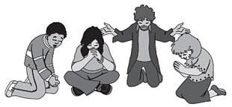

**PRAYER LIST**

Our Prayer List continues to lengthen and we realize the important need for prayers and healing. Sometimes the unfortunate result is that someone has passed away, and the words “The Family & Friends of” appear before someone’s name. However, sometimes we forget names are still on the list and their health has improved or the they are no longer struggling, and they can be removed. Please share the good and bad stories as we continue to pray for strength and healing. Names can be added or removed from the list on the clipboard in the Narthex prior to the Worship Service, by calling the church office, or addressing it on the Conference Call. Please let us know the relation to the person(s) you listed so we can be more mindful with our prayers. Names will stay on the list until removed by the person(s) who requested prayer.

**TITHES, OFFERINGS, & ENVELOPES**

2025 Offering Envelopes are available. Please see Heather if you have not received yours, or would like to have some. For we do indeed worship God with our tithes and offerings. We hear this in scripture, “Each of you must give as you have made up your mind, not reluctantly or under compulsion, for God loves a cheerful giver.”

(2 Corinthians 9:7) Feel free to drop your envelopes in the offering plate, mail them to the church, or drop them off in the locked mailbox. Thanks for your continued support in the mission of our church, its ministries, the NJ Synod, and other needs!

**ED GREEN CAPITAL IMPROVEMENT FUND**

We continue raising money for unforeseen costs or repairs.Kathy sells Wawa Tickets for $6, the donation bin is in the back of the church, and we have our Annual Church Rummage Sale. Thanks for your continued donations, prayers, and support!

**PROPERTY USE**

​​​​​Do you know anyone interested in utilizing our Fellowship Hall for a Party or Event?

It is a suggested $50 refundable security deposit, and $250 for facility use. There is no alcohol or games of chance permitted due to ELCA policy. Please contact Vicar Vince or the Church Office with questions, for info, or to reserve a date and time.

**NEWSLETTER**

Collect information, stories, pictures, and reports for our next seasonal publication. Submit them to Vicar Vince in-person or via email at vpie8282@gmail.com.



Vicar Vince was introduced to Milestones Ministries weekly guides for faith-filled studies and conversations through a Seminary class. A decision was made to pass these along to you. If you missed a week, or lost your insert, check our website for past issues. Feel free to ask questions and provide feedback to Vicar Vince.

**INTERESTED IN BECOMING A NEW MEMBER**

Have you been attending our church for a while? Have you just recently returned to church after being away for a bit? Maybe you transitioned from another church,

or just started to recently attend our church. We are glad to have you, and would love to have you as a member of our Congregation. See Vicar Vince for more info.

**BAPTISM**

We are a church whose unity is in Jesus Christ, who gathers us around word and water, wine and bread. Baptism is a significant part of our faith journey as we come from the baptismal waters to live a new life as children of God. Our baptism sets us out on a lifelong journey that is characterized by our relationship to God, our relationship to our faith community, our relationships in our community and the wider world. Living our baptismal covenant means living a life of growth in the faith practices of discipleship. Please see Vicar Vince for more information.

**FIRST COMMUNION**

Although no particular age for first communion is prescribed by The Use of the Means of Grace, one guideline is offered. Because admission to the Sacrament is by invitation of the Lord to the baptized, "baptized children begin to commune on a regular basis at a time determined through mutual conversation that includes the pastor/vicar, the child, and the parents or sponsors involved, within the accepted practices of the congregation.” Each congregation is encouraged to ask the question of readiness for first communion, establish their own policies regarding age and practice, and accompany that practice with catechesis appropriate to the age of the communicant. If anyone has questions, please see Vicar Vince.

**LIBRARY**

New books are added to our library from time to time. Several are borrowed and read and exchanged. Who knows, you might find one particularly interesting and share that with someone as well. Reading is a great way to pass spare time, learn, and explore. You may find some fresh ideas for prayer, ways to grow more spiritually, ways to grow closer to God, or some opportunities to understand our faith more. Visit the library between the church offices and see what books are there!

We also have an extended library located in Vicar Vince’s office. There are Bibles of various translations, books from his personal collection, books inherited from Pastor Leah, movies, past Bible Study Curriculums, and more. Just ask to check things out!



**FAVORITE HYMNS**

Carol is willing to play some of your favorite hymns for the Prelude & Postlude each Sunday during our Worship Service. Feel free to let her know of your suggestions.

**2025 CHURCH DIRECTORY**

Additional copies are by the Church Office on the bookshelves. We continue keeping it updated and undoubtedly miss a few changes or have made a few errors. There are spaces for changes in info, new people’s info, notes, and your favorite Bible verses. Please continue to inform the Church Office of any changes or updates.

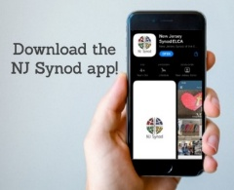

Jersey Jottings is a weekly e-newsletter that connects our synod together with weekly prayer, upcoming events, synod and churchwide activities, mission stories, congregational activities, and more. You can also sign up by going to https://www.njsynod.org/stay-connected and filling out the form! You can also get the app on your smartphone in the Apple App Store or on Google Play on your android.

**VICE PASTOR UPDATE**

Pastor William Hodgetts continues to attend our monthly Church Council Meetings. Pastor William continues to provide Supervision and Direction for Vicar Vince.

**VICAR APPOINTMENT ON MARCH 19TH, 2023**

A Memorandum of Understanding on the Matter of Pastoral Appointment

In Theological Education for Emerging Ministries (TEEM) Candidacy

TO: Congregation Council, Holy Spirit Lutheran Church, Villas

FROM: The Rev. Tracie L. Bartholomew, Bishop, New Jersey Synod

Dear Brother and Sisters in Christ,

This memorandum is in support of your discussions with Vincent Piekarski as pastor of Holy Spirit, Villas. Because this is not the usual pattern for completing the educational and candidacy requirements for ordination, it is my hope that this memorandum will both provide guidelines and engage in conversation with those who are invested in this process.

I would say at the outset that because Vincent is an outstanding candidate for the Ministry of Word and Sacrament, we will all want to do whatever is necessary to assure that his placement serves the mission of the church in the best possible fashion.

The following notes reflect my own understanding of this matter:

(1) The appointment for Vincent will begin on April 1, 2023. At this time, Vincent

will assume all responsibilities of a regularly called pastor, including presiding at

the Sacrament of Holy Communion and Baptism at Holy Spirit, Villas.

(2) A pastoral appointment in the TEEM process is an option for completing

seminary educational requirements and the steps of the candidacy process.

Upon completion of the candidacy process and seminary education, the

candidate may receive and accept a call to ordained ministry from the

congregation where the appointment is being served.

(3) This appointment is jointly supervised by the Office of the Bishop and the TEEM

pastor’s seminary. A mentoring relationship with a local pastor is required for the

length of this appointment.

(4) The synod of candidacy origin will be responsible for the approval process.

(5) Upon approval for ordination, the congregation would be expected to extend a

call to the pastoral appointee.

(6) Compensation for the TEEM pastor will be according to the guidelines of the New

Jersey Synod. All normal forms of compensation should be in place for the term

of the appointment, including stipulation that base salary and housing shall be in

accord with synod guidelines for first call at time of ordination.

(7) The ELCA Portico benefit plan for lay persons in full-time church service should

be used for the pastoral appointee up to the time of ordination, whereupon the

benefit package is to be converted to the plan for ELCA clergy.

(8) A decision for Pastoral Appointment is made with the agreement of a synod and

its candidacy committee, and the ELCA, normally represented by the regional

staff person of each in consultation with the seminary and its Director for

Contextual Education.

(9) Pastoral Appointment in a TEEM Candidacy is an option that is to serve the

mission of the Church in a particular and vital way and is not to be viewed or

used as a means to circumvent the normal candidacy process and/or first call

placement process.

In the specific case of Vincent, the New Jersey Synod remains responsible for the candidacy and approval process, and has agreed to this proposal for Appointment at Holy Spirit, Villas.

Continued blessings to both Holy Spirit and Vincent Piekarski as you embark on this journey of mutual ministry. As partners in ministry, we walk with you and rejoice in this new relationship.

**VICAR VINCE’S DAY OF REST**

A day of rest can have physical, mental, and spiritual benefits. “Mittwoch,” German for mid-week, or Wednesday, is the day that Vicar Vince will use to recharge and do some other things. Please do not hesitate to reach out if there is an emergency!

**TRUE DELIVERANCE PRAISE & WORSHIP CENTER**

Reverend Maria Brooks and True Deliverance Praise & Worship Center utilize our facilities from 1-4PM on Sundays. TDPWC helps with the Food Pantry and hosts or assists with other events throughout the year. TDPWC hosts a **Prayer Line** on **Mondays, Thursdays, & Fridays at 5PM** on the **Conference Call 1-657-390-7957**.

**TUESDAY SEWING CIRCLE**

**COFFEE, CHIPS, FELLOWSHIP, QUILTS!**

You all—men included—are warmly invited to join **Holy Trinity Lutheran Church in Wildwood on Tuesday morning at 10 AM**. No sewing skills required! We welcome anyone looking to be part of a friendly group that enjoys doing a variety of activities together. We meet in the front room of the Parish Hall at 2810 Atlantic Ave. There’s parking available behind the church, and you can enter through the rear door. Just bring a sandwich or snack for lunch! For more information, please contact: Louise McHugh at tillie26@verizon.net or Martha Neff at marthaneff1@yahoo.com

**CHURCH STAFF & VOLUNTEERS**

**VICAR, BIBLE STUDY & FAITH DISCUSSIONS,**

**EVENTS, NEWSLETTER, & WEBSITE**

Vicar Vince Piekarski

**VICE PASTOR**

Pastor William Hodgetts

**ORGANIST & PIANIST**

Carol Amundsen

**CHURCH OFFICE, SUNDAY SCHOOL, & FOOD PANTRY**

Heather Piekarski

**CHURCH COUNCIL PRESIDENT**

Mary Melnicoff

**CHURCH COUNCIL VICE PRESIDENT**

Judy Brannan

**CHURCH COUNCIL TREASURER**

Bonnie Millard

**CHURCH COUNCIL SECRETARY**

Vicki Rinier

**CHURCH PROPERTY**

Frank Ford & Wayne Rand

