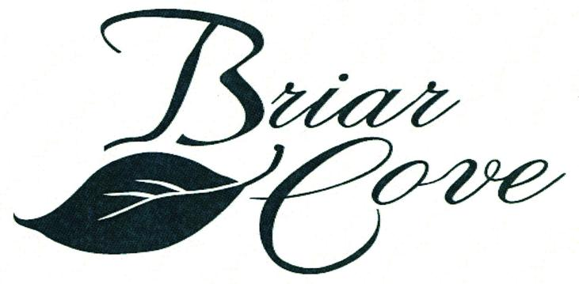 | NEWS  AROUND  THE  NEIGHBORHOOD  SUMMER 2016
2016 Board of Directors

Ralph Flens, President Nick DeLaurentis, Director
Joe Arias, Treasurer Ron Szikora, Director
Tom Whitely, Secretary

Summer is now in full swing and so are the Briar Cove summer activities .

.This year will be filled with activity as you will see below:
> The Briar Cove painting program is now in full swing. This is phase two of the program and
phase three will be completed next year
> The second phase of our driveway asphalt resealing program was completed during the
month of June. The non coal tar material was used as was in phase one in 2015.
> The installation of rip-rap along the shoreline of the pond is also on the agenda.This will
be completed at a date to be determined.
> The fencing system to keep the geese from gathering around the pond area was installed
during the month of May. It appears to be keeping the geese from the area.Also,the
fencing is nearly invisible.
> The plants installed by the developer in the front landscaped areas will be evaluated and
corrective action taken where needed. This program is a new approach and may be spread over
several years.
> The efforts of the lawn maintenance contractors, Mastercut, ForeverGreen andThomas
Irrigation seem to be working as the lawns look good. Also, new mulch was laid in the
landscaped areas.
.> A number of trees were also replaced in June. This is an ongoing program.
> The landscape committee also did a great job of the plantings at the waterfall as well
as at the entrance on Ludington.
> A review will be made on a procedure for filling the cracks in the driveways.

SAFETY HINT
Our homes are now getting older and a maintenance item that you need to address
is the cleaning of your dryer vent (if you have not already done so) . Some of us
previously owned/lived in homes that had a basement and a short dryer vent pipe
to the outside.Now our homes have dryer vent pipe out to the roof and more prone
to getting clogged with lint.

MAINTENANCE
Please remember that in Briar Cove the outdoor maintenance is contracted to vendors
for lawn mowing, fertilization ,etc..If you see Mastercut/Forever Green/Thomas Irrigation
on your property ,they are there to perform a service.If you see something that is being done
please contact Peter Bylen,1st American Management and let him know.

PLEASE adhere to the rules (in actuality and spirit) of the Briar Cove Community. If unsure whether your change idea is within the guidelines, please check the rules/covenants in the book that you received at closing. Also, the Welcoming Committee provides a copy of the rules when they visit and welcome the new residents. Peter Bylen, 1st American Management can also be contacted.

YOUR COMMUNITY

Thank you all for your support in helping to get a sufficient number of signatures to pass the three
important amendments pertaining to the responsibility the trees, the changes to the Architectural
Committee and the guidelines for holding a position on the Briar Cove Board. A last minute decision
by our State Representatives will delay the implementation of these changes.

The Briar Cove board meetings are scheduled for July 21 and October 20. The annual meeting is scheduled for November 17. Please make plans to attend the meetings.

Please get involved in YOUR community. There are a number of active committees that would welcome your time and talent. Also, please consider running for a position on the HOA Board of Directors. There will be two positions up for election this year. If interested, please send a note Peter Bylen, 1st American Management Co. to express your desire to run. A brief resume should be included. Remember this is YOUR community.

PLEASE REMEMBER THE FOLLOWING

- Pick up after your pets whether on your property or your neighbors.
- Please confine your pet to the parkways when walking your pet.
- Please be sure to have your pet under control at all times when out of doors.
- Please remember that certain dog breeds are NOT allowed in Briar Cove.

HELPFUL HINT

If you wish to be alerted to last minute changes, alerts please notify Peter Bylen and supply
him with your email address

GET TO KNOW YOUR NEIGHBOR

On the second Tuesday of the month, a number of residents gather at a local restaurant for dinner and conversation. If you wish to be placed on the email list/call list, please contact Cindy Dupczak via email: cdupczak@att.net

The next open Board meeting is scheduled for 6:30 pm on Thursday, July 21, 2016. The meeting will be held at the Dyer/Schererville public library in Schererville.

Peter Bylen 1st American Management 219-464-3536 Ext 310 / 800-990-3536
pbylen@1stpropertymanagers.com
www.briarcovehomeownersassociation.com

