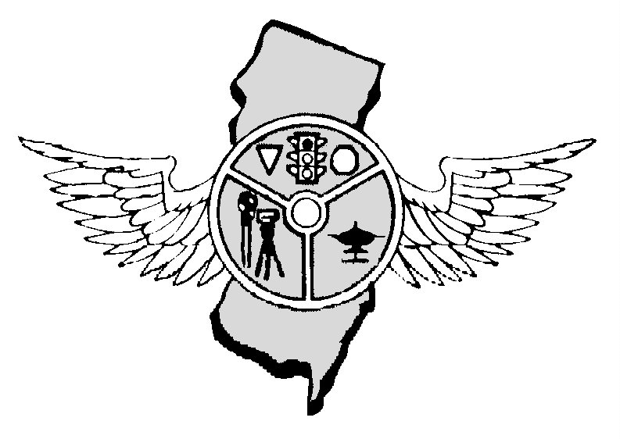

JUNE 2018 OUR 45th YEAR

Nicholas Schock, President Tony Parenti, Executive Director, editor Frank Fiore, First Vice-President Mark Wilson, Operations Secretary
N.J.P.T.O. A. P.0. Box 664, Voorhees, NJ 08043 - 856-220-1433 - NJPTOA.ORG or NJPTOA@HOTMAIL.COM
JUNE IS A MILESTONE FOR OUR ASSOCIATION – WE ARE NOW IN OUR 45TH YEAR. WHEN CHIEF PARENTI GOT THE IDEA FOR A STATE ASSOCIATION HE NEVER DREAMED IT WOULD LAST THIS LONG. THE WAY THINGS ARE GOING IT LOOKS LIKE MANY MORE YEARS WILL FOLLOW.
PRESIDENTS MESSAGE: As we gear up for the summer months, the Click it or Ticket mobilization will run from May 21 - June 3. Please remain vigilant for seatbelt and child safety seat violations during this time, and I encourage everyone to report their department's statistics back to the Division of Highway Safety, regardless of funding status. Our next regular business meeting will be held at the Police & Security Expo in Atlantic City on June 27 at 10:00 am. There will be no meeting in Hamilton on June 6. As a reminder, Association membership dues are to be paid by June 30, or your agency will be dropped from the active roster. Please contact Operations Secretary Mark Wilson if you have any questions concerning your department's status. Thanks, Nick.
PATERSON POLICE OFFICER KILLED IN CAR CRASH: Officer Tamby Yagan was killed on-duty in a car crash on 4/22/2018 morning. Officer Tamby Yagan was driving a marked patrol vehicle when he collided with a parked car near 150 Getty Avenue just before 11 a.m. Yagan was taken to St. Joseph's Regional Medical Center in Paterson where he died. Paterson Police posted the following message on its Facebook page: "From Director (Jerry) Speziale, Chief (Troy) Oswald and all members of the Paterson Police Department, our heartfelt and sincere sympathies to the family of our brother, Tamby Yagan." "May you Rest in Peace!" The president of the state's police union, Patrick Colligan, said in a tweet that Yagan's death "leaves a loss for all of us.
INFORMATION WANTED: Officer Kurt Morris is of the Sparta Police Department is looking for info on vehicles your departments have towed for either an accident or getting impounded for whatever reason. “My local tow yard is having problems with people just leaving their vehicles and never returning to claim the car. I’m getting different info from multiple sources on the procedure for obtaining a junk or Abandonment titles. Also who is responsible for doing so the police department or the company who towed the vehicle. I spoke to three separate people from MVC and got three different answers. Any info would be a help.” Please send any information directly to Officer Morris.
CHILDREN RIDING IN CAR SEATS: In 2011, the American Academy of Pediatrics recommended that children ride in rear-facing car seats until age 2. Before that, the recommendation was until age1. It’s not terribly hard to get small babies into an American-style rear-facing car seat, but those who are nearly 2 years old are a different story. NHTSA’s crash database from 1988 through 2003 found that children from newborn to 23 months who were restrained in a front-facing car seat were 76 percent more likely to be seriously injured than children in a rear-facing seat. In side crashes, injury was four and a half times more likely. Then in 2016, a biostatistician hired as an expert witness in a lawsuit against a car seat manufacturer tried to replicate the 2007 study. She couldn’t get the numbers to work. She contacted the journal, which contacted the study authors. They realized they had made a mistake with survey weights that, when corrected, made the results no longer significant.
CARS SAFER: The National Highway Traffic Safety Administration released new data that shows new model year vehicles are the safest on U.S. roads. NHTSA’s analysis looked at fatal crashes involving passenger cars, SUVs, and pickup trucks, and the data showed that a greater proportion of deaths among passengers in fatal crashes occurred within older model year vehicles, compared to new model year vehicles.
As of May 20, 2018 there were 194 fatalities on NJ roads compared to 173 during the same period in 2017, AN INCREASE OF 21 DEATHS.
COUNTY | 2018 | 2017 | CHANGE | COUNTY | 2018 | 2017 | CHANGE
Atlantic | 08 | 15 | -07 | Bergen | 07 | 09 | -02
Burlington | 22 | 12 | +10 | Camden | 13 | 10 | +03
Cape May | 04 | 03 | +01 | Cumberland | 09 | 05 | +04
Essex | 14 | 12 | +02 | Gloucester | 17 | 12 | +05
Hudson | 09 | 07 | +02 | Hunterdon | 00 | 03 | -03
Mercer | 08 | 08 | 00 | Middlesex | 25 | 16 | +09
Monmouth | 11 | 10 | +01 | Morris | 10 | 08 | +02
Ocean | 14 | 20 | -06 | Passaic | 04 | 05 | -01
Salem | 03 | 06 | -03 | Somerset | 08 | 07 | +01
Sussex | 03 | 01 | +02 | Union | 04 | 14 | -10
Warren | 01 | 05 | -04
Deaths: Driver,97; Passenger, 36; Pedalcyclist, 06; Pedestrian, 55. Crashes, 177.
DRIVING WHILE ON MARIJUANA: The Colorado DOT found that a lot of cannabis users don’t take the law seriously, even though it can result in a DUI, or an accident. A statewide survey collected responses from 7,698 marijuana users and 3,722 non-users said. Findings and analysis won’t be finalized until summer. But there’s a big number that already sticks out: Of the users, 69 percent said they have driven under the influence of marijuana in the past year, with 27 percent saying they drive high almost daily.
USE AIRPLANES: A survey by the American Association of State Highway and Transportation Officials finds that 35 of 44 responding are using unmanned aircraft systems or drones, for a wide range of purposes. The survey finds that 20 state DOTs have incorporated drones into their daily operations. Another 15 DOTs are in the research phase. All state DOTs deploying drones follow FAA's Part 107 Rule or the state DOT has received a public Certificate of Waiver or Authorization (COA) from the FAA to conduct drone operations. "This is another example of how state DOTs are advancing innovation to improve safety and productivity for the traveling public," said the AASHTO executive director. "Drones are being used to significantly cut the time it takes to gather data, which is leading to major time and cost savings." All 20 of the state DOTs operating drones on a daily basis, are deploying them to gather photos and videos of highway construction projects, 14 states reported using them for surveying, 12 for public education and outreach, 10 for bridge inspections, eight for emergency response, six for pavement inspections, five for scientific research, two for daily traffic control and monitoring. One state DOT was using drones to conduct high-mast light pole inspections. HIGH SPEEDS SLOW TRAFFIC: A new IIHS study shows that increases in speed limits over two decades have cost 33,000 lives in the U.S. In 2013 the increases resulted in 1,900 additional deaths, canceling out the number of lives saved by frontal airbags that year. "Although fatality rates fell during the study period, they would have been much lower if not for states' decisions to raise speed limits," says Charles Farmer, IIHS vice president and the author of the study. Maximum speed limits are set by the states, and they have been on the rise since 1995. However, during most of the 1970s and 1980s, the threat of financial penalties held state speed limits to 55 mph. In 1973, Congress required that states adopt 55 mph as their maximum speed limit in order to receive their share of highway funds. Concerns over fuel availability, rather than safety, had prompted Congress to pass the measure, known as the National Maximum Speed Limit, but the most dramatic result was a decrease in fatalities. In 1987, with energy concerns fading, Congress relaxed the restriction, allowing states to increase speed limits to 65 mph on rural interstates. The law was completely repealed in 1995. Proponents of raising the speed limit often argue that such increases simply bring the law in line with reality, since most drivers exceed the limit. People driving under the influence of marijuana in the past year, with 27 percent saying they drive high almost daily and faster.
PLEASE NOTE THE NEXT REGULAR MEETING IS JUNE 27, 2018 IN ATLANTIC, CITY
REMEMBER TO WEAR YOUR SAFETY BELTS AND BULLETPROOF VEST WHILE ON DUTY

NJ Police Traffic Officers Association
PO Box 664
Voorhees, NJ 008043
856-220-1433
E-MAIL: njptoa@hotmail.com

2018 INVOICE

DATE | ITEM | AMOUNT
1/1/2018 | Annual Membership Dues for Police Department | $50.00
 | TOTAL: | $50.00

DATE: 1/1/2018 SIGNED: NICHOLAS SCHOCK, President
Our Tax ID number is 22-2344113
Copies of purchase orders can be faxed to 856-783-0012 or scanned for an e-mail and sent to NJPTOA@Hotmail.com.

Note: If you would like to receive the newsletter by e-mail instead of by postal mail, please send your request to njptoa.tparenti@gmail.com

(Please check mailing label. Correct if necessary by phone call, text, or e-mail)

