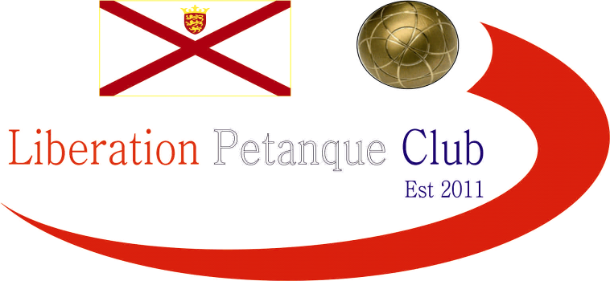

2022
International Doubles Open

Eighteen teams took part in our first International Doubles Open in our first weekend of competitions.

In Round one three matches did not make it to thirteen, the closet saw Callum Stewart & Toby Northern lose 11 – 10 to Welsh pair Dave Snook & Tony Griffiths. Another top Jersey team lost as Matt Buesnel & Ross Payne went down 12 – 7 to Scottish pair Michael Watt & Alec Davie. Andrew & Lorna Limbrick lost 10 – 4 to John Wilson & Robert Stronach.

There were expected wins for two of Jersey top teams as Andrew Bellamy & Geoffroy Buffetrille won 13 – 2 against Ann-Marie & Chris Bigmore and Matt Pinel & Matt Ryan won 13 – 5 against Shirley Legge & Gemma Foster.

Round two saw the first 13 – 0 result with Matt Pinel & Matt Ryan getting the win over Scottish pair Michael Watt & Alec Davie and Andrew Bellamy & Geoffroy Buffetrille also won 13 – 0 over Welsh pair Dave Snook & Tony Griffiths.

Several big scorelines as Andrew & Lorna beat Paula & Mo 13 – 4, Keith Pinel & Graeme Follain beat Gareth Smart & Jay Geldert from Wales 13 – 1.

Two matches not making it to thirteen as a Jim Page & Glifton Gonsalves won 8 – 7 over Chris Bigmore & Ann Marie Stanley and John Wilson & Robert Stronach beat Gary Cowburn & Wendy Ritzema.

A shock in Round three as Andrew & Geoffroy lost 10 – 9 to Gary & Wendy and Shirley & Gemma lost 13-11 Paula Fauvel & Mo De Gruchy.

A big win in an all-Scottish tie as John Wilson & Robert Stronach won 13 – 3 over Lynn Jenkins & Derek Adam.

Matt Buesnel & Ross Payne just won 11 – 10 over Andrew & Lorna Limbrick and Callum & Toby got their first win.

Matt Pinel & Matt Ryan made it four straight wins 13 – 2 over John Wilson & Robert Stronach. Andrew & Geoffroy recovered to make it three wins in four over Brian Harris & Keith Priaulx 11 – 9.

Jim Page & Clifton Gonsalves beat Matt Buesnel & Ross Payne 13 – 12! The same result as Keith Pinel & Graeme Follain over Neil Selby & James Gennoe.

Two 13 – 1 wins as Paula & Mo beat Dave Snook & Tony Griffiths and Shirley Legge & Gemma Foster beat Chris Bigmore & Ann-Marie Stanley.

As places in the Main knockout stages were up for grabs some big results.

Matt Pinel & Matt Ryan made it five wins from five with a win over Keith Pinel & Graeme Follain 13 – 2 to top the Swiss Rankings with Graeme & Keith finishing seventh.

A surprise 13 – 0 win for Andrew & Geoffroy (Their second of the competition) over John Wilson & Robert Stronach to finish third with the latter finishing fourth. Same score for Lynn Jenkins & Derek Adam over Paula Fauvel & Mo De Gruchy to finish second with Mo & Paula finishing fourteenth and into the plate.

Brian Harris & Keith Priaulx won 13 – 2 over Jim Page & Clifton Gonsalves to take fifth place with the latter dropping to thirteen and into the Plate.

Gary & Wendy saw another match not make it to thirteen but did win 11 – 6 over Michael Watt & Alec Davie to finish sixth with Michael & Alec just missing out on the Main Competition finishing nineth.

Matt Buesnel & Ross Payne made up the top eight with a 13 – 5 win over Gareth Smart & Jay Geldert.

A Big loss at the bottom of the table saw Andrew & Lorna Limbrick eliminated from the competition as were their opponents Chris Bigmore & Ann-Marie Stanley despite winning 13 – 1, their first win of the competition.

Final Swiss Rankings

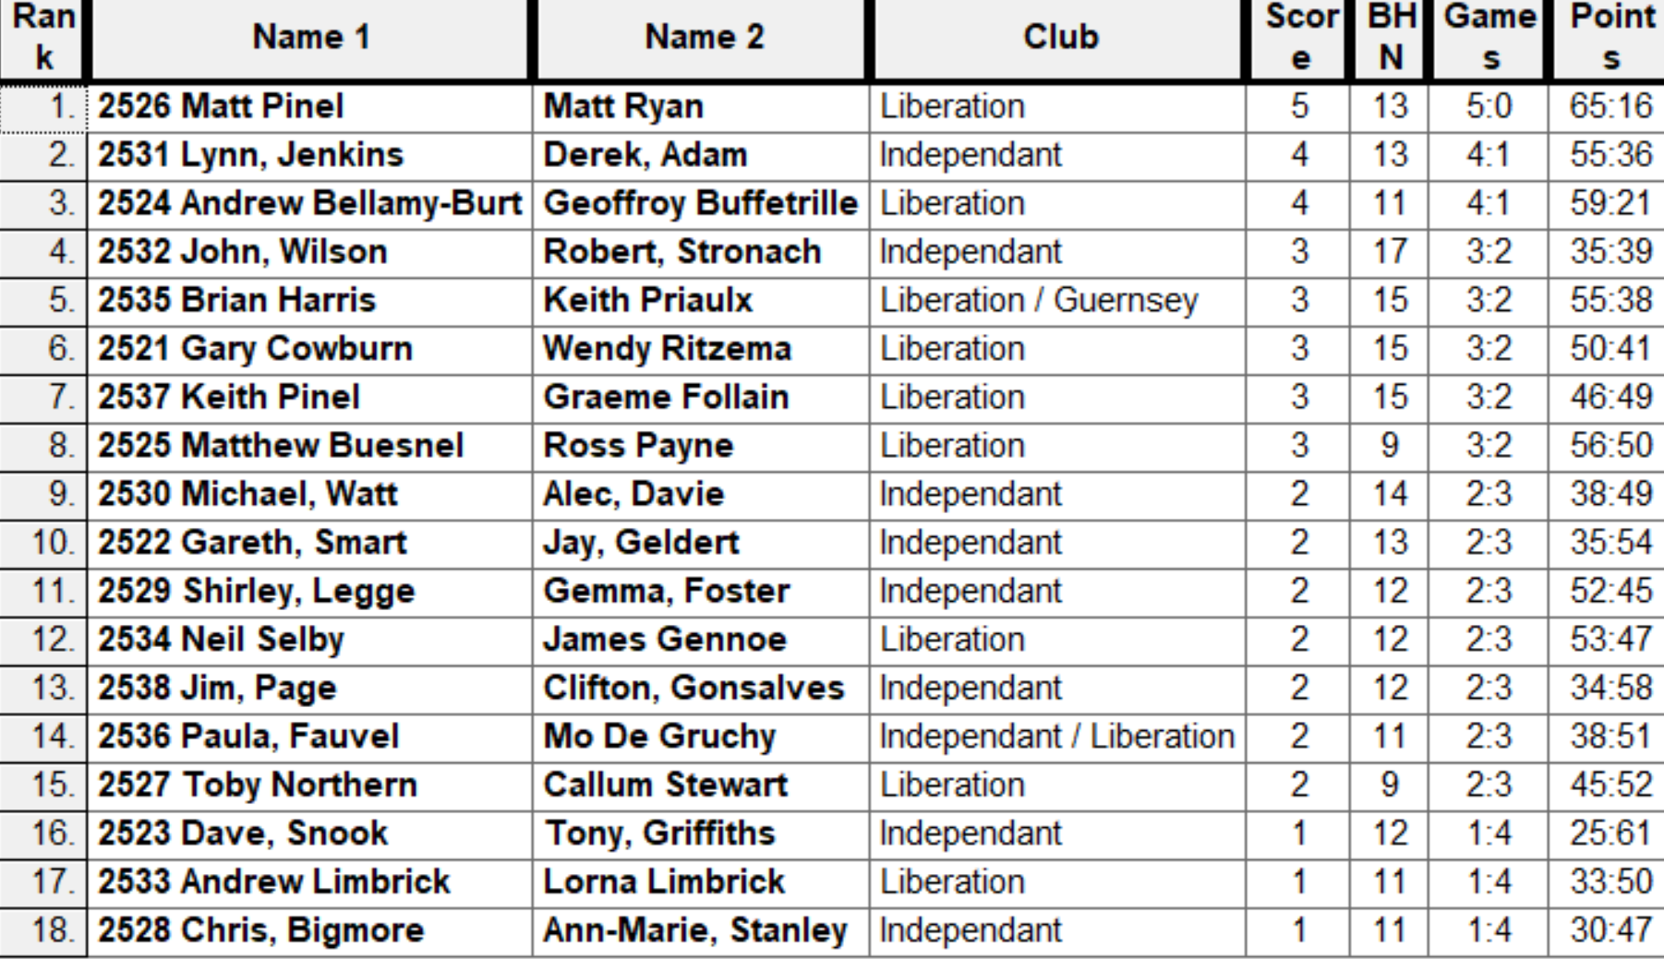

The Main Competition

Quarter Finals

Ranked 1st Matt Pinel & Matt Ryan v Matt Buesnel & Ross Payne Ranked 8th

Ranked 2nd Lynn Jenkins & Derek Adam v Keith Pinel & Graeme Follain Ranked 7th

Ranked 3rd Andrew Bellamy-B & Geoffroy Buffetrille v Gary Cowburn & Wendy Ritzema Ranked 6th

Ranked 4th John Wilson & Robert Stronach v Brian Harris & Keith Priaulx Ranked 5th

In the first quarter final four of Jersey top players took each other on, but it was the top ranked pair of Matt Pinel & Matt Ryan who took the win 13 – 7 over Ross Payne & Matt Buesnel.

Scottish pair Lynn Jenkins & Derek Adam won comfortably 13 – 6 over very experienced Jersey team of Keith Pinel & Graeme Follain.

A comfortably win also for Andrew Bellamy-Burt & Geoffroy Buffetrille 13 – 3 over Gary Cowburn & Wendy Ritzema and a surprisingly timed out match at 11 – 3 for John Wilson & Robert Stronach over Brian Harris & Keith Priaulx.

The Main Competition

Semi Finals

Ranked 1st Matt Pinel & Matt Ryan v John Wilson & Robert Stronach Ranked 4th

Ranked 2nd Lynn Jenkins & Derek Adam v Andrew Bellamy-B & Geoffroy Buffetrille Ranked 3rd

So, Jersey versus Scotland in both Semi-Finals. Matt Pinel & Matt Ryan winning all six matches going into the semi-final would have been confident but coming up against two of Scotland best players. It was the top ranked team from Jersey though that made the first International Doubles Open final winning 13 – 6.

The second semi-final also went Jersey way as much fancied pair of Andrew Bellamy & Geoffroy also made the final winning 13 – 5 over Lynn Jenkins & Derek Adam.

Third Place went to John Wilson & Robert Stronach who claimed bragging rights over fellow Scottish pair Lynn Jenkins & Derek Adam winning 13 –

In the final Matt & Matt got off to a good start picking up three points and they did not really look back as Andrew & Geoffroy failed to produce anywhere near the best losing 13 – 6. Matt Pinel & Matt Ryan winning the first International Doubles Open.

2022 – Winners – Matt Ryan & Matt Pinel

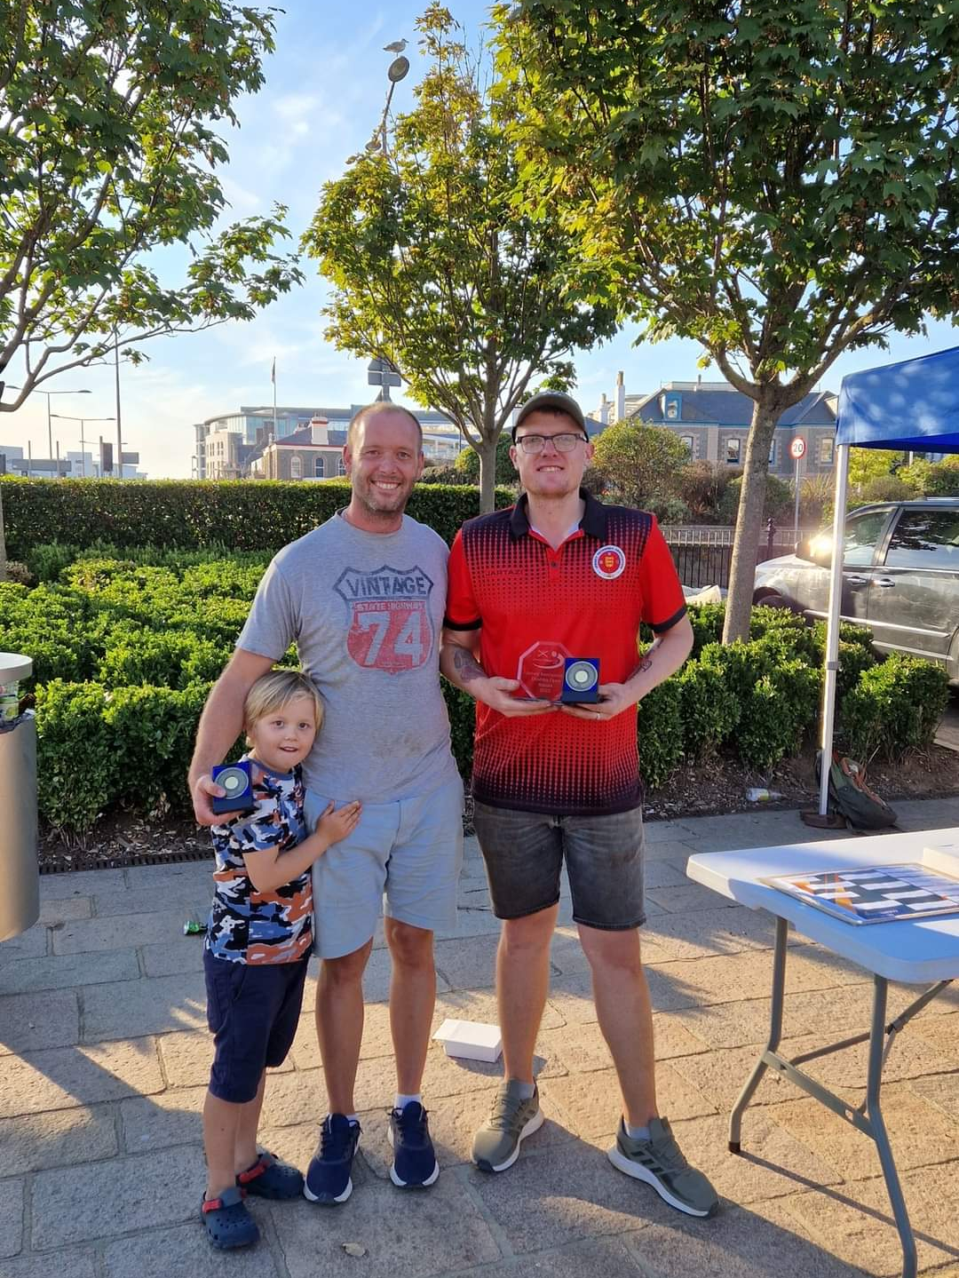

The Plate Competition

Quarter Finals

Ranked 9th Michael Watt & Alec Davie v Dave Snook & Tony Griffiths Ranked 16th

Ranked 10th Gareth Smart & Jay Geldert v Toby Northern & Callum Stewart Ranked 15th

Ranked 11th Shirley Legge & Gemma Foster v Paula Fauvel & Mo De Gruchy Ranked 14th

Ranked 12th Neil Selby & James Gennoe v Jim Page & Clifton Gonsalves Ranked 13th

In the first Quarter-Final the top ranked team in the plate was Scottish pair Michael & Alec, they beat Welsh pair Dave & Tony 11 – 9 to make the Semi-Finals. The Welsh did better in the second quarter-final as Gareth & Jay beat Callum & Toby 13 – 8 for the second time on the day.

Shirley & Gemma won the match in an all-female tie against Paula & Mo who had only met on the day of the tournament! 13 – 5.

Neil & James recovered some pride for Jersey as they beat Welshman Jim and Englishman Glifton to make the Semi Finals winning 13 - 3.

Michael & Alec kept up their momentum beating Neil & James 13 – 5 to make the final and an all Scottish final as Shirley & Gemma beat Gareth & Jay 13 - 10.

Third Place went to Neil Selby & James Gennoe who beat Gareth Smart & Jay Geldert 13 -

The winners and congratulations to Shirley Legge & Gemma Foster who won the Plate with a 13 – 9 win over friends Michael Watt & Alec Davie.

2022 – Plate Winners – Gemma Foster & Shirley Legge

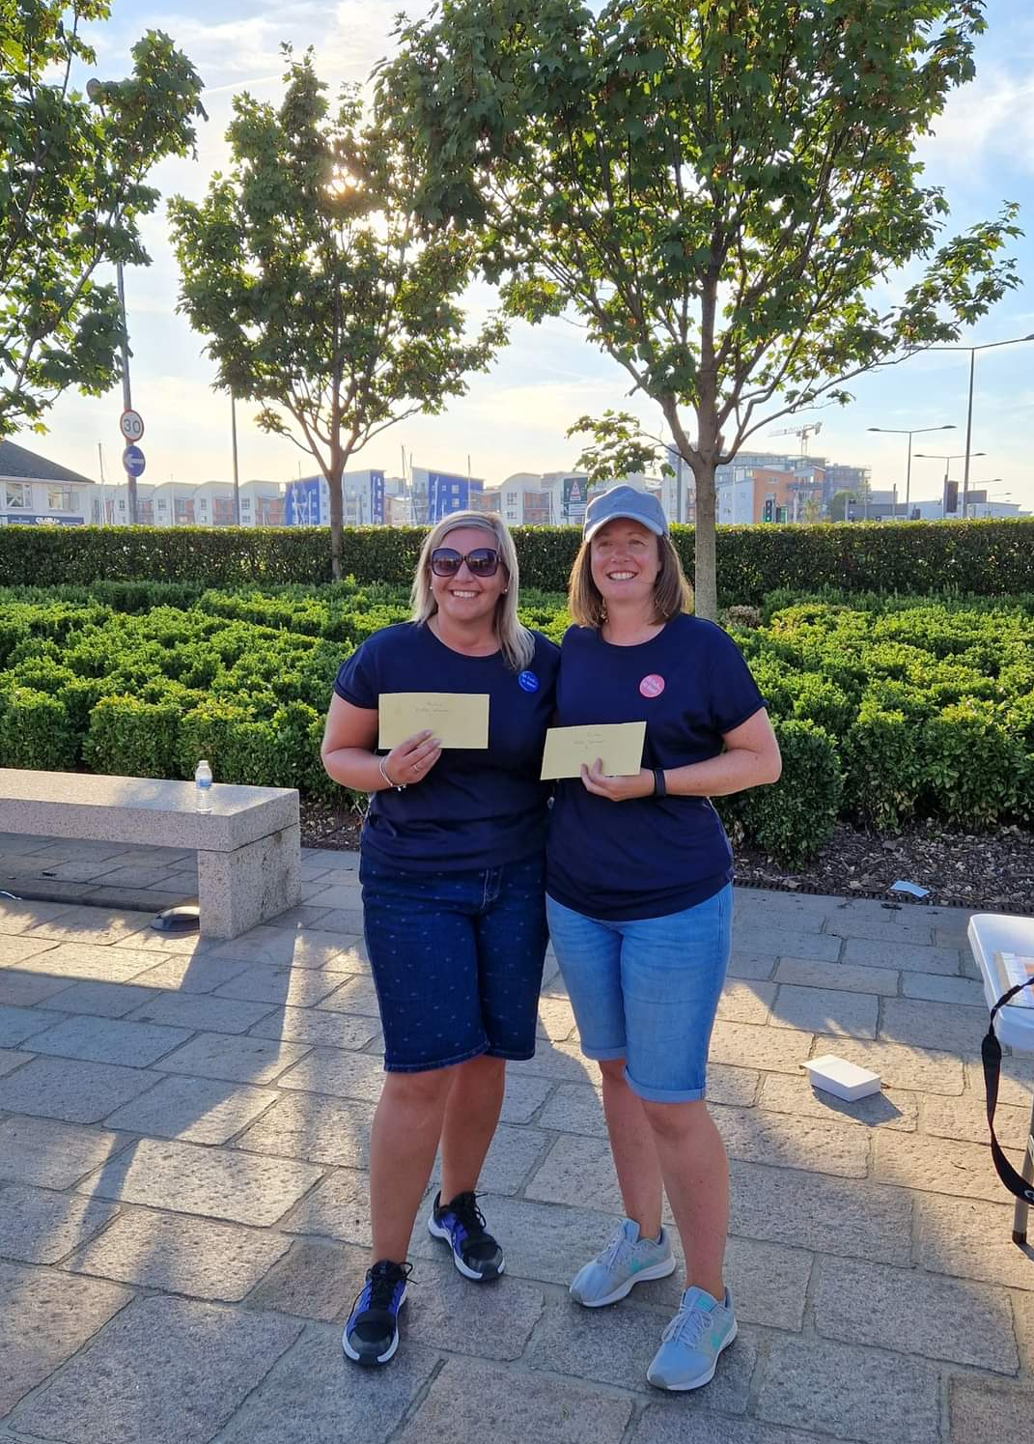

Thanks to all those who helped, especially Dawn Buckley on the day to make it another great competition.

Sponsored by



CoinShares | Digital Asset Investment Strategies for Professionals 🚀

Club email address - liberationpc@gmail.com

Club Website - www.liberationpetanque.co.uk

Kind Regards

Toby Northern

Chairman

Liberation Petanque Club

