RSAI Position Paper: State Supplemental Assistance (SSA) for 2019
http://www.rsaia.org/legislative.html
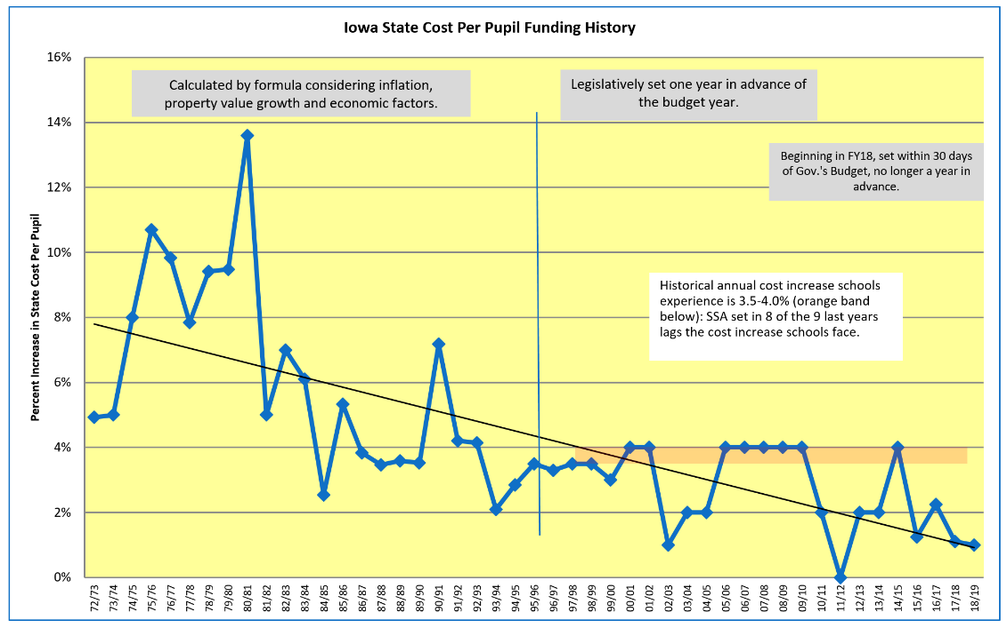
There is a cumulative impact to low per pupil funding increases in Iowa over many years. This chart shows the historical percentage increase in Iowa’s state cost per pupil, previously called Allowable Growth, now State Supplemental Assistance, since the funding formula began in 1972-73:
Current reality: Annual cost increases have not been enough to pay for staff salaries sufficient to compete with the private sector, employee benefits, insurance, busing (drivers, fuel), textbooks, utilities, professional development and staff training, paper and materials, library books, instructional software, science labs and equipment, staffing and materials for specific student programs (dropout prevention, at-risk, English-language learner, special education, Talented and Gifted, CTE programs), assessments, administrative leadership and support. Low funding impacts the weightings, or multipliers, assigned to students requiring special education services, English language learner supports, concurrent enrollment (college credit) and preschool.
The funding percentage is also applied to Teacher Salary and Professional Development supplements and the new Teacher Leadership and Compensation (TLC) supplements. These funds are strictly regulated for specific purposes. AEA supports for special education and school improvement are also dependent on an adequate increase in the per pupil cost. Unfunded mandates from the state and federal level are paid from the per pupil amount. When costs increase more than funding, program and staff reductions follow.
Benchmarks/Economic Measures for Comparison:
When comparing the state cost per pupil to economic benchmarks and comparisons with other states, Iowa school funding falls short. For example:
- The Gross Domestic Product (GDP) for Iowa grew 20% controlling for inflation, 2011 to 2017, compared to the state cost per pupil which grew 14% without controlling for inflation (means the gap is even larger.) https://www.legis.iowa.gov/docs/publications/FTNO/966760.pdf
- Expressing the state cost per pupil as a percentage of one billion GDP shows a disturbing trend. In the 1990s, the SCPP ranged between 52-44% of one billion GDP. In the 2000s, the SCPP ranged from 45-37% of one billion GDP. Since 2010, the SCPP has ranged from 37-34% of one billion GDP, with the last four years showing the lowest comparison in the formula’s history.
- Iowa Per Capita Personal Income increased 21%, 2010-2017 https://fred.stlouisfed.org
- Iowa Nominal Median Household Income increased by $8,286 or 17.3%, 2010-2016. https://www.deptofnumbers.com/income/iowa/
Recent Iowa Investments in Education: During the 2018 election, candidates mentioned an increase in state funding of $765 million since 2011. Some additional context explains what school leaders believe:
State funding did increase by $765 million over those 8 years. However, $90 million of that was state money that offset reductions in property taxes (see HF 2230 fiscal note 2018); $159 million was the Teacher Leadership Program; $86 million paid for new teachers and classrooms for 13,802 new students (enrollment data from DE Education Statistics web site https://educateiowa.gov/education-statistics). Although $765 million sounds like a lot of money, the remaining amount supporting the regular education classroom translates into 58 cents per student per instructional day.
Other State Comparisons: First, from 2016 US Census data updated May 2018 https://www.census.gov/data/tables/2016/econ/school-finances/secondary-education-finance.html
- Iowa ranks 25th in per pupil public elementary and secondary school system revenue, which is $734 below the national average.
- Iowa ranks 21st in state sources of revenue, which is $507 higher per pupil than the national average (Iowa’s local taxpayers contribute relatively less to education than in other states).
- Iowa per pupil spending on employee benefits (pension and health insurance, etc.) is $336 per pupil below the national average.
A true apples-to-apples comparison is found if you consider what percent of total state resources are spent on education. NASBO (National Association of State Budget Officers) State Expenditure Report analyzes all state expenditures:
- In FY 2018, Iowa’s education expenditures were 16.9% of total state expenditures. Plains states averaged 20.5%. All states averaged 19.6%.
- Iowa ranks compared to all 50 states: FY15 Iowa ranked 33rd. FY16 Iowa ranked 36th. FY17 Iowa ranked 34th. FY18 Iowa ranked 32nd.
- RSAI calculates it would take an additional $612.4 million for Iowa to reach the national average of 19.6% which is $1,194 per pupil.
Impact: Schools have been working very hard to deliver results for students. Iowa has seen slight growth in NAEP scores despite significant growth in poverty and ELL students. Iowa continues to rank first in the nation in graduation, with over 91% of our students graduating with their class in four years. Schools are committed to school improvement efforts, such as TLC, early literacy and STEM initiatives. More students are taking higher level courses and achieving college credit while in high school. These efforts will be compromised if the basic foundation of school funding is not sustained. Schools in Iowa are experiencing an increasing number of teacher shortage content areas. There are not enough qualified applicants to fill jobs, generally indicating that the profession of teaching is being outpaced in the marketplace. Class sizes are going up, making the job even harder. Programs are being eliminated. Districts are offering fewer extracurricular and fine arts opportunities for students, especially in middle school.
This trend will diminish the quality of Iowa’s workforce and impact our state’s future quality of life.
RSAI sets the increase in the state cost per pupil, known as State Supplemental Assistance, as one of the top four priorities for 2019: Formula funding is especially critical to students in rural Iowa due to transportation costs, economies of scale, unique needs of students, mandates and compliance, the need for quality AEA services, and the ability to attract and retain staff. The sustainability of a quality education in rural schools depends on the return of education as the state’s top priority with an investment of meaningful new resources to improve opportunities for students.

