Wilderness Safety?—A Debate Between Ultralightists and Traditionalists
(Provided by: HighCountryExplorations.com)

The media, through the years, has successfully made the judgment that lightweight backpackers are survival freaks waiting for an accident that will put them into a state of hypothermia forever. Another way of putting it: lightweight hikers provide great search and rescue targets. Nothing could be further from the truth. On the contrary, lightweight hikers tend to study and practice more advanced outdoor techniques.
—Ryan Jordan, ultralight backpacking expert

Central Questions Addressed in This Article
What are the best ways to maximize my safety and survival in the wilderness? What is the relationship between pack weight and wilderness safety? Is a traditional or a lightweight approach to backpacking inherently safer, all else being equal? Are things like knowledge, experience and skill much more important than the items carried in your pack?

Setting the Debate Stage
Many interesting issues and criticisms can be raised about the lightweight backpacking movement: expense of lightweight equipment, undue influence by gear manufacturers, record setting competitions, fanaticism by advocates, elitism, reduced comfort levels bordering on masochism, not having essential emergency and survival items. However, the last issue of safety and survival is often foremost for hikers and backpackers as they contemplate the lightweight packing philosophy. The tension between pack weight and wilderness safety is the focus of this article and of this debate.
The issue of maximizing safety and survival in the wilderness can be approached in many ways. The various articles in the Safety and Prevention section of this website deal with it in the context of risk prevention strategies. The Emergencies section of this website focuses on dealing with emergencies when and if they arise. This current article deals with safety and survival in the context of two contrasting philosophies of backcountry travel: Ultralightists vs. Traditionalists. Even though there is a whole continuum of lightweight and heavyweight packing, I will use the following working definitions for this debate: Ultralight = 10 pounds or less base pack weight; Traditionalist = 20 pounds or more of base pack weight. Base pack weight does not include consumables or items worn while hiking.
To put this debate into a realistic context, I offer some starting assumptions. First, assume that both the Ultralightist and Traditionalist are experienced and knowledgeable in the ways of wilderness travel (i.e., not beginners). Also, assume there are no special circumstances that would dictate carrying more and heavier gear for either participant in the debate (e.g., young children present, leader of an inexperienced party, winter like conditions, climbing gear needed). One unique context that is hotly debated, but is not explicitly dealt with in this article, is the “fast and light” alpinism crowd. Finally, assume that the target audience for this debate is not aboriginals or highly trained survivalists who pride themselves on being able to survive with almost nothing but the clothes on their backs.
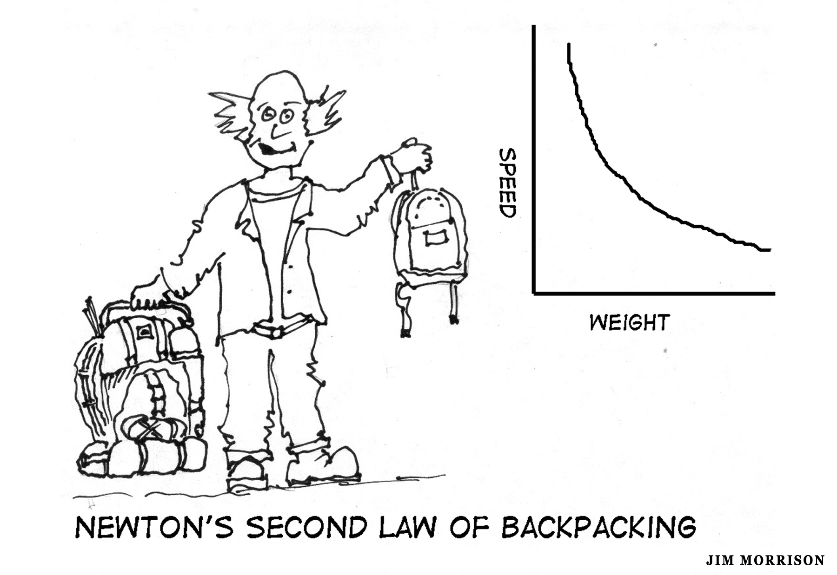

Both Sides Speak out on Safety Issues

Colin Fletcher expresses his safety concerns from the Traditionalist perspective:
. . . remember that real pleasure [in the mountains] demands, above all, gear that has enough reserve strength (and sometimes reserve items too) to tide you over those inevitable occasions when Murphy’s Law—If things can go wrong, they will—exerts its stern way. Perhaps this is the nub of the issue. A very experienced all-weather backpacker who works for a leading mountain shop said to me recently “Yes, I’ve played the ultralight game—and backed off a ways. For a week’s trip, now, I’m generally back at fifty pounds, or close to it. The trouble is, as you go lighter, so the chances of failure increase . . . . What matters is the danger of being let down in the field. Soon that risk grows too big.
—Colin Fletcher, The Complete Walker III, page 30
Upon taking a closer look at this “safety-in-the-wilderness” issue, I started with the assumptions that most Ultralights would agree they are compromising safety for other higher values: more freedom and flexibility, more time in the wilderness, more fun and enjoyment, etc. I was quite surprised to find Ultralightists who also claim the high ground on the safety issue. In the words of Ray Jardine:
The bulk of advertisements and articles in today’s outdoor magazines are telling us . . . that we need a wide selection of the very best in heavy-duty gear in order to survive out there, let alone to have a good time. These ads use a common tactic: they attempt to arouse your fears of nature, and then they rescue you with the company’s wares as the ultimate weapons against the big, bad, natural world . . . . Accidents do happen, but they are more related to overconfidence and inattentiveness than to lack of heavy-duty gear . . . . I am not promoting minimalism, but simply a reduction in what is not necessary. And I have found that this reduction, when thoughtfully and skillfully done, actually enhances both our safety and comfort.
—Ray Jardine, Beyond Backpacking, pages 12 and 17-21

The stage is now set. We have the opening salvos from both sides. Now to the details. (Yes, the devil is always in the details.) In this article, the details are made explicit in a dialogue and debate format with a sequence of “arguments,” “replies” and “counterreplies.” During the debate, I will state the strongest positions possible on both sides of selected issues, attempting to walk in the boots (or trail shoes for the Ultralightists) of each philosophical position. I will make the dialogue as realistic and as objective as possible, saving my own conclusions for the end of the article.

Traditionalists Argue for Having the Proper Essentials
Traditionalists, like Fletcher, imply that a backpacker must throw out many of the “ten essentials” or “reserve items” to get lightweight packs. He believes that to achieve these low weights (10 pounds or less base pack weight), it is necessary to seriously compromise safety and not be able to adequately deal with emergencies. As an ultralightist, I want to reply to this critique on several levels.
1st Ultralightist Reply—The Essentials Are Relatively Light: Going light is not going without the necessary equipment. It is finding lightweight alternatives and taking gear that will serve more than one function. Going light is questioning whether seldom or never used items are really necessary and essential. Most experienced backpackers, of whatever philosophy, carry emergency gear, most of which is relatively light (e.g., knife, first aid, map, compass, sun glasses, fire starter, flashlight, signaling items). The heavy stuff for which the ultralightist seeks serious reductions are things like boots, pack, tent, sleeping bag, water, cooking gear, extra clothing. We can argue about what kind of knife is necessary, about how much first aid to carry, what kind of flashlight to carry, and so on. Even on these relatively light items, the Traditionalist often goes overboard, weightwise. For example, a razor blade of some sort is usually quite sufficient for a sharp edge rather than a large hunting knife. Regarding the potentially heavy items mentioned, the issue is mostly a matter of comfort, not safety. The need for extra clothing, as a matter of safety, will be addressed in a later context (hypothermia potential).
Traditionalist Counterreply To “Essentials Are Relatively Light”: Ultralightists obtain their low pack weight only by cutting corners on everything possible. The issue is not any one item but the cumulative impact of the whole kit. In emergency situations all carried items become important. In addition, “comfort items” often become safety gear.

2nd Ultralightist Reply—Heavy Duty Gear Is Seldom Useful in Emergencies: As quoted earlier by Ray Jardine, “Accidents do happen, but they are more related to overconfidence and inattentiveness than the lack of heavy-duty gear.” Ultralight guru Ryan Jordan (“How Light is Too Light?”), makes a similar point:
Of course, catastrophes happen. Broken legs. Heart attacks. Seizures. Strokes. A bear eating your food. Or a bear eating you. These are the things that spell an early end to your hike and may require knowledge of signaling techniques and assisted extrication. Ironically, most of these catastrophes cannot be avoided by carrying a heavier pack. In fact, I could argue that a lighter pack could avoid some of these major problems by not taxing your body to its load-bearing limit.
In summary, heavy duty gear is seldom useful in either preventing or dealing with life threatening events.
Traditionalist Counterreply to “Heavy Duty Gear Is Seldom Useful”: The point is well taken that most accidents and catastrophes that do happen are not caused by a lack of gear. But this avoids the real issue: dealing with real emergencies. Yes, the fleet of foot ultralightist can get out for help a few hours faster, but what about those that must stay with the patient? If I am that patient or an attendee, I will be most appreciative of whatever “just in case” gear can be pressed into service. Also, Ryan Jordan’s reference to taxing the body with a heavy load is best dealt with by a good conditioning program, not a severe reduction in gear.
3rd Ultralightist Reply—Skills and Experience Are the Key: As a serious and conscientious ultralightist, I will not be put into the Traditionalist box of having to choose between safety and saving weight. This is a serious issue, but greatly oversimplified by my opponent. The truth is that you can have both. Real safety is having the right skills and knowledge along with some old fashioned good sense, not the right gear. A quote from the ProLite Gear.com web site expresses this point quite well: “Ultralite backpacking is practiced by extremely experienced backpackers who have years of trail experience and have extensively educated themselves for wilderness travel and safety.”
Furthermore, those with all the latest and greatest outdoor gear are often prevented from learning these skills and gaining this knowledge, knowledge that can be best learned by a “do more with less” approach or (using a flying analogy) a “seat-of-the-pants” approach. Expanding on the “do more with less” approach, my philosophy is to carry no more and usually a little less than I think I might need. Dealing with some adversity resulting from this approach will challenge our backpacking skills, knowledge and creativity and push it to higher levels so that I will be even better prepared to deal with adverse or emergency situations.
Traditionalist Counterreply to “ Skills and Experience Are the Key”: It goes without saying that real safety is based in skills and knowledge and common sense. But why take an either/or position? Having the prerequisite skills and knowledge plus the right kinds of gear to cover most contingencies is the best of both worlds. Regarding the last point above, there are many ways to obtain essential wilderness skills and knowledge besides going the minimalist route of doing without. The school of hard knocks can sometimes be severe.
4th Ultralightist Reply—Negative Attitude Towards Nature: The high priority given by traditionalists to safety and survival gear is often based on an underlying attitude that the wilderness is an alien, inhospitable, and dangerous place. It is an enemy that must be conquered. One has to overcome hardship and adversities to first survive and then get some enjoyment. This negative attitude is largely a myth originating from the early days of settling the wild frontier areas of our country. It has been perpetuated by outdoor gear advertisers and unconsciously accepted by Traditionalists. The power of the mind is such that if this negative attitude is held deeply enough, it will often turn out to be true for that individual. It becomes a self-fulfilling prophecy: sure enough, bad things happen to those expecting them. This type of negative attitude is commonly seen among law enforcement officers when they are surrounded by so much crime and violence that they begin looking at the whole culture as filled with bad people. This negative and fearful attitude is also seen among those who are confined to their quarters and watch too much violent media. It is an attitude, seldom a reality. Regarding being out in the wilderness, the reality is one of a benign and friendly place, if one has a positive attitude and knows what they are doing. There are noteworthy exceptions for those pushing the limits. But, this is not the reality for most hikers and backpackers with the right attitude.
Traditionalist Counterreply to “Negative Attitudes”: If this characterization is true for any specific individual, it is deeply embedded and is not going to be changed by a demonstration of ultralight backpacking techniques and gear.
5th Ultralightist Reply—Backbreaking Mentality: The crux of the problem is with Traditionalists who try to prepare for almost any emergency by carrying many items they will seldom if ever use, and by carrying heavy comfort items. It is like the old saying about “carrying everything but the kitchen sink.” In the process they carry backbreaking packs that often negate the main reasons for going into the high country: to enjoy and experience the wilderness. One often hears Traditionalists comment that certain items are always in the bottom of the pack “just in case.” Some have gotten so used to the backbreaking work of carrying a heavy pack that they don’t question it anymore (“suck it up and get used to it”). One good example is packs: does one need to carry a full-featured 6-7 pound model (as opposed to a 1-2 pound lightweight model or an ultralight model that is less than a pound)? Because the Traditionalist starts with the bias of needing all this heavy gear, it follows naturally that you also need a heavy duty pack and heavy duty boots to carry it all comfortably. A basic tenet of the Ultralightist philosophy is to break this vicious circle, self-fulfilling, backbreaking mentality.
Traditionalist Counterreply to “Backbreaking Mentality”: This philosophy is mostly wishful thinking. Yes, we would all love to get by with a ultralight pack, but this is not the reality for most. It is a common experience for beginning ultralightists to strip out all of the “just in case” items and then start adding them back in over time when they experience adversity and scary situations. For example, after weathering a serious storm lasting several days, it is easy to come to the conclusion about the need for a full storm suit or a stronger tent. Another example is attempting off-trail travel in trail shoes rather than boots. Trail shoes often work okay off-trail, but sometimes not. A compromise is often made to go to lighter mid-height boots. In general, it is common for Ultralightists to experiment with lighter and lighter loads, but then seldom take a truly “ultralight” kit because of this school of hard knocks. It is not bragging to say that traditionalists are relying on tradition—years, if not centuries, of experience in these matters. This wisdom should not be ignored. Furthermore, the Ultralightist should not assume that enjoyment of the backcountry and wilderness experiences come only with lightweight packs. It is common for the Traditionalist to carry a relatively heavy pack into base camp and day hike with a light pack.
Traditionalists Argument About Gear Failure
Colin Fletcher, quoted earlier, uses phrases like “gear failure” and “reserve strength.” I will give the reader only two short replies to this type of criticism of Ultralight backpacking philosophy.
1st Ultralightist Reply—Most Gear Is Overbuilt: It is my belief that most backpacking gear is overbuilt by manufacturers for various reasons: to avoid law suits, to get consumers to spend more dollars, to entice consumers with “new and improved” advertising messages, etc. All of these usually translate to increased profit.
2nd Ultralightist Reply—Quality Lightweight Gear: The more important issue here is quality gear. Many ultralightists spend quite a bit of money to obtain both lightweight AND quality gear. Many make their own gear to their own standards. The criticism of broken and failed gear that is too light to handle the strain is possibly true, if purchased from discount stores like K Mart, Walmart or Fred Meyer. Put succinctly, heavy gear can be made cheaply; lightweight gear can be made strong and of high quality.
Traditionalist Counterreply to Both Replies: I will also make my counterreply brief: better to err on the side of reserve strength. In addition, traditionalists have a wider range of choices: cheap or expensive, lightweight or heavyweight—usually somewhere in between.

Ultralightist Argument on the Adrenaline Rush
On a more philosophical note, many adopt the ultralight backpacking philosophy because they get hooked on the increased risk. The following quote by Mark Twight) captures the extremes of this perspective:
Wolfing down my third toasted cheese sandwich . . . I relished the luscious, bracing high that comes from getting naked [climbing extremely light] where you’re not supposed to. And not getting caught.
—“Getting Naked” in the Patagonia, Early Spring 2001 catalog
Here is another quote by Karen Berger expressing a similar attitude:
[Alpine-style] climbers pick their time. They are akin to lightweight hikers: fast, light, skilled, ready to change their plans at a moment’s notice, and well aware of the risks they are taking by traveling without a safety net. And to carry the comparison one step further: Ultralight hikers may be the equivalent of the extreme alpinist who travels solo without oxygen.
—Hiking Light Handbook, page 19
Ultralightists often go into the mountains to get away from the safety and security net of the city where a 911 medic is usually only minutes away and a trauma center with a highly skilled ER staff only a short helicopter ride away. We go into the mountains to get out of this comfort zone, to get the adrenaline rush that comes from pushing the envelope. Ultralight backpacking and “fast and light” alpinism are obviously not for everyone. It depends upon your comfort and security and safety needs. But you must ask the question: Have you have been brainwashed into the Traditionalist lifestyle, both at home and in the mountains? Is it possible that contemporary culture is conditioning most of us to be obsessed with safety and security and comfort? Are most of us losing the edge and the challenge that makes life really worth living?
Traditionalist Reply to the “Adrenaline Rush”: Ah-ha! We finally have an admission that ultralightists choose to go without a safety net. This is the core issue of this whole debate. The philosophy of risk assessment and risk tolerance are always interesting intellectual topics, but the reality is that those with a high tolerance for risk might be no better than the cocaine and heroin junkies on the streets. Some might even have a subconscious death wish. Ultralightists often get away with practicing their chosen philosophy for years without a problem. But when they eventually get caught short, the consequences can be disastrous. Most of us have evolved in the opposite direction. As we get older, we become more conservative and have a lower tolerance for risk. Some of this conservatism comes from being older and more aware of our mortality. But much comes out of genuine concern for loved ones and those who depend upon us. Of course, if you are single and unmarried and don’t have people who depend upon you at home or at work, maybe this extreme “fast and light” philosophy is defensible. If you have an unrealistic sense of your own mortality (“it always happens to other people”), you might be able to justify this lifestyle. For Traditionalists, the risks inherent in going ultralight are not a real choice. The adrenaline rush is not enough of a hook.
Ultralightist Counterreply: I can’t deny that some ultralightists are like junkies addicted to the adrenaline rush, but this is a matter of degree. The rush experienced by the Mark Twights of the world is a long way from that experienced by most ultralightists. This is not to claim that ultralight hiking is not without risk, but the experienced hiker and backpacker carefully manages the risks involved. The challenge and adrenaline rush is there but to a much lesser degree and with much less frequency. Most ultralightists get high just by being out on the trail and in the wilderness.

Traditionalist Concerns About Hypothermia
Probably the most critical safety issue, especially when hiking in cool and rainy climates like the Pacific Northwest, is the greatly increased threat of hypothermia with the Ultralight style. From a practical standpoint, the obvious factor with hypothermia prevention is creating and maintaining adequate body warmth. Body warmth is a function of eating properly (stopping frequently to eat food rich in calories), drinking properly (staying hydrated by frequent intake of water), dressing properly (e.g., disciplined use of the layering system for both the body core and the extremities) and exercising properly (not exerting beyond one’s level of conditioning). The big question is whether there is a strong tendency for Ultralightists to scrimp on most of these factors. [Note: review the website article “Understanding and Preventing Hypothermia” for more information on these and other factors.]
As a Traditionalist, my answer is that there is a strong tendency for Ultralights to carry fewer clothes for layering (if you get cold) and changing into (if you get wet). There is also a tendency to carry less high calorie, energy producing food and also less water (both heavy items). There is a tendency to get into a rhythm of covering the miles rather than into a more relaxed pace of stopping regularly to add or subtract clothing layers and to stoke the body furnace. Finally, there is a strong tendency to scrimp on insulated clothing and storm shells, both weighty items. Since all of the items mentioned are important in avoiding hypothermia and since they make up a large portion of the carried weight, it is too easy for Ultralightists to seriously compromise safety in this way.
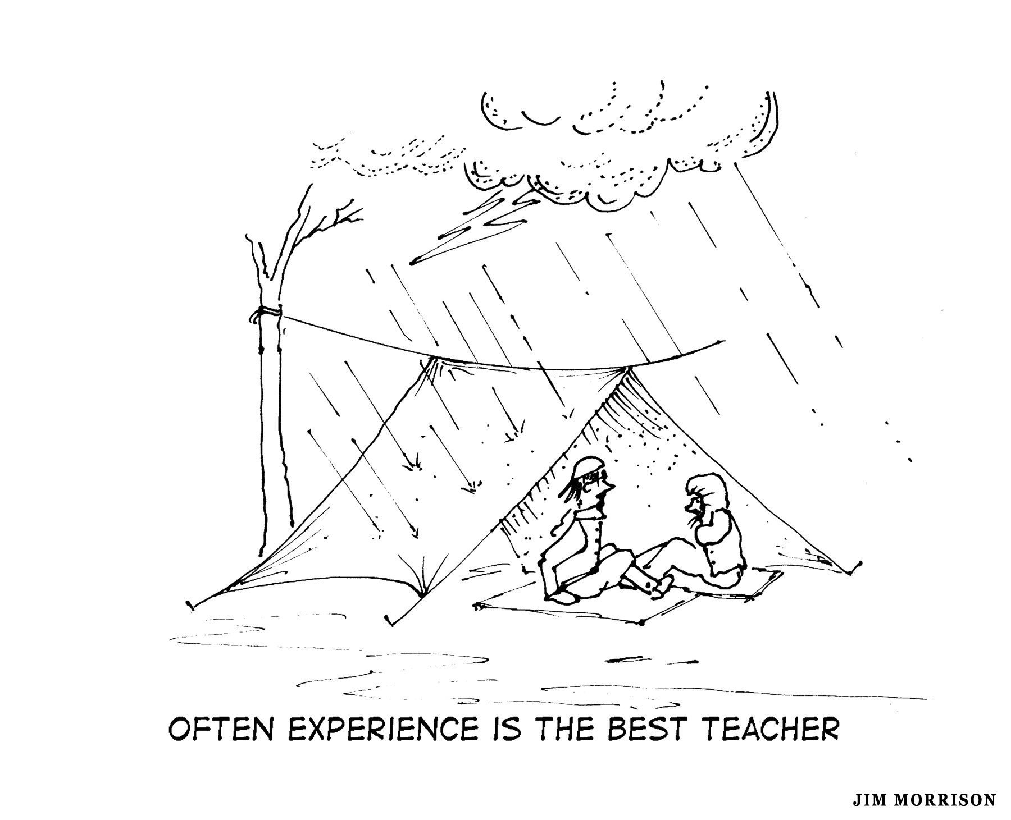
1st Ultralightist Reply - A Rare Occurrence: Hypothermia is rare among experienced hikers and backpackers whether they are packing light or heavy. Generally, it is a problem with those inexperienced in the ways of the mountains who go out with little or nothing in their packs. This debate started with the assumption that we are dealing with experienced and skilled outdoors people.
2nd Ultralightist Reply—Easy to Deal with Adversities: When packing light, you can usually move quickly to lower and warmer and more protected areas. In more serious situations, you can stop, prepare hot drinks, set up a tarp, and get into a sleeping bag if necessary to avoid getting chilled. If day hiking, you can get back to the vehicles more quickly with less fatigue. In addition, it is a good idea to always have warm, dry clothes in the trailhead vehicle for such emergencies, especially if you need to go back out to help companions.
3rd Ultralightist Reply—Reduced Threat: Whether day hiking or backpacking, packing light means less fatigue, less sweating and less need for calories and water which, when combined together, will significantly reduce the threat of hypothermia. Experienced hikers know that they need to stop regularly to rest and eat and drink which will also reduce the threat.
4th Ultralightist Reply—More Conservative Decisions: Maybe most important is the fact that because of the lighter gear and less fatigue, there is a higher likelihood of making better decisions to stay out of trouble. In addition, Ultralightists will be more likely to make conservative decisions to avoid the hypothermia problem in the first place simply because they know their style can push the limits. They learn to rely more on skill and knowledge rather than on their gear, especially if the situation is getting out of hand.
Traditionalist Counterreplies to “More Conservative Decisions”: I am glad the Ultralights have raised an important issue here: common sense—sound judgment—good decision-making. The fact is that neither Traditionalists nor Ultralightists have a corner on the market of this essential commodity. Furthermore, hypothermia can come on very quickly and is often not recognized by experienced hikers—even with the most conservative decision-making. One of the symptoms of hypothermia is irrationality and loss of mental function to make accurate self-diagnoses. If other members of the party are not experienced enough to detect hypothermic symptoms, the condition itself will make it difficult to make good decisions. Ultralightists often hike by themselves, which provides little or no feedback from others.

Traditionalists Find Trail Shoes Lacking
Ultralightists almost universally wear lightweight trail shoes, which are the source of several problems: colder and wetter feet, dirtier feet, less side hill traction, more injuries. It is the latter two problems that are of concern in the present context. There is good reason why substantial boots have become the favored footwear in the wilderness.
1st Ultralightist Reply to “Trail Shoes Lacking”: Boots do not prevent injuries and sometimes cause them. Wearers of boots suffer ankle and knee sprains and broken legs similar to those suffered while wearing lighter types of hiking footwear. [Note: See the website article “Boots, Shoes, Sandals or Barefeet?” for another debate that goes into depth on the issue of injuries related to footwear.]
Traditionalist Counterreplies: There is no scientific evidence available to determine the truth of this claim; I doubt any studies have been done regarding the frequency of injury with different types of footwear. More important, the phrase “similar to” does not deal with the issue of frequency. Experience says that wearers of boots will suffer fewer of these types of injuries, especially when off the beaten track, than wearers of lighter footwear.
2nd Ultralightist Reply to “Trail Shoe Lacking”: Let me be more explicit about boots causing injuries, injuries that are often more serious than their alternatives. Instead of merely stumbling over an obstacle when inattentive, boots can cause falls and tumbles; ankle-top fractures are not unheard of among booted hikers. There are several reasons for this phenomenon:
(1) The heavier the footwear, the harder it is to accurately place the feet in rough terrain; with boots, the ankle is not flexible enough to place foot flat when coming down on uneven surfaces.
(2) The heavier the footwear, the less you can feel uneven terrain beneath your feet.
(3) With heavier footwear, the reaction time is slower when the brain signals the body to take evasive action.
(4) Boots have a higher profile than alternative footwear, especially in the heel section; a higher profile provides a less stable platform.
(5) Most people will pay more attention to where they are walking when wearing lightweight trail shoes. I know this is counterintuitive from the traditional approach, but this reasoning makes sense.
Traditionalist Counterreplies: The causes of serious injuries from falling are multiple and my guess is that the type of footwear worn would be near the bottom of the list.

Ultralightists Argue Additional Safety Considerations
Lighter packs provide many safety benefits. They give us the ability to more safely negotiate difficult terrain, to get down to lower elevations and protected areas more quickly in stormy weather and to get out of the way of falling objects (like trees, rocks, avalanches, horses). One lightweight advocate, Charles Lindsey, adds yet another important safety consideration: “A light pack decreases the risk of fatigue related injuries and injuries from undue stress on back, legs, knees and feet.” (“The Philosophy and Practice of Traveling Light in the Backcountry,” backpacking.net)
Traditionalist Replies to Additional Safety Considerations: On the surface, there is some truth in these arguments. However, an underlying issue here is proper conditioning—the importance of conditioning the body and the mind. All hikers, no matter their style, will have problems of the kind related above if they are not in good shape. Most well-conditioned hikers will be able to take evasive action. The “weekend warrior” type who goes all out without much conditioning will be more prone to these safety-related problems no matter the pack weight. It is conditioning, not pack weight, that is at issue.
Ultralightist Counterreplies: The weight of the pack, the level of physical conditioning, one’s mental attitude, one’s genetic material, one’s age, the strength of the party—all of these and more affect the safety considerations mentioned above. However, all else being equal, pack weight is still a significant factor.

Traditionalists Concerns About Solo Hiking
[Moderator’s note: Since the Ultralightist has gotten more space so far in this debate, let’s allow the Traditionalist to have the last word.]
Since I have the last word, I will make the following observation: a good portion (I have no way of judging the actual percentage) of Ultralight hikers I have seen or heard about are doing much of their hiking solo which is itself a serious safety consideration. Solo hiking and backpacking is a high-risk activity, especially if one spends much time off-trail in the high country.
Ultralightist Reply to Concerns About Solo Hiking: I would love to reply in depth, but will graciously allow the Traditionalist to have the last word. However, keeping quiet is really hard, note that two other articles available on this website (“How Dangerous Is Solo Hiking, Really?” and “Strategies For Solo Hiking”) deal in depth with the subject of safely hiking and backpacking solo.]

Who Won the Debate?

In my considered opinion, no one has won the debate so far (it could be carried much further with even more detail). Each philosophy has provided many reasonable arguments and positions. Even if one doesn’t agree, this debate format is a good way to bring the fundamental issues out into the light of day.
In more general terms, both sides tend to focus too much on the extremists (a common problem in debates on controversial subjects). For example, if the Ultralightist is right on your tendencies to carry “everything but the kitchen sink,” then the Ultralightist wins that line of argument. However, most experienced Traditionalists are concerned about weight and are quite careful about not overloading themselves.
What about carrying necessary emergency and survival gear? In my judgment, the Ultralightist has effectively answered most of the criticisms regarding this safety issue. However, if you are an experienced hiker but often leave home without some of the “essentials” in order to go fast and light (another extremist position), then I think the Traditionalist wins that line of argument. If the shoe fits, put it on.
Who won the debate regarding the gear failure issue? The Ultralightist handled these criticisms with ease unless one has a “penny-pinching” personality and buys much of their gear at thrift and secondhand stores.
What about the issue of hypothermia? The Traditionalist raises some serious concerns about the hypothermia potential for Ultralightists. In my judgment, the Ultralightist has effectively answered most of these concerns. However, if one does not stop regularly for food and drink and rest, if one doesn’t carry much calorie rich food, if one doesn’t take the time to add or subtract layers, if one tries to complete their objectives (“fast and light”) no matter the conditions (i.e., holds a more extremist position), then the Traditionalist wins that line of argument.
If viewed from the perspective of different types of trips with different goals and contexts, then both win the debate. Most wilderness travelers acknowledge that there are some situations where going “fast and light” is quite appropriate and other situations where it would be irrational to do this. My basic philosophy is to be a “situationalist”. This approach is explained in the next section.
Consider Adopting a “Situationalist” Ethic
Extreme Ultralight? Superultralight? Ultralight? Lightweight? Conventional? Heavyweight? Which of these philosophies make the most sense and best fits my style? Instead of adopting just one of these philosophies or styles, consider adopting most of them. Theoretically at least, one person could qualify for most of these labels or definitions, depending on the time of year, the location, the goals of the trip, etc. In other words, why not adopt a “Situationalist” philosophy? The Situationalist packs according to all the variables, especially the conditions that will likely be encountered. The Situationalist packs according to need, not to hit some target weight. Here are most of the situations that should have an impact on pack weight, for the situationalist:

- Time of year, current weather patterns and weather predictions.

- Goals and target activities (e.g., leisurely with lots of time around camp or more aggressively with lots of miles to cover each day; doing mainly day trips from base camp or carrying full packs most of the time).

- Distance from the trailhead; proximity of escape routes if weather turns bad

- Length of time out in the backcountry

- Type and difficulty of the terrain (e.g., the amount of off-trail travel above the treeline)

- Size, strength and experience of the party

- Knowledge of first aid and wilderness survival techniques

- Knowledge of the terrain

- Knowledge, skill and experience level with backpacking in general and with LWP techniques specifically.

- Personal responsibilities to a group (e.g., team leader; most experienced first aider; close friend)

- Height, weight and body fat

- Age and gender

- Metabolism and warmth needs (some can get by with little food or clothing)

- Safety and functionality of dual use items (e.g., a poncho tarp for shelter and storm gear; extra socks for mittens and pack strap padding).

- Level of physical conditioning

- Physical or mental problems being dealt with; predominant mental attitude and comfort zone

- Amount of time, money and energy to research, purchase and experiment with LWP gear and techniques.

With these considerations in mind —wow, a lot of them—an Extreme or Minimalist approach might work well in hot and dry climates (e.g., the Southwestern desert regions). A “Superultralight” or “Ultralight” approach might work well in midsummer in lower elevations (e.g., hiking the Appalachian Trail), especially involving experienced wilderness travelers in good physical condition. Such approaches are probably not appropriate when planning a multiday, solo trek in the fall on the exposed northern sections of the Pacific Crest Trail (PCT) or the Continental Divide Trail (CDT) when driving rain and snow storms could pin one down for several days.
Why would one use the phrase “Situationalist Ethic” as the focus for this philosophy? Simply because most hikers and backpackers do have family, friends, coworkers, etc., who care very much about what happens to the hiker, and whose lives would be seriously impacted if the worst happens. In addition, there is the impact on emergency personnel if one gets into serious trouble. Because of these potential impacts and conflicts, this is very much an ethical matter that deserves careful consideration from an ethical point of view.
For loved ones, perception is often as important as the reality. In other words, can you convince loved ones that you have the gear, skills, experience and mental toughness to deal with emergency situations that might come up given your chosen pack weight and style of hiking?

Final Thoughts
As this debate should show, the relationship of pack weight to safety is complicated. There are no obvious answers. Each must search out their answers based on experience combined with sound arguments and judgments.
The Ultralight approach can appear extreme when first confronted with it. I vividly remember one hot summer day coming down from an overnight at Upper Lena Lake in the Olympics carrying 25 pounds or so of base pack weight and meeting a young, slender Ultralightist going up the trail carrying 5-8 pounds. He said he was out for 3-4 days, much of it off-trail in the wilderness, eating only cold food and sleeping for brief periods only in the clothes that he carried and using only a light bivy sack for shelter. At the time, I couldn’t conceive of this scenario. I now understand how it might be possible to do this safely under the right conditions.
If this debate brings up new perspectives and considerations regarding safety and survival, I have succeeded with this article. If you decide to experiment with lighter loads, do it gradually; experiment with what works and does not. The pendulum on this issue of pack weight will likely swing back and forth many times before you reach the limits of your backpacking comfort zone.
The second piece of advice: Get Out of Thy Comfort Zone! Comfort, and safety and security are definitely an obsession in our society. (For example, we often measure 911 responses in minutes.) Make sure your choices on this issue are your own and not the subconscious voice of the society in which you were raised. Consider reviewing the website document Getting out of One’s Comfort Zone for numerous reasons to follow this advice.

*************************

Legal Disclaimer: Nothing in this website article can substitute for experience, careful planning, the right equipment, and appropriate training. There is inherent danger hiking and backpacking and viewers must assume full responsibility for their own actions and safety. The Author will not be responsible for the safety of those who visit this site.

Mark and two other climbers had made the third ascent of the Czech Direct route on Denali in 60 hours going light without tents or bivy gear.

