The Cosmos Theatre presents a Staged Reading of

L’EBREO
(The Jew)

A Carnival Comedy from 1614 by
Michelangelo Buonarotti the Younger

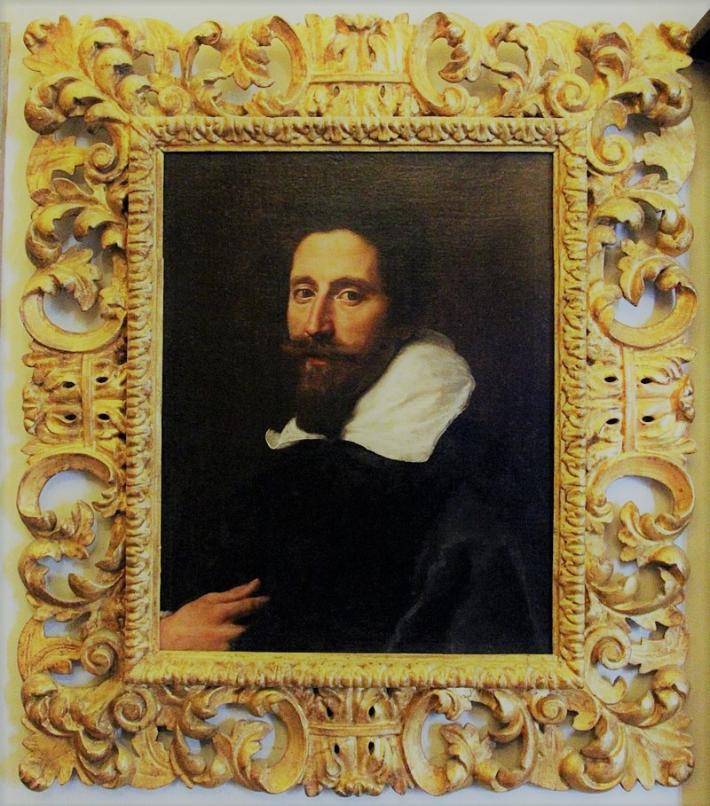

SATURDAY MARCH 23, 2019
11:30 AM
WARNE LOUNGE
COSMOS CLUB

Adapted by: Edward Goldberg
Directed by: Tarpley Long
Executive Producer: Anthony E. Gallo

CAST:
MONNA SIMONETTA TARPLEY LONG
ALAMANNO TOLOSINI STANLEY CLOUD
DIANORA TOLOSINI GLORIA RALL
ORETTA TOLOSINI SOPHY BURNHAM
LUCIA LEONORE SALZMAN
RIHA BEATRIX WHITEHALL
GIOVANNI BARBA MILES BENSON
GIROLAMO AMIERI RICHARD WAUGAMAN
AMBROGIO BORDONI MARK YOUNG
FEDERIGO RODNEY ROSENSTEIN
MELCHISEDEC GEORGE SPENCER
UNDERSTUDY BUNTY KETCHUM
SOUND DIRECTOR BEATRIX WHITEHALL

PLACE AND TIME:
Florence, in 1614, during the Carnival season.
The story unfolds—scene after scene—in the course of a single day.

ACT ONE
SCENE 1 A FLORENTINE STREET
SCENE 2 THE HOME OF GIROLAMO AMIERI
SCENE 3 THE HOME OF AMBROGIO BORDONI
SCENE 4 IN THE STREET
SCENE 5 THE HOME OF ALAMANNO TOLOSINI
SCENE 6 THE HOME OF AMBROGIO BORDONI
SCENE 7 THE HOME OF ALAMANNO TOLOSINI
SCENE 8 ON THE PONTE VECCHIO
SCENE 9 IN THE STREET
SCENE 10 THE HOME OF ALAMANNO TOLOSINI

FIFTEEN MINUTE INTERMISSION: DESSERT, FRUIT, COFFEE AND TEA WILL BE SERVED

ACT TWO
SCENE 1 IN THE STREET
SCENE 2 MELCHISEDEC’S HOME IN THE GHETTO
SCENE 3 IN THE STREET
SCENE 4 IN THE STREET
SCENE 5 UPSTAIRS IN THE TOLOSINI HOME
SCENE 6 UPSTAIRS IN THE TOLOSINI HOME
SCENE 7 ELSEWHERE IN THE TOLOSINI HOME
SCENE 8 IN THE STREET
SCENE 9 UPSTAIRS IN THE TOLOSINI HOME
SCENE 10 THE HOME OF GIROLAMO AMIERI
SCENE 11 THE HOME OF ALAMANNO TOLOSINI
SCENE 12 IN THE STREET
SCENE 13 THE HOME OF AMBROGIO BORDONI
SCENE 14 IN THE STREET
SCENE 15 IN THE STREET
SCENE 16 MELCHISEDEC’S HOME IN THE GHETTO
SCENE 17 IN THE STREET

ABOUT L’EBREO:
A world première, no less! This rollicking comedy— with a Jew in the title role—was written for the Carnival of 1614 at the Medici Court, by Michelangelo Buonarroti the Younger (great-nephew, heir and namesake of the celebrated painter, sculptor and architect).

“Think Molière,” says Tony Gallo (’93), who is directing the staged reading, “but better!” Buonarroti (1568-1646) and Moliere (1622-73) were both intrigued by the Italian commedia dell’arte, with its manic energy, exaggerated characters and preposterous conflicts. But what is a Jew doing in the midst of this comic mayhem—especially a Turkish Jew named Melchisedec (“King of the Righteous”), with a turban, a long robe and a hennaed beard?

“1614 was a wild time in the Tuscan capital,” Goldberg explained, “especially when it came to the Jewish population. Rich Sephardic merchants were arriving from the Ottoman Empire, forming a small but exclusive circle in the local ghetto. With their exotic dress, foreign manners and evident wealth, they seized everyone’s attention—in the streets of Florence and at the Medici Court.”

Ed Goldberg is a Washington native with a Ph.D. from Oxford. For most of the last forty years, he has lived in Florence, exploring public and private archives. Along the way, he published various books and articles, including Jews and Magic in Medici Florence and A Jew at the Medici Court (both University of Toronto Press, 2011).

What about Michelangelo the Younger’s play, L’Ebreo (The Jew)? Goldberg discovered the autograph manuscript in the Casa Buonarroti, that family’s historic palazzo, only a few blocks from his own home. In scene after raucous scene, we see Melchisedec—a classic Levantino (Jew from the East)—surrounded by boisterous characters from the commedia dell’arte: impetuous young lovers, overbearing elders, riotous servants and gossipy neighbors, plus a pompous lawyer and a scheming marriage broker. We watch them trip over each other’s feet in the mad whirl of the Florentine Carnival, the annual silly season between Epiphany (Twelfth Night) and Lent.

“Melchisedec is the ultimate anti-Shylock”, Goldberg observed. “Ironic but good-natured. Always in on the joke.” “Buonarroti was far less tolerant, when it came to lawyers,.” Gallo noted with a laugh. “If there are ‘bad guys’ in the piece, it’s them!”

Brilliant and lively, richly evocative of Late Renaissance Florence, L’Ebreo (The Jew) seems like a guaranteed hit. So, why did it have to wait four hundred years for its début on the world stage?

“No one could read it!” Goldberg sighed. “Buonarroti abandoned L’Ebreo as a scrawled draft, with a dense overlay of cross-outs and rewrites. Thank God for high-resolution photography! Thank God for image-enhancement!”

With L’Ebreo (The Jew), Goldberg faced a triple challenge. First he had to retrieve the author’s own words. Next, he needed to delve beneath layers of revision to reveal the play’s dramatic core. Only then could he shape this material into a performable script—in English—while preserving the sound and sense of the original.

