BOARD NOTICES
RULES. YOU MAY NOT LIKE THEM, BUT YOU STILL MUST LIVE BY THEM.

Who do you think breaks the most rules here in Medvil? The new folks, who may not be fully versed in all the rules and what it means to be in a cooperative? Or the folks who have been here for a long time and don’t always remember to check the rules or who may feel that living here for an extended period entitles them to do what they want, when they want…forgetting what it means to live in a cooperative?

We’re not sure. But we want to remind everyone about a few of the rules that seem to be the hardest to follow, regardless of the reason why.

- Don’t cut trees! Trees are community property. You can trim your shrubs and bushes but the large trees in front of your house are our responsibility. Yes, we are behind with the trimming but there is a plan in the works to get the trees trimmed, and dead or diseased trees removed. We don’t always work on the schedule folks think we should but rest assured, trees are part of a bigger plan that we will talk about in the coming months.

- Pick up after your dog! Need we say more? It appears we do. Don’t let your dog urinate on other people’s lawns! The smell attracts other dogs and before you know it, your neighbor has a large, dead brown spot on their lawn. Your lawn or some sandy spot along Constitution is the perfect spot to let your dog “make his mark.”

- There is no overnight parking in the street here in Medvil…ever. That goes for parking your boat or your camper in the street overnight before leaving on a trip; if it doesn’t fit in your driveway it must be parked in the designated area on Constitution or in the lower storage area.

- And along with that…campers or RVs should never be used to house families or friends who come to visit; either on Constitution or in your driveway.

- Never park on your lawn; park on driveways only.

- The speed limit in our community is 15 mph; not 25 or 30 but 15 miles per hour. Be sure to let your family know and advise anyone who visits on a regular basis always to be mindful of their speed.

- With fall quickly approaching please take a moment to survey your home, shed, and if necessary, your carport and make sure any painting or home repairs that need to be done gets done before the weather prevents it. Our rules require all homes will be maintained in good condition, in keeping with the general appearance of the community and incomplete skirting, broken windows or shutters, unfastened trim boards, non-painted surfaces, siding or skirting with mildew is not allowed.

- And finally, having friends and family visit is great but more than 30 days is considered residency, which requires board approval.
So, whose rules are they anyway? Not the board’s, we are just elected to enforce them. These are resident-approved rules for reasons of preserving the value of what for many of us is our greatest personal asset. Medvil is a sought-after community to live in. Not because we have too many rules, but mainly because we have rules that preserve the value of homes and we are a pleasant place to live. We all have a stake in the rules being followed. Please be considerate of your neighbors and your elected, volunteer board members.

Thank you.
Your Board of Directors

FEWER THAN HALF

That’s the estimated number of homes who receive email blasts from Medvil. These blasts contain information about upcoming events, notices of changes to trash and recycle pick-up and just about anything that impacts the residents of Medvil.

If you haven’t provided us with your email address, please send a message to medvil@comcast.net; give us your name and ask to be placed in the email blast group. It’s that simple.

Thank you.
Karen Kirkpatrick, Secretary
OTHER NOTICES
WANTED—OFFICE VOLUNTEERS
We are looking for office workers for the front office of the Donald Drive Clubhouse. Simple administrative work (answering the phone, helping people who come into the office with questions, keeping things organized in the office. Morning work is 9 AM to 12:30 PM. Afternoon is 12:30 to 4 PM. You would work one day a week in the morning OR afternoon. There will be training so you can learn what you need.

If interested in learning more call Kathy Parry at 603-867-4871 and I will be glad to meet with you.

MEDVIL HAS A NEW SUNSHINE LADY!

A big round of applause for Linda Robinson who has graciously volunteered to continue the tradition of our Sunshine Lady. Many thanks to Jan Soucy who, after dedicating many years of mailing hundreds of cards to residents and their families, has ‘passed the baton’ to Linda.

For those of you who are new to our community, the Sunshine Lady sends cards of condolences to those who have lost members of their immediate family; she also sends many get well cards to individuals who are sick; who may be in the hospital or who find themselves in a long term care facility working on their rehab.

If you know of someone who is ill and could use a bit of cheering up, please call Linda at 851-5209 and let her know.

FLU VACCINE CLINIC

The Flu Vaccine clinic will be held on Thursday, 10/17 from 11:30 –1:30 pm upstairs at the PLC. Call Irene Gagne @ 622-1869 to be on the list, assigned a time, and to get your paperwork. See notices in the mail houses for more details. Provided by the VNA, this has been a very popular benefit to the residents The VNA needs to bring the right amount of the vaccine, so please call as soon as possible if you want to attend. IG

MONDAY NIGHT CRIBBAGE CLUB

A reminder that the Monday night cribbage starts on 9/2 to play for fun & learning at PLC from 6:30 pm to 8 pm. Anyone interested in joining the group should arrive by 6:15 pm. Contact Irene Gagne at 622-1869 if you have any questions. We play until the end of March and there is no cost. IG

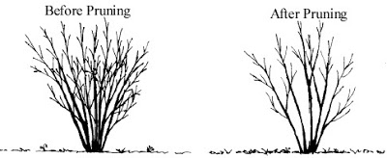
DID YOU KNOW. . .

. . .that the shrubs in your yard will be healthier, more attractive and grow within more predictable bounds if you learn to train and maintain them with a few well-placed pruning cuts once a season? Well, we have even more good news for you: one of Medvil's avid gardeners will be more than happy to pay you a visit and show you exactly how to get those shrubs under control! It's easier than it sounds--Jane even managed to teach me! Call Jane Von Geldern at 603-727-8226 and--this is important--LEAVE A MESSAGE for her to get back to you. A lovely yard can be yours! (If you don't believe me, ask to see Jane's!) MBW
BOARD & COMMITTEE
REPORTS

BOARD OF DIRECTORS

The eighth 2019 meeting of the Medvil Board of Directors began on August 20 at 6:01 with the Pledge of Allegiance.

Initial member Comments included questions about an apparently diseased maple, a colony of invasive purple loosestrife, and maintenance of the frog pond.

The Treasurer's Report was accepted with no discussion. Both income and expenses were slightly higher than budgeted. The Finance Committee has completed the 2020 budget which will be reviewed at a dedicated special board meeting on October 8 at 5:00 PM, following that month's Finance Committee meeting.

The Secretary's Report was approved with six votes for and one abstention. No changes were made to the July minutes.

The Operations Report began with a request for permission to install a small freestanding storage locker for garden tools on a small lot. After discussion, the request was approved.

The Donald Drive Clubhouse lower level restroom facilities are now usable. Further construction in the kitchen area faces a short delay until the new counter is delivered for installation.

There was discussion about choosing the vendor for installation of new pedestals next year. Drainage issues at Kelly Court were addressed. Discussion about in-house and vendor repair tasks and vendor quotes. Dig Safe will be invited before requests for quotes go out.

Security at the clubhouses was discussed. The locks are left unlocked too often after people rent space. Various new procedures and locking equipment were considered, and research will be conducted for a new lock system as a possible fix.

At least three quotes for bathroom cleaners for the club houses will be procured and considered.

The board is interviewing for and considering making an offer to a potential new hire for our maintenance team. There was considerable discussion.

Roger Bruneau, who has been voluntarily maintaining The Frog Pond, has requested support from maintenance. In the past he has performed all the upkeep with help from volunteers. The board will get quotes from landscapers competent in pond care to augment our dwindling volunteer network. Thank you, Roger!

Safety vests for volunteers are under consideration, and/or an A-frame sign to indicate volunteers at work. Some residents have confronted volunteers about their activities; vests, etc. will allow residents to differentiate between rogue workers and those with authority to perform on-site tasks.

A "No Outlet" sign was requested for Williams Way. Occasionally non-residents drive through looking for a shortcut to neighboring developments, and depart the cul-de-sac speeding. Much discussion with no final decision at this time.

Continued speeding problem: After long discussion, the board voted to buy two temporary speed bumps to be moved around to areas where people tend to speed. These will supplement our permanent speed bumps.

Membership report included three new memberships and one additional home resident. All had been board approved by email and ratification was unanimous.

Sonja presented a resident’s question about rules on freestanding solar panels. (Solar panels are not yet light enough to work on most roofs in Medvil.) The discussion was tabled pending additional consideration.

Events Committee has a number of projects in the works, watch for announcements!

The Election Committee has candidates for every board position that will have an opening.

Old Business: Our Fundraising Committee asked for and received permission from the board to sell items directly on EBay instead of selling only through consignment stores. A motion with several stipulations was made to allow such sales and it passed with five votes For and two Abstentions.

New Business: The board discussed plans for the annual meeting and the timing to get candidate information into the newsletter in time to be distributed in October.

The distinction between service animals and emotional support animals was read out and discussed. Service animals must be accepted into the cooperative. Only dogs and miniature horses can legally be so designated. Emotional support animals have no legal protections.

Speeding and enforcement were discussed, as were speed limit signs and a bump on Country Way.
Outsourcing landscaping was discussed and needs further investigation. The board has had difficulty getting vendors because of the low unemployment in the state. A landscaper would not replace our volunteer gardeners.

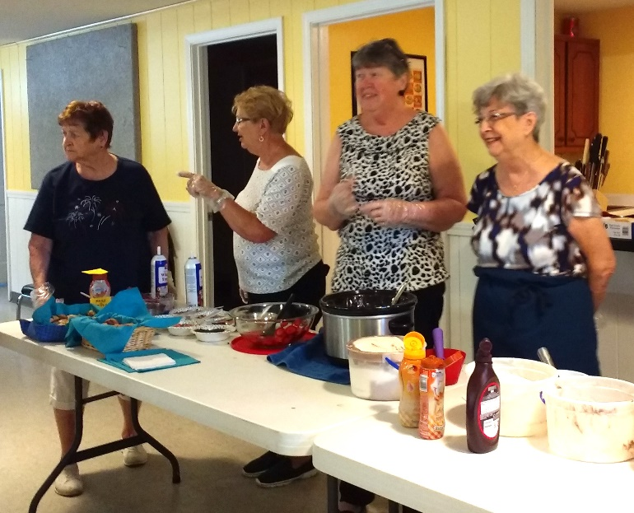
Final member comment period included a suggestion for signs with "Slow--Pedestrians Walking" and crosswalks painted at intersections to help reduce speeding. This met with some support by the board, who also suggested large entrance signs inscribed "15 MPH Speed Limit Throughout the Community."

Motion to end the meeting was made and approved without dissent at 7:49 PM August 20, 2019 and the Board went into executive session.

Alyn Miller reporting
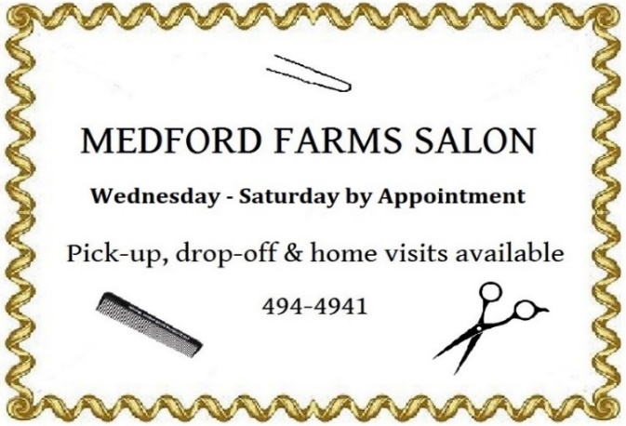
Ice cream, anyone?

EVENTS COMMITTEE UPDATE
Wow, what a busy summer we've had, and it isn't nearly over yet!
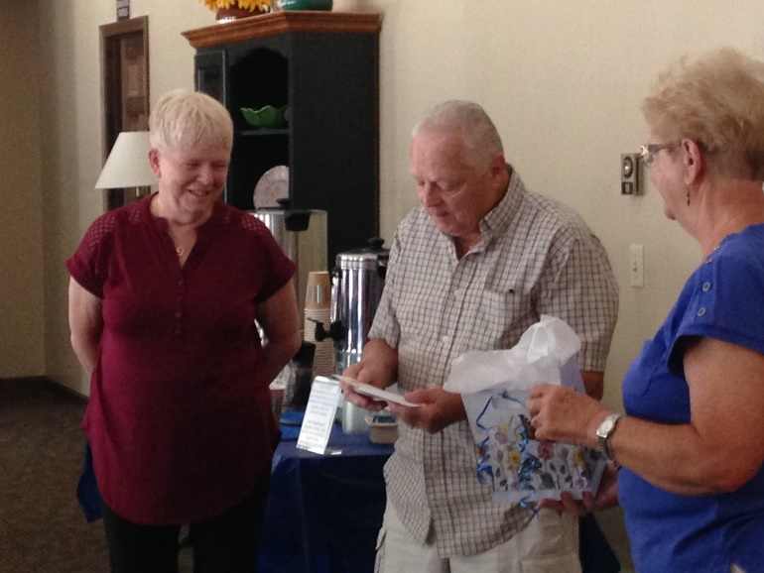
In addition to the great Yard Sale on June 22 and 23, our wonderful community enjoyed an Ice Cream Social at the Donald Drive Clubhouse on June 30; we had a total of 84 people attend this scrumptious afternoon treat that was provided free to our residents through the hard work of all the dedicated workers on the Events Committee. An added treat was a lively performance by the Medvil Strummers. Yvonne Gosselin won the 50/50 drawing—congratulations, Yvonne!

The Fish Fry on July 12 was a huge success. We served 114 meals, with Kim and his crew slaving away over the deep fryers to get the delicious
Blueberry fest with thank-you to the Keoughs

haddock and fries to our wonderful neighbors and friends. Of course, we mustn't forget the tasty homemade coleslaw and tartar sauce—thanks, Kim. Patty Gamache won the 50/50 and Len Stuart won Breakfast for 2 in the Raffle drawing. The Blueberry Festival on July 27 was a big hit. We had so many different tasty contributions that it was difficult to know where to start on the culinary tour. It was also a chance for the Events Committee to thank Steve Keough and his lovely wife Trish for their many years of dedication to the committee and the community. (Don't worry—they'll be back to help with our upcoming Meat Bingo in November!)
Another highly popular free event was the Medvil Strummers concert at Partridge Lane Clubhouse on August 14. The group provided lyric sheets for a lively sing-along and the group of at least 65 attendees enjoyed many tuneful old favorites plus a couple of rousing versions of The Locomotion, including the dance line. Special thanks to the ladies who ventured onto the dance floor (you know who you are....)
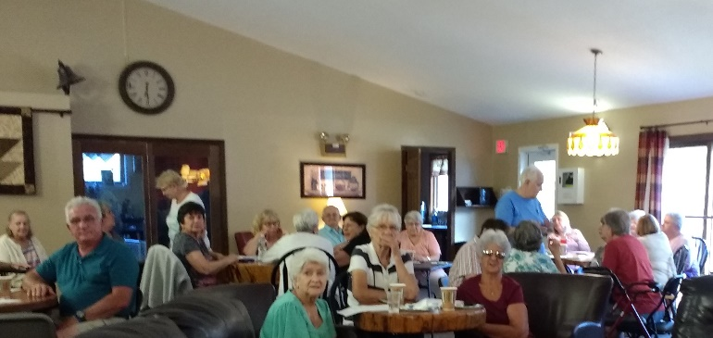
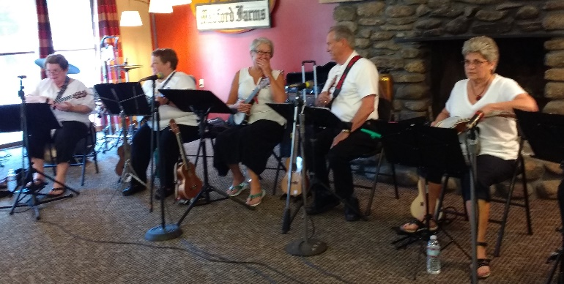
A full house for the Strummers
Medvil Strummers having fun!

Upcoming events are: another Fish Fry on August 23; the Annual Picnic on September 14; Apple Fest on September 28; Beer & Brats on October 5; and the Halloween Party on October 26. Watch this space and the mail houses for more information.
CP

FUNDRAISING COMMITTEE
Homemade blueberry goodies!

Contact Irene Gagne at 622-1869

Fundraising Pool

The 8/1 winner was Yvonne Gosselin for $250. All numbers are being played with a guaranteed winner. There are currently 4 residents on the wait list but more are needed. Please call the office at 497-4440, Option “0” to place your name on the list. It’s only $5/month and you can play more than one number.

Consignment Store/Yard Sale

If you have items to donate please contact Irene. What doesn’t get accepted by the consignment stores will be placed in the 10/5/19 yard sale. If you’re moving out, moving in, remodeling, etc. give us a call. We are willing to help you rid yourself of unwanted items. However, we do not
take electronics, TVs, large appliances, furniture, or exercise equipment.

Fall Festival – 10/5/19
We are already accumulating items for the next yard sale. Our closet is filling fast. If you want to volunteer to help, please call Irene at 622-1869. We are also looking for resident crafters to rent tables for $10 to sell their goods.

Committee Members

We are a committee of 9. We are looking for more members with fresh ideas and help with yard sales.
Ideas Needed

You don’t have to be a committee member to give us suggestions for projects to use our funds for the benefit of the Medvil community – call Irene at 622-1869 with suggestions.
IG

REAL ESTATE COMMITTEE

From June 21 to July 20, 2019, the Real Estate Committee had 17 showings, 5 listings, 3 closings and 1 Purchase & Sales Agreements. From July 21 to August 20, 2019, the Real Estate Committee had 7 listings, 1 closing, 2 Purchase and Sales Agreements. The Committee now has 4 homes for sale at the present time.

If you are thinking of selling your home the first step is to fill out the Intent to Sell form and return it to the office. The second step is to locate a realtor. Please consider Medvil Real Estate to help you sell your home. Sales benefit Medvil community.

Medvil RE Committee - 497-4440 Prompt 2

Website: www.medvilcooperative.com Homes for Sale

Dorrie Kossuth
Chairperson

SINCERE CONDOLENCES

Heartfelt condolences to those who have recently lost a loved one:

We meet them in the lives they’ve shaped. We enjoy them in the jokes and wisdom they’ve passed down. Be active in the community they’ve built. It is a way of walking with them into the future. It is a way of never losing them.
SENIOR SAFETY

STOPPING ABUSE

Steps you can take to prevent elder abuse

Taken, in part, from an article written by Lynn Snierson for the June 2019 edition of NH Magazine.
Have you heard about the latest grandma scam?
The honest answer is, “Which one?” There are so many con jobs to trick vulnerable seniors into handing over their life savings that it’s hard to keep current.
Financial exploitation is but one of the different types of elder abuse, with physical, verbal, emotional and sexual abuse, and neglect and self-neglect as the others, and the effects are devastating and often irreparable. Watchdog groups find there are more than 5 million victims being taken for more than $3 billion each year in the United States through financial abuse alone, and the numbers for all types of abuse cases are climbing even though the widespread problem remains seriously underreported.
New Hampshire is no exception.
“This is a vulnerable population. The victims cut across all socioeconomic and educational levels. Elder abuse of all types can affect anyone and come from anywhere,” says Rachel Lakin, the adult protective services administrator for the New Hampshire Department of Health and Human Services. She adds that in state fiscal year 2018 the agency received 3,156 reports to be investigated because they met the criteria and, of those, 2,456 were for people over the age of 60. “We’re the second-oldest state in the country, and as the population continues to rapidly age, this problem is only going to get bigger.”
The standardized definition of elder abuse is to knowingly commit an intentional or negligent act that causes harm or serious risk of harm to a vulnerable adult. Those working in the banking industry are all too familiar with the fallout.
“We see all the scams. The romance scam, the Publishers Clearing House scam where they think they’ve won a million dollars or are getting a Mercedes, the Sheriff called and is coming to arrest me if I don’t send money to pay back taxes scam. The My grandchild is in trouble scam. All of them,” says Susan Bonenfant, the compliance officer for the Salem Cooperative Bank and its branch across the border in Massachusetts.
“Generally, the scammers tell them to take out the cash from the bank and go to a store and get a money card and then call them with the numbers on the back.”
Federal banking regulations require that suspicious activity involving an elder be reported to the government, but there is no mandate to file a report with elder services. Nonetheless, some financial institutions, from a local bank to a major monetary concern, now have set up guardrails to combat the problem. Bonenfant is a warrior for the senior set.
“We’re not social workers here, but we are hot on the trail looking out for any elder who is taking out an unusual amount of money. There are different red flags. We have a process in place, and although it’s not a policy, it is a guideline for employees to recognize the certain types of elder abuse, exploitation and even the diminishment of their capabilities,” she explains. “I provide all employees with a form to fill out with why they are worried about an elder. We are trained to handle it. We immediately will look at the account activity, talk to the customer and may ask further questions, and then we decide whether a report needs to be made to elder services.”
Isolation and loneliness are open doors to abuse and the telephone often is the weapon. Predatory practitioners know this all too well and are manipulative and controlling when sweet-talking a targeted senior.
“My best advice is don’t answer your phone. I’m serious. I say that to elders all the time. If it’s important and the caller is legitimate, they will leave a message and then you can go back and listen to it when you’re relaxed and not put on the spot, and you can think about it and then decide whether to call back. I promise you, though, you’re not going to want to once you can take a breath and think it over,” Bonenfant says. “If you do answer these calls, don’t engage. Not at all. There is a value to the lists that the scammers sell to each other so, if you answer your phone, you’re on a list that you are a person who may bite and then you have more value. The more you don’t answer your phone, the less value you have to them.”
Experts say that the best defenses against elder abuse of all types are to have open conversations — without lecturing — to raise awareness and empower seniors to report if they have been victimized, and to always check on family, friends and neighbors.
“There is no easy fix to stopping elderly abuse, but awareness is huge. Have those conversations. This is great advice that I share: If you have an elderly person who is vulnerable in any way who you’re concerned about, you should visit them every day. If you can’t visit them every day, you should at least contact them every day. That’s when you’re going to pick up on things they might say like ‘I’ve got a new friend now,’” says Lakin.
“Keep an eye out. Be aware. Pay attention. But in New Hampshire that’s a hard thing. We tend to think inherently that good fences make good neighbors. But looking out for others is a good thing to do.”
MEMBERS’ MISCELLANY
New Hampshire was one of the first states to enact an Adult Protection Statute [RSA 161-F:42-57] and was also one of the first to include mandatory reporting in its law. The reporting requirement, enacted in 2015 and updated since then, is comprehensive and not limited to professionals as it stipulates that all individuals are required to report. Immunity is granted to those who do.
Moreover, in 2016 New Hampshire’s Department of Justice established the Elder Abuse and Exploitation Unit, comprising prosecutor Brandon Garod and victim advocate Sunny Mulligan Shea, to prevent, investigate, and prosecute crimes involving elderly victims of abuse, neglect and financial exploitation on a statewide basis.
“Brandon is doing great work. We collaborate whenever we can. If we have to interview an alleged victim, we often do it together so we’re not putting the person through it twice. It works out well,” says Lakin, who adds victims are often too ashamed, embarrassed, frightened, ill or incapacitated to self-report.
For anyone needing assistance or to file a report, the Elder Abuse Advisory Council of the NH Department of Health and Human Services (dhhs.nh.gov/dcbcs/beas/elderabusecouncil.htm) has 12 district offices statewide from Berlin to Salem and Keene to Portsmouth, and can be contacted at (800) 949-0470 or (603) 271-7014.
After-hours and on weekends and holidays, call local authorities at 911. The New Hampshire Department of Justice unit (doj.nh.gov/consumer/elder-abuse/index.htm) can be reached at (603) 271-3658. All calls are confidential.

A THANK-YOU FROM A NEWCOMER--By Karolina Nolan
Hi. My name is Karolina (Kahroleena or Karleena) and I now live in Medvil at 278 Donald Drive. I taught for over 40 years, 33 at Keeseville Elementary School in northern NY, two at Plattsburgh State, teaching student teachers, and seven part time at Moriah Shock Incarceration Facility. LOVED my jobs. My husband passed in March, and I felt very alone. My daughter had worked for the Elliot as a home care nurse and one of her bases was at Medvil. She said she would call and see about any homes that might be for sale. Thank heaven, there was a house, the one I have now. I went through the process and found out I had been accepted. The interviewing committee was terrific and so friendly for my interview via my tablet, and that night I knew I was making the right decision. I came here on a Saturday from New York State. Took over four hours because of construction, and I cried half the way, just thinking about leaving everything I had known for all my life. The welcoming committee consisted of Denise and her sister, and what a pair they were! I instantly felt at home and welcomed with open arms. I then had to complete the home purchase and I met Paul Morin, the owner, who was so kind to me. It was so difficult for him to sell his pride and joy.
It took about three weeks for me to get settled here. I was worried that perhaps the neighbors wouldn't like me, since they had bonded with Mr. Morin and his wife, but soon after I had thought that, they came and introduced themselves. Carmen, Ellyn, Mr. Santa Claus (Norm) and his wife, Sue. Denise came to visit and I met her husband, John, Sally from the other half of the park came and talked because she knew my daughter, and other people out and about would wave and greet me. When I came here, I had felt so lost and sad because my husband and I did everything together. He was also a jack of all trades. So when I needed someone to check out a wall and floor connected to a bathroom, I called David, another neighbor a few houses away. He came over and told me exactly what was wrong. Irene got me going with the "toenail nurse.” I have yet to meet Irene, but she's been so helpful. At the fish fry, my daughter Isabella and I met a lot of other great people. I just want to extend my thanks to such a wonderful community. I never anticipated such friendliness. A huge thanks, also, to Paul Allard, who always answered my frantic calls when I was still in NY because I wasn't sure if the dryer was hooked to 220. LOL. I love living here and want to thank everyone who made it so comfortable for me to settle in.

The Medvil Messenger encourages members to submit articles for consideration. Recipes, helpful hints, reminiscences, jokes, poems--please keep it upbeat and positive. Due to space considerations, original material will take precedence over reprints from other sources, including printouts of email pass-arounds. If you submit previously published material, please try to cite a source. We reserve the right to reject material that may offend, divide our community or cause political arguments. Please submit your items to our email: medvilnewsletter@comcast.net Or place a copy in the Messenger mailbox in the Reception Office in the DDC.
Deadline for submissions not from the Board is noon the day of the Board Meeting (3rd Tuesdays.) Board submissions deadline is noon of the Wednesday.

Medvil Messenger Staff: Jocelyn Bergeron, Debbie Cyr, and MB. Wulf

Medvil Messenger Writers: Jocelyn Bergeron, Kim Capen, Debbie Cyr, Sonja Fuller, Irene Gagne, John Menczywor, Alyn Miller, Karolina Nolan, Cat Pragoff, Linda Robinson

Special thanks to Irene Gagne for additional proofreading.

