**HOLY SPIRIT LUTHERAN CHURCH**

A Member of the Evangelical Lutheran Church in America, New Jersey Synod

1220 Bayshore Rd., Villas, NJ 08251

609-886-2414

holyspiritlutheran@comcast.net

holyspiritvillas.com

facebook.com/holyspiritvillas

Vicar Vince Piekarski can be contacted at any time for conversation or prayer through call or text at 412-225-0287, or through email at vpie8282@gmail.com.

**THIRD SUNDAY IN LENT**

**SUNDAY, MARCH 23RD, 2025**

**10:30AM WORSHIP SERVICE WITH HOLY COMMUNIO****N** 





We, the Evangelical Lutheran Church of the Holy Spirit, are People of God, who

are called by the Holy Spirit to pray, worship, joyfully proclaim Jesus Christ,

and compassionately witness and serve others in Christian Love.

**AN ESPECIALLY WARM WELCOME TO OUR VISITORS**

We are glad that you joined us for Worship today! Thank you for enriching our time together! We would like to get to know you better, and we would like for you to get to know us better too. Brochures, welcome gifts, prayer shawls, Bibles, and other items are available at our welcome areas. Church members are happy to show you around and share about our ministries. Please don’t hesitate to speak up and ask questions. Please make sure you sign-in on our clipboard on the podium in the lobby.



Our Worship Services are conducted in coordination with our Conference Call.

Join us at 657-390-7423, and if that does not allow you to gain access utilize

701-802-5170, with access code 8221190#. You may need to dial 1 first depending on your phone plan. After logging in please announce your name and feel free to talk with others until we get started with our Worship Service.

**ARE YOU INTERESTED IN CANDLE MEMORIALS?**

Candles cost $10 each. Sign-up sheets are located on the bulletin board between the church offices. Please feel free to see Vicar Vince with any questions.

**SANCTUARY CANDLE**

March’s is given to the Glory of God & in memory of

DONNA GAIN by Jean, Phil, & Bob Zimmerman.

**ALTAR CANDLES**

March’s are given to the Glory of God & in memory of

ED GREEN by Fran Green & Family.

**CONFERENCE CALL CHECK-IN**

(Roll Call and Attendance.)

**WELCOME & ANNOUNCEMENTS**

(Offered by Vicar, Assistant, and Congregation.)

**INTRODUCTION**

A. The warnings are plentiful and blunt on the third Sunday in Lent. Cut it out or get

cut down! The warnings are accompanied by God’s invitation to attentiveness:

“Incline your ear, and come to me; listen, so that you may live.” The landowner’s

ultimatum is forestalled by the gardener’s readiness to till the ground one more

year. That is good news for all of us. Thanks be to God!

**PRELUDE**

(Music offered by our Organist before the start of our Worship Service.)

**Andante Tranquillo**

**CHIMES**

(Music offered by our Organist before the start of our Worship Service.)

**Blessed Assurance**

(We invite you to stand as you are able.)

**CONFESSION & FORGIVENESS**

(All may make the sign of the cross, the sign that is marked at baptism.)

V. Blessed be the holy Trinity, **☩** one God,

who forgives all our sin,

whose mercy endures forever.

**C. Amen.**

V. Let us return to God, confessing our sin in the assurance of God’s abiding love.

(Silence is kept for reflection.)

V. Compassionate One,

**C. you are slow to anger and abounding in steadfast love,**

**but our lives do not always reflect you**

**and your love for the world.**

**We do not show others the tender compassion**

**you have shown to us.**

**We do not welcome others with the radical hospitality**

**you grant to all people.**

**We oppress others,**

**even though you have set us free again and again.**

**We squander the abundant gifts of the earth.**

**Transform our lives**

**and guide us again in the way of the cross.**

**Amen.**

V. Beloved in Christ,

God’s arms are always stretched open wide

to welcome the wandering ones home.

In **☩** Christ your sins are forgiven.

You have a place in God’s house forever.

**C. Amen.**

(We invite you to remain standing as you are able.)



**GATHERING HYMN**

(We invite you to sing along with the music offered by our Organist.)

Lutheran Book of Worship—Green Book

**467—Eternal Father, Strong to Save**

**APOSTOLIC GREETING**

V. May the grace of our Lord Jesus Christ, the love of God,

and the communion of the Holy Spirit be with you all.

**C. And also with you.**

**KYRIE**

V. In peace, let us pray to the Lord.

**C. Lord, have mercy.**

V. For the peace from above, and for our salvation, let us pray to the Lord.

**C. Lord, have mercy.**

V. For the peace of the whole world, for the well-being of the church of God,

and for the unity of all, let us pray to the Lord.

**C. Lord, have mercy.**

V. For this holy house, and for all who offer here their worship and praise,

let us pray to the Lord.

**C. Lord, have mercy.**

V. Help, save, comfort, and defend us, gracious Lord.

**C. Amen.**

**PRAYER OF THE DAY**

V. The Lord be with you.

**C. And also with you.**

V. Let us pray,

Eternal God, your kingdom has broken into our troubled world through the life,

death, and resurrection of your Son. Help us to hear your word and obey it, and

bring your saving love to fruition in our lives, through Jesus Christ, our Savior and

Lord, who lives and reigns with you and the Holy Spirit, one God, now and

forever.

**C. Amen.**

(We invite you to be seated for our Readings and Psalm.)

**FIRST READING**

To those who have experienced long years in exile, the return to their homeland

is a celebration of abundant life. God calls them into an everlasting covenant of

love. Those who return to God will enjoy new life and forgiveness, because God’s

ways are not our ways.

R. Our First Reading is from the 55th Chapter of Isaiah (Verses 1-9).

R. 1 Hear, everyone who thirsts;

   come to the waters;

  and you who have no money,

   come, buy and eat!

 Come, buy wine and milk

  without money and without price.

 2 Why do you spend your money for that which is not bread

  and your earnings for that which does not satisfy?

 Listen carefully to me, and eat what is good,

  and delight yourselves in rich food.

 3 Incline your ear, and come to me;

  listen, so that you may live.

 I will make with you an everlasting covenant,

  my steadfast, sure love for David.

 4 See, I made him a witness to the peoples,

  a leader and commander for the peoples.

 5 Now you shall call nations that you do not know,

  and nations that do not know you shall run to you,

 because of the Lord your God, the Holy One of Israel,

  for he has glorified you.

 6 Seek the Lord while he may be found;

  call upon him while he is near;

 7 let the wicked forsake their way

  and the unrighteous their thoughts;

 let them return to the Lord, that he may have mercy on them,

  and to our God, for he will abundantly pardon.

 8 For my thoughts are not your thoughts,

  nor are your ways my ways, says the Lord.

 9 For as the heavens are higher than the earth,

  so are my ways higher than your ways

  and my thoughts than your thoughts.

R. This is the Word of the Lord.

**C. Thanks be to God.**

**PSALM**

R. Our Responsorial Psalm is from the 63rd Psalm (Verses 1-8).

**C.** **O God, eagerly I seek you; my soul thirsts for you.** (Ps. 63:1)

R. 1 O God, you are my God; eagerly I seek you;

   my soul thirsts for you, my flesh faints for you, as in a dry and weary land

where there is no water.

  2 Therefore I have gazed upon you in your holy place,

   that I might behold your power and your glory.

  3 For your steadfast love is better than life itself;

   my lips shall give you praise.

  4 So will I bless you as long as I live

   and lift up my hands in your name.

**C. O God, eagerly I seek you; my soul thirsts for you.** (Ps. 63:1)

R. 5 My spirit is content, as with the richest of foods,

   and my mouth praises you with joyful lips,

  6 when I remember you upon my bed,

   and meditate on you in the night watches.

  7 For you have been my helper,

   and under the shadow of your wings I will rejoice.

  8 My whole being clings to you;

   your right hand holds me fast.

**C. O God, eagerly I seek you; my soul thirsts for you.** (Ps. 63:1)

**SECOND READING**

Paul uses images from Hebrew Scriptures and prophecy to speak the truth of

Jesus Christ: He is our rock, our water, our food, and our drink. Christ is the living

sign of God’s faithfulness.

R. Our Second Reading is from the 10th Chapters of 1st Corinthians (Verses 1-13).

R. 1 I do not want you to be ignorant, brothers and sisters, that our ancestors were

all under the cloud, and all passed through the sea, 2 and all were baptized into

Moses in the cloud and in the sea, 3 and all ate the same spiritual food, 4 and all

drank the same spiritual drink. For they drank from the spiritual rock that followed

them, and the rock was Christ. 5 Nevertheless, God was not pleased with most of

them, and they were struck down in the wilderness.

6 Now these things occurred as examples for us, so that we might not desire evil

as they did. 7 Do not become idolaters as some of them did, as it is written, “The

people sat down to eat and drink, and they rose up to play.” 8 We must not

engage in sexual immorality, as some of them did, and twenty-three thousand fell

in a single day. 9 We must not put Christ to the test, as some of them did, and

were destroyed by serpents. 10 And do not complain, as some of them did, and

were destroyed by the destroyer. 11 These things happened to them to serve as

an example, and they were written down to instruct us, on whom the ends of the

ages have come. 12 So if you think you are standing, watch out that you do not

fall. 13 No testing has overtaken you that is not common to everyone. God is

faithful, and he will not let you be tested beyond your strength, but with the testing

he will also provide the way out so that you may be able to endure it.

R. This is the Word of the Lord.

**C. Thanks be to God.**

V. I invite you to stand as you are able, and I invite you to announce the Gospel

Acclamation with me.

**GOSPEL ACCLAMATION**

**C. Jesus began to proclaim, Repent, for the kingdom of heaven has come**

**near.** (Matt. 4:17)

**GOSPEL READING**

Asked about current tragic events, Jesus turns a lesson about whether suffering

is deserved into a hard call to obedience. He then tells a parable that holds out

hope that the timeline for ultimate judgment will be tempered by patience.

V. The Holy Gospel According to Luke, the 13th Chapter (Verses 1-9).

**C. Glory to you, O Lord.**

V. 1 At that very time there were some present who told Jesus about the Galileans

whose blood Pilate had mingled with their sacrifices.2 [Jesus] asked them, “Do

you think that because these Galileans suffered in this way they were worse

sinners than all other Galileans? 3 No, I tell you, but unless you repent you will all

perish as they did. 4 Or those eighteen who were killed when the tower of Siloam

fell on them—do you think that they were worse offenders than all the other

people living in Jerusalem? 5 No, I tell you, but unless you repent you will all

perish just as they did.”

6 Then he told this parable: “A man had a fig tree planted in his vineyard, and he

came looking for fruit on it and found none. 7 So he said to the man working the

vineyard, ‘See here! For three years I have come looking for fruit on this fig tree,

and still I find none. Cut it down! Why should it be wasting the soil?’ 8 He replied,

‘Sir, let it alone for one more year, until I dig around it and put manure on it. 9 If it

bears fruit next year, well and good, but if not, you can cut it down.’ ”

V. This is the Gospel of the Lord,

**C. Praise to you, O Christ.**

(We invite you to be seated.)

**SERMON**

(Delivered by Vicar Vince Piekarski.)

(Following the Sermon, we invite you to stand as you are able.)



**HYMN OF THE DAY**

(We invite you to sing along with the music offered by our Organist.)

Lutheran Book of Worship—Green Book

**327—Rock of Ages, Cleft for Me**

**APOSTLES’ CREED**

V. God has made us his people through our Baptism into Christ. Living together in

trust and hope let us confess our faith together using the Apostles’ Creed.

**C. I believe in God, the Father almighty,**

**creator of heaven and earth.**

**I believe in Jesus Christ, God’s only Son, our Lord,**

**who was conceived by the Holy Spirit,**

**born of the Virgin Mary,**

**suffered under Pontius Pilate,**

**was crucified, died, and was buried;**

**he descended to the dead.**

**On the third day he rose again;**

**he ascended into heaven,**

**he is seated at the right hand of the Father,**

**and he will come to judge the living and the dead.**

**I believe in the Holy Spirit,**

**the holy catholic church,**

**the communion of saints,**

**the forgiveness of sins,**

**the resurrection of the body,**

**and the life everlasting. Amen.**

**PRAYERS OF INTERCESSION**

(The prayers are prepared locally for each occasion.)

V. Led by the Spirit, let us turn to God in prayer for the church, the world, and all

those in need.

(A brief silence.)

A. We pray for the church, called to be a witness to all peoples. Grant humility and

wisdom to bishops, pastors, deacons, elders, councils, and congregations, that

they may call upon you in making decisions. God, in your mercy,

**C. receive our prayer.**

A. We pray for the earth, called to provide abundantly. Teach your people the

goodness of your generosity, that in sharing what we have been given, all life

may flourish on the planet that is our shared home. God, in your mercy,

**C. receive our prayer.**

A. We pray for the nations, called to protect their inhabitants and collaborate in the

work of justice and peace. Forge bonds of compassion and mutual care across

human borders and boundaries, that all the world may have enough to live. God,

in your mercy,

**C. receive our prayer.**

A. We pray for those in need, called to receive your compassion; especially:

BettyAnn Rich-White (Church Member)

Chip & Marie Hand (Church Member)

Lynn Bargstadt (Church Member)

Frank & Sharon Ford (Church Member)

Carol Amundsen (Church Member)

Kim McGinley (Church Member)

Judy Brannan (Church Member)

Blanche Cameron (Church Member)

Joan Sommerman (Church Family)

Arleen Kinka (Church Family)

Rick Lang (Church Family)

Suzie Clark (Rose Lang's Friend)

Francis Clock (Dianna DeNote’s Family)

Andrew Hudak (Rose Lang’s Friend)

Viena Murtha (Bob Fritsch’s Friend)

Sharon Waicus (Skip & Bonnie Millard's Friend)

Karen O'Brien (Paul Bowker's Friend)

Dustin Irizzary (Mary Melnicoff's Family)

The Bryan Family (Wanda Bryan's Family)

Ernie Kinzler (Marie Hand & Doreen Kinzler’s Family)

Craig Brearey (Judy Brannan & Mary Melnicoff's Friend)

Sarah Dutton (Frank & Sharon Ford's Family)

Christina McNasby (Fran Green’s Family)

The Kinkson Family (Judy Brannan's Friends)

Mark Stephen Dennis (Diana DeNote's Family)

Dellie Valcourt (Skip & Bonnie Millard's Family)

Bill Lodge (Skip & Bonnie Millard's Friend)

Patrick & Denise Brannan (Judy Brannan's Family)

Ron Anderson (Bill Kelly's Friend)

Jerry P (Wanda Bryan's Friend)

Pat Labrae (Kathy Poehler's Friend)

Bud Brearey (Judy Brannan & Mary Melnicoff's Friend)

Mary Skain (Kathy Poehler's Friend)

Bill Rand (Wayne & Eleanor Rand's Family)

Kevin Naylor (Vicki Rinier's Friend)

Robert Chaplin (Mary Melnicoff's Friend)

Jack Wieckouski (Theresa & Kim McGinley's Family)

Carolyn Santarpio (Bob Fritsch's Friend)

Cathy Hines (Rose Lang's Friend)

Ken Mortensen (Del McKenna's Family)

Harry (Judy Brannan's Friend)

Janet K (Philomena Noak's Friend)

Michael Hart (Diana DeNote's Friend)

Rocco Leonard DeNote (Diana DeNote's Family)

Julie Schlereth (Diana DeNote's Friend)

Al Singer & Family (Frank & Sharon Ford's Friends)

Sherri Lynn (Bob Fritsch's Friend)

John Bannco (Bob Fritsch's Friend)

Nancy Pazarinie (Bob Fritsch's Family)

Jane & Paul Eiben (Rose Lang's Friend)

​ Jean Marcucci (Wayne Rand's Friend)

Joe DiMassimo (Judy Brannan & Mary Melnicoff's Friend)

Vivian (Mesher Family Member)

Tommy Stanford (Sue Waltz's Family)

Audrey McAlister (Sue Waltz's Family)

Joe Waltz (Sue Waltz's Family)

Ronald Velli (Kathy Poehler's Friend)

Denny Papst (Rose Lang’s Friend)

Mike Rhoades (Rose Lang’s Friend)

Jannet Paynter (Leon Stitt’s Friend)

Chris (Judy Brannan's Friend)

Carla Krouse (Skip & Bonnie Millard's Friend)

Helen Ehlers (Judy Brannan's Friend)

Hailey (Fran Green's Friend)

Emily Delaney (Kathy Poehler's Family)

Jason McGlinchey (Fran Green's Friend)

Betsy Marsh (Jean Zimmerman's Family)

(Additional Names Added Prior to the Worship Service.)

A. Comfort those whose lives have been disrupted through natural disasters and

human conflict. Aid communities in coming together to mourn, heal, and rebuild.

God, in your mercy,

**C. receive our prayer.**

A. We pray for this assembly, called to welcome its neighbors to the table of your

grace. Bless food pantries, community gardens and kitchens, clean water

projects, and all ministries that address human hunger and thirst. God, in your

mercy,

**C. receive our prayer.**

A. We give thanks for the faithful lives of those who proclaimed your gospel in times

of challenge and strife, and for all those whose lives of love and service have

ended. May their witness inspire our own. God, in your mercy,

**C. receive our prayer.**

(Here other intercessions may be offered.)

V. Watch over all of us who are worried and suffering, and especially those whose

names we now say aloud or hold within our hearts (extended pause). God, in

your mercy,

**C. receive our prayer.**

V. Receive the prayers of your people and draw all things together in your love, in

the name of Jesus, who leads us from death to life.

**C. Amen.**

**SHARING OF THE PEACE**

V. May the peace of the Lord be with you always.

**C. And also with you.**

V. Let us share God’s Peace with one another.

(Please remain in your pews and offer the sign of peace with a peace sign or wave.)



(Following the Sharing of the Peace, we invite you to be seated.)

**ANTHEM**

(Special Music for Everyone to Enjoy.)

**Come to the Garden**

**OFFERING**

V. We now worship God with our tithes and offerings, wine and bread for use in holy

communion, and monetary gifts to support our ministry for service in God’s name.

Our Ushers will be around to your pews to pass the Offering Plates.

(Ushers come forward to get the Offering Plates from the Assistant.)

(Vicar and Assistant prepare the Altar for Communion.)

**OFFERING SONG**

(We invite you to sing along with the music offered by our Organist.)

Evangelical Lutheran Worship

**811—On My Heart Imprint Your Image**

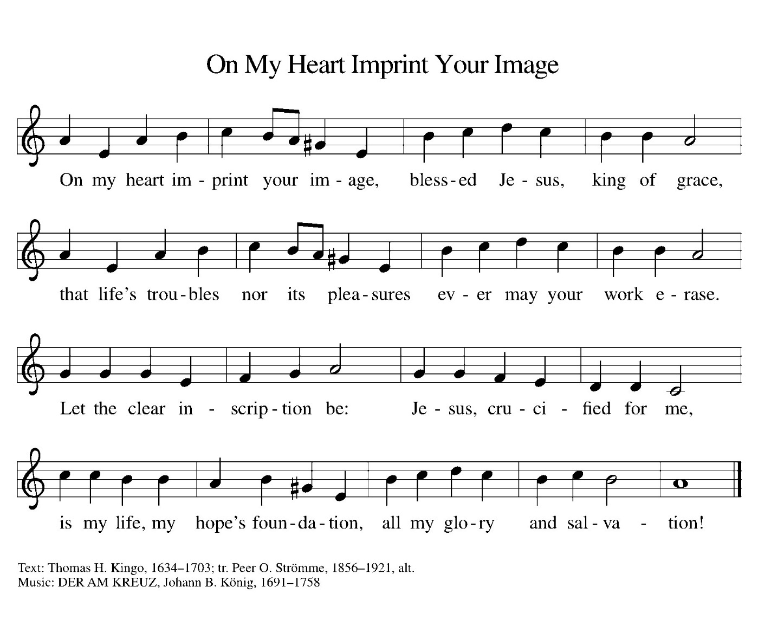

(Usher(s) brings the Tithes and Offerings up front to the Assistant.)

(We invite you to stand as you are able.)

**OFFERING PRAYER**

V. Let us pray,

Gracious Provider,

you set your immense treasures among us,

opening your heart to the world.

As we prepare to feast on your bountiful love,

deepen our commitment to sharing those

treasures with others,

through our Savior, Jesus Christ.

**C. Amen.**

**GREAT THANKSGIVING**

V. The Lord be with you.

**C. And also with you.**

V. Lift up your hearts.

**C. We lift them to the Lord.**

V. Let us give thanks to the Lord our God.

**C. It is right to give him thanks and praise.**

V. It is indeed right and salutary that we should at all times and in all places offer

thanks and praise to you, O Lord, holy Father, through Christ our Lord; who rose

beyond the bounds of death and, as he promised, poured out your Spirit of life

and power upon the chosen disciples. At this the whole earth exults in boundless

joy. And so, with the Church on earth and the hosts of heaven, we praise your

name and join their unending hymn:

**SANCTUS**

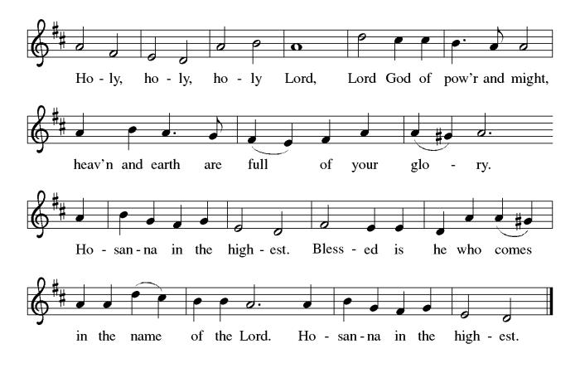

**THE EUCHARISTIC PRAYER**

V. Blessed are you, Lord of heaven and earth, in mercy for our fallen world you gave

your only Son, that all those who believe in Him should not perish, but have

eternal life. We give thanks to you for the salvation you have prepared for us

through Jesus Christ. Send now your Holy Spirit into our hearts that we may

receive our Lord with a living faith as He comes to us in His holy supper.

**C. Amen. Come, Lord Jesus.**

V. In the night in which he was betrayed our Lord Jesus took bread,

he gave thanks; broke it, and gave it to his disciples, saying:

*Take and eat; this is my body, given for you.*

*Do this for the remembrance of me.*

V. Again, after supper, He took the cup, he gave thanks,

and gave it for all to drink, saying:

*This cup is the new covenant in my blood,*

*shed for you and for all people for the forgiveness of sin.*

*Do this for the remembrance of me.*

**THE LORD’S PRAYER**

(We ring the bell throughout the Lord’s Prayer at all services to

invite those in the community to join in praying the Lord’s Prayer.)

V. May we now join with one another and pray together as Jesus has taught us.

**C. Our Father, who art in heaven, hallowed be thy name, thy kingdom come,**

**thy will be done, on earth as it is in heaven. Give us this day our daily**

**bread; and forgive us our trespasses, as we forgive those who trespass**

**against us; and lead us not into temptation, but deliver us from evil. For**

**thine is the kingdom, and the power, and the glory, forever and ever.**

**Amen.**

**LAMB OF GOD**

**C:\Users\Vince and Heather\Downloads\Lamb of God, ELW Setting Four (Melody).tif**

(We invite you to be seated.)

**HOLY COMMUNION**

V. Communion here is pretty simple, and all who believe in Jesus Christ are

welcome at this very table.

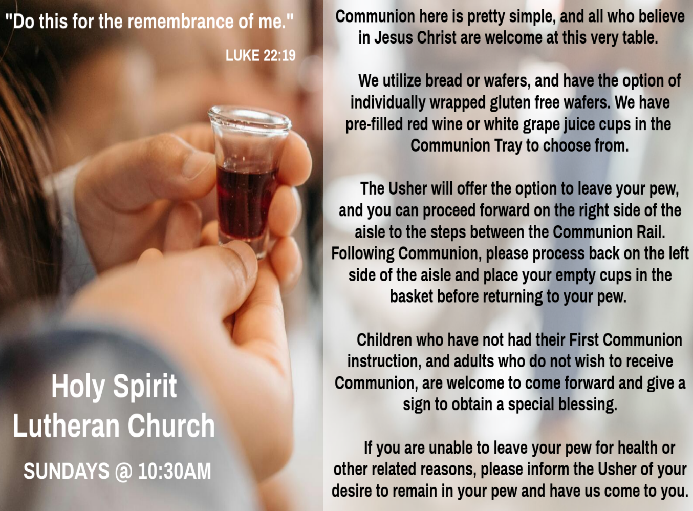

**INVITATION TO COMMUNION**

V. All who are hungry, come!

The feast of grace is spread.

**C. Amen.**

(Distribution of Holy Communion)

**COMMUNION HYMN**

(Please enjoy various music offered by our Organist during your

quiet time, prayer, and reflection following Holy Communion.)

(Vicar and Assistant remove Communion Vessels from the Altar.)

(We invite you to stand as you are able.)

**POST COMMUNION BLESSING**

V. May the body and blood of our Lord Jesus Christ strengthen us and keep us

always in His grace.

**C. Amen.**

**POST COMMUNION CANTICLE**

**C:\Users\Vince and Heather\Downloads\Lord, Now You Let Your Servant Go, LBW Setting Two (Melody).tif**



**PRAYER AFTER COMMUNION**

A. Let us pray,

Generous Host,

you have shared your feast with us and made us new.

Send us now to set tables of love and grace in our communities,

that your liberating love might nourish the world into freedom,

in the name of the crucified one, Jesus Christ our Lord.

**C. Amen.**

**BLESSING**

V. God our tender parent,

God the crucified one,

God the reconciling Spirit,

**☩** bless you now and forever.

**C. Amen.**



**SENDING HYMN**

(We invite you to sing along with the music offered by our Organist.)

Lutheran Book of Worship—Green Book

**343—Guide Me Ever, Great Redeemer**

(Assistant extinguishes the Altar Candles half way through the Sending Hymn.)

(Vicar processes out once the Altar Candles have been extinguished.)

(We invite you to be seated.)

**BIRTHDAYS, ANNIVERSARIES, & ANNOUNCEMENTS**

(Offered by Assistant and Congregation.)

**BIRTHDAYS**

25th Bob Rinier

28th Sharon Yarwasky

**DISMISSAL**

A. Go in peace. Care for others as God cares for you.

**C. Thanks be to God.**

**POSTLUDE**

(Music offered by our Organist as we depart following our Worship Service.)

**How Sweet the Name of Jesus Sounds**



|  |  |
| --- | --- |
| **2025 FINANCIAL STANDING** | |
| **FEBRUARY INCOME** | $6,844.00 |
| **FEBRUARY SPENDING** | $5,674.81 |
| **FEBRUARY GAIN OR (LOSS)** | $1,169.19 |
| **2025 INCOME** | $11,229.00 |
| **2025 SPENDING** | $14,407.84 |
| **2025 GAIN OR (LOSS)** | ($3,178.84) |
| **ED GREEN CAPITAL IMPROVEMENT FUND** | $11,844.55 |
| **FOOD PANTRY FUND (SOCIAL MINISTRY)** | $12,828.09 |
| **CD** | $25,585.16 |
| **75TH ANNIVERSARY** | $0.00 |

**WHAT IS THE EVANGELICAL LUTHERAN CHURCH IN AMERICA?**

The ELCA was formed in 1987 by the merger of three Lutheran Church bodies –

the ALC (American Lutheran Church), the LCA (Lutheran Church in America),

and the AELC (Association of Evangelical Lutheran Churches).

To learn more, go to the ELCA's website at www.elca.org.

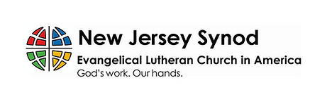

**WHAT IS THE NEW JERSEY SYNOD?**

The New Jersey Synod is a geographical grouping of Evangelical Lutheran Church in America (ELCA) congregations that share the mission and ministry of the Church on the New Jersey territory. It is one of 65 synods in the ELCA. The NJ Synod is comprised of 146 congregations, which include over 45,000 baptized members.



**SUNDAY SCHOOL & CONFIRMATION**

“Here We Stand” is a program that allows our young folks to go through a 2-year process while focusing on the Bible and Luther’s Small Catechism. The program is on **Sundays from 9-10AM** with snacks, games, arts & crafts, and other fun things.

We are also exploring resuming regular Sunday School classes for children of all ages to attend. We are looking at various dates and times in this planning process.

See Heather, Bonnie, & Vicar Vince for more information.

**NEWSLETTER**

Pick up your Spring Edition **TODAY, Sunday, March 23rd**. Collect information, stories, pictures, and committee reports for our next seasonal publication and submit them to Vicar Vince in-person or via email at vpie8282@gmail.com.

**WORSHIP MINISTRY**

The most important thing we do each week is gather together as God's people to worship. God is the center and focus of everything we do. Participating in worship is active. Liturgy means the work and actions of the people gathered. Everything we do during the week to prepare for worship, and everything we do as we assist in leading worship is important. We are thankful for all the wonderful work being done. If you are interested in any position let Vicar Vince know so a training can be set-up.

Sign-up sheets are located on the bulletin board between the church offices.



**40 DAYS – 40 ITEMS**

We will be joining True Deliverance Praise & Worship Center on this Lenten Challenge to support those in need in our communities. It is rather simple, for each day of Lent remove one item from your closet, drawers, chest, etc. that you no longer wear or need and place it in a trash bag. Brings the bags into the church on or before Easter Sunday, April 20th, 2025. All items will be donated to the Branches in Rio Grande and the Atlantic City Rescue Mission. Make sure you grab a trash bag and card from the church with directions for this Lenten Journey Challenge.

**PREACHING AT BROOKDALE**

Vicar Vince will be Preaching at Brookdale Senior Living in Cape May Court House

**TODAY, Sunday, March 23rd, at 1PM**. Holy Communion will follow the service.

**MINISTERIUM DAY**

Vicar Vince will be attending the Social Hour with The Bishop, Assistants, Pastors, and Vicars on **Monday, March 24th, from 7 to 9PM** at Homewood Suites in Hamilton. Then, will be attending the lecture on **Tuesday, March 25th, from 8:30AM to 2:30PM,** at the Hibernian Club, led by Rev. Barbara Lundblad who will be preparing us to preach Easter in our current climate of political and social tension.

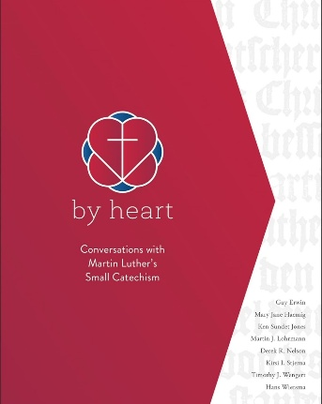

**BIBLE STUDY & FAITH DISCUSSIONS**

​​​​​Bible Study & Faith Discussions was started in order to focus on various readings,

books, Bible verses, people of faith, and other general topics. Group Members offer

various points of view while reviewing the Bible and various aspects of faith while

being respectful and supportive of each other. Join us on **Tuesdays at 6PM**.

**FOOD PANTRY & COMMUNITY DELIVERIES**

**Open every Thursday**, and the **last Saturday of every month**, from **10AM to 1PM**. 79 people were served in February. 164 people have been served in 2025. Donations can be dropped in the basket in the Narthex, placed in the outdoor drop-box by the Church Office door, placed in the money jug in the back of the Church, mailed into the Church Office, or placed in the Offering Plate. Volunteers are needed each week. Sign-up sheets are located on the bulletin board between the church offices. If you have questions or need training see Heather, Vicar Vince, or Bonnie.

|  |  |  |
| --- | --- | --- |
| **Thursday, 3/27** | **Saturday, 3/29** | **Thursday, 4/3** |
| Cathie & Garnet | Vicki & Bonnie | Tori & Cathie |

Our local North Cape May Acme provides us with Expiring Soon, Recently Expired, and Slightly Damaged Foods & Items weekly. Kathy helps those in need by delivering items each Saturday in the community. Kathy then brings leftover items to the Church for church members in need, and those who visit the food pantry during the week. Additional items are then taken over to the Branches Outreach in Rio Grande. A special thanks to all who donate, pray, and help in any way!

**BULLETIN ENTRY DEADLINE**

The Bulletin is Printed on **Thursdays** during Church Office Hours. Changes need to be submitted to Vicar Vince or Heather no later than **Thursday by 4PM**. Thank you!

**CHURCH OFFICE**

Open **Thursdays from 6PM to 8PM** to serve the Congregation, the Community,

and to continue handling the business of the Church. Feel free to stop in to talk,

pick-up or drop off something, pray in the Sanctuary, or for whatever reason.

**75TH ANNIVERSARY**

Our 75th Anniversary will be occurring this year! The Synod has been contacted, and we have been placed on the Bishop’s Calendar for **Sunday, October 19th**. This congregation is a legacy that we have all lived in and through over all of these years, or maybe just for a short time. However, it is a legacy that we hope and desire to continue to carry on and move forward for those people that will be able to gather and worship with us and following us as well. We are the church carries a strong mentality with it, and it does not just mean within these very walls. We need to celebrate those 75 years of being part of this community, and all that has led up to the very start of this church body as well. I encourage you all to start thinking how we are going to celebrate this legacy as we continue preparations at our second Committee Meeting on **Sunday, March 30th, after our Worship Service**.

**DONATION STATION**

Get on the train and place all purchased items in the specified project donation bins located on the counter by the front doors. See Heather for more information.



**WOMEN OF THE CHURCH**

The Women of The Church will be taking time off during the Winter months and

their next monthly meeting will be held on **Monday, April 7th, at 6PM**.

New members are always welcome to attend! Contact Judy for more information.

**SOUP & SCRIPTURE**

Did you ever look forward to sitting around a fire in the church yard hanging out with some folks, enjoying s’mores, and studying scripture? We will shift this Fellowship time to **Soup & Scripture** and be **indoors** following the holidays. **Join us on Saturday, April 12th, at 6PM**. Ask Heather or Vicar Vince for more information.

**COFFEE HOUR**

The Women of the Church will be hosting our next monthly Coffee Hour on **Sunday, April 13th**, following our Worship Service. See Judy or Kathy for more information.

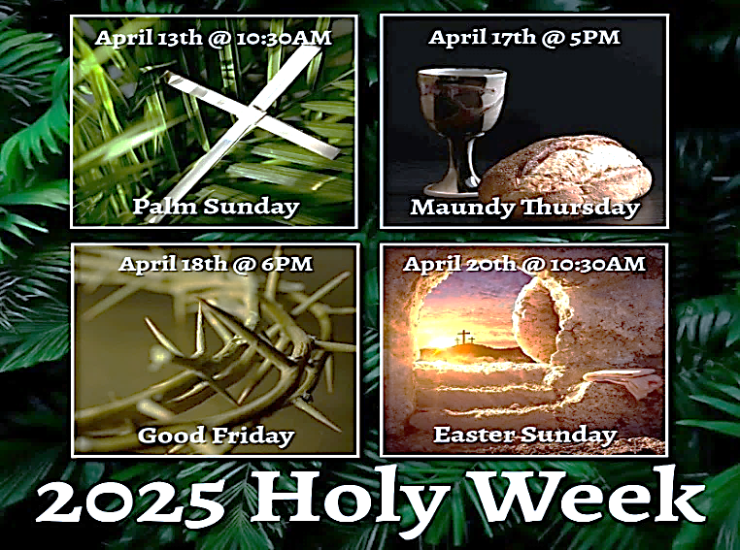

**CHURCH COUNCIL**

Share your comments, concerns, questions, or joys with one of our Church Council Members who can bring them back to our meetings. Visitors are always welcome to attend and listen to what is going on in and around the church. Join us In- Person or on our Conference Call at our next Meeting on **Tuesday, April 15th, at 6PM**.

**HOLY WEEK INVITATION & EXTRA OPPORTUNITY**

Mother Allison and Father Marcel, together with their congregations, started celebrating Easter Vigil together a few years ago. Last year Father Marcel became aware that not all congregations celebrate it. With the Episcopal Church and Lutheran Church (ELCA) being in full communion with one another, we have been extended an invitation to celebrate the **Easter Vigil at St. Simeon's By The Sea in North Wildwood, on Saturday, April 19th, at 5:30PM**. Carol has volunteered to read, and Vicar Vince has been asked to deliver the Sermon. Please see Vicar Vince with any questions, or to inform him of your interest or intent in attending.

**ANNUAL RUMMAGE SALE**

It’s that time of year again that we begin our spring cleaning, and get our committee together and plan for our Annual Church Rummage Sale on **Saturday, May 31st, from 7AM to 12Noon**. Please start gathering items until we come up with a date to bring them in. We will plan to coordinate things before Whale of A Day so that all unsold items can be transported there to have a second chance in being sold to raise funds for the Property Owners Association of Townbank. We look forward to this event raising funds for our 75th Anniversary. Join us at our next Committee Meeting on **Sunday, May 4th, after our Worship Service**.

**37TH NJ SYNOD ASSEMBLY**

Behold! I Make All Things New. (Revelation 21:5) Assembly will transition from a one to a three-day event due to the election of a new Bishop, and other business. Vicar Vince is looking for two other church members to be able to attend the event. We will be at the Hilton East Brunswick Hotel - 3 Tower Center Blvd, East Brunswick, from **Thursday, June 5th to Saturday, June 7th**. Online registration opens in February, and the **deadline for registration is April 21st**. Synod Council has designated funds to cover most of the costs for attending with the hope that relieving the financial burden of attendance will prompt all congregations to send a full contingent of voting members. Voting Member: $25 (includes Friday evening banquet) / $50 (after April 21st). Rooms have been blocked for the NJ Synod. Rates are $179 per night. **Hotel deadline is May 22nd**. Reach out to Vicar Vince with any questions.

**THEOLOGICAL EDUCATION FOR EMERGING MINISTRIES**

Vicar Vince will be back in Gettysburg, PA at United Lutheran Seminary for Lutheran Heritage, Biblical Foundations, & Lutheran Leadership for Mission intensive classes from **Sunday, June 22nd, following Worship Service, to Saturday, June 28th.**



Vicar Vince was introduced to Milestones Ministries weekly guides for faith-filled studies and conversations through a Seminary class. A decision was made to pass these along to you. If you missed a week, or lost your insert, check our website for past issues. Feel free to ask questions and provide feedback to Vicar Vince.

**2025 CHURCH DIRECTORY**

Additional copies are by the Church Office on the bookshelves. We continue to keep it updated throughout the year. Undoubtedly, we probably miss a few changes, and have made a few errors. The printed church directories have spaces for changes in information, new people’s information, notes, and your favorite Bible verses. Please continue to make it a point to inform the Church Office of any changes or updates.

**FAVORITE HYMNS**

Carol is willing to play some of your favorite hymns for the Prelude & Postlude each Sunday during our Worship Service. Feel free to let her know of your suggestions.

**HOME COMMUNION MINISTRY**

A Minister is available if you have a loved one, or if you desire services. We look forward in sharing the Word and Holy Communion! Please inform Vicar Vince, Kathy, or the Church Office so plans can be made for visits.

**PRAYER SHAWL MINISTRY**

Prayer Shawls, Lap Quilts, Scarves, and other items have been made with love. Blessed items are located in the Narthex, and are free for anyone. Members of the group continue working at home on new stitches and patterns. We are blessed to be able to continue collecting new items. We have a donation station of yarn and other items located in the Narthex. You can find some new supplies for your next creation!

**PRAYER LIST**

Our Prayer List continues to lengthen and we realize the important need for prayers and healing. Sometimes the unfortunate result is that someone has passed away, and the words “The Family & Friends of” appear before someone’s name. However, sometimes we forget names are still on the list and their health has improved or the they are no longer struggling, and they can be removed. Please share the good and bad stories as we continue to pray for strength and healing. Names can be added or removed from the list on the clipboard in the Narthex prior to the Worship Service, by calling the church office, or addressing it on the Conference Call. Please let us know the relation to the person(s) you listed so we can be more mindful with our prayers. Names will stay on the list until removed by the person(s) who requested prayer.

**INTERESTED IN BECOMING A NEW MEMBER**

Have you been attending our church for a while? Have you just recently returned to church after being away for a bit? Maybe you transitioned from another church,

or just started to recently attend our church. We are glad to have you, and would love to have you as a member of our Congregation. See Vicar Vince for more info.

**BAPTISM**

We are a church whose unity is in Jesus Christ, who gathers us around word and water, wine and bread. Baptism is a significant part of our faith journey as we come from the baptismal waters to live a new life as children of God. Our baptism sets us out on a lifelong journey that is characterized by our relationship to God, our relationship to our faith community, our relationships in our community and the wider world. Living our baptismal covenant means living a life of growth in the faith practices of discipleship. Please see Vicar Vince for more information.

**FIRST COMMUNION**

Although no particular age for first communion is prescribed by The Use of the Means of Grace, one guideline is offered. Because admission to the Sacrament is by invitation of the Lord to the baptized, "baptized children begin to commune on a regular basis at a time determined through mutual conversation that includes the pastor/vicar, the child, and the parents or sponsors involved, within the accepted practices of the congregation.” Each congregation is encouraged to ask the question of readiness for first communion, establish their own policies regarding age and practice, and accompany that practice with catechesis appropriate to the age of the communicant. If anyone has questions, please see Vicar Vince.

**LIBRARY**

New books are added to our library from time to time. Several are borrowed and read and exchanged. Who knows, you might find one particularly interesting and share that with someone as well. Reading is a great way to pass spare time, learn, and explore. You may find some fresh ideas for prayer, ways to grow more spiritually, ways to grow closer to God, or some opportunities to understand our faith more. Visit the library between the church offices and see what books are there!

We also have an extended library located in Vicar Vince’s office. There are Bibles of various translations, books from his personal collection, books inherited from Pastor Leah, movies, past Bible Study Curriculums, and more. Just ask to check things out!

**TITHES, OFFERINGS, & ENVELOPES**

2025 Offering Envelopes are available. Please see Heather if you have not received yours, or would like to have some. For we do indeed worship God with our tithes and offerings. We hear this in scripture, “Each of you must give as you have made up your mind, not reluctantly or under compulsion, for God loves a cheerful giver.”

(2 Corinthians 9:7) Feel free to drop your envelopes in the offering plate, mail them to the church, or drop them off in the locked mailbox. Thanks for your continued support in the mission of our church, its ministries, the NJ Synod, and other needs!

**ED GREEN CAPITAL IMPROVEMENT FUND**

We continue raising money for unforeseen costs or repairs.Kathy sells Wawa Tickets for $6, the donation bin is in the back of the church, and we have our Annual Church Rummage Sale. Thanks for your continued donations, prayers, and support!

**PROPERTY USE**

​​​​​Do you know anyone interested in utilizing our Fellowship Hall for a Party or Event?

It is a suggested $50 refundable security deposit, and $250 for facility use. There is no alcohol or games of chance permitted due to ELCA policy. Please contact Vicar Vince or the Church Office with questions, for info, or to reserve a date and time.

**JERSEY JOTTINGS**

Jersey Jottings is a weekly e-newsletter that connects our synod together with weekly prayer, upcoming events, synod and churchwide activities, mission stories, congregational activities, and more. You can also sign up by going to https://www.njsynod.org/stay-connected and filling out the form! You can also get the app on your smartphone in the Apple App Store or on Google Play on your android.



**VICAR APPOINTMENT ON MARCH 19TH, 2023**

A Memorandum of Understanding on the Matter of Pastoral Appointment

In Theological Education for Emerging Ministries (TEEM) Candidacy

TO: Congregation Council, Holy Spirit Lutheran Church, Villas

FROM: The Rev. Tracie L. Bartholomew, Bishop, New Jersey Synod

Dear Brother and Sisters in Christ,

This memorandum is in support of your discussions with Vincent Piekarski as pastor of Holy Spirit, Villas. Because this is not the usual pattern for completing the educational and candidacy requirements for ordination, it is my hope that this memorandum will both provide guidelines and engage in conversation with those who are invested in this process.

I would say at the outset that because Vincent is an outstanding candidate for the Ministry of Word and Sacrament, we will all want to do whatever is necessary to assure that his placement serves the mission of the church in the best possible fashion.

The following notes reflect my own understanding of this matter:

(1) The appointment for Vincent will begin on April 1, 2023. At this time, Vincent

will assume all responsibilities of a regularly called pastor, including presiding at

the Sacrament of Holy Communion and Baptism at Holy Spirit, Villas.

(2) A pastoral appointment in the TEEM process is an option for completing

seminary educational requirements and the steps of the candidacy process.

Upon completion of the candidacy process and seminary education, the

candidate may receive and accept a call to ordained ministry from the

congregation where the appointment is being served.

(3) This appointment is jointly supervised by the Office of the Bishop and the TEEM

pastor’s seminary. A mentoring relationship with a local pastor is required for the

length of this appointment.

(4) The synod of candidacy origin will be responsible for the approval process.

(5) Upon approval for ordination, the congregation would be expected to extend a

call to the pastoral appointee.

(6) Compensation for the TEEM pastor will be according to the guidelines of the New

Jersey Synod. All normal forms of compensation should be in place for the term

of the appointment, including stipulation that base salary and housing shall be in

accord with synod guidelines for first call at time of ordination.

(7) The ELCA Portico benefit plan for lay persons in full-time church service should

be used for the pastoral appointee up to the time of ordination, whereupon the

benefit package is to be converted to the plan for ELCA clergy.

(8) A decision for Pastoral Appointment is made with the agreement of a synod and

its candidacy committee, and the ELCA, normally represented by the regional

staff person of each in consultation with the seminary and its Director for

Contextual Education.

(9) Pastoral Appointment in a TEEM Candidacy is an option that is to serve the

mission of the Church in a particular and vital way and is not to be viewed or

used as a means to circumvent the normal candidacy process and/or first call

placement process.

In the specific case of Vincent, the New Jersey Synod remains responsible for the candidacy and approval process, and has agreed to this proposal for Appointment at Holy Spirit, Villas.

Continued blessings to both Holy Spirit and Vincent Piekarski as you embark on this journey of mutual ministry. As partners in ministry, we walk with you and rejoice in this new relationship.

**VICAR VINCE’S DAY OF REST**

A day of rest can have physical, mental, and spiritual benefits. “Mittwoch,” German for mid-week, or Wednesday, is the day that Vicar Vince will use to recharge and do some other things. Please do not hesitate to reach out if there is an emergency!

**VICE PASTOR UPDATE**

Pastor William Hodgetts continues to attend our monthly Church Council Meetings. Pastor William continues to provide Supervision and Direction for Vicar Vince.

**TRUE DELIVERANCE PRAISE & WORSHIP CENTER**

Reverend Maria Brooks and True Deliverance Praise & Worship Center utilize our facilities from 1-4PM on Sundays. TDPWC helps with the Food Pantry and hosts or assists with other events throughout the year. TDPWC hosts a **Prayer Line** on **Mondays, Thursdays, & Fridays at 5PM** on the **Conference Call 1-657-390-7957**.

**TUESDAY SEWING CIRCLE**

**COFFEE, CHIPS, FELLOWSHIP, QUILTS!**

You all—men included—are warmly invited to join **Holy Trinity Lutheran Church in Wildwood on Tuesday morning at 10 AM**. No sewing skills required! We welcome anyone looking to be part of a friendly group that enjoys doing a variety of activities together. We meet in the front room of the Parish Hall at 2810 Atlantic Ave. There’s parking available behind the church, and you can enter through the rear door. Just bring a sandwich or snack for lunch! For more information, please contact: Louise McHugh at tillie26@verizon.net or Martha Neff at marthaneff1@yahoo.com

**CHURCH STAFF & VOLUNTEERS**

**VICAR, BIBLE STUDY & FAITH DISCUSSIONS,**

**EVENTS, NEWSLETTER, & WEBSITE**

Vicar Vince Piekarski

**VICE PASTOR**

Pastor William Hodgetts

**ORGANIST & PIANIST**

Carol Amundsen

**CHURCH OFFICE, SUNDAY SCHOOL, & FOOD PANTRY**

Heather Piekarski

**CHURCH COUNCIL PRESIDENT**

Mary Melnicoff

**CHURCH COUNCIL VICE PRESIDENT**

Judy Brannan

**CHURCH COUNCIL TREASURER**

Bonnie Millard

**CHURCH COUNCIL SECRETARY**

Vicki Rinier

**CHURCH PROPERTY**

Frank Ford & Wayne Rand

**LICENSES & EXPIRATION DATES**

Worship Service Content is used via permission through Augsburg Fortress Liturgies Annual License #SB144368. The next Subscription Renewal Date is 2/28/2026.

Our Hymns and Worship Music are used via permission through CCLI One License #11327166. The next Subscription Renewal Date is 1/31/2026.