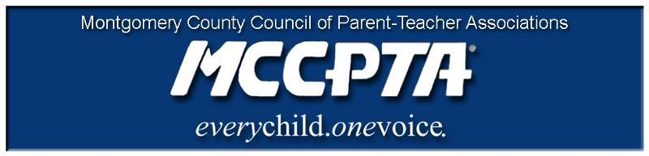
Delegates’ Assembly Meeting Agenda
Tuesday, October 24, 2017
8:00 PM CESC Auditorium
DRAFT UNTIL APPROVED BY DA
(35 voting members to achieve quorum)

Mission of PTA
To make every child's potential a reality by engaging and empowering families
and communities to advocate for all children.
Hacer una realidad el potencial de cada niño al comprometer y apoderar las familias
y comunidades para que intercedan por todos los niños.

Please join us at 6:30 PM for MCCPTA Presents!

Welcome and Approval of Agenda and Minutes

Old Business

- Vote: Undocumented Students Resolution
- Vote: Advocacy Priorities
- 2017-18 budget

New Business

- Access for All vs. One Size Fits All – Cynthia Simonson, VP Educational Issues

Officer Reports and Committee & Cluster Reports (new format). Officers and Chairs will:

- Answer questions members have about the reports they've already read
- Mention important events occurring since preparation of a report
- Emphasize important events/happenings

Announcements

- Councilmember Rice CIP Presentation – 11/13/17 at Gaithersburg HS

Adjournment & Committee Meetings

