HOUSE OF WORSHIP
SAFETY & SECURITY SEMINAR
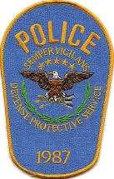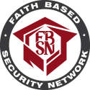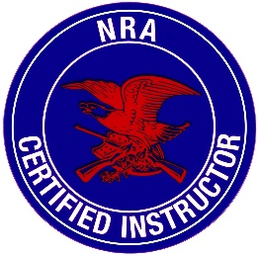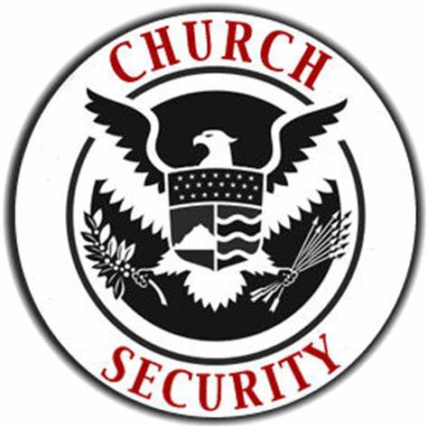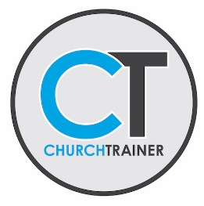
TOPICS COVERED:
- INTRODUCTION TO THE CHURCH SAFETY TEAM
- VERBAL JUDO : DE-ESCALATION TECHNIQUES
- PHYSICAL SECURITY ASSESSMENTS
- LIABILITY ISSUES & SEX CRIMES
- ACTIVE SHOOTER MITIGATION
- ESTABLISHING AN EMERGENCY ACTION PLAN/OPSEC
- DOMESTIC TERRORISM THREATS TO ORGANIZED RELIGION
- MEDICAL RESPONSE OVERVIEW
- FIREARMS SAFETY AND BEST PRACTICES
- FACILITATING REALITY BASED TRAINING
SATURDAY, MARCH 21, 2020 9AM-4PM
BERGLUND CENTER * 710 WILLIAMSON ROAD NE * ROANOKE, VIRGINIA
$35 PER PERSON * GREAT SHEPHERD SEMINARS ON FACEBOOK
ABOUT THE INSTRUCTOR
Glenn Blandford is a 29-year veteran law enforcement and antiterrorism officer. Currently employed by the Pentagon Force Protection Agency, Glenn holds numerous certifications from the Federal Law Enforcement Training Center and has served as an EMT, deputy sheriff, police officer, investigator, police academy instructor, firearms unit supervisor & anti-terrorism officer . Glenn is the Director of Safety & Security at Hartwood Presbyterian Church, a Faith Based Chapter Leader with the FBSN and a frequent lecturer at conferences and seminars.
glenndps@yahoo.com glennblandford.com (804)484-9694

