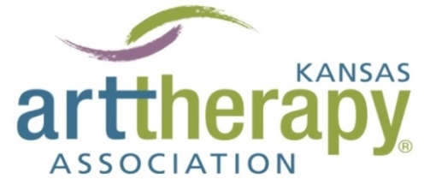
Presents the 38th annual Kansas Art Therapy Association Symposium
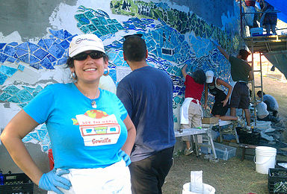
ART THERAPY in the COMMUNITY
September 8th-9th, 2017
InterUrban ArtHouse
OVERLAND PARK, KS

Keynote speaker: Art Therapist Wanda Montemayor LPC-S-AT, ATR-BC who has been creating public art for more than 18 years. She brings the people of her community together to collectively create massive public works of art through art therapy. Her public art is visible all over Austin, Texas. Her murals adorn the walls and exteriors of schools, and her works in public parks are iconic pieces that receive rave reviews from critics and the public alike.

All conference activities will be held at InterUrban ArtHouse 8001 Conser Overland Park, KS
Friday, September 8th
4 pm ceramic tile making with Wanda Montemayer
5 pm happy hour networking
7 pm Art Therapy: The Movie

Saturday, September 9th
8 am registration and breakfast (provided)
9 am “The Nuts & Bolts of Community Art Therapy” by Wanda Montemayer
10:15 am break
10:30 am keynote resumes
11:30 am lunch (provided) & poster session (Madeline Schmitt)
12:30-1:45 pm Breakout A: Cross Cultural Community Art Therapy (Wanda)
Breakout B: The Use of Social Media in Art Therapy (Allison Boughn)
1:45 pm break
2:00-3:15 pm Breakout A: Mind Mapping to Inspire Creativity in the lives of busy Art Therapists (Sherri Jacobs)
Breakout B: Art Therapists on their favorite Art Therapy Directives (Renee Lyons, Noel Kearns, Amy Nadler, Nannie Mead & Katie Brewer)
3:15 pm break
3:30 pm KATA business meeting (optional for non-members)

Make checks payable to KATA and send payment to:
Registration must be postmarked/accepted by September 5th
Name/credentials:_________________________________________________________________________Address:_________________________________________________________________________________City/State/Zip_____________________________________________________________________________Profession:_______________________________________________________________________________Phone__________________________Email:____________________________________________________

KATA member: $75
Non-member: $100
Student member: $25
Student non-member: $30
Register day of: $120

Melissa Kochen 8205 W. 72nd St. Overland Park, KS 66204
PayPal is available for credit card payments! Just click the button under the “upcoming events” section at our website kansasarttherapy.org
PayPal receipt is verification of conference registration.

