***Pleasant Township Board of Trustees Meeting Highlights***

**Date _July 23, 2024______________ Next Resolution No._ 58—7-23-2024_ _**

* **Call to Order -- The meeting tonight will also be on WebEx.**
* **Please stand for moment of silence. --Pledge of Allegiance--Roll Call**
* **Visitors –*Hanna Poling*** with the Southwest Messenger via WebEx.
* **Minutes to approve**- No minutes-Randi asked where we are with getting caught up with minutes, Paula said they are being worked on.
* **Financial Reports** – Motion to pay expenditures.
* **Franklin County Sheriff’s Report- Community Liaison, Deputy Adkins- (Cell: 614-809-5843)**

06/25/2024 through 07/23/2024

* + Total Calls for Service/Self-Initiated Runs: 306
  + Total Reports Taken: 26
  + Total Arrests/Citations: 18
  + Burglaries: 1 (6100 Block of London-Groveport Road)
  + Traffic Crashes: 22
  + Medic Runs: 37
  + Thefts: 1 (3200 Block of Pebble Beach)
  + Missing Persons: 0
  + Stolen Vehicles: 0
  + Suspicious Persons/Vehicles: 19
  + Vandalism:2
  + Traffic Offenses: 35
  + Motorcycle/ATV/Bike Complaints: 1
  + On 06/24/2024, Deputies responded to the 3200 block of Pebble Beach Road on the report of theft from a vehicle. During the overnight hours, an unknown individual(s) broke out the rear window of a vehicle and took approximately $2,000 worth of power tools. This investigation is ongoing.
  + Working on speeders on Creamer Rd.
* **Road Department****- Rick Haag in for Robert**
* Ed received a complaint about brush blocking at the east end of Avon Dr.
* Received this complaint by email- I am writing to express a concern for a large bush that is very much blocking the view when pulling out of the Oakhurst neighborhood. It forces anyone leaving the neighborhood to pull dangerously far into Norton road to see if anyone is coming from the left. Often times cars on Norton will blow their horn or swerve as they are concerned for how far out cars are stopped.

The home is 6200 Oakhurst Drive. One day the resident was out front so I stopped and asked them to kindly consider trimming it back to improve the line of sight. He said he would try but that has been a few months ago. We are really thankful but surprised no bad accidents have taken place due to this but it is sure to happen if not taken care of.

I have called and left a few messages with the township over the past few months but again it is still there. I am hoping to get some assistance with this.

* 2 trees removed Avon Dr.
* Clear brush corner of Boyd & Gay
* Brush mowing
* Trim trees Oak Grove
* Equipment maint.
* 1 burial
* 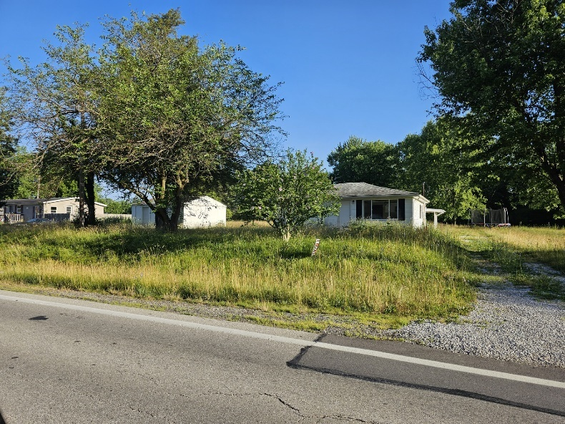We received this complaint for 6912 London Groveport Road by email. Robert is aware, has anything been done with it? “Is there anyway to enforce this home owner to cut the grass? As you can see in the photo, the grass is as tall as the front of the property/window.”
* *Any updates on Gay Rd. about repairs due to heavy rains washing the roadway and gravel away. (meeting on 8-8-23 we said we’d keep it on the agenda till resolved in some way.)*
* **Fire Dept. – Chief Whiting**
* Apparatus
* M-231 at Brawn.
* M-232-replaced alternator, A/C line
* Now using American Force, a company that comes to the site to do the work.
* Personnel
* No issues.
* Equipment
* Fire Gear Ordered.
* Training
* Continue to use the training house on
* Paramedic school on-going.
* EMS Billing (Medicount)
* No Updates
* Outdated and Unused Equipment sold on GovDeals-Chief asked for future reference how should he handle this situation. Randi said he should bring it to the Board first for a resolution to sell.
* Resolution 58 to spend no more than $24,843.00 from the grant money, the township is responsible for 5%, for physicals and cancer screenings. We have 3 bids to open.
* **New Business –**
  1. Letter of support to sign--Received an email from Haley Ingram, Planning & Design Project Coordinator, Columbus & Franklin County Metro Parks to request a Letter of Support from the Pleasant Township Board of Trustees regarding Metro Parks' upcoming application to the Clean Ohio Greenspace Conservation Fund.

Resolution 59 to send a letter of support.

* Ed read a letter of appreciation for the dedicated work that Deputy Adkins does for the township.
* Announcing a time change for the Special Meeting for the purpose of an executive session with township legal council and a mediator for contract negotiations on July 25, 2024 changed from 9:00 a.m. to 10:00 a.m.
* **Clerk Updates- Paula**
* Miscellaneous correspondence
* Resolution 60 to sign the Stop/Loss agreement for the insurance. Randi signed with the electronic signature during the meeting.
* **Open the bids for phyiscals-**
  1. NSD - $18,270
  2. Memorial Hospital Union County - $18,963 plus additions
  3. BioCare - $14,155 add $2,500 for travel

Chief will review all three and choose the most appropriate.

* **Adjourn**