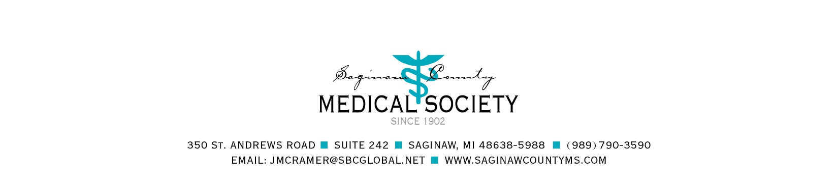

MEDICAL STUDENT LOAN APPLICATION

The Saginaw County Medical Society (SCMS) Foundation was established in 1968 and originally funded through physician donation of earnings from educational and charity work. Currently, the Foundation is funded by donations and an annual golf outing. The SCMS Foundation makes low interest loans to medical students with ties to the Saginaw area. In the past, the amount of each loan has ranged anywhere from $1,000 to $10,000 with some students receiving loans several years in a row. Maximum loans awarded during medical school are $20,000 per student.
The terms of these loans are generous. No interest is charged while the student is in medical school, simple interest is charged at a rate of four percent per annum during a residency program, and interest is charged at a rate of eight percent per annum upon completion of a residency program.

The Foundation also has a loan forgiveness program. If the loan recipient returns to Saginaw to practice upon completion of their residency and they are a dues paying member of the SCMS/MSMS, 25 percent of the principal balance and any accrued interest will be forgiven at the end of each year they are practicing in Saginaw County, with a maximum of $5,000 per year forgiven.
The Foundation Board generally considers students who are past their first year of medical school, and among other things, according to:
- Strength of connection to Saginaw
- Financial need
- Scholastic performance
- Community service/extracurricular activities
The intent of the Foundation loans are to assist and encourage students to return to Saginaw to practice medicine.
Only applicants enrolled in a United States medical school will be considered.
If you would like to be considered for a loan, please complete the attached application and return with required documentation and signature, per the application, to the SCMS Foundation by March 31, 2022. The Foundation Board will review your application and will notify you as soon as they have made a decision (generally by the second week in May).

DUE DATE: MARCH 31, 2022
Only applicants enrolled in a United States medical school will be considered.
APPLICATION FOR FINANCIAL ASSISTANCE FOR EDUCATIONAL PURPOSES
The completed application with all information, signatures, notary and medical school verification should be emailed to jmcramer@sbcglobal.net. In addition to submitting by email, the original signed and notarized application and documentation must be mailed to the address above. Incomplete applications will NOT be considered.
I. PERSONAL DATE _____________________

___________________________________________________________________________
Last Name First Name Middle Initial

Date of Birth ___/___/___ Place of Birth ___________________ Sex Male Female

Social Security Number _____-_____-_____ Email ________________________________

Driver’s License Number __-____-____-____-____ License State ______________________

Current Address _____________________________________________________________

Telephone (_____) __________________

Permanent Address __________________________________________________________

Telephone (_____) ___________________

Marital Status Single Married Spouse's Name _____________________________

Spouse’s Occupation _________________________________________________________

Spouse’s Cell Number (____) _________ Spouse’s Email ____________________________

Undergraduate College/University _______________________________________________

Year Graduated _______________ Degree ____________

Medical School ______________________________________________________________

Year of Study M1 M2 M3 M4 Student ID#: ________________

**Applicant MUST submit an official letter from their Medical School with complete contact information (name, position, address, phone, fax and email) verifying enrollment and year of study as of the date of this application along with their transcript.**
Father's Name ______________________________ Occupation ______________________

Current Address _____________________________________________________________

Telephone (_____) __________________ Email _______________________________

Mother's Maiden Name _______________________ Occupation ______________________

Current Address _____________________________________________________________

Telephone (_____) __________________ Email _______________________________

II. INTERVIEW

A. In what ways, if any, have you contributed toward your own support or your own savings?

___________________________________________________________________________

___________________________________________________________________________

B. Do you intend to work while continuing your education?

___________________________________________________________________________

___________________________________________________________________________

C. Amount saved toward school expenses:

___________________________________________________________________________

___________________________________________________________________________

D. Have you applied, or do you intend to apply for, other scholarships or loans?

___________________________________________________________________________

___________________________________________________________________________

E. List scholarships or grants already received:

___________________________________________________________________________

___________________________________________________________________________

F. In what way do you think you will benefit by continuing your education?

___________________________________________________________________________

___________________________________________________________________________

G. How might your education benefit Saginaw County?

___________________________________________________________________________

___________________________________________________________________________

H. Of all the things you have accomplished in or out of school, which have given you the greatest personal satisfaction?

___________________________________________________________________________

___________________________________________________________________________

III. On a separate sheet, please provide a brief story of your life. (Please include what person or event most influenced your plans for the future; which studies you liked best (and least); your ambitions, interests, aims, ideals, philosophy of life, hobbies, etc.).

Please include a current CV and your current transcript.

PLEASE CONTINUE TO PAGE 5
IV. PLEASE COMPLETE THE FOLLOWING BUDGET (in approximate figures)

INCOME | LAST YEAR  ATTENDED | YEAR FOR WHICH ASSISTANCE IS REQUESTED
Cash on hand at beginning of school year | $ | $
Income from parents
Income from spouse
Earnings expected
Income from other sources (explain)
Loans (received or pending)
Gifts or scholarships
TOTAL INCOME | $ | $
EXPENSES
Tuition and fees | $ | $
Room and board
Books and instruments
Clothing
Laundry, recreation, misc.
Transportation
TOTAL EXPENSES | $ | $
AMOUNT OF LOAN REQUESTED |  | $
I fully understand that any significant misstatements in, or omissions from this application, constitute cause for denial of a loan and/or for any loans previously granted to me to be immediately due and payable in full with interest. All information submitted by me in this application is true to my best knowledge and belief. A collection agency will be used immediately if there is a default on the loan, or lack of communication indicates potential default.

I further agree to contact the SCMS Foundation on or before March 31 of each year by email or postal mail with my updated contact and medical school/residency information. Current contact information can be found at www.SaginawCountyMS.com.

____________________________________________ Date: __________________
Signature (e-signature not valid)
PLEASE CONTINUE TO PAGE 6

AUTHORIZATION TO RELEASE PRIVILEGED INFORMATION

I hereby authorize ________________________________________________________________________
Insert name of medical school above

as well as, any future internship/residency/fellowship training programs, hospital systems, practice group/PO/PHO, etc., that I may be affiliated with, to verify my education, training, employment, etc., and release any other requested information including, but not limited to, participation, programs, contact information, training, employment and status to the Saginaw County Medical Society Foundation, 350 St. Andrews Road, Suite 242, Saginaw, Michigan 48638-5988, phone 989-790-3590, or its designee, for ten (10) years from the date of this Authorization.

Date: __________, 20___ Student ID#: ______________ Date of Birth: _____/_____/_____

Name: ____________________________________________________________________
Last Name First Name Middle Initial

Address: __________________________________________________________________________

__________________________________________________________________________

Telephone: (_____) _____________________ Email: ______________________________________

Year of Study as of the Date of this Authorization: M1 M2 M3 M4

Signature: _____________________________________________________________________________
(e-signature not valid)

