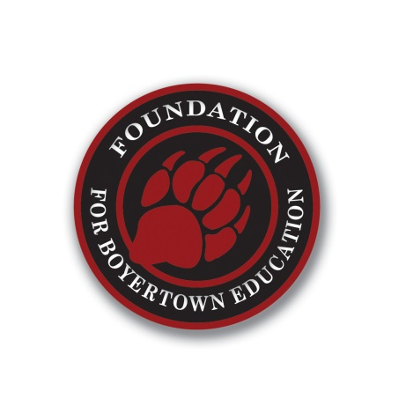

Foundation for Boyertown Education
Grant Application 2022-2023
The Foundation for Boyertown Education is a 501 (c) 3 non-profit education foundation. We are dedicated to providing a source of financial support to fund innovative educational programs and extracurricular initiatives for the students of the Boyertown Area School District.
Awarding of Funds:
Each year, the foundation will allocate a limited amount of money to grant requests. There is no guarantee that grants will be awarded to all applicants. Each grant will be reviewed based on merit, innovation and funding available. If funding is not available, grant applications will be kept on file and reconsidered as funding becomes available for the remainder of the year.
Application Submission:
The Foundation seeks to make grants available across all grade levels within the Boyertown Area School District. The Foundation accepts applications throughout the year for consideration. Completed applications may be submitted to the Foundation for Boyertown Education, by way of:
- Inter-office mail (our office is located at BASH)
- Mail: P.O. Box 218 Boyertown, PA 19512
- Email: amuzopappa@boyertownasd.org
General Guidelines:
- Proposals must be consistent with the goals and mission of the Boyertown Area School District and Foundation for Boyertown Education, which is to enrich the educational experience, maintain academic excellence and encourage innovative opportunities for our students.
- Projects must take into account safety at all times.
- Funding of grants will range from $250-$2,500 (exceptions may be granted) and are for a single year of funding.
- Grants should contribute to developing students as leaders and life-long learners.
- Grantees must do a follow-up with the foundation, showing how the grant money was used to benefit students. Updates should be submitted at 3-months, 6-months and 1-year.
- Projects must state the impact to students & learning as well as how many students will benefit from the project on an ongoing basis.

Eligibility Criteria:
Grants will be awarded based on the following areas:
- Impacts a significant number of students
- Provides enrichment opportunities
- Expands innovative education programs
- Enhances technology
- Enriches extracurricular initiatives
- Appropriateness of budget costs
The Foundation is unable to fund:
- Salaries
- Items or services that are regularly part of the BASD budget
- Compensation for time spent on a project
- Capital improvements/Infrastructure
- Ongoing operating support for what has been a pilot project
- Membership fees
- Scholarships
- Food
- One-time field trips
- Textbooks
- T-shirts or giveaway items.

Application Process:
- Submit your application to your building principal for their approval and signature.
- Your application will be reviewed and applicants will be notified within two months of submission date regarding the status of the grant.
- Grants approved must be documented and financial reports be submitted by June 1 of that grant year.
- Acknowledgements on any written or printed materials must be given to the Foundation for Boyertown Education.
- Each grantee must provide a summary and follow-up with photos and a finalized budget at the conclusion of the grant.

Questions?
Please contact: Amy Muzopappa
Executive Director, Foundation for Boyertown Education
amuzopappa@boyertownasd.org

