RSAI Legislative Update
Jan. 20, 2022

In this RSAI Weekly Report from the 2022 Legislative Session, find information about:
- Governor’s Flat Tax Proposal Introduced – Impact on State Revenues
- Update on SSA/School Funding Process
- School Choice Data Update: Public Dollars Spent on Private Education
- House and Senate Education Committee Action
- Bills Introduced
- Advocacy Action Steps for This Week
- Links to Advocacy Resources
- Members of the House and Senate Education Committees
Week Two of the 2022 Session: Initial subcommittees are held on minor policy bills and first Education Committee action in the House and Senate
Governor’s Flat Tax/Income Tax Proposal
HSB 551/SSB 3044 Governor’s Tax Plan: Identical bills were introduced and assigned to the House and Senate Ways and Means Committees. Subcommittees have not yet been scheduled. RSAI is registered opposed to this bill. A significant reduction in state general fund revenues will challenge future legislatures to adequately fund priorities of Iowans, including public education. The bill includes:
Flat Income Tax: Beginning in tax year 2023, implement four tax brackets ranging from 4.4% to 6.0%.
- Eliminates the top rate annually until a 4% flat tax rate is achieved in tax year 2026.
- The Governor’s website states that a 4% flat tax is projected to save Iowa taxpayers more than $1.583 billion by tax year 2026.
Retirement Income Exemption: Beginning in tax year 2023, Iowans age 55 and older would be exempt from state tax on retirement income earned from individual retirement account (IRA) distributions, taxable pensions and annuities.
Farmer Retirement Income Exemption: Beginning in tax year 2023, Iowa farmers age 55 and older who farmed for at least 10 years but have retired from farming operations, can elect an exemption of income from either cash rent or farm crop shares for all years the income is earned; or elect one, lifetime election to exclude the net capital gains from the sale of farmland.

Update on School Funding SSA: Governor Reynolds recommended 2.5% increase in the State Cost Per Pupil, known as SSA. See last week’s report for details. The IALNS Newsletter reported on Thursday, Jan. 20, that the House Republicans are expected to bring up a school aid bill next week on the floor for a vote. “House Republicans called the 2.5% proposal reasonable but have not revealed their support number and whether they will include other funding, such as more funding for transportation to help districts which cover a large geographic area. Democrats have said that 2.5% is not enough aid for schools and does not make up for the underfunding in prior years.”

See the ISFIS New Authority Report for impact of the 2.5% recommendation. Change the dropdown box to any other percentage you’d like to compare.
Here’s an example of the individual district tab for RSAI’s new member district, Midland CSD. The 2.5% increase in SSA results in an increase of $112,069 due to an enrollment growth of 2.6 students. However, after subtracting last year’s budget guarantee amount, the net increase is $102,486.
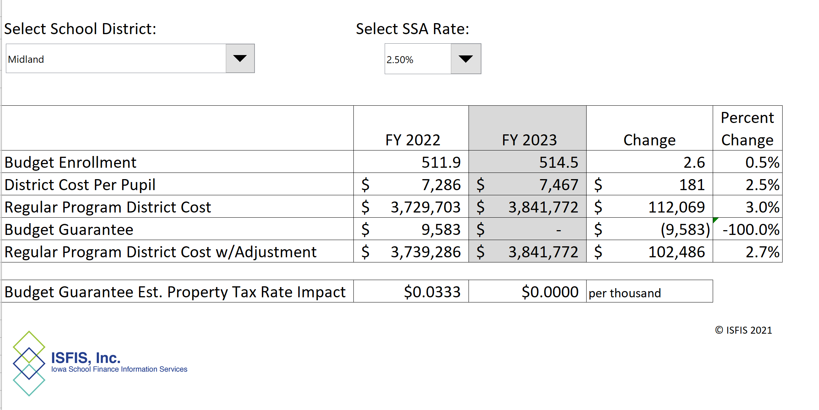
School Choice Status
Next week is National School Choice Week, so we may see the Governor’s voucher bill introduced. Meanwhile, keep talking with legislators. Stress these: 1) Use public dollars for public schools. Period.
2) Public funds require public accountability and transparency. 3) This proposal is a slippery slope toward a costly and expansive voucher program. 4) Iowa already has many parent choice options
Here is some additional information about the extent of public dollars that already support private education in Iowa. These figures are updated with the latest information available:
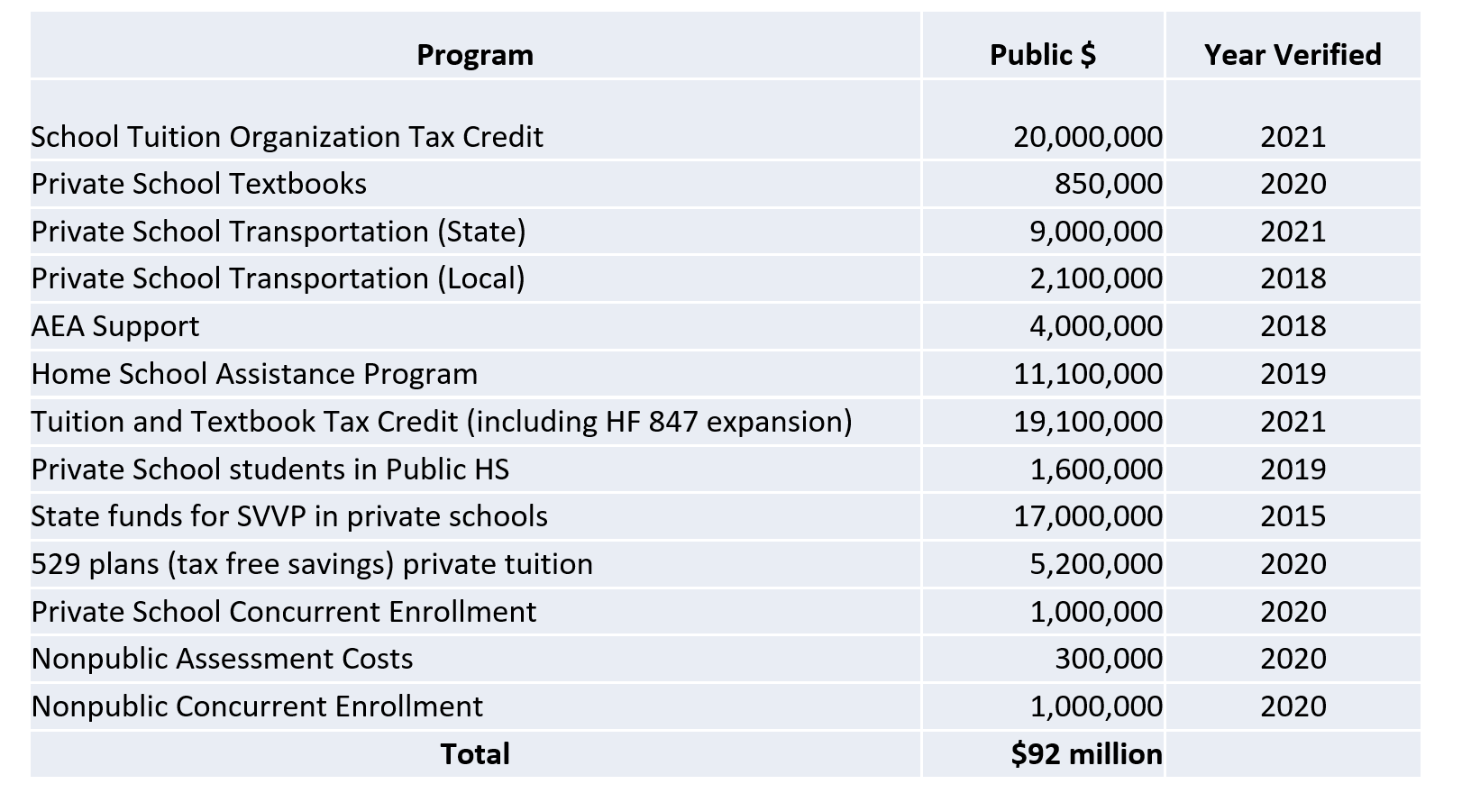

House Education Committee Action:
HF 2037 Shared Operational Functions (Education. Will receive a new bill number) This bill increases the supplementary weighting for schools that share operational superintendent management functions from 8 students to 9 students. Passed 23-0; FM: Dolecheck. RSAI is registered in support.

HSB 519 Teach Iowa Grants (Education. Will receive a new bill number) This bill makes teachers who finish preparation programs in the top 50% of the class eligible for Teach Iowa grants if the teacher is going to teach in-state. Splits grants for teachers based on the size of the district (half for under 1,000 students, half for over 1,000 students). Authorizes the College Student Aid Commission to make different awards if there are not enough applicants to award all of the reserved funds. Passed 23-0; FM: Dolecheck. RSAI is registered in support.

HSB 520 Teacher Assessments (Education. Will receive a new bill number) Strikes the ability of colleges to administer a pre-professional assessment to teaching candidates and the requirement to use a subject assessment from a national testing program but instead requires the DE and Universities to create another assessment. An amendment replaced the entire bill, instead eliminating any requirement for a pre or post-test to become a teacher. The amendment further required that Iowa Universities contact alumni who scored below the cut-off point on Praxis and notify them the test is no longer required. Passed 23-0 as amended; FM: T Moore. RSAI supports the bill.

HSB 521 TIF Divisions (Education. Will receive a new bill number) This bill prohibits a TIF division of school property taxes in an urban renewal area if the area contains a wind energy conversion project subject to special valuation that has been approved by local government. Effective for FY 2024. Amended and passed 16-7; FM: Hite. RSAI is registered in support of this bill.

Senate Education Committee Action
SF 2079 Required Immunizations (Education; Successor to SSB 3004) This bill pre-empts local ordinances regarding immunization requirements. Deems religious and medical exceptions apply to any immunization requirements from the State Board. SSB 3004 was approved 14-0. FM: Kraayenbrink. RSAI is monitoring this bill.
SF 2080 Student Invasive Health Screenings (Education; Successor to SSB 3005) This bill prohibits schools from doing invasive physical exams, or screenings not required by law, of students without written parent permission. Makes exceptions for emancipated minors, emergent care situations and child abuse assessments. SSB 3005 was approved 14-0. FM: Sinclair. RSAI is registered as undecided.
SF 2081 Computer Science Grants (Education; Successor to SSB 3002) This bill allows the recipients of grants for computer science professional development to spend the money until the September 30th past the fiscal year the grants are awarded. FM: Cournoyer. RSAI is registered in support.

Bills Introduced
House Bills
HF 2026 Excluding Retirement Income (Mohr, 54 R’s) (Ways & Means) This bill exempts all retirement income from the state income tax as of the 2022 tax year. RSAI is registered opposed to this bill. Although it doesn’t go as far as the Governor’s Tax Plan detailed above, it is still a significant reduction in state general fund revenues that will challenge future legislatures to adequately fund priorities of Iowans including public education.
HSB 574 School Year Start Date (Hite) (Education) This bill strikes Iowa Code provisions that prohibit a school from beginning before August 23. Requires schools to adopt a school calendar beginning after June 1 or before August 15 by the preceding February. Subcommittee of T. Moore, Brink and Gaines. RSAI is registered in support.
HSB 581 Bona Fide Retirements (State Government) This bill excludes the employment of a licensed teacher for a non-administrative position as covered employment in terms of determining a bona fide retirement under IPERS, between July 2022 through July 2026. Requires IPERS and the IASB to submit reports on the cost and effectiveness of these provisions. RSAI is registered in support.
Senate Bills Introduced
SF 168 Special Education Nonpublic Schools: (Education) This bill requires health services, special education support, and related services be provided to children at nonpublic schools. Subcommittee of Sens. Cournoyer, Giddens, and Johnson moved the bill forward 2:0. RSAI is registered opposed to this bill.
SF 233 Driving Privileges Special Minor’s DL: (Transportation) This bill sets a 50-mile limit for driving privileges of students issued a special minor’s driver’s license who attend a public school. (Formerly SF 67.) Subcommittee: Koelker, Driscoll, and T. Taylor. RSAI is registered as undecided.
SF 2024 Gender Identity Instruction (Carlin) (Education) This bill prohibits the school curriculum for grades 1-6 to include gender identity. Allows parents to opt out of this prohibition for the child through written consent but also allows the child to opt out of such instruction. It refers to the definition of Gender Identify in Iowa Code 216.2 10. “Gender identity” means a gender-related identity of a person, regardless of the person’s assigned sex at birth. RSAI is registered as undecided.
SF 2025 BATHROOM BILL (Carlin) (Education) This bill requires schools to designate multi-occupant toilets for one sex. Prohibits someone of a different biological sex from using a bathroom designated for the other biological sex. Exempts the bill from the provisions of the Iowa Civil Rights Act. Similar to last year’s SF 224. RSAI is registered opposed to this bill.
SF 2026 Iowa Scholar Program (Carlin) (Education) This bill increases the amounts that may be awarded in loan forgiveness for the Iowa Scholar Program to$7,500 a year, $37,500 total. It establishes a priority list for award recipients to include 1) renewals, 2) graduates of approved teacher preparation programs, 3) minorities, 4) Iowans. Similar to SF 547 approved in the Senate last year. RSAI is registered in support.
SF 2037 Race Scapegoating (Dickey) (Education) This bill prohibits school administrators from permitting race or sex scapegoating, or related concepts, to be taught. Establishes penalties for violations, including suspension without pay. RSAI is opposed to this bill.
SF 2039 School Racial Events (Dickey) (Education) This bill requires schools to prohibit school-sponsored events that are open only to members of a particular race or that limit participation or assess outcomes based on race. RSAI is registered as undecided.
SF 2040 Charter School Data (Dickey) (Education) This bill prohibits charter schools from collecting student data on race, religion or national origin from charter schools, except as required by federal law. Prohibits the charter schools from collecting such data, except as required by federal law. We believe this bill would prohibit a charter school from having goals related to closing the gap and collecting data to verify they did it. The bill would also prohibit the state board of education from requiring that data be provided to assess efficacy of the charter school. RSAI is opposed to this bill.
SF 2041 Child Relocation (Dickey) (Education) This bill requires a parent, with joint or sole custody, who is relocating a child outside of the child’s school district to give 60-days’ notice to the court and non-relocating parent. Requires the court to determine if the relocation is in the best interest of the child, upon a motion from either parent. Allows the court to make changes to the custody order, based on the best interest determination. RSAI is monitoring this bill.
SF 2042 State Undergraduate Work (Dickey) (Education) This bill requires the state universities to offer an undergraduate program that does not require a student to complete general education courses or courses outside the student’s field of study. RSAI is monitoring this bill.
SF 2043 Teacher Pledge of Allegiance (Dickey) (Education) This bill requires a K-12 teacher to take the pledge of allegiance and to stand for the pledge unless the teacher has a documented disability. Prohibits teachers from speaking about the pledge to a student in a manner that can be understood to be unpatriotic or to politically influence the student. The bill mandates specific penalties beyond ethics review by BOEE. RSAI is opposed to this bill.
SF 2044 Corporal Punishment Court Costs (Dickey) (Education) This bill allows a school employee who is wrongfully accused of afflicting corporal punishment on a student to collect attorney’s fees if the employee prevails in a lawsuit. RSAI is undecided on this bill.
SF 2047 High School Sports/Activity Classes (Dickey) (Education) This bill prohibits schools from paying fees to a High School extracurricular activity organization if the organization does not classify private schools one class higher than enrollment would require. Does not apply to private schools in the largest classes. RSAI is registered as undecided.
SF 2058 Property Tax Deferrals: (Carlin) (Ways and Means) This bill allows a surviving spouse to defer property taxes under certain conditions (homestead owned for at least 15 years, no tax liens or mortgage for more than 75% of the value of the home, income under $60,000). Allows the deferral until the claimant dies or remarries, sells the property or otherwise ends deferral. Requires the DORF to pay the deferred tax amounts until the deferral ends or until the deferred taxes equal 75% of the value of the home. Requires the taxes to be paid within a year of the end of the deferral. RSAI is registered undecided on this bill.
SF 2059 School Tax Exemption (Carlin) (Ways and Means) This bill exempts the homestead of a senior from certain school property taxes. Requires the senior to file for the exemption. Applies to tax years beginning 2023. RSAI is registered opposed to this bill.
SF 2071 Sex Education Requirements (Petersen) (Education) This bill requires health and human growth curriculum (sex ed) for K-6 to include instruction on identifying parts of the body and age-appropriate, research-based information on empathy and respecting personal boundaries. Requires the curriculum for 7-12 to include information on consent and on identifying sexually predatory behavior and unhealthy relationships. RSAI is registered as undecided on the bill.
SF 2074 PK Programs (Mathis) (Education) This bill allows schools to request DE approval to use SAVE funds for three school years for costs related to starting or expanding PK programs. Requires schools to demonstrate that there is not sufficient capacity in the area to serve children who are not English proficient or the number of students who qualify for FRPL or if more than 15% of students are not reading proficiently. RSAI is registered in support.
SF 2075 Suicide Prevention (Mathis) (Education) This bill requires the regents and school boards to requires K-12 schools and universities that issue IDs to include the 3-digit suicide hotline number from DHS. Encourages private schools to do the same. RSAI is registered as undecided.
SSB 3003 Loan Forgiveness for Mental Health Professionals (Sinclair) (Education) This bill establishes a student loan forgiveness program for mental health professionals practicing in Iowa. RSAI is registered in support.
Advocacy Actions This Week
- Always start with a thank you! See the 2021 Legislative Session Successes on the RSAI website and find one you are grateful for them accomplishing.
- Express interest in the Governor’s Teacher and Para educator Registered Apprenticeship Program and support for expanding teacher student loan forgiveness programs in both the House and Senate Education Committees: Share grow your own programs and initiatives in your district already underway that might inform this policy discussion.
- Explain the SSA numbers to your legislators, especially in light of inflation and workforce shortage. Talking points:
- Supplemental state aid is the biggest source of per pupil funding in Iowa, but our funding has not kept pace nationally, putting our students and state at a disadvantage. Sufficient funding provides for a high-quality education that translates to a successful future and economic growth in our state. The Governor’s recommendation of 2.5% SSA only amounts to an estimated $81.6 million in statewide new money, below previous years’ investment in Iowa schools.
- As a result of the legislature eliminating the Commercial and Industrial Replacement payment for school districts but increasing the foundation level, the cost of school aid will increase by $59 million without providing any new money to school districts. The funding source becomes the state general fund instead of local property taxes.
- Inflation and cost-of-living increases should be considered when determining school aid funding. School districts must pay competitive salaries to retain teachers and staff, especially during a labor shortage. The legislature should provide funding that considers the impact inflation has on recruiting and retaining school employees
- School funding is enrollment-driven and increases in enrollment impact the supplemental state aid amount. On the flip side, declining enrollment combined with low SSA means more rural schools will have to consolidate or face closure by the state because they depend on adequate state funding to remain open.
- Low SSA amounts also lead to more districts being eligible for budget guarantee, which shifts the funding burden to local property taxpayers. At the Governor’s proposed 2.5% SSA, 82 districts would be eligible for the budget guarantee at a total cost to property taxpayers of $9.1 million.
Find more SSA information and talking points in the RSAI Issue Brief on Adequate Funding on the RSAI website here.
- Shore up Voucher Opposition: Circle back with your legislators who’ve previously told you they opposed vouchers and reiterate key messages:
  - Use public dollars for public schools. Period.
  - Public funds require public accountability and transparency.
  - A slippery slope toward a costly an expansive voucher program.
  - Iowa already has many parent choice options
Gratitude: Tell your legislators and the Governor thank you for the preschool funding supplement through the SBRC. THANK YOU for getting that done. (We will need to do it again this coming year.)
Connecting with Legislators: To call and leave a message at the Statehouse during the legislative session, the House switchboard operator number is 515.281.3221 and the Senate switchboard operator number is 515.281.3371. You can ask if they are available or leave a message for them to call you back. You can also ask them what’s the best way to contact them during session. They may prefer email or text message or phone call based on their personal preferences.
Find biographical information about legislators gleaned from their election websites on the ISFIS site here: http://www.iowaschoolfinance.com/legislative_bios Learn about your new representatives and senators or find out something you don’t know about incumbents.
Find out who your legislators are through the interactive map or address search posted on the Legislative Website here: https://www.legis.iowa.gov/legislators/find
RSAI Advocacy Resources: To find Advocacy Resources such as Position Papers, RSAI Weekly Legislative Reports and video updates, RSAI Calls to Action when immediate advocacy action is required, testimony presented to the State Board of Education, the DE or any legislative committee or public hearing, and links to fiscal information that may inform your work, visit the RSAI legislative web page here: http://www.rsaia.org/legislative.html. Also, check out the newly released 2022 RSAI Advocacy Handbook, and also available on the legislative page of the RSAI website

Education Committee Members in the Senate and House:

Senate Members
- Amy Sinclair (R, District 14), Chair
- Jeff Taylor (R, District 2), Vice Chair
- Herman C. Quirmbach (D, District 23), Ranking Member
- Jim Carlin (R, District 3)
- Claire Celsi (D, District 21)
- Chris Cournoyer (R, District 49)
- Eric Giddens (D, District 30)
- Tim Goodwin (R, District 44)
- Craig Johnson (R, District 32)
- Tim Kraayenbrink (R, District 5)
- Ken Rozenboom (R, District 40)
- Jackie Smith (D, District 7)
- Annette Sweeney (R, District 25)
- Sarah Trone Garriott (D, District 22)
- Brad Zaun (R, District 20)

House Members
- Dustin D. Hite (R, District 79), Chair
- Skyler Wheeler (R, District 4), Vice Chair
- Sharon Sue Steckman (D, District 53), Ranking Member
- Jacob Bossman (R, District 6)
- Holly Brink (R, District 80)
- Sue Cahill (D, District 71)
- Cecil Dolecheck (R, District 24)
- Tracy Ehlert (D, District 70)
- Joel Fry (R, District 27)
- Ruth Ann Gaines (D, District 32)
- Eric Gjerde (D, District 67)
- Garrett Gobble (R, District 38)
- Chad Ingels (R, District 64)
- David Kerr (R, District 88)
- Mary Mascher (D, District 86)
- Thomas Jay Moore (R, District 21)
- Sandy Salmon (R, District 63)
- RasTafari Smith (D, District 62)
- Ray Sorensen (R, District 20)
- Art Staed (D, District 66)
- Henry Stone (R, District 7)
- Phil Thompson (R, District 47)
- John H. Wills (R, District 1)

Contact us with any questions, feedback or suggestions to better prepare your advocacy work:
*Margaret Buckton, RSAI Professional Advocate, margaret@iowaschoolfinance.com , 515.201.3755 Cell
*Dave Daughton, RSAI Grassroots Advocate, dave.daughton@rsaia.org, 641-344-5205 Cell
Thanks to our RSAI Corporate Sponsors: Special thank you to your RSAI Corporate Sponsors for their support of RSAI programs and services. Find information about how these organizations may help your district on the Corporate Sponsor page of the RSAI website at www.rsaia.org/corporate-sponsors.html.
 | www.apptegy.com
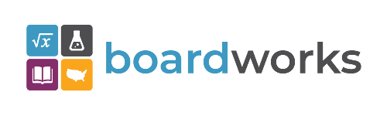 | www.boardworkseducation.com
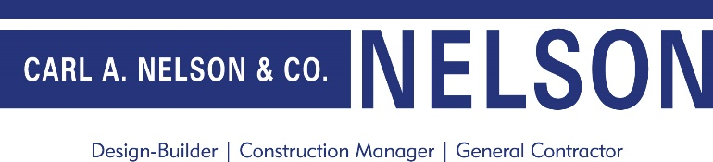 | www.carlanelsonco.com
 | www.classroomclinic.com
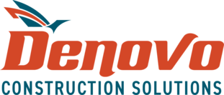 | www.teamdenovo.com
 | www.friedman-group.com
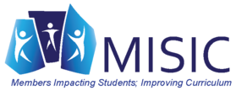 | www.misiciowa.org
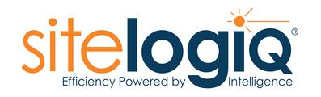 | www.sitelogiq.com

