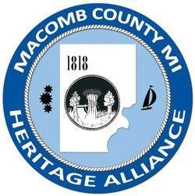
Macomb County Heritage Alliance Annual Meeting
Saturday, April 29, 2023

Hosted by: Ford House

Agenda

8:45-9:00 Registration, Refreshments, Meet and Greet, Assembly of Notebooks
9:00-9:40 Pledge of Allegiance – Ford House Staff
Welcome – Mark Heppner, President of Ford House
Opening Remarks: Deborah Remer
Introduction of Current Board
Approval of Minutes April 2022
Accept and file Treasurer’s Report
Member Benefits
Election of Officers
9:40 -10:00 Break – snacks and bid on silent auction items.
10:00-11:00 Historic Preservation: Best Practices for Sourcing Solutions presented by Rebecca Torsell, Director of Historic Preservation at Ford House, Q&A
11:00- 11:15 Presentation of Alexander Macomb Awards & MCHA Heritage Grant – Deborah Remer
11:15-12:30 Lunch, Auction Bidding, Networking
12:30-12:45 Auction Winners & Closing Remarks
1:00-3:00 Visit the Main Residence at Ford House for a self-guided tour and walk the grounds.

