Merry Christmas

From your Texas WMA officers

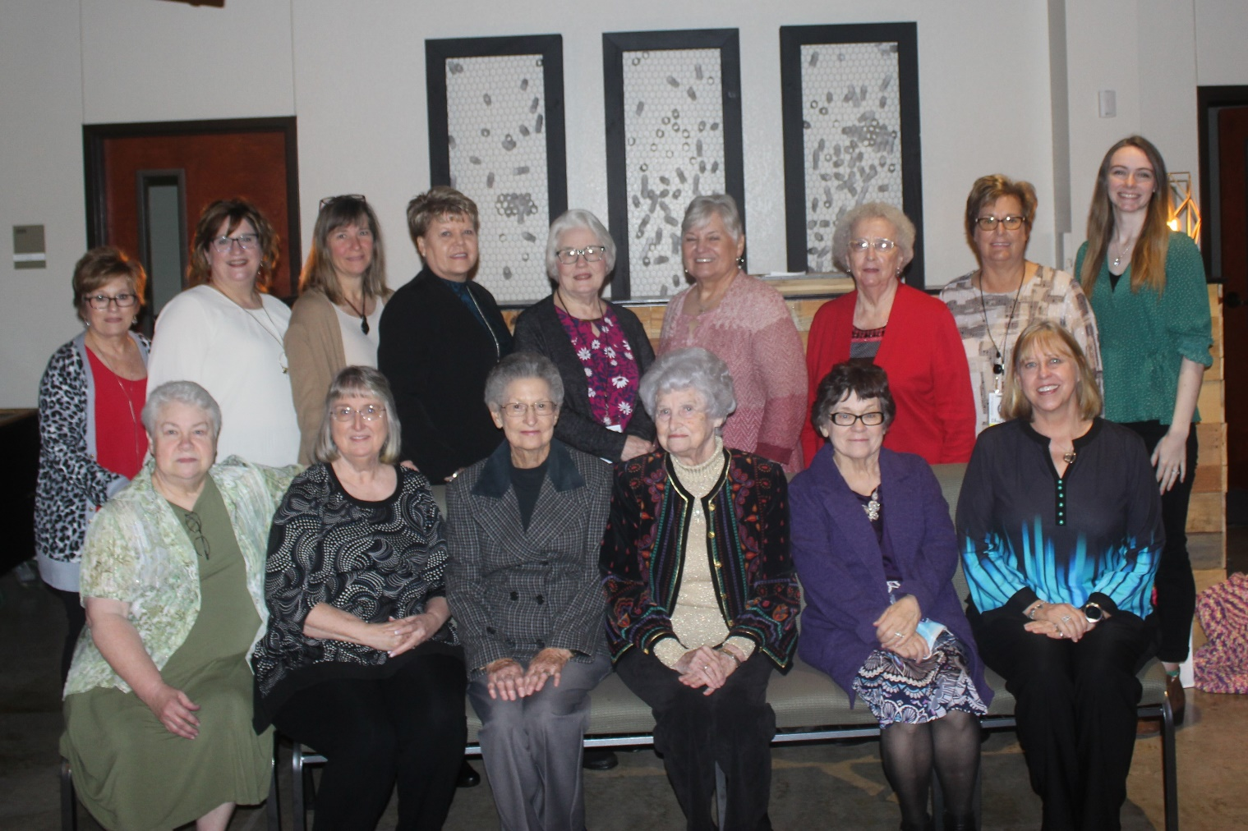

Left to Right, Back Row: Diana Morris, Kristi Key, Cindy Allen, Charlotte Johnson, Jackie Ricks, Jeannie Walker,

Elizabeth Midkiff, D’Andra Smith, and Hayley Rasco

Front Row: Johnnie Ross, Jo Strong, Ann Pugh, Claudie Thompson, Lynda Marsh, and Glenda Chamberlain.

Not Pictured: Maeva Thompson, Alicia Johnson, Katie Allen, Vera Koontz, Shirley Hoffpauir, Christi McDermott,

Lynelle Teas, and Candace Jordan