SAMPLE PRESS RELEASE
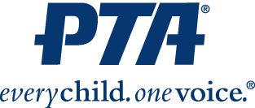
Contact:
{NAME AND CONTACT INFO}

{NAME OF PTA®} Plans {SPECIAL EVENT}

{CITY, STATE} (DATE) – Decades of research show a direct link between family engagement and student achievement, regardless of race, religion, background or socio-economic status. That’s why {NAME OF PTA SCHOOL} in {NAME OF CITY, STATE} is hosting {Name of Program or Event}.
{NAME OF PTA SCHOOL} in partnership with {Sponsors or Community Partners} will {List Events} to {Program Goals}.
{Insert quote from PTA President or school principal about importance of this program.}
{Insert boilerplate information about the program from the National PTA website, if available.}
About National PTA
National PTA® comprises millions of families, students, teachers, administrators, and business and community leaders devoted to the educational success of children and the promotion of family engagement in schools. PTA is a registered 501(c)(3) nonprofit association that prides itself on being a powerful voice for all children, a relevant resource for families and communities, and a strong advocate for public education. Membership in PTA is open to anyone who wants to be involved and make a difference for the education, health, and welfare of children and youth.

