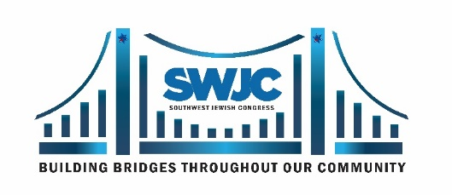
SWJC TEXAS SIZED EVENT
TUESDAY, OCTOBER 3, 2023
Dinner & Awards
Edison’s in Downtown Dallas

HONOREE NOMINATION FORM
Submit nomination by April. 24, 2023. Email to Susan Myers: susan@swjc.org or mail to the address below.
Please use additional pages to describe your Nominee’s community involvement. Include their short bio, a photo, and give recommendations and comments from yourself and others.
Date Submitted: Nominator’s Name:
Nominator’s Cell: Nominator’s Email:
NOTE: If your nominee is selected, SWJC may ask for your assistance in helping to make sure the friends, family and associates of your honoree know of this event. Some of our recipients are very humble and don’t publicize this recognition, not realizing that many of these people would like to be there to celebrate with them.

ELIGIBILITY: • Nominee must receive the award in person on Tuesday, October 3rd, 2023.
- Actively engaged in service to the DFW Metroplex Community.
- Biography and multiple photos required at a later date for event purposes.
• Agree with the principles and mission of the Southwest Jewish Congress. *

NOMINATING FOR: ❑ Women’s Award: Audrey Kaplan Inspiring Women of the Southwest Award
(choose one) ❑ Men’s Award: Stan Golden Men of Action Award
❑ Young Adult’s Award: Future Inspiring Women and Future Men of Action Award
Nominee must be 14-21 years of age and have parental or guardian approval.

NOMINEE’S NAME:
Address:
Cell: Email:
ADDITIONAL INFORMATION NEEDED (AGES 14-21) Age: Grade: School:
Parents’ Names: Parents’ phones:
*SWJC Mission Statement:
Southwest Jewish Congress is a membership organization, open to all, that welcomes diversity and builds bridges throughout our community. We provide quality educational programs and events supporting the U.S. Constitution and human rights; regarding Jewish culture and history; promoting Israel and its role in the world; and honoring those who have significantly contributed to the advancement of our society, culture, and lives.

